AXI-Lite Slave IP with Memory Specification
High-Level Design Specification (HLDS) — Milestone 1
ECE-593: Fundamentals of Pre-Si Validation
Portland State University

Document Information
Field | Value
Project | AXI-Lite Slave IP with Memory (axi_lite_mem)
Document ID | HLDS-AXIL-001
Design Version | RTL v0.1 (MS1 baseline, unchanged through MS5)
Verification Level | Block-level
Milestone | MS1 baseline – maintained through MS5 (Final)
Team Members | Patrick, Pratibha
Prepared By | Patrick, Pratibha
Date Created | April 18, 2026
Revision | 1.1 – MS5 Final (verification-validated)
Status | Released

Block Diagram
The DUT is organized as a top-level wrapper (s_axil_top) that instantiates a write-channel submodule (AXI Lite Write), a read-channel submodule (AXI Lite Read), and a shared Block RAM. The AXI Lite Master (testbench) drives the five AXI4-Lite channels into the DUT. The write submodule produces w_addr, w_data, w_enable, and w_strb signals to the Block RAM; the read submodule produces r_addr and r_enable and receives r_data from the Block RAM.
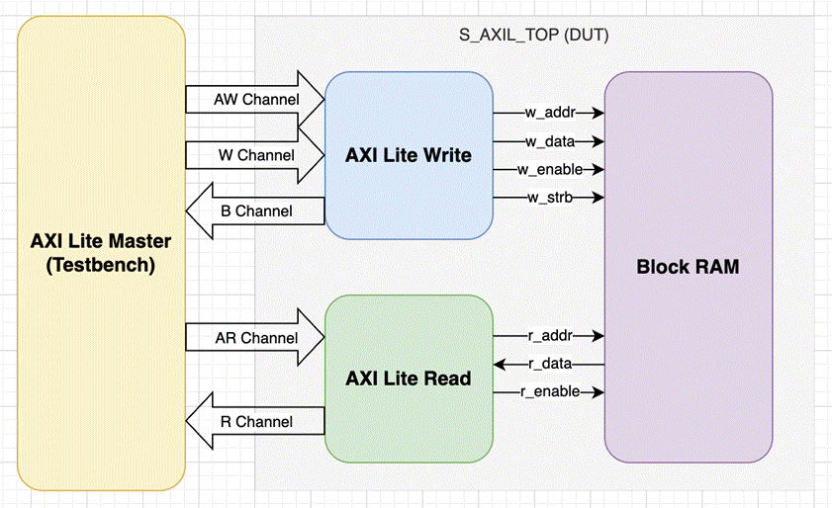
Figure 1. AXI-Lite Slave IP with Memory — block diagram.
Module hierarchy:
s_axil_top
├── s_axil_wr (AW, W, B channels)
├── s_axil_rd (AR, R channels)
└── mem[MEM_DEPTH] (shared storage, 32-bit)

Functional Description
This IP implements a parameterized AXI4-Lite slave with an internal block RAM. The design is fully synchronous to a single clock (clk) with an active-low synchronous reset (resetn). All five AXI4-Lite channels follow the standard VALID/READY handshake defined in the AMBA AXI4-Lite specification.

Write Path
The AW (write address) and W (write data) channels are accepted independently. Each channel latches its payload on a successful handshake and raises an internal "active" flag. A write is committed to memory only once both channels have completed their handshake and a B-channel response is not already pending. Byte lane strobes (WSTRB) control which bytes within the addressed word are updated; un-strobed bytes retain their previous value.
On commit, the slave returns BRESP = OKAY for in-range addresses and BRESP = SLVERR for out-of-range accesses, which are silently dropped (no memory update occurs). The B-channel response is held valid until the master asserts BREADY.

Read Path
A read address is accepted on the AR channel. A registered memory read is issued on the following cycle and the retrieved data is presented on the R channel one clock cycle after that. ARREADY is gated until any in-flight read has drained on the R channel, ensuring at most one outstanding read transaction at a time. Out-of-range addresses return 0x0 on RDATA with RRESP = SLVERR; in-range reads return the word contents with RRESP = OKAY.

Write-Before-Read Forwarding
When the write and read paths target the same word address in the same clock cycle, the incoming write data (merged with the current memory contents through WSTRB) is forwarded directly to the read data path. This avoids the one-cycle stale-read window that would otherwise exist between the memory write and the next read.

Reset Behavior
A synchronous active-low reset (resetn) initializes all control state — AW/W latches, B-response pending, R-valid pending, and the read pipeline registers. The memory array contents are not reset; if the MEM_INIT parameter is non-empty, the memory is loaded from the specified $readmemh file in an initial block. Otherwise, memory contents are unspecified until first written.

Parameters
Parameter | Default | Description
DATA_WIDTH | 32 | AXI data bus width in bits. Must be 32 or 64.
ADDR_WIDTH | 12 | AXI byte address bits (≤ 32). Defines the decoded address range.
MEM_DEPTH | 256 | Number of DATA_WIDTH-wide words in the memory block. Power-of-2 required for clean decode.
MEM_INIT | "" | Optional path to $readmemh-compatible hex file for memory preload. Empty string skips init.

Derived Quantities and Calculations
Quantity | Expression | Value at Defaults
STRB_WIDTH | DATA_WIDTH / 8 | 4
WORD_BITS | $clog2(STRB_WIDTH) | 2 (byte offset bits)
MEM_AW | $clog2(MEM_DEPTH) | 8 (word-address bits)
Addressable bytes | MEM_DEPTH × STRB_WIDTH | 1024 (1 KB of storage)
AXI byte space | 2^ADDR_WIDTH | 4096 (4 KB window)
In-range condition | awaddr[ADDR_WIDTH-1:WORD_BITS] < MEM_DEPTH | byte_addr[11:2] < 256
Address decomposition at defaults (ADDR_WIDTH=12, DATA_WIDTH=32):
byte_addr[11:10] unused / upper decode (reserved for range check)
byte_addr[9:2] word index into mem[256]
byte_addr[1:0] byte offset within word (ignored by logic; byte selects via WSTRB)

Port Definitions
Signal | Dir | Width | Description
clk | I | 1 | Clock
resetn | I | 1 | Active-low synchronous reset
s_axi_awvalid | I | 1 | Write address valid
s_axi_awready | O | 1 | Write address ready
s_axi_awaddr | I | ADDR_WIDTH | Write byte address
s_axi_awprot | I | 3 | Write protection type (accepted but not enforced)
s_axi_wvalid | I | 1 | Write data valid
s_axi_wready | O | 1 | Write data ready
s_axi_wdata | I | DATA_WIDTH | Write data
s_axi_wstrb | I | DATA_WIDTH/8 | Write byte lane strobes
s_axi_bvalid | O | 1 | Write response valid
s_axi_bready | I | 1 | Write response ready
s_axi_bresp | O | 2 | Write response (OKAY / SLVERR)
s_axi_arvalid | I | 1 | Read address valid
s_axi_arready | O | 1 | Read address ready
s_axi_araddr | I | ADDR_WIDTH | Read byte address
s_axi_arprot | I | 3 | Read protection type (accepted but not enforced)
s_axi_rvalid | O | 1 | Read data valid
s_axi_rready | I | 1 | Read data ready
s_axi_rdata | O | DATA_WIDTH | Read data
s_axi_rresp | O | 2 | Read response (OKAY / SLVERR)

Response Encoding
Response codes are defined in s_axil_defs.svh as enum type axi_resp_t:
Encoding | Mnemonic | Usage in this DUT
2'b00 | RESP_OKAY | Returned on every successful in-range read or write.
2'b01 | RESP_EXOKAY | Defined but not used (exclusive access not supported in AXI-Lite).
2'b10 | RESP_SLVERR | Returned when the addressed word index is ≥ MEM_DEPTH.
2'b11 | RESP_DECERR | Defined but not generated by the slave (decode done upstream in an interconnect).

Channel Behavior and Handshake Details

Write Address (AW) Channel
• AWREADY asserts whenever resetn is high and no address is currently latched (aw_active = 0).
• On AWVALID && AWREADY handshake, AWADDR and AWPROT are captured; aw_active asserts.
• aw_active clears on the cycle the committed write fires (see Write-Commit Condition below).

Write Data (W) Channel
• WREADY asserts whenever resetn is high and no data beat is currently latched (w_active = 0).
• On WVALID && WREADY handshake, WDATA and WSTRB are captured; w_active asserts.
• The AW and W handshakes are independent and may occur in any order.

Write-Commit Condition
A memory write fires (mem_w_en = 1) when the following conditions all hold simultaneously:
• aw_active = 1 (address captured)
• w_active = 1 (data captured)
• b_pending = 0 (no prior B response is still waiting on BREADY)
• Address is in range; otherwise the write is silently dropped and SLVERR is returned.

Write Response (B) Channel
• BVALID asserts the cycle after a write-commit event.
• BRESP = RESP_OKAY for in-range writes, RESP_SLVERR for out-of-range.
• BVALID remains asserted until BREADY is sampled high.

Read Address (AR) Channel
• ARREADY asserts when resetn is high and no read is in flight (ar_active, read_pending, and r_valid all 0).
• On ARVALID && ARREADY handshake, ARADDR is captured; ar_active asserts for one cycle.
• In-range check is evaluated and latched at the same time.

Read Data (R) Channel
• The memory read is issued one cycle after AR handshake (BRAM-style 1-cycle latency).
• RVALID asserts the cycle after the memory read issues, presenting the data on RDATA.
• For in-range reads, RDATA = mem[word_addr] and RRESP = RESP_OKAY.
• For out-of-range reads, RDATA = 0 and RRESP = RESP_SLVERR.
• RVALID stays asserted until RREADY is sampled high.

Timing Behavior
The following narrative diagrams describe the cycle-by-cycle behavior. Graphical waveforms (e.g., from WaveDrom or simulator snapshots) should be added before final submission.

Single In-Range Write (Best Case: AW and W Concurrent, BREADY High)
Cycle 0: master asserts AWVALID, WVALID, BREADY; slave has AWREADY = WREADY = 1.
Cycle 1: aw_active, w_active both high; write_fire asserts; mem_w_en pulses; BRESP latched.
Cycle 2: BVALID high with BRESP = OKAY; BREADY already high → handshake completes.
Cycle 3: all control flags cleared; slave ready for next transaction.

Single In-Range Read
Cycle 0: master asserts ARVALID, RREADY; slave has ARREADY = 1.
Cycle 1: ar_active asserts; mem_r_en pulses; read_pending asserts for next cycle.
Cycle 2: RVALID asserts; RDATA = mem[word_addr]; RRESP = OKAY.
Cycle 3: RREADY high → handshake completes; r_valid clears.

Out-of-Range Write (SLVERR)
Same timing as an in-range write, except mem_w_en stays low (write silently dropped) and BRESP = SLVERR on the B handshake.

Out-of-Range Read (SLVERR)
Same timing as an in-range read, except mem_r_en stays low, RDATA = 0, and RRESP = SLVERR.

Write-Before-Read Forwarding
When mem_w_en and mem_r_en both assert in the same cycle and mem_waddr == mem_raddr, the memory read multiplexer substitutes the WSTRB-merged write data in place of the old memory contents on the read data path.

Verification Status
This design was verified at block level through Milestone 5 of the ECE-593 final project. The RTL is unchanged from the MS1 baseline. Verification was performed with a UVM 1.2 environment under Synopsys VCS R-2020.12, using a 50-seed constrained-random regression supplemented by directed sequences.
Verification results: all functional covergroups (11 total) reached 100%; code coverage reached an overall score of 96.77% with line, branch, and functional coverage all at 100%, toggle coverage at 98.55%, and condition coverage at 85.29%. FSM coverage is not applicable because the control logic uses independent handshake flag registers rather than an encoded state machine. The residual condition and toggle gaps were reviewed and waived as architecturally unreachable (combinational READY signals that cannot present VALID-while-not-READY, and the constant bit 0 of the two-valued BRESP/RRESP response). All 50 regression seeds pass with zero scoreboard errors. Refer to the Verification Plan (VPL-AXIL-001, Rev 1.3) for the complete coverage tables, unreachable analysis, and bug-injection validation.

Acknowledgements
This project is submitted for ECE-593: Fundamentals of Pre-Si Validation at Portland State University, instructed by Venkatesh Patil. The design specification template and project framework are based on course-provided reference documents.

References
• AMBA AXI and ACE Protocol Specification (ARM IHI 0022E) — https://developer.arm.com/documentation/ihi0022/e
• Comprehensive Functional Verification — Bruce Wilde (course reference text)

Document Revision History
Revision | Date | Author | Description
0.1 | 2026-04-18 | Patrick, Pratibha | Initial draft for internal review
1.0 | 2026-04-20 | Patrick, Pratibha | Baselined for MS1 submission
1.1 | 2026-05-28 | Patrick, Pratibha | MS5 final: status set to Released; design confirmed unchanged from MS1 baseline and validated by the MS5 verification effort (96.77% code coverage, 100% functional coverage, all 50 regression seeds passing). Added Verification Status note.

