**1. Ideal Low-pass filter**

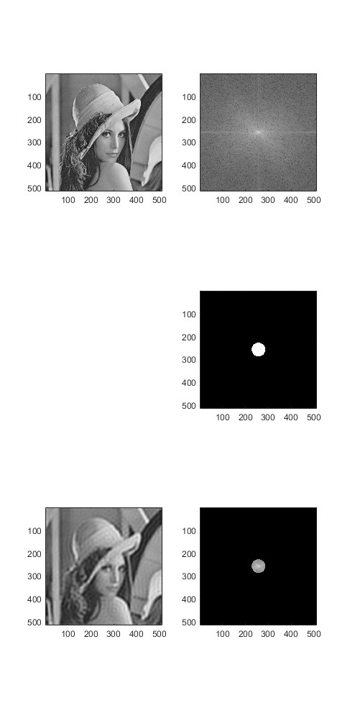

**2. Ideal High-pass filter**



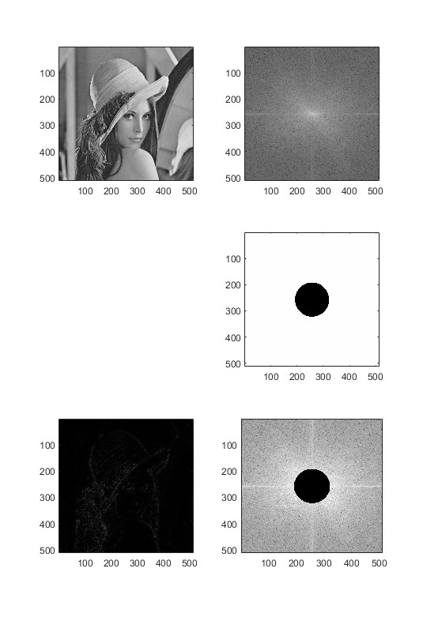

**3. Butterworth low-pass filter (blf)**





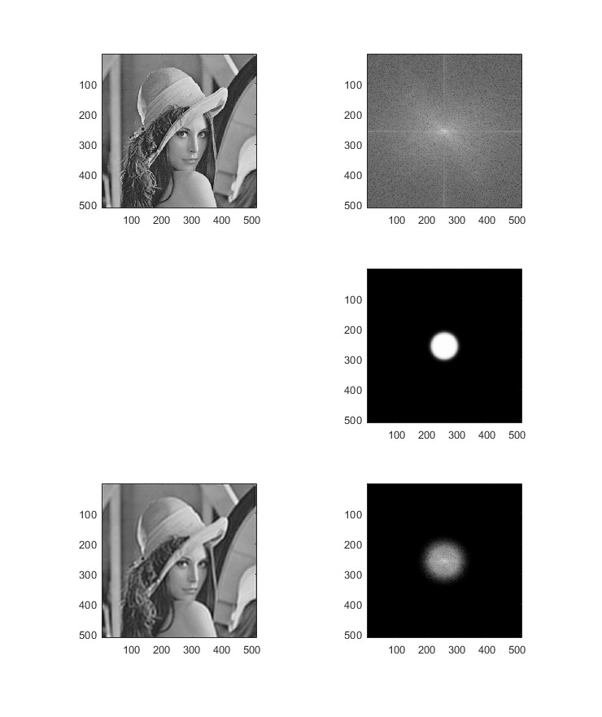

**4. Butterworth high-pass filter (bhf)**





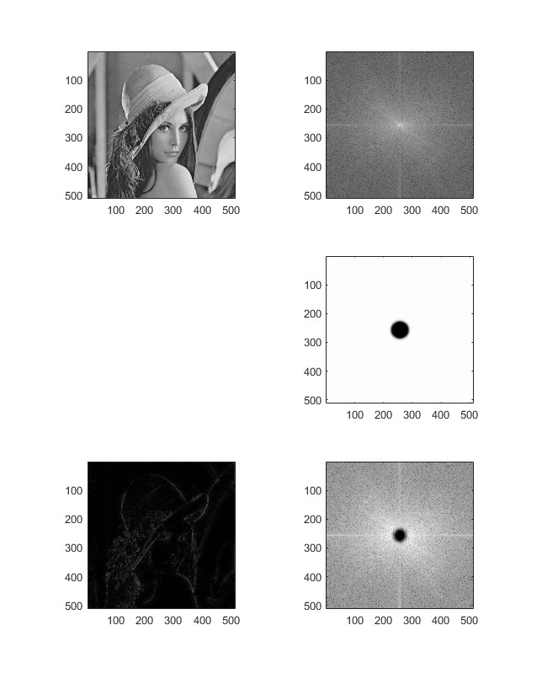

**5. Gaussian Low-Pass Filter (glf)**



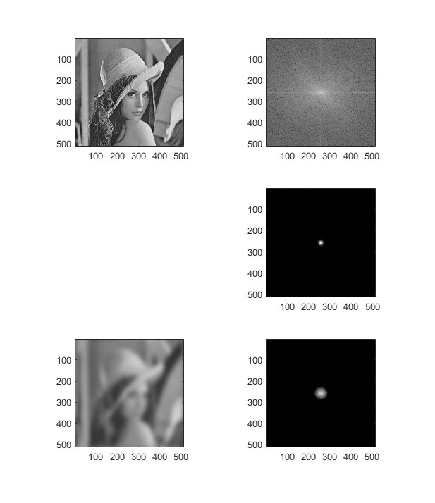

**6. Gaussian High-Pass Filter (ghf)**



