Chapter 4 — Results and Conclusions
This chapter summarises the key exploratory findings (EDA) and presents a horizon-wise evaluation of baseline and hybrid forecasting models for UK CPI inflation. Results are reported for horizons t+1, t+3, and t+5 using MAE, RMSE, and R², alongside visual diagnostics.

4.1 Exploratory Data Analysis (EDA) — key findings
EDA figures are included to motivate feature selection and highlight the behaviour of CPI and candidate drivers (bank rate, exchange rates, petrol/oil price changes, unemployment, and GVA growth). The plots also illustrate correlation structure, lead–lag patterns, rolling relationships, and potential structural changes.
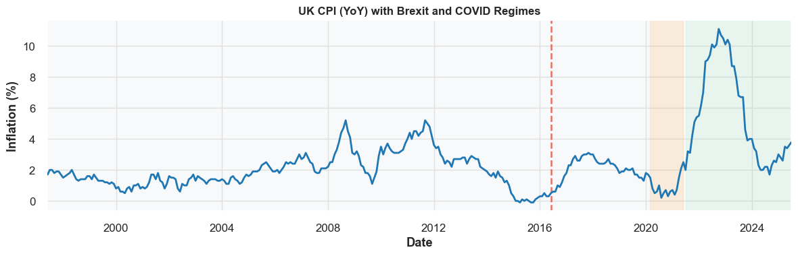
Figure 4.1.1: fig1_cpi.png
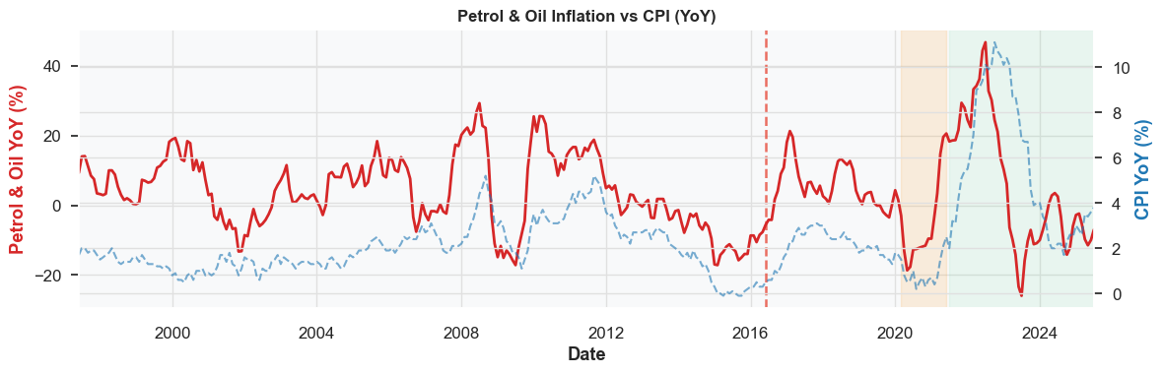
Figure 4.1.2: fig2_petrol.png
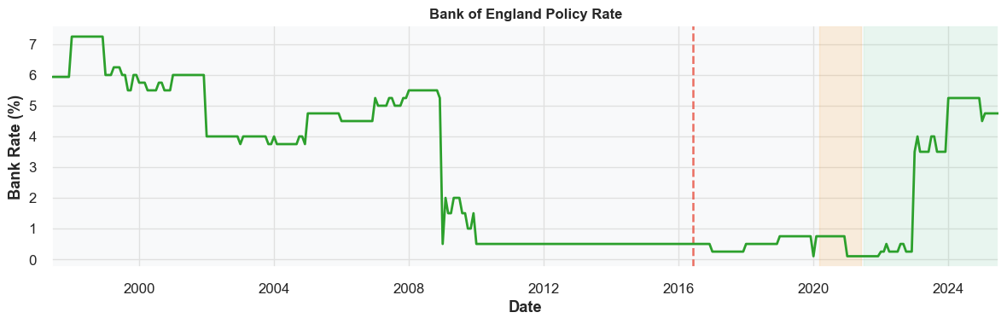
Figure 4.1.3: fig3_bank.png
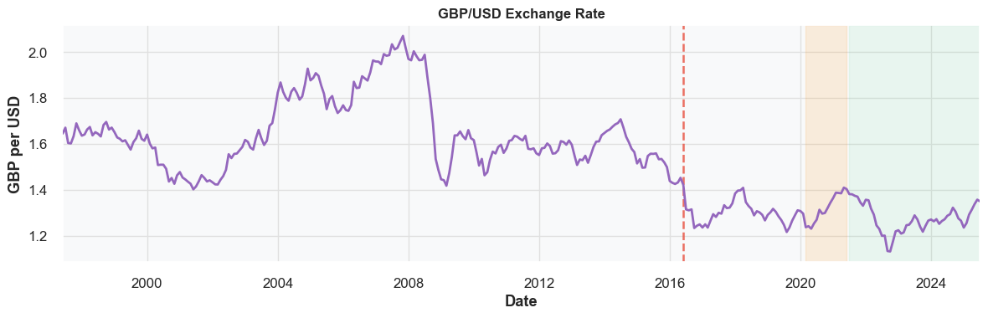
Figure 4.1.4: fig4_fx.png
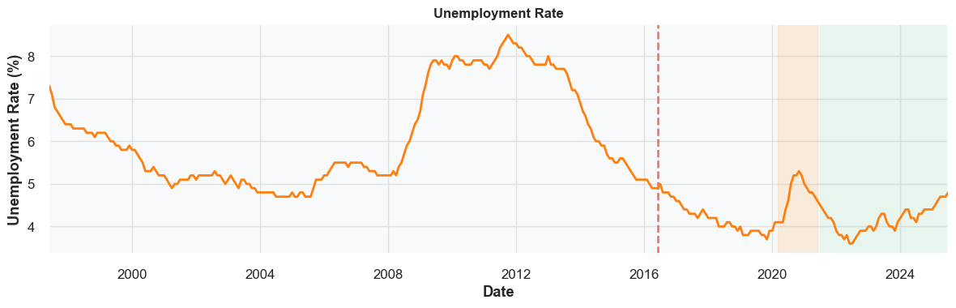
Figure 4.1.5: fig5_unemp.png
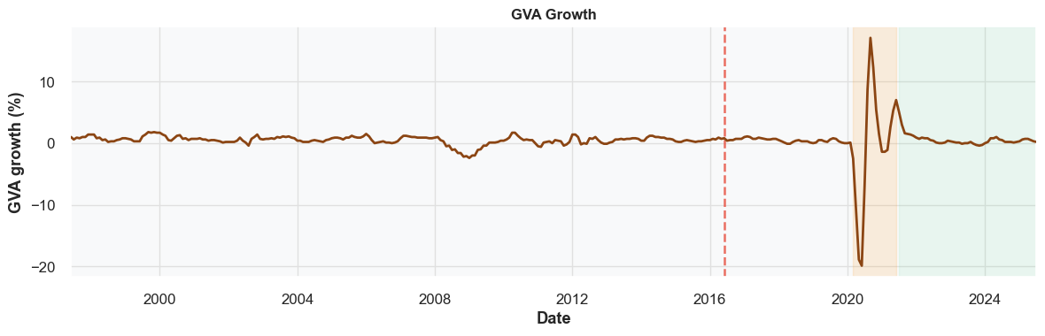
Figure 4.1.6: fig6_gva.png
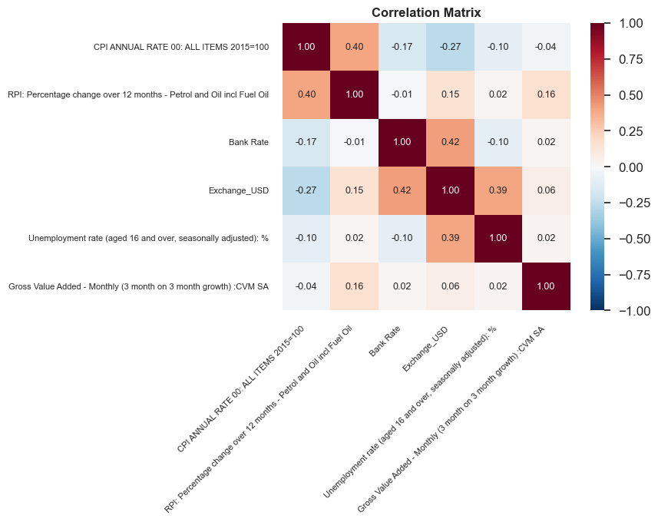
Figure 4.1.7: fig7_corr.png
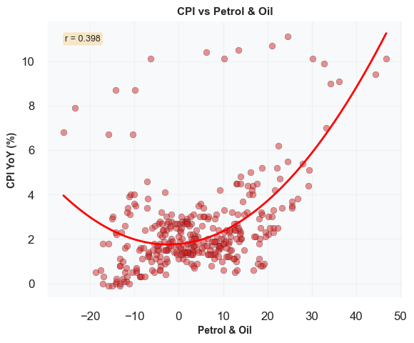
Figure 4.1.8: fig8_scatter.png
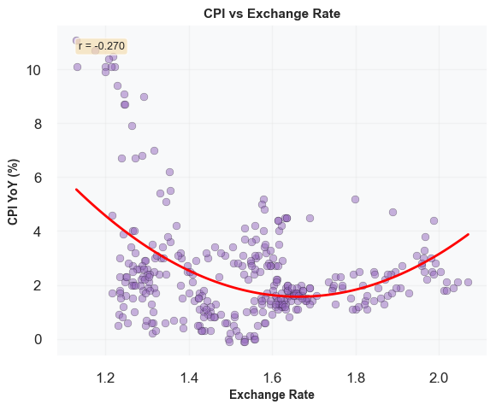
Figure 4.1.9: fig9_scatter.png
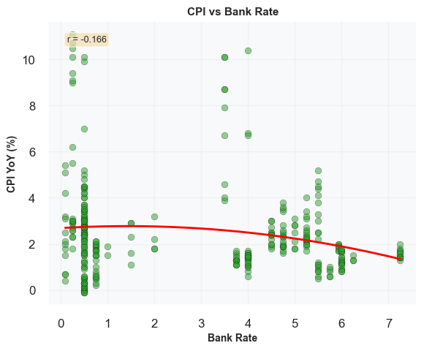
Figure 4.1.10: fig10_scatter.png
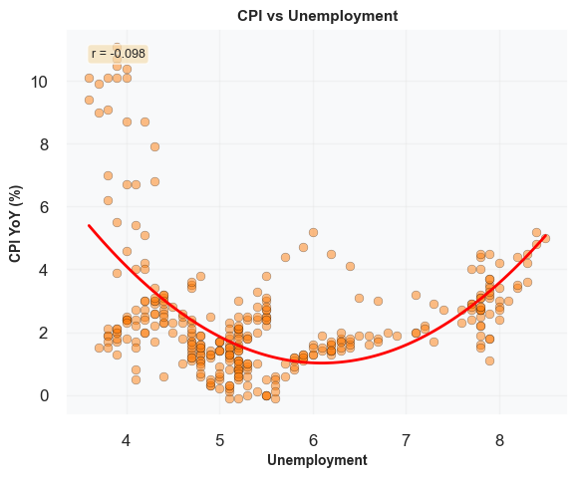
Figure 4.1.11: fig11_scatter.png
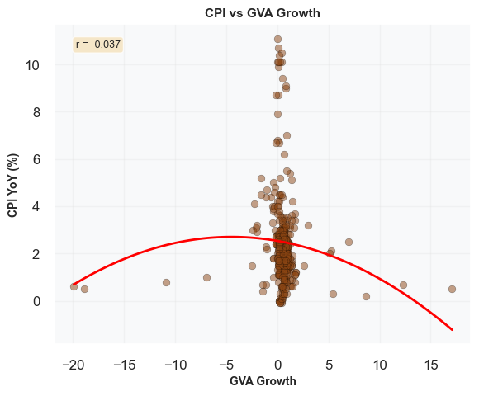
Figure 4.1.12: fig12_scatter.png
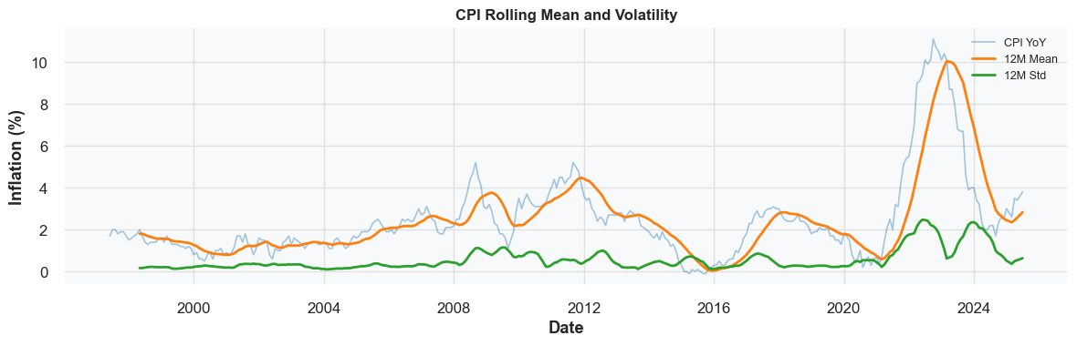
Figure 4.1.13: fig13_rolling.png
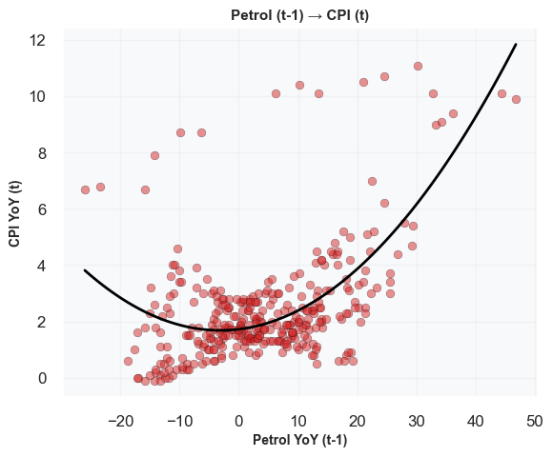
Figure 4.1.14: fig14_leadlag.png
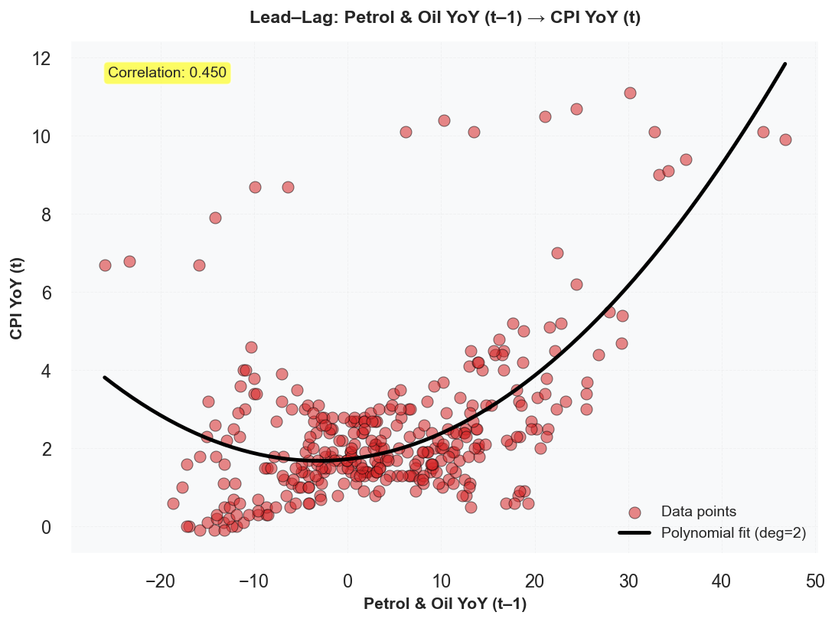
Figure 4.1.15: fig14_leadlag_petrol.png
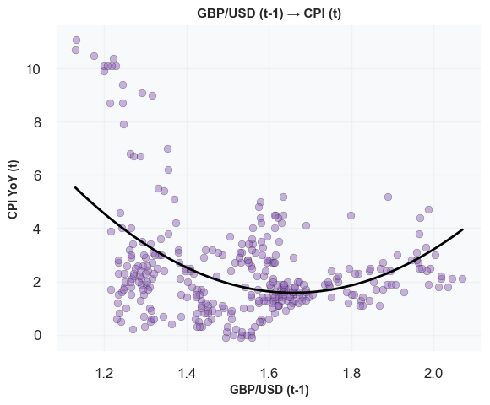
Figure 4.1.16: fig15_leadlag_fx.png
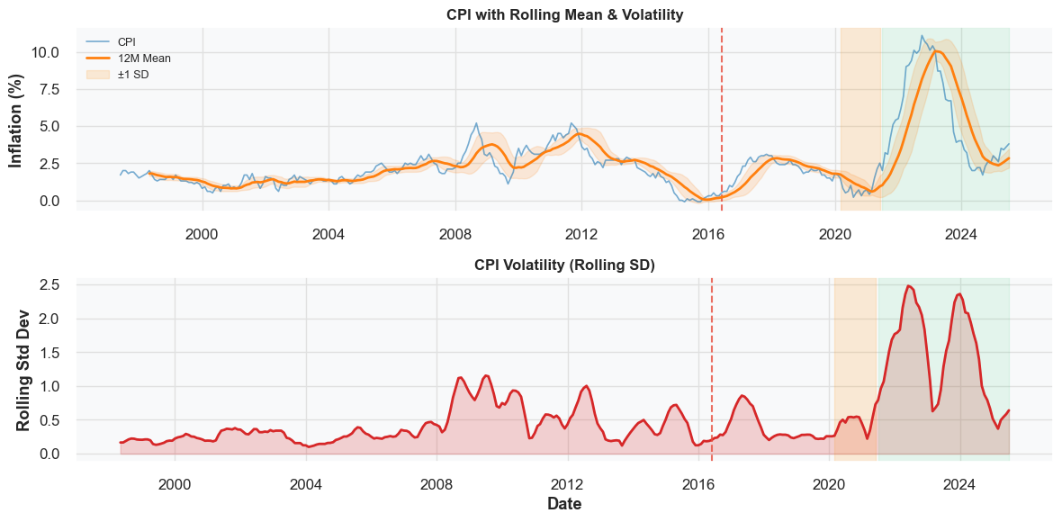
Figure 4.1.17: fig16_structural.png

4.2 Statistical baseline — ARIMA
ARIMA is treated as a classical univariate benchmark. Forecasts are loaded from saved artifacts and evaluated on the test period.
ARIMA test-set metrics
split | series | n | MAE | RMSE | R2
test | CPI (univariate) | 38 | 2.993 | 3.266 | -0.015
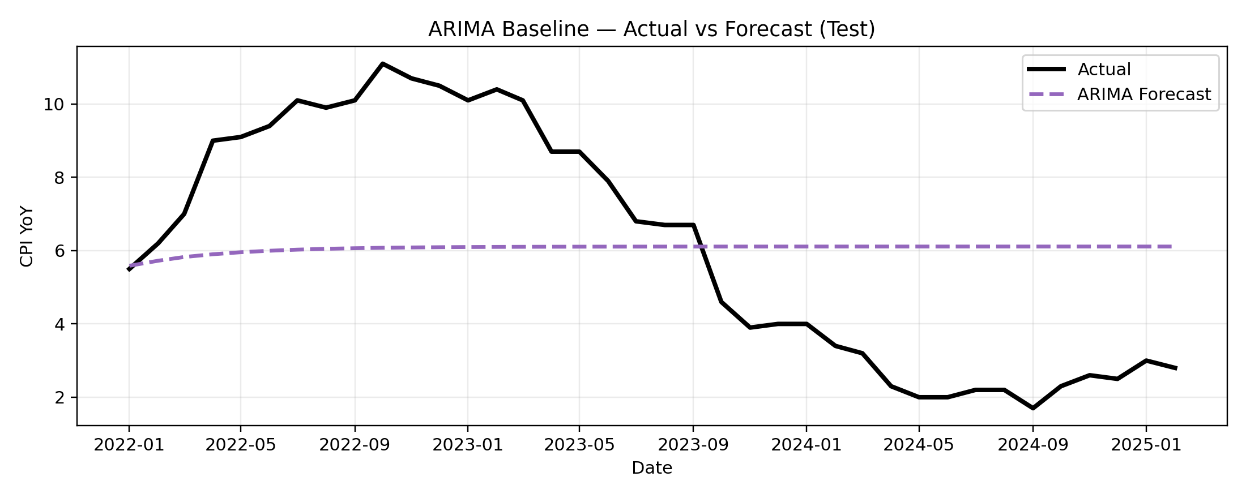
Figure 4.2.1: ARIMA baseline — Actual vs Forecast (test)

4.3 Forecast performance summary (test set)
Table 4.3.1 compares the principal models (ARIMA, Random Forest, Hybrid LSTM–XGBoost) on the common test-set dates for each horizon.
Table 4.3.1: Forecast performance comparison (test set)
horizon | model | MAE | RMSE | R2 | n
t+1 | RandomForest | 2.257 | 3.275 | 0.043 | 32
t+1 | ARIMA | 3.198 | 3.413 | -0.013 | 32
t+1 | Hybrid(LSTM+XGB) | 2.470 | 3.512 | -0.100 | 32
t+3 | RandomForest | 2.005 | 2.790 | 0.232 | 32
t+3 | Hybrid(LSTM+XGB) | 2.629 | 3.686 | -0.341 | 32
t+5 | RandomForest | 1.932 | 2.597 | 0.162 | 32
t+5 | Hybrid(LSTM+XGB) | 2.341 | 3.266 | -0.326 | 32
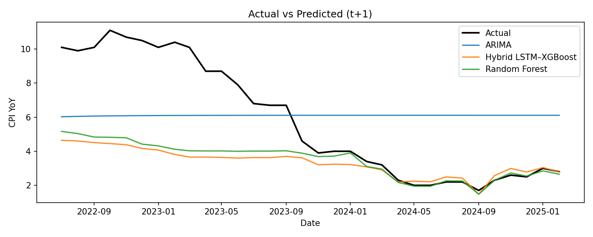
Figure 4.3.1: graph1_actual_vs_predicted_h1.png
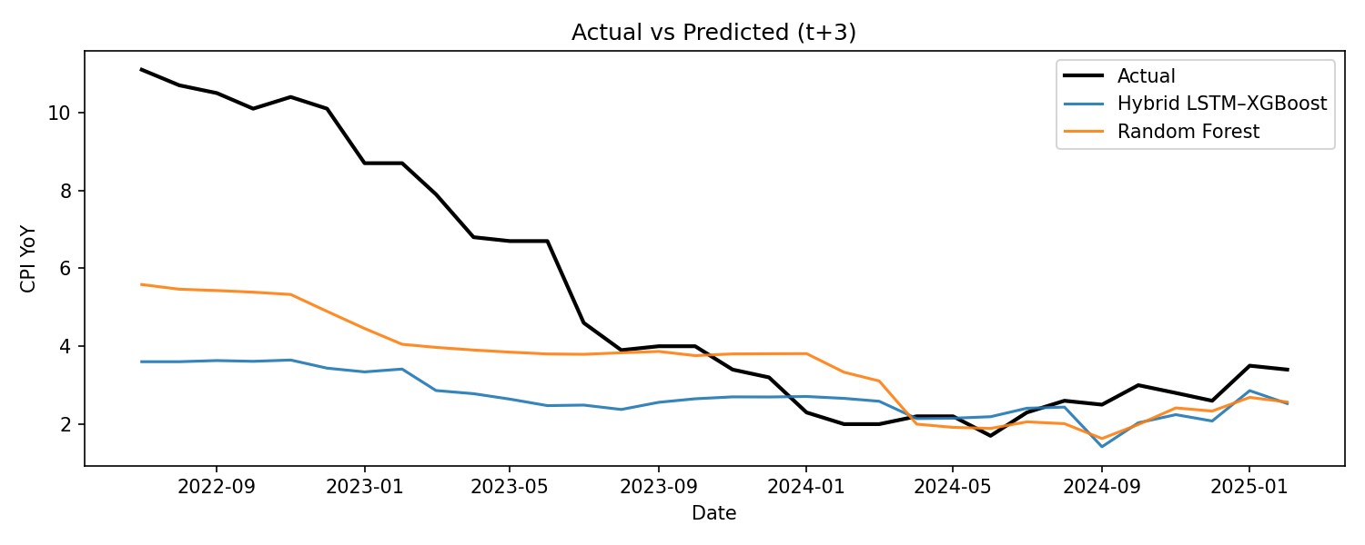
Figure 4.3.2: graph1_actual_vs_predicted_h3.png
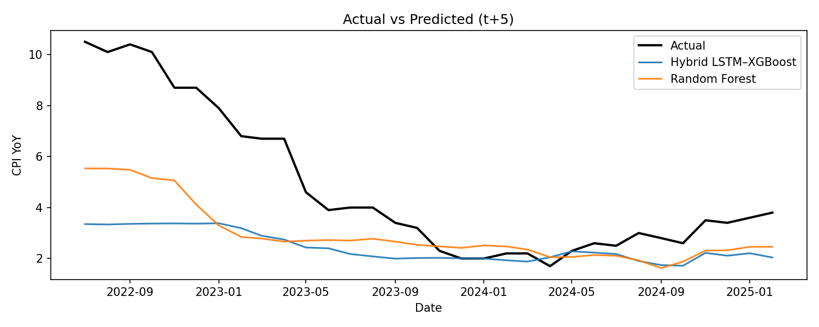
Figure 4.3.3: graph1_actual_vs_predicted_h5.png
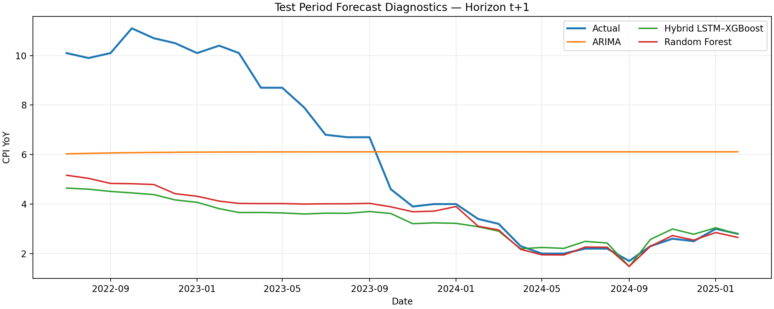
Figure 4.3.4: forecast_diagnostics_h1.png
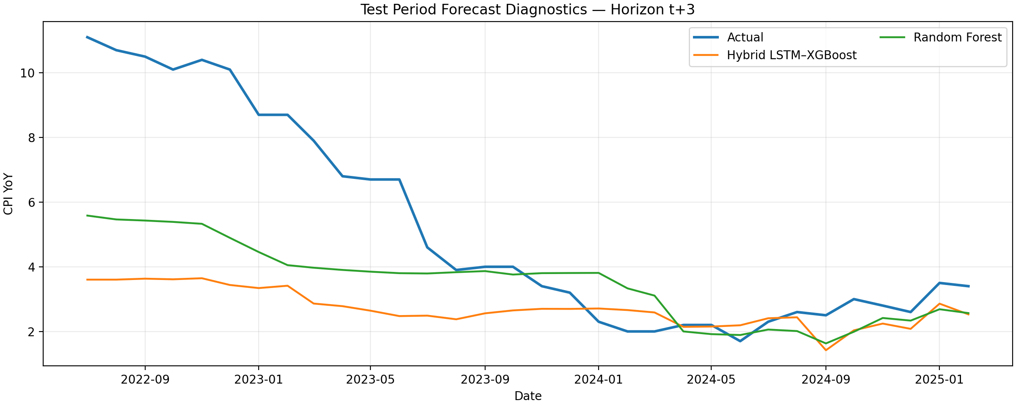
Figure 4.3.5: forecast_diagnostics_h3.png
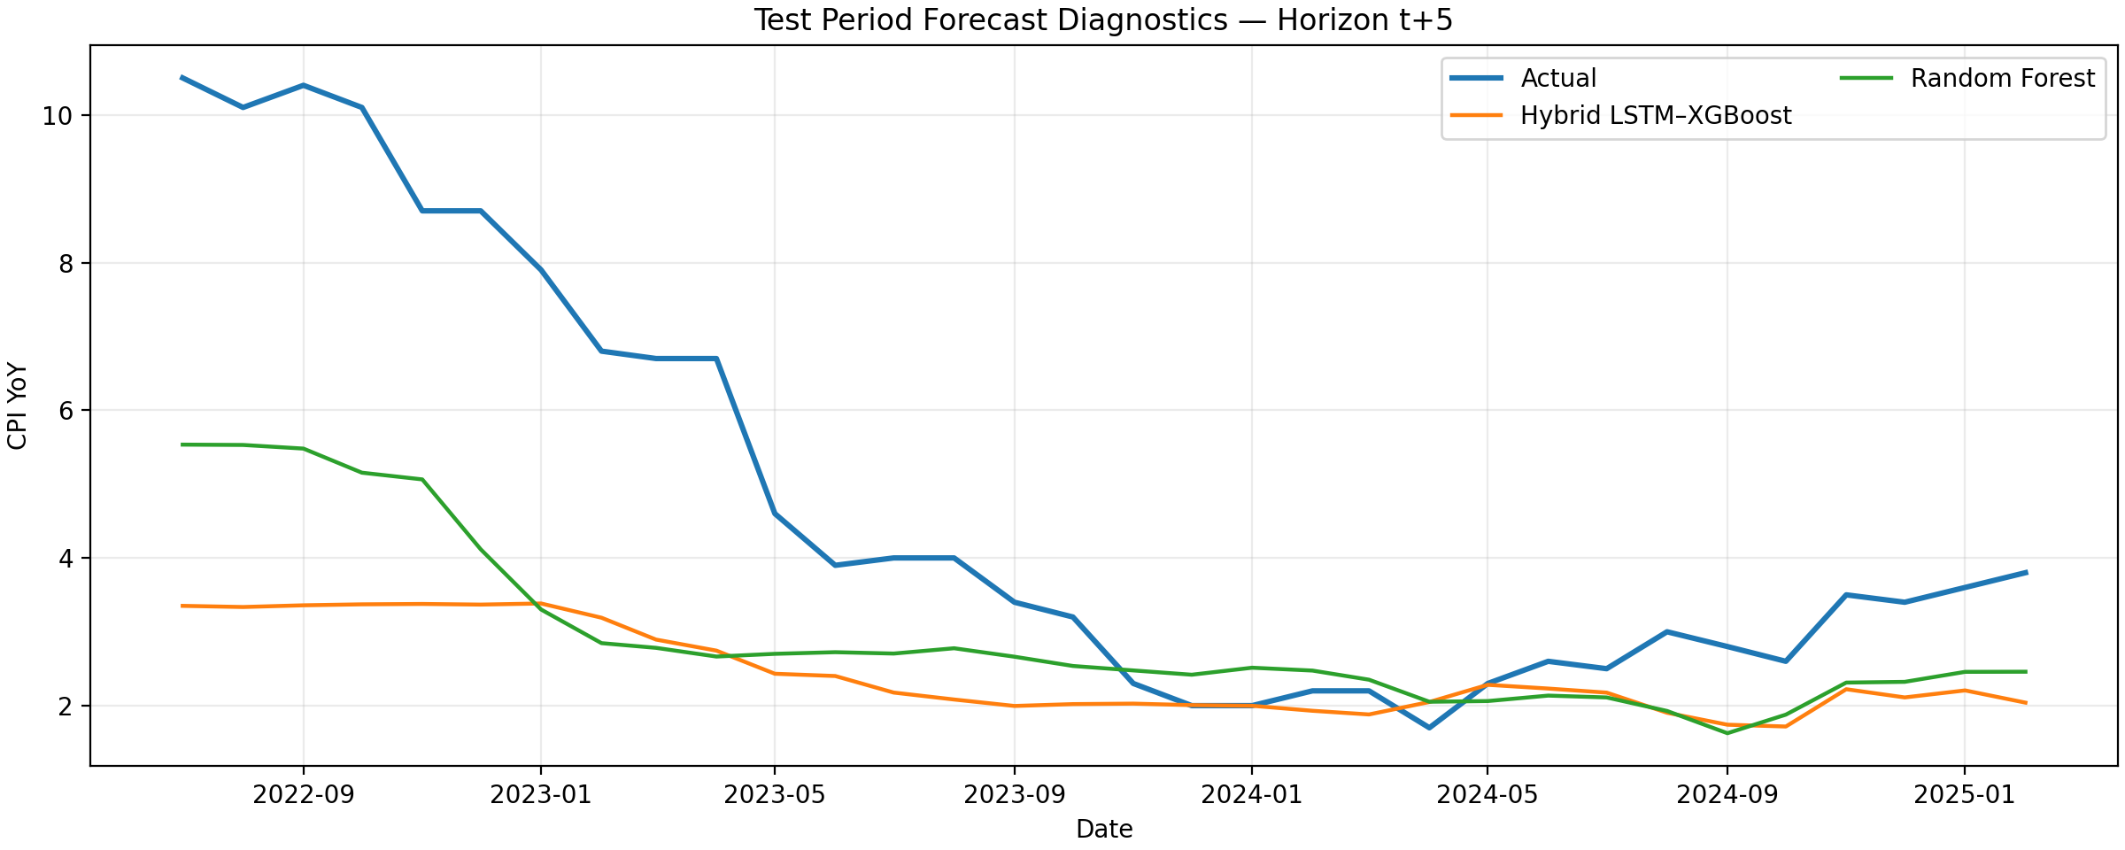
Figure 4.3.6: forecast_diagnostics_h5.png
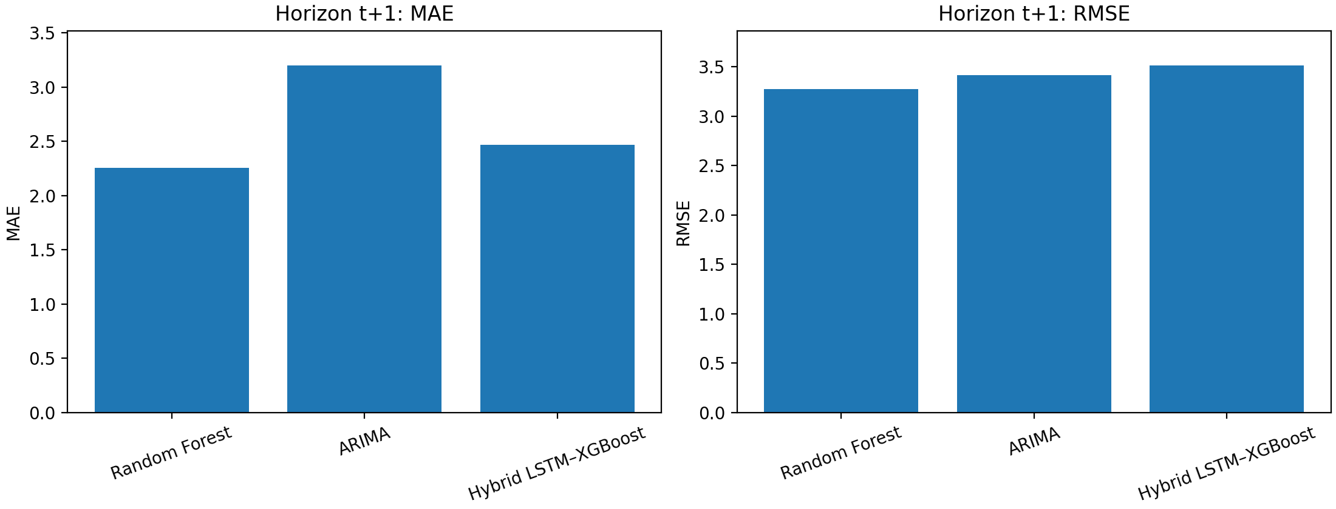
Figure 4.3.7: error_bars_h1.png
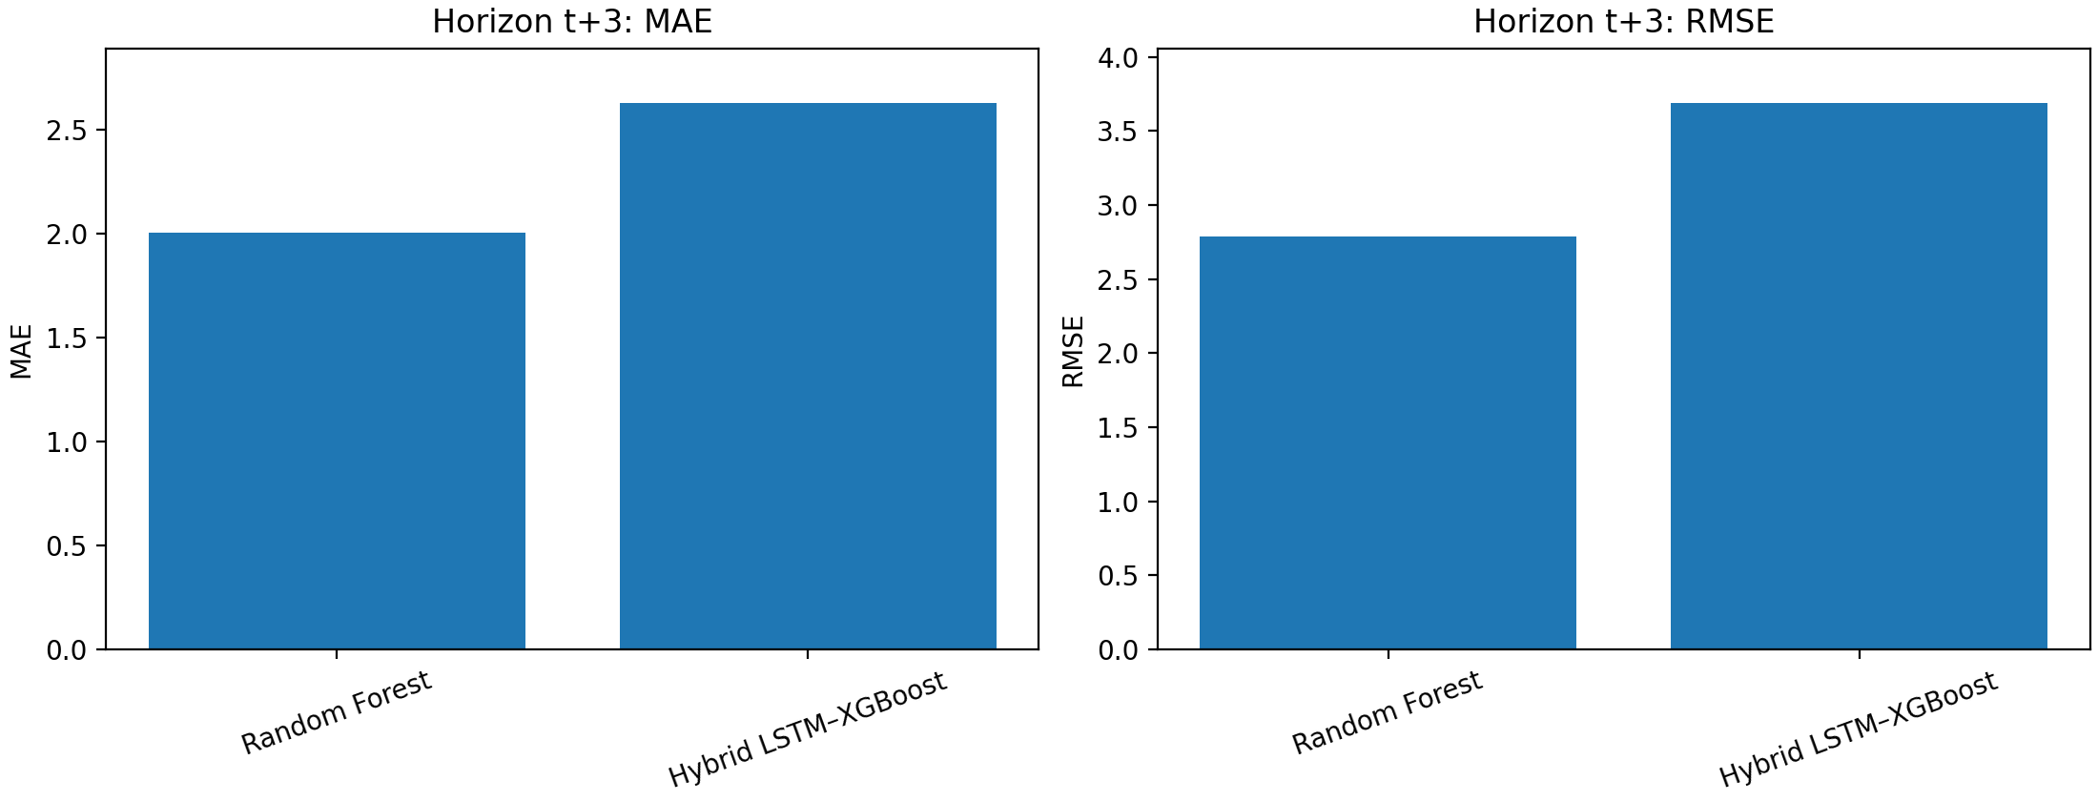
Figure 4.3.8: error_bars_h3.png
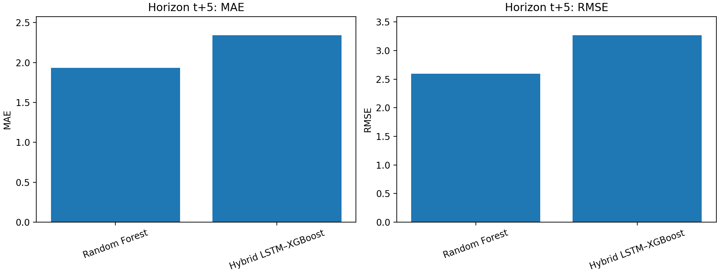
Figure 4.3.9: error_bars_h5.png
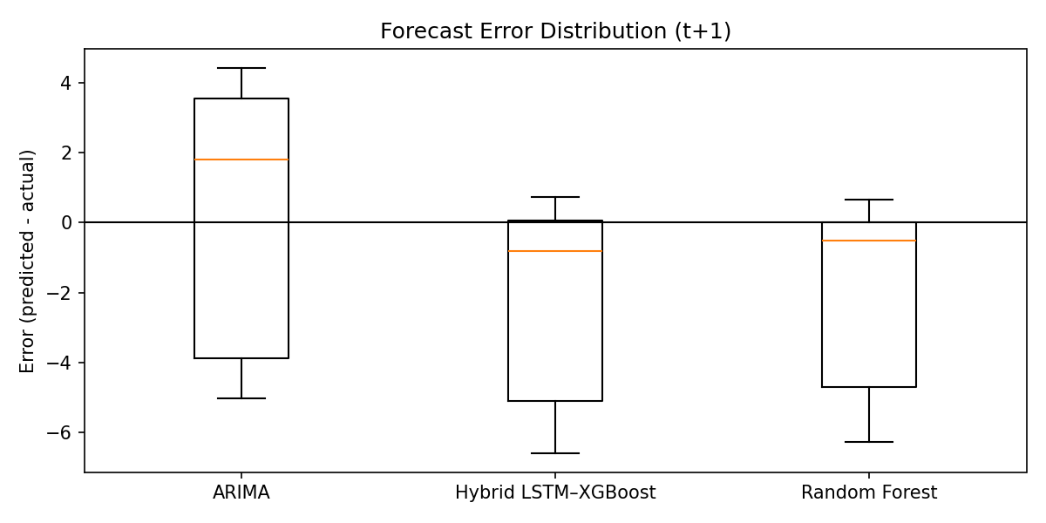
Figure 4.3.10: graph5_error_distribution_h1.png
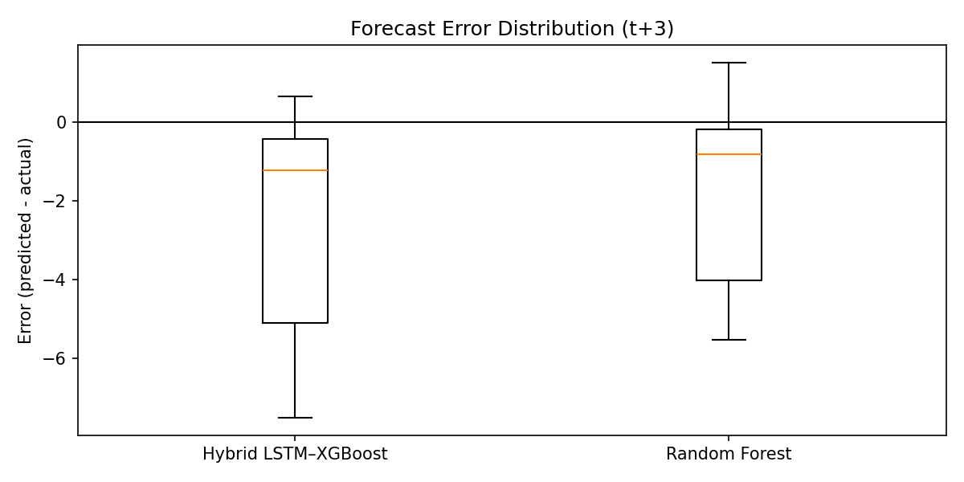
Figure 4.3.11: graph5_error_distribution_h3.png
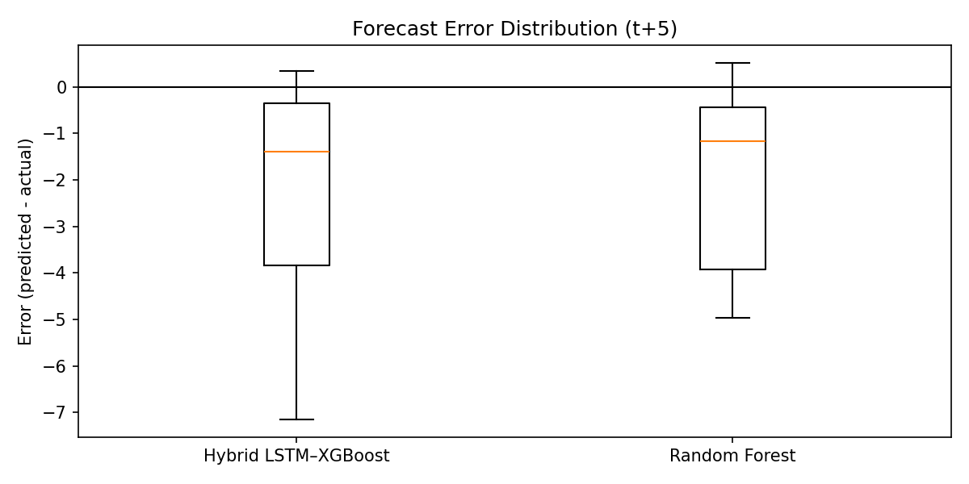
Figure 4.3.12: graph5_error_distribution_h5.png
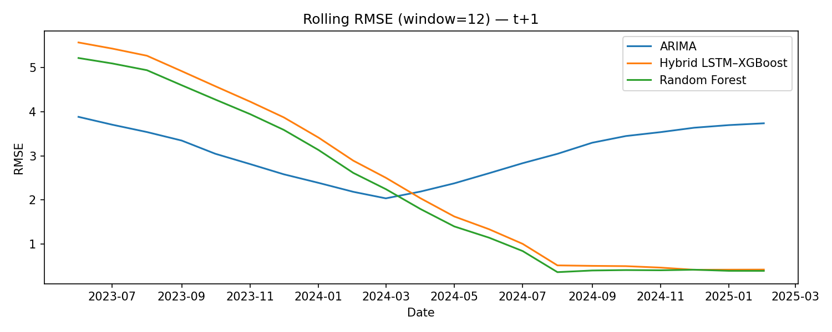
Figure 4.3.13: graph6_rolling_rmse_h1.png
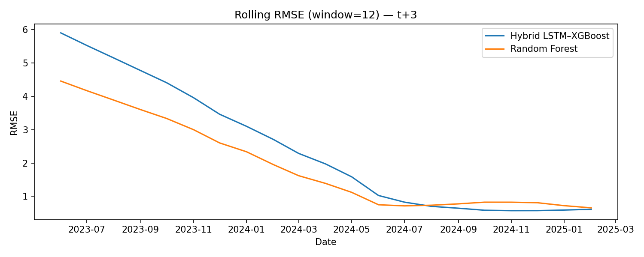
Figure 4.3.14: graph6_rolling_rmse_h3.png
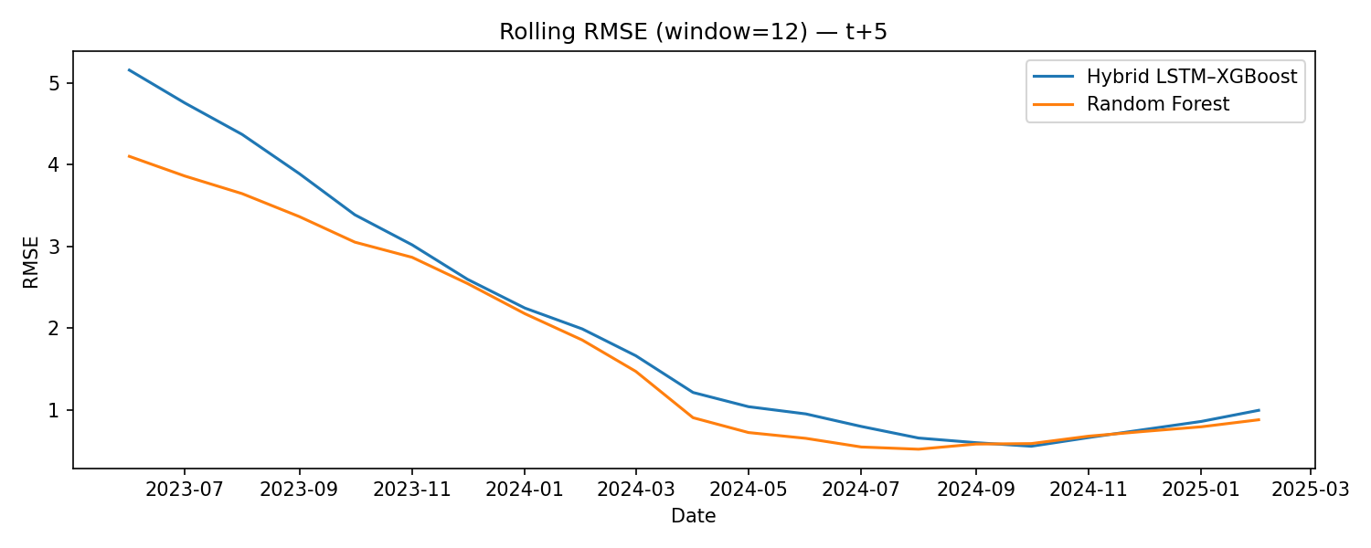
Figure 4.3.15: graph6_rolling_rmse_h5.png

4.4 Machine learning baseline — Random Forest (RF)
The RF baseline is evaluated across train/validation/test and provides multi-horizon predictions. Diagnostic plots are provided for each split, plus combined 3-in-1 horizon images.
Table 4.4.1: RF baseline metrics (train/validation/test)
split | horizon | mae | rmse | r2
train | cpi_t1 | 0.103 | 0.140 | 0.984
train | cpi_t3 | 0.134 | 0.192 | 0.971
train | cpi_t5 | 0.147 | 0.218 | 0.962
validation | cpi_t1 | 0.337 | 0.462 | 0.853
validation | cpi_t3 | 0.724 | 1.062 | 0.512
validation | cpi_t5 | 1.312 | 1.822 | 0.213
test | cpi_t1 | 2.724 | 3.713 | -0.274
test | cpi_t3 | 3.069 | 4.148 | -0.545
test | cpi_t5 | 3.044 | 4.116 | -0.571
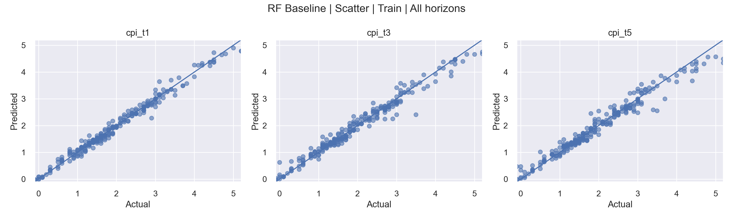
Figure 4.4.1: scatter_train_all_horizons.png
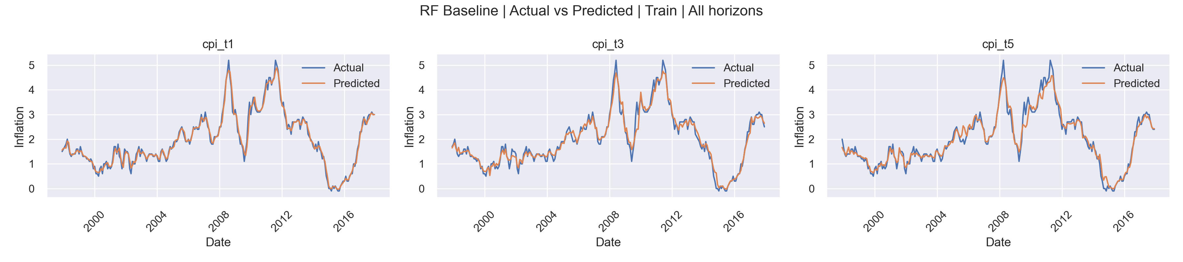
Figure 4.4.2: line_train_all_horizons.png
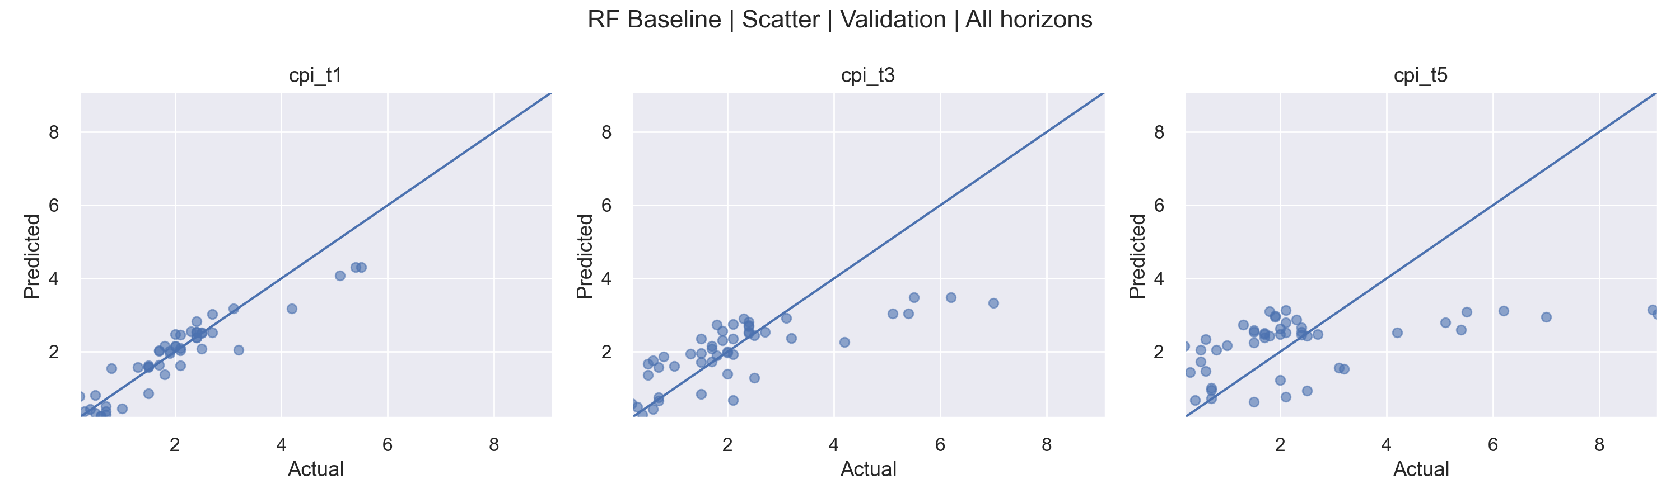
Figure 4.4.3: scatter_validation_all_horizons.png
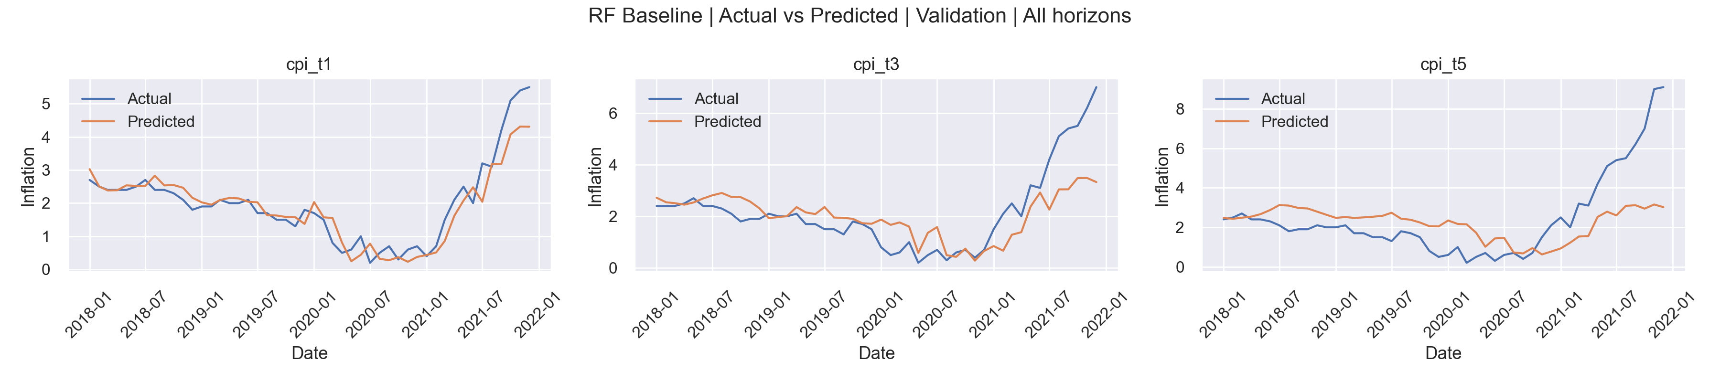
Figure 4.4.4: line_validation_all_horizons.png
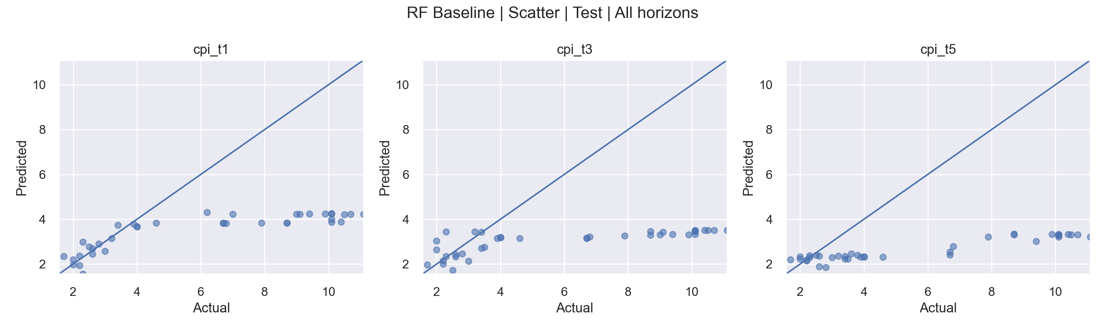
Figure 4.4.5: scatter_test_all_horizons.png
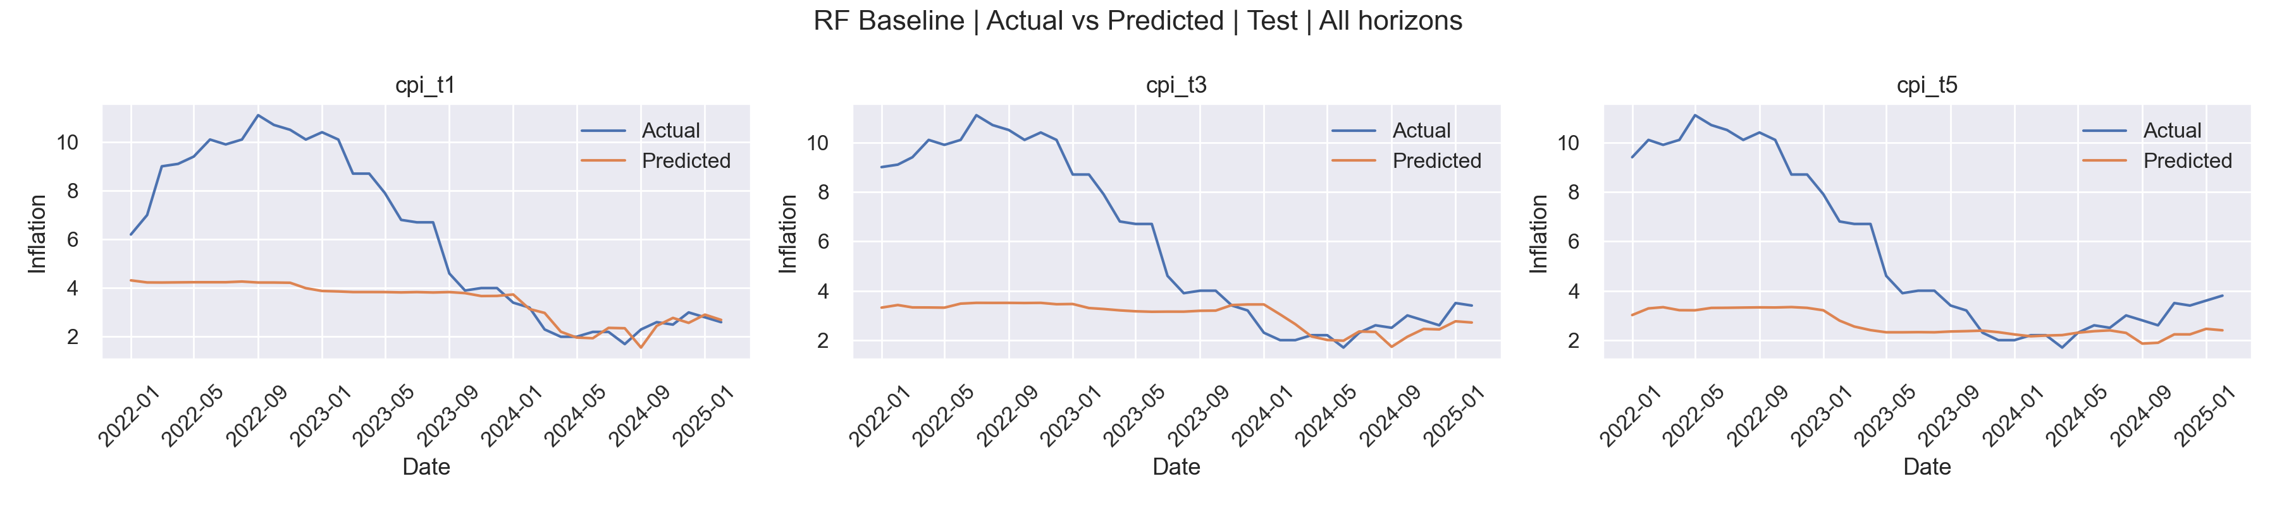
Figure 4.4.6: line_test_all_horizons.png

4.5 Proposed model — Hybrid LSTM–XGBoost
The Hybrid model combines an LSTM representation stage with an XGBoost meta-learner. Test-set results are reported by horizon and compared directly to RF.
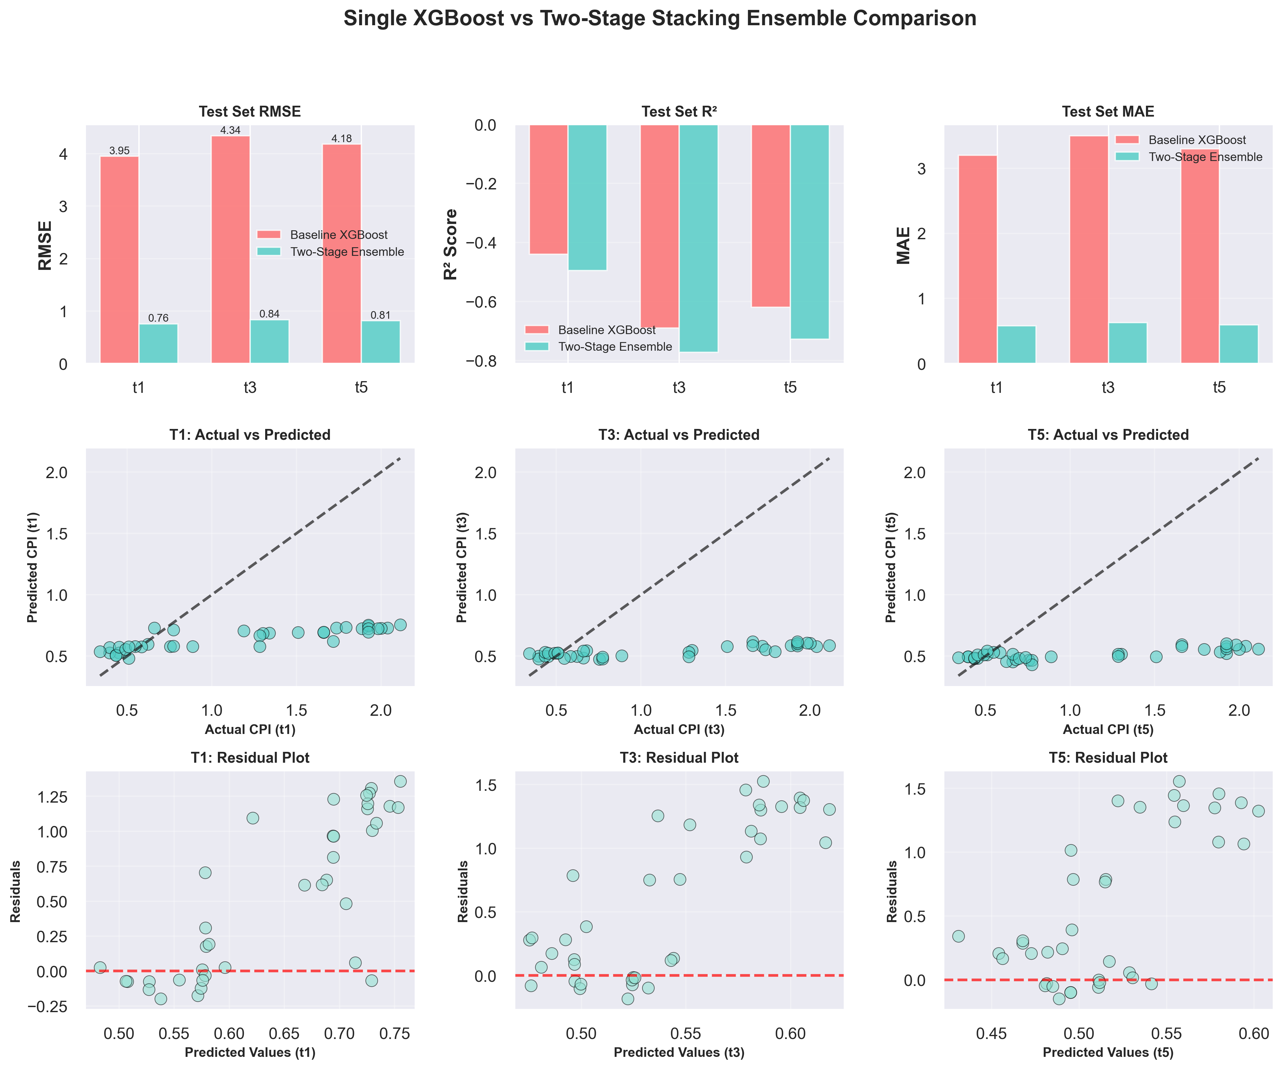
Figure 4.5.1: stacking_ensemble_comparison.png
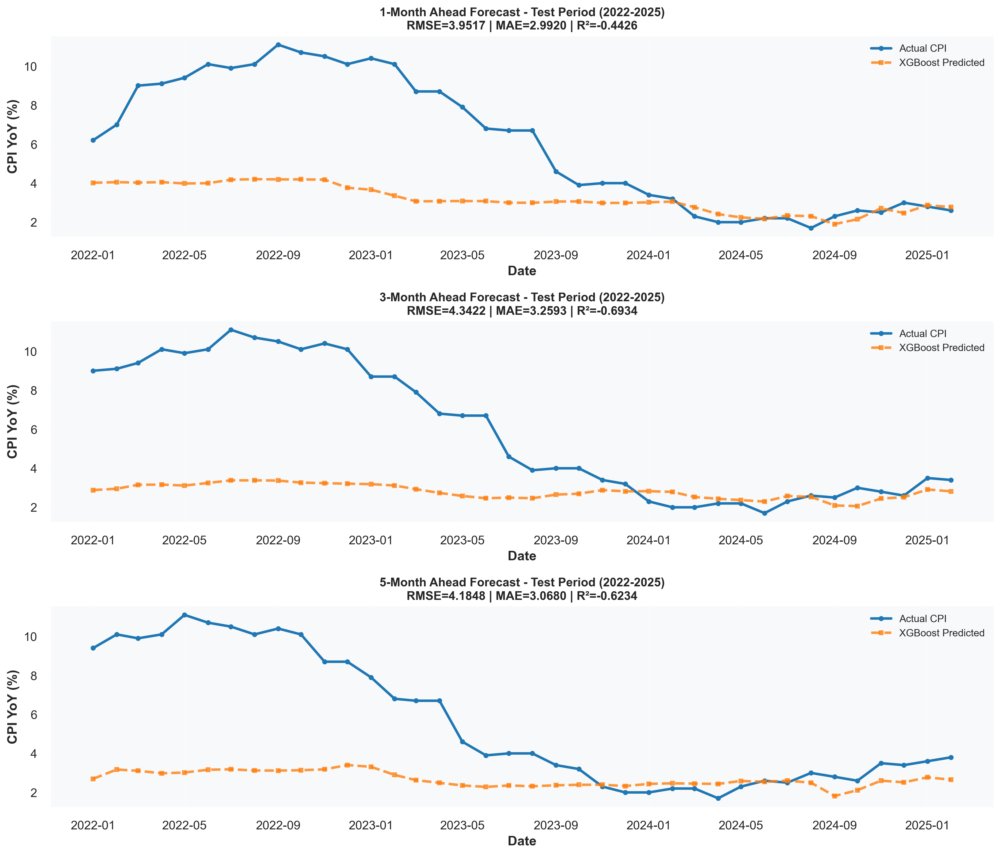
Figure 4.5.2: xgboost_actual_vs_predicted.png
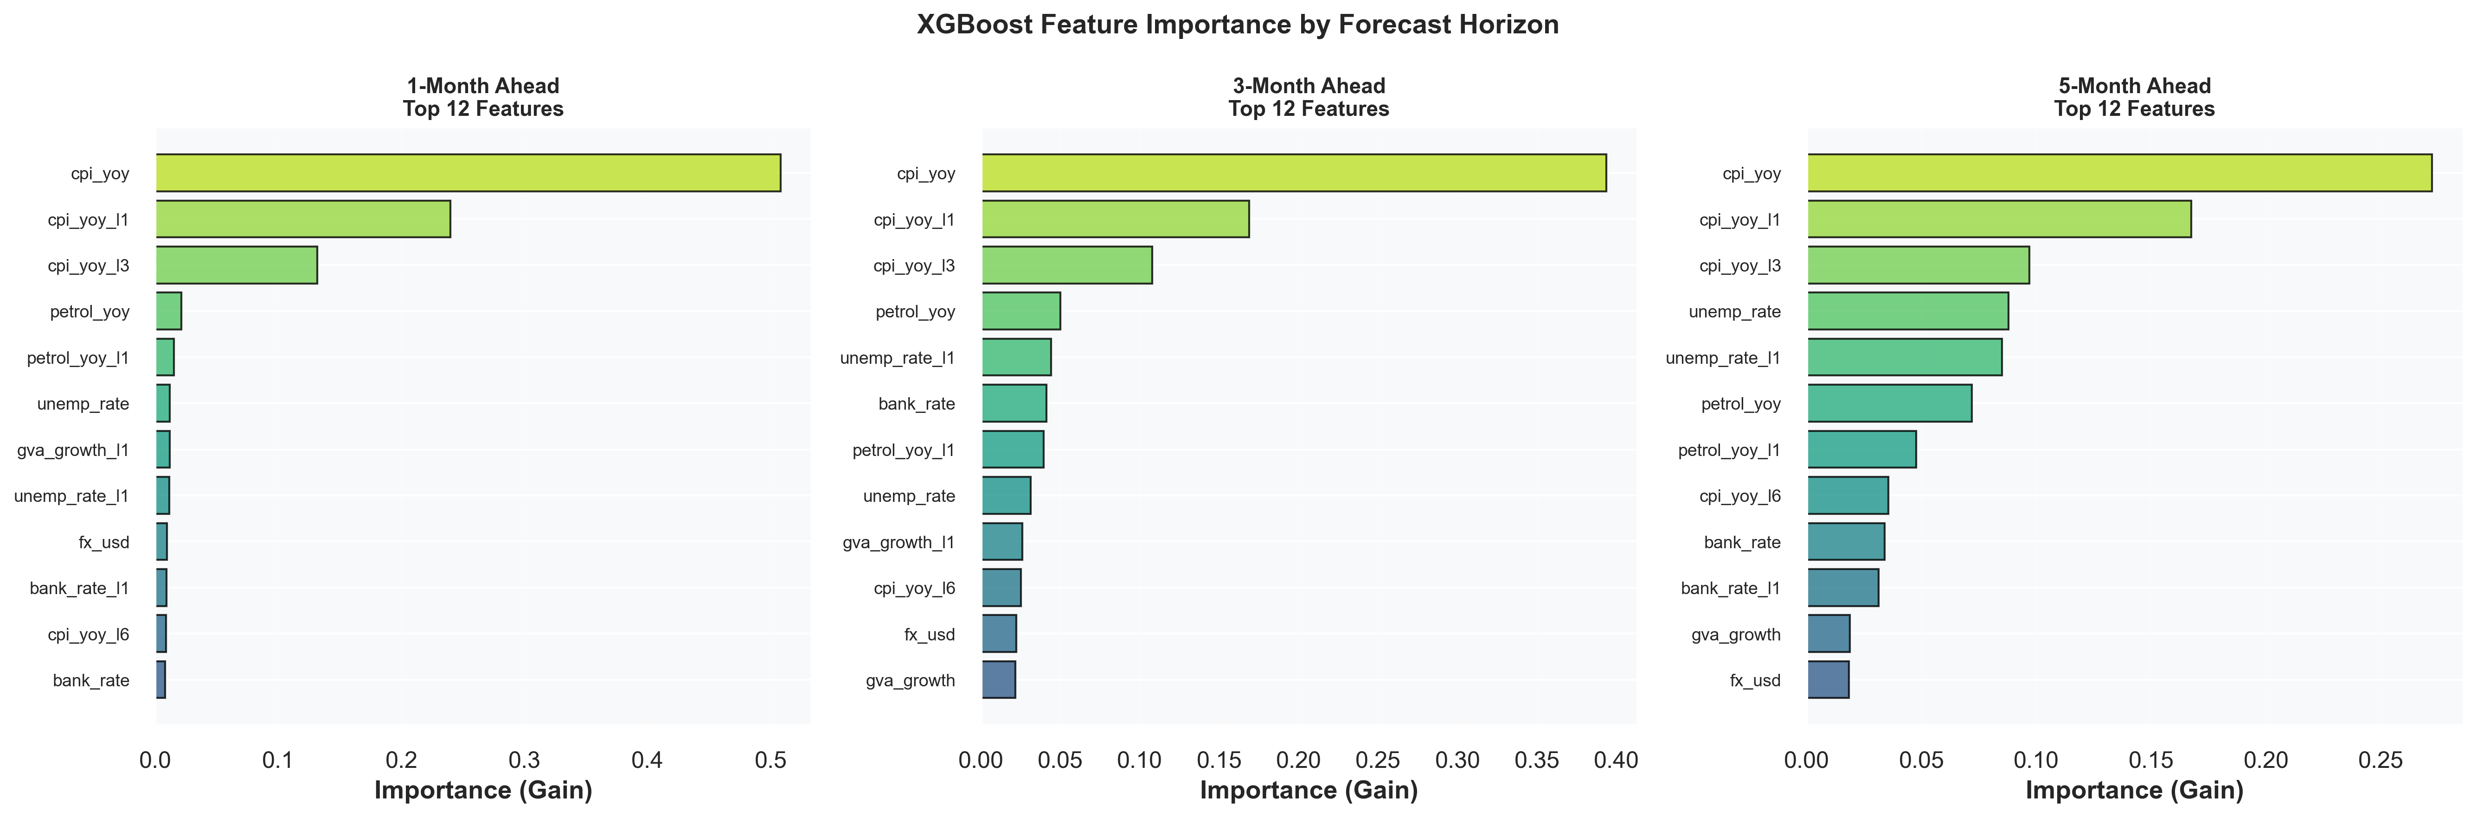
Figure 4.5.3: xgboost_feature_importance.png
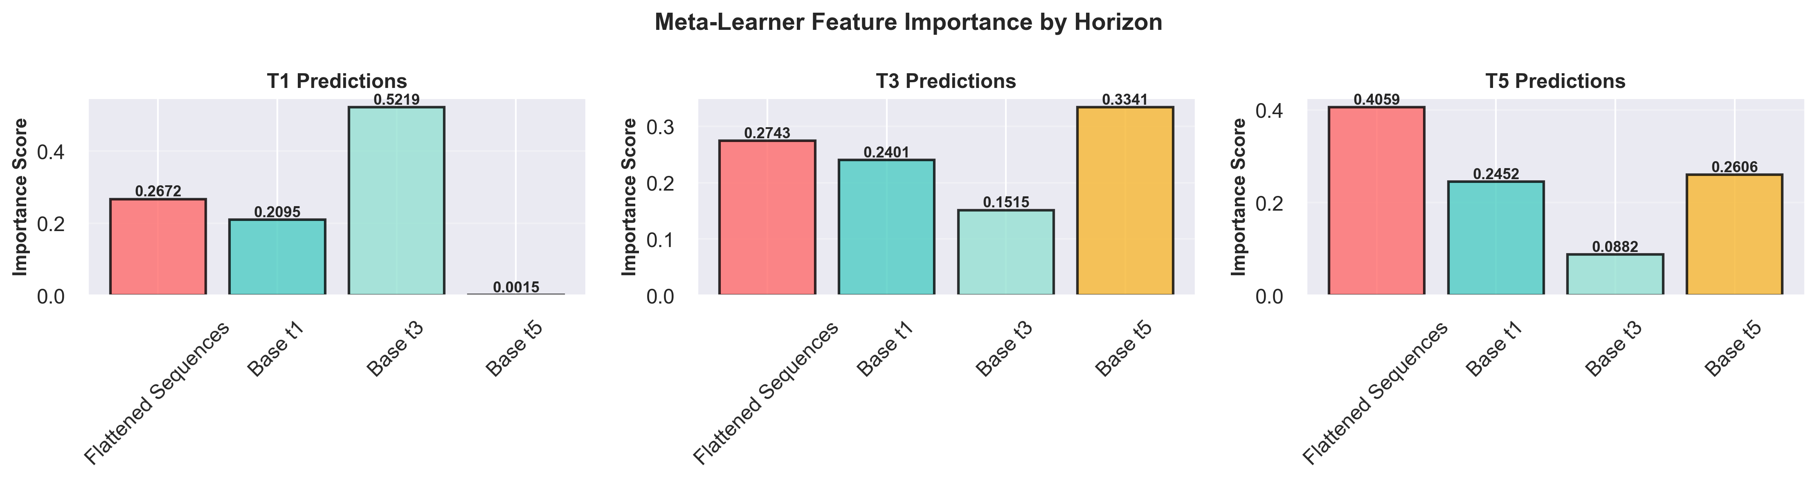
Figure 4.5.4: feature_importance_meta_learner.png
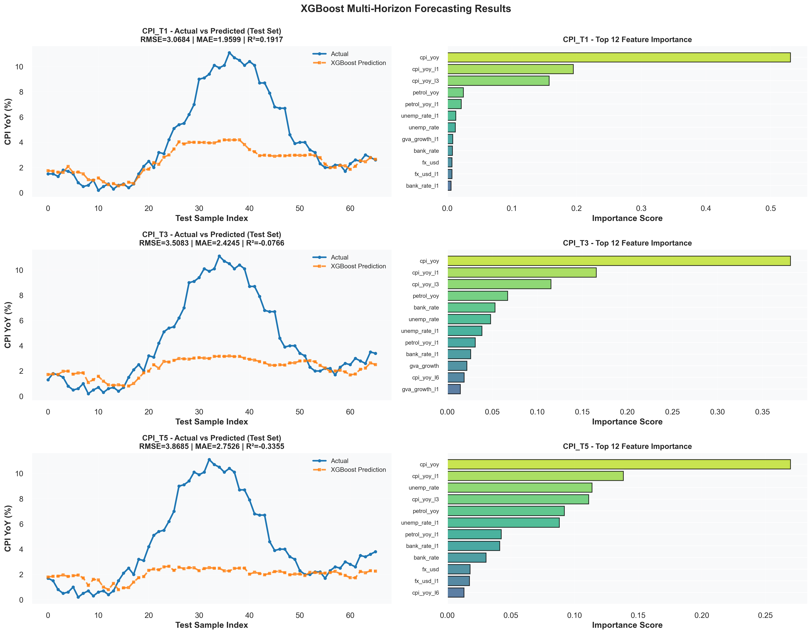
Figure 4.5.5: xgboost_results.png
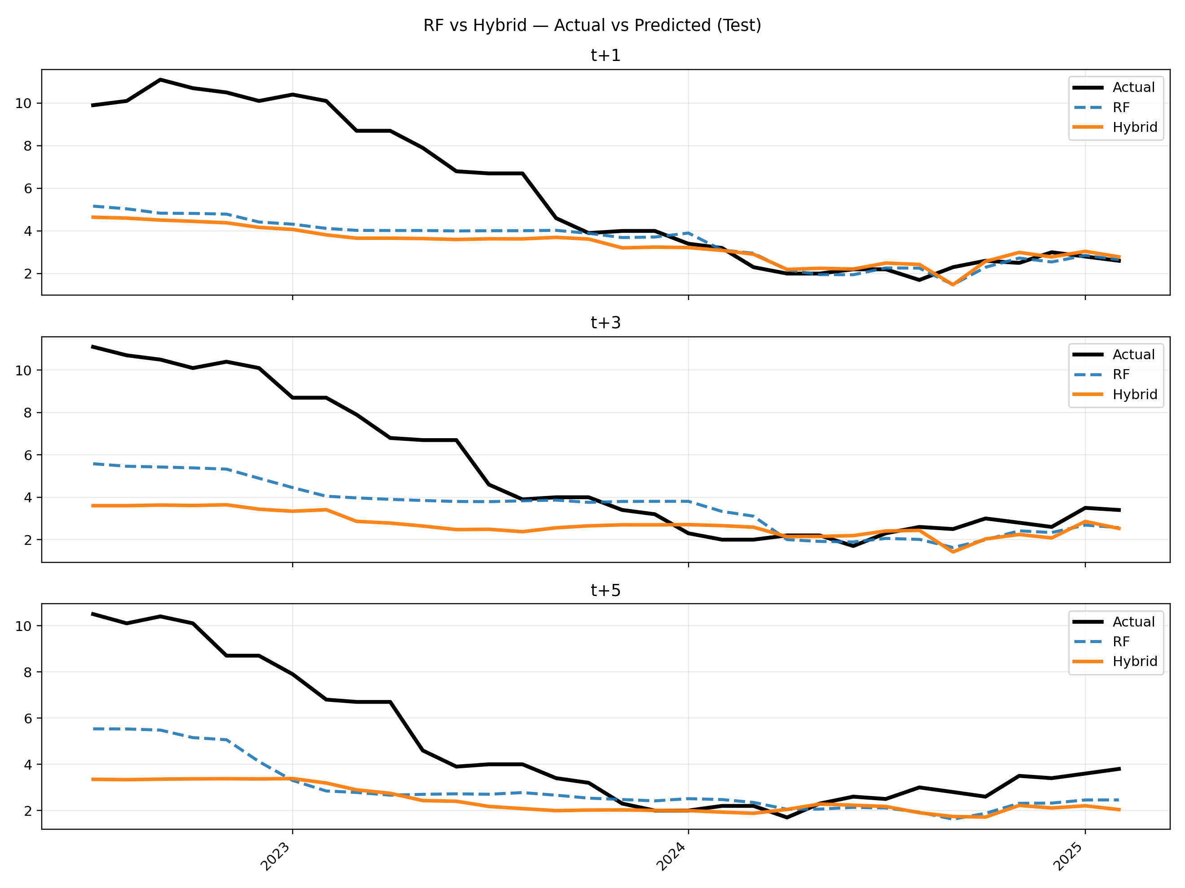
Figure 4.5.99: RF vs Hybrid — Actual vs Predicted (test)

4.6 Conclusions
Key conclusions from the empirical results are summarised below.
Forecast error increases with horizon length (t+1 → t+5), which is consistent with compounding uncertainty in macroeconomic forecasting.
Across the common test window, Random Forest provides the strongest overall baseline among the evaluated methods in this project’s artifact set.
The Hybrid LSTM–XGBoost model demonstrates competitive tracking in parts of the test period, but its aggregate error metrics are not consistently better than RF on the common-date comparison.
ARIMA remains a useful classical benchmark but is generally outperformed by feature-based ML baselines on the selected test window.
Future work should explore: re-tuning hybrid components, alternative sequence models, probabilistic forecasting, and robustness checks over multiple test windows / rolling-origin evaluation.

