3.2 Exploratory Data Analysis (EDA)
This section summarises the behaviour of UK inflation and its macroeconomic drivers using monthly data from 1997 to 2025. Each subplot supports the modelling approach by making the drivers and their transmission channels visually explicit.

3.2.1 CPI Year-on-Year Trend
CPI YoY shows long stable stretches followed by regime breaks around the financial crisis, Brexit, COVID-19, and the 2021–2023 surge. This motivates regime-aware modelling and time-varying volatility controls.
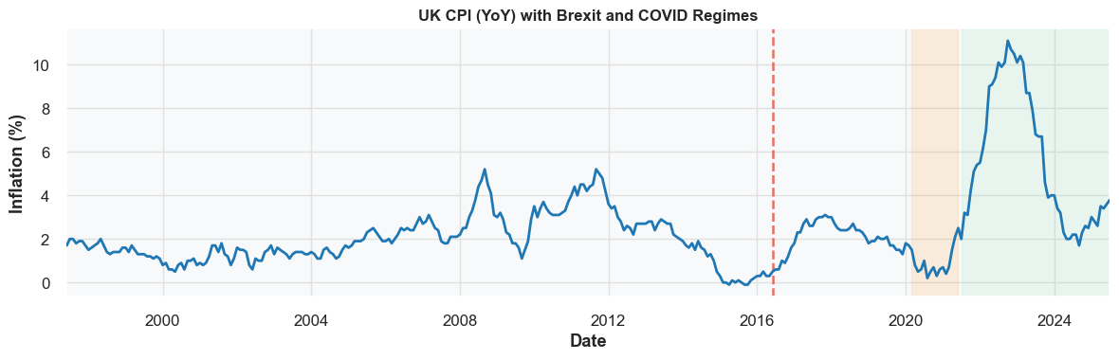
Figure: 3.2.1 CPI Year-on-Year Trend supporting visual.

3.2.2 Petrol and Oil Price Inflation
Petrol inflation is highly volatile and co-moves with CPI during global energy shocks. Energy shocks enter the model as fast-moving cost-push drivers.
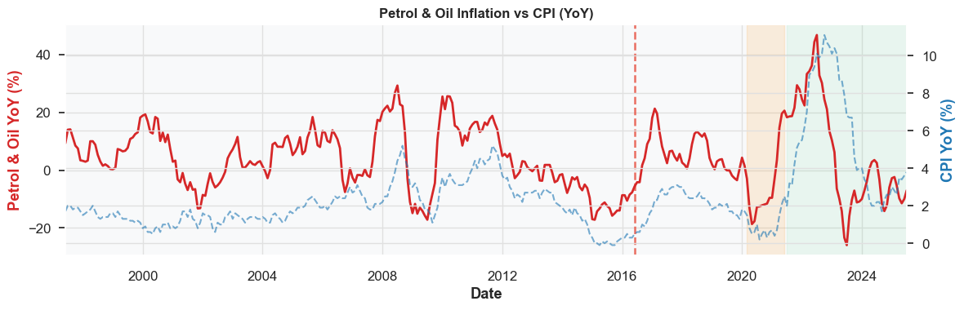
Figure: 3.2.2 Petrol and Oil Price Inflation supporting visual.

3.2.3 Bank Rate Dynamics
Distinct policy regimes are visible: pre-2008 stability, 2009–2021 lower bound, and rapid tightening from 2021. This supports including policy-rate levels and lags to capture reaction functions.
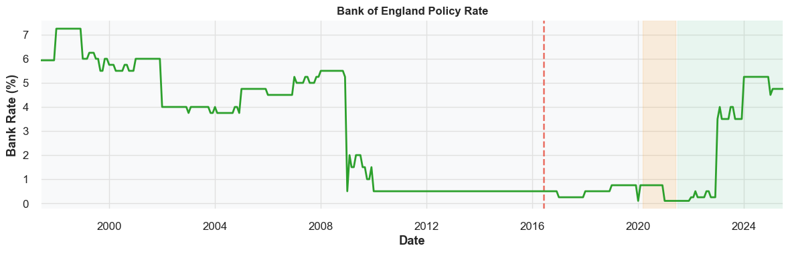
Figure: 3.2.3 Bank Rate Dynamics supporting visual.

3.2.4 Exchange Rate (GBP/USD)
GBP shows long-run depreciation with sharp drops at major events, aligning with import-price inflation episodes. FX shocks justify pass-through terms and short lags in the forecasting design.
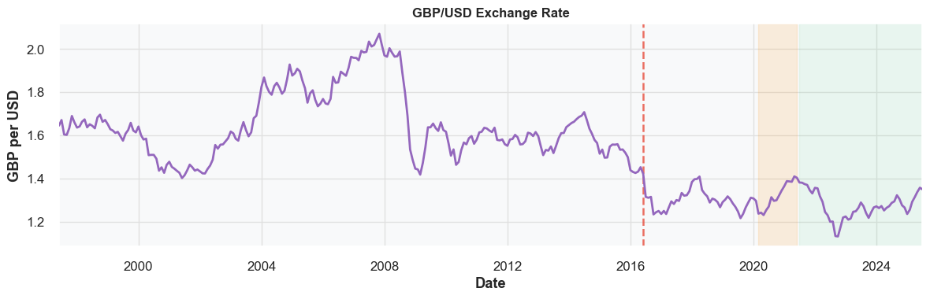
Figure: 3.2.4 Exchange Rate (GBP/USD) supporting visual.

3.2.5 GVA Growth (3m-on-3m)
GVA growth tracks economic momentum, highlighting the 2008 and 2020 recessions. Demand conditions inform output-gap style controls.
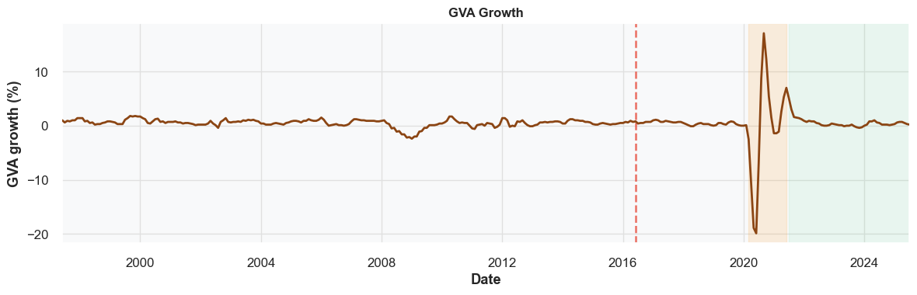
Figure: 3.2.5 GVA Growth (3m-on-3m) supporting visual.

3.2.6 Unemployment Rate
Unemployment is cyclical—rising in downturns and falling in recoveries. Labour slack provides a Phillips-curve channel for inflation pressures.
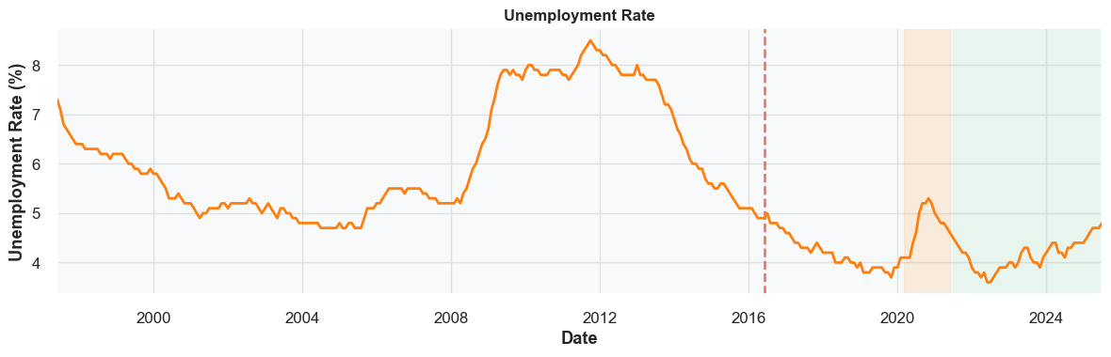
Figure: 3.2.6 Unemployment Rate supporting visual.

3.2.7 CPI and Petrol Inflation
Overlay shows petrol spikes typically precede CPI moves, reinforcing petrol as a leading cost-push driver.
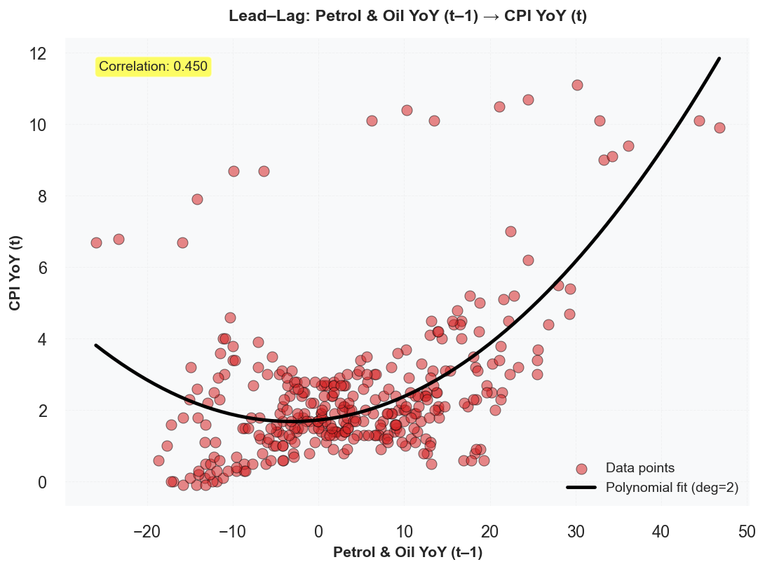
Figure: 3.2.7 CPI and Petrol Inflation supporting visual.

3.2.8 CPI and Exchange Rate
Sterling depreciation often coincides with higher CPI, especially around large shocks. Supports modelling FX pass-through with short lags.
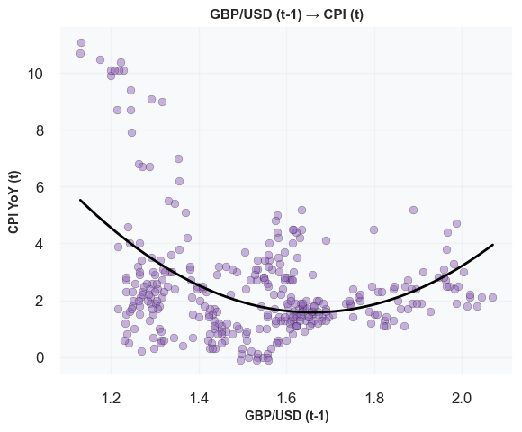
Figure: 3.2.8 CPI and Exchange Rate supporting visual.

3.2.9 Correlation Structure
Correlations are moderate, indicating a multi-factor inflation process. This motivates combining energy, FX, demand, and labour indicators.
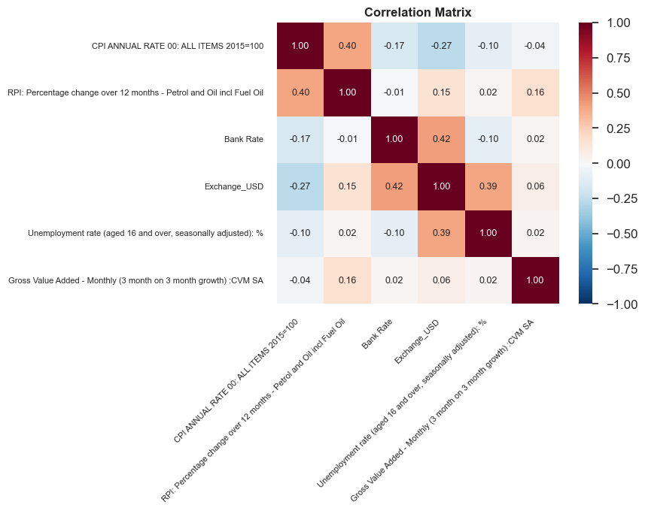
Figure: 3.2.9 Correlation Structure supporting visual.

3.2.10 Scatterplots
Non-linear and threshold patterns appear for petrol and FX; weaker contemporaneous links for unemployment and Bank Rate. Suggests trying flexible terms (splines/interaction) rather than only linear effects.
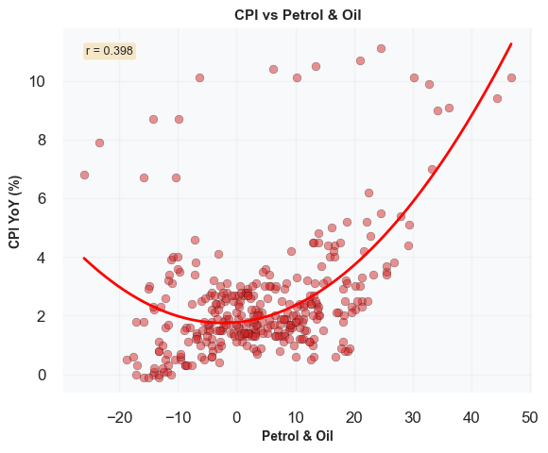
Figure: 3.2.10 Scatterplots supporting visual.

3.2.11 Rolling Mean and Volatility
Rolling moments highlight volatility clustering: calm pre-2016 vs. high volatility during COVID and the 2021–2023 surge. Justifies heteroskedasticity-robust errors and potential regime indicators.
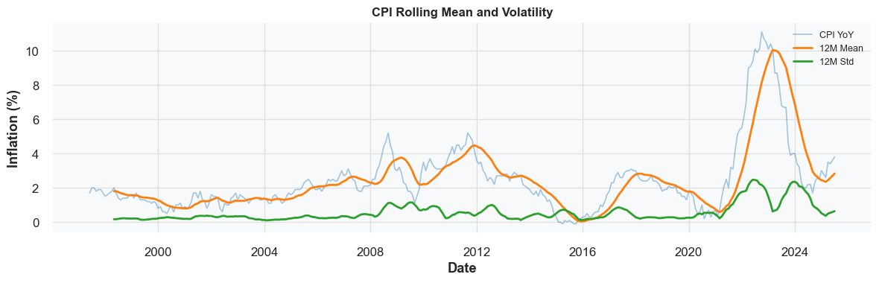
Figure: 3.2.11 Rolling Mean and Volatility supporting visual.

3.2.12 Summary
Inflation is persistent but sensitive to energy and FX shocks, with demand and labour-market conditions shaping magnitude. The patterns support a multi-factor, regime-aware forecasting setup with lagged drivers and robustness to volatility changes.
[Graph not available in this run – please regenerate figures if needed.]

