Methodology Part 2: Exploratory Data Analysis
UK Inflation Forecasting with Explainable AI

Author: Awais Khan
Institution: University of the West of England, Bristol
Date: December 2025

Abstract
This exploratory data analysis examines UK macroeconomic time-series data for inflation forecasting. The investigation analyzes the Consumer Price Index (CPI) and its key drivers including energy prices, exchange rates, monetary policy, labour market conditions, and economic growth. The analysis identifies structural breaks associated with Brexit (2016), the COVID-19 pandemic (2020-2021), and the subsequent inflation surge (2022-2023), providing empirical justification for non-linear modelling approaches.

Research Questions
- What are the main drivers of UK inflation volatility?
- How do structural breaks affect the stability of inflation dynamics?
- Which variables exhibit predictive lead-lag relationships with CPI?

1. Data Loading and Environment Setup
The analytical environment was initialized with essential Python libraries including pandas for data manipulation, numpy for numerical computations, and matplotlib/seaborn for visualization. A dynamic path detection mechanism ensures portability across different computing environments, facilitating reproducible research and collaborative workflows.
The processed macroeconomic dataset (final_merged_dataset.csv) containing UK economic indicators was successfully loaded from the project data directory. The dataset comprises monthly observations spanning multiple decades of UK economic history.

2. Data Quality Assessment
Data integrity was examined through systematic validation of the dataset structure, missing values, duplicates, and temporal consistency. Understanding data quality is essential for reliable econometric analysis and model development.

2.1 Data Structure
The dataset contains multiple economic indicators including CPI (Consumer Price Index), petrol and oil prices, Bank of England policy rate, GBP/USD exchange rate, unemployment rate, and Gross Value Added (GVA) growth. All variables are measured at monthly frequency with appropriate temporal alignment.

2.2 Missing Data Analysis
Missing value analysis revealed minimal data gaps across the core variables. The Date column was validated and converted to datetime format. No duplicate observations were identified, confirming the integrity of the temporal index.

3. Temporal Evolution and Regime Analysis
The temporal evolution of UK inflation and its key macroeconomic drivers was examined across distinct economic regimes: pre-Brexit (before June 2016), Brexit transition, COVID-19 pandemic (March 2020–June 2021), and the post-pandemic inflation surge (July 2021 onwards). These regime markers help identify structural breaks that may affect forecasting model stability.

3.1 Time-Series Visualizations
The following visualizations examine temporal patterns across major economic regimes:
Figure 1: UK CPI (YoY) with Brexit and COVID Regimes
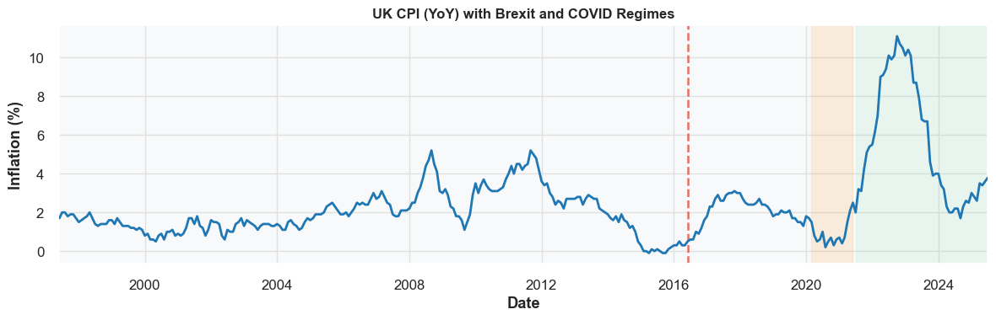

Figure 2: Petrol & Oil Inflation vs CPI (YoY)
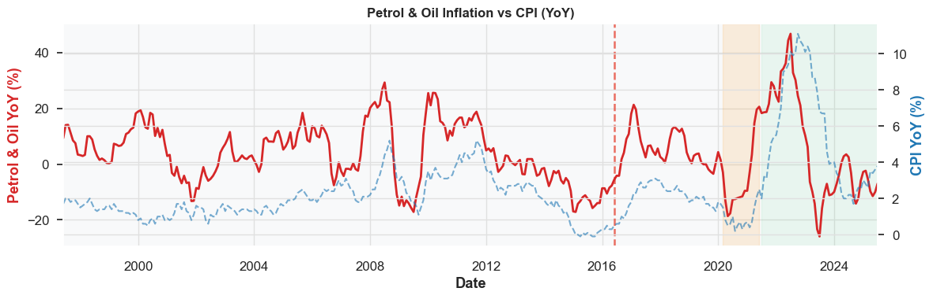

Figure 3: Bank of England Policy Rate
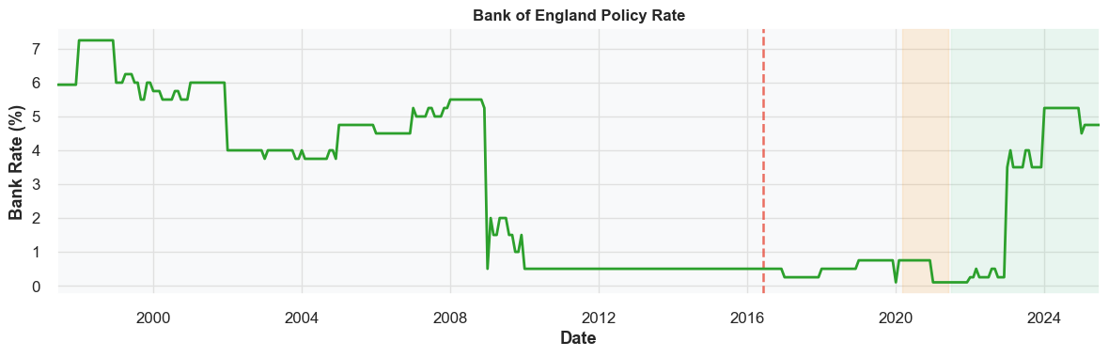

Figure 4: GBP/USD Exchange Rate
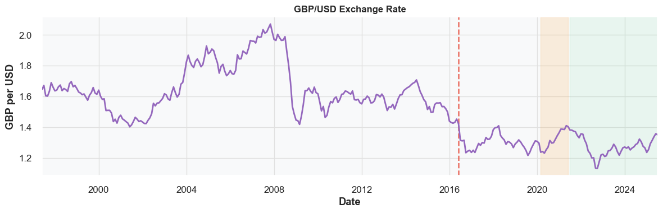

Figure 5: Unemployment Rate Evolution
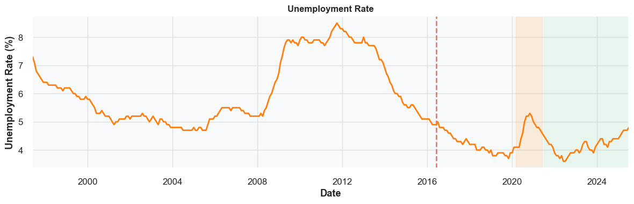

Figure 6: Gross Value Added (GVA) Growth
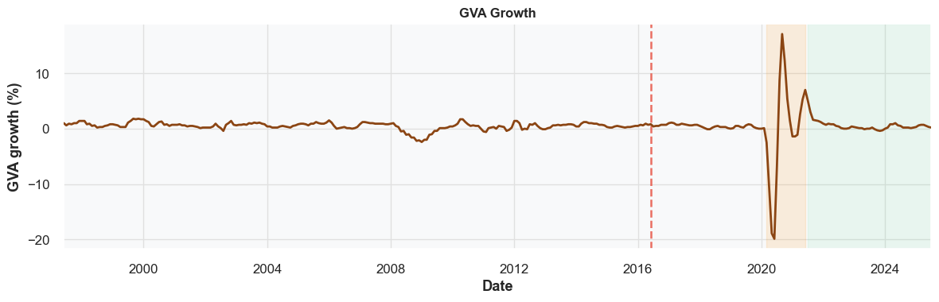

3.2 Key Observations from Time-Series Analysis
Brexit Impact (June 2016): The referendum triggered immediate GBP depreciation (approximately 1.6 → 1.2 USD/GBP), creating inflationary pressure through import price pass-through mechanisms.
COVID-19 Pandemic (March 2020–June 2021): The pandemic induced simultaneous supply and demand shocks. Monetary policy responded with emergency rate cuts to near-zero levels, while unemployment initially spiked before recovering.
Post-COVID Inflation Surge (2021–2023): This period exhibits the sharpest inflation acceleration in four decades, peaking near 11% in 2022. Energy price shocks combined with supply chain disruptions created cost-push inflation.

4. Correlation Structure and Variable Relationships
This section investigates the linear and non-linear relationships between CPI inflation and potential predictor variables. The correlation matrix identifies candidate features for forecasting models, while scatter plots reveal the functional form of these relationships.

4.1 Correlation Matrix Results
Figure 7: Correlation Matrix of Key Macroeconomic Variables
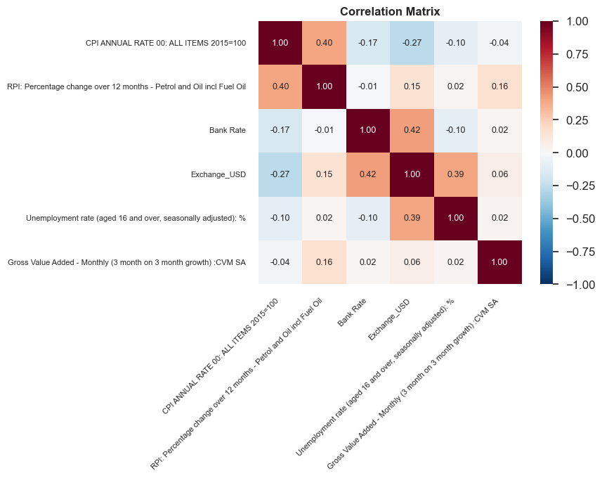

The correlation heatmap reveals the following key relationships:
- Petrol/oil prices show the strongest linear relationship with CPI (r ≈ 0.45)
- Exchange rates exhibit negative correlation with CPI (r ≈ -0.26), reflecting import price pass-through
- Unemployment demonstrates negative correlation (r ≈ -0.25), supporting Phillips curve dynamics
- Bank Rate shows moderate positive correlation, though causality is complex due to policy endogeneity

4.2 Scatter Plot Analysis
The following scatter plots with polynomial trend lines reveal non-linear relationships between CPI and key drivers:
Figure 8: CPI vs Petrol & Oil Inflation
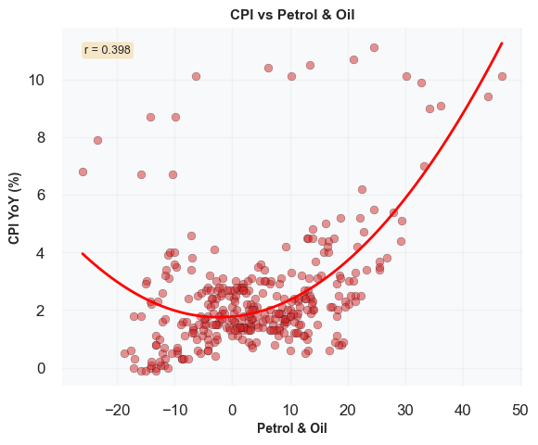

Figure 9: CPI vs Exchange Rate (GBP/USD)
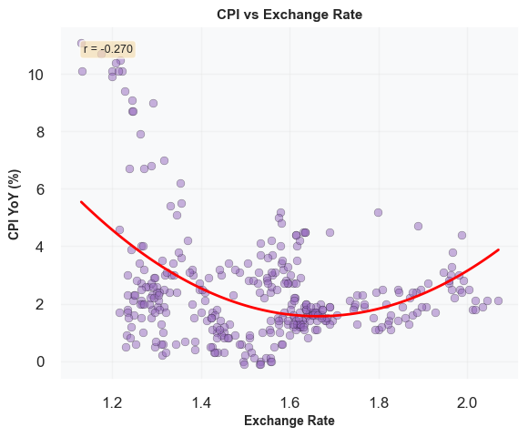

Figure 10: CPI vs Bank Rate
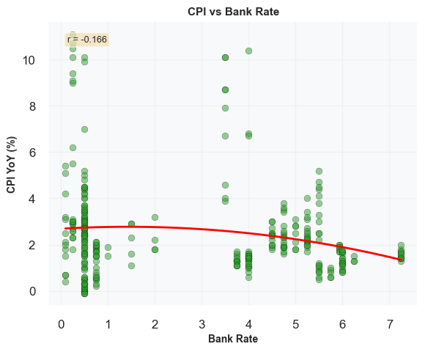

Figure 11: CPI vs Unemployment Rate
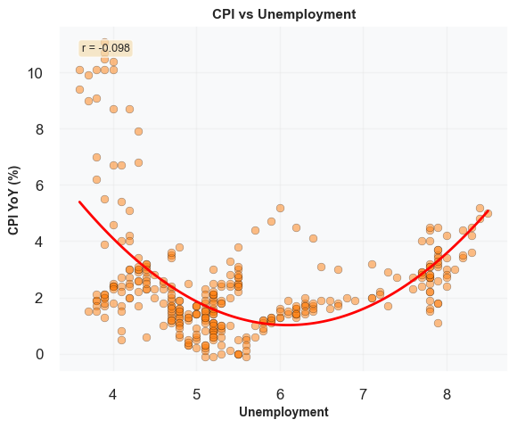

Figure 12: CPI vs GVA Growth
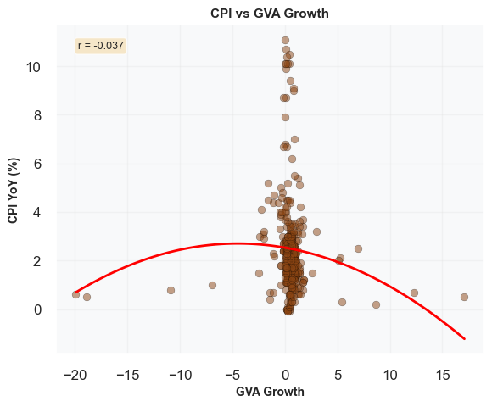

These scatter plots reveal U-shaped patterns, particularly for energy prices and exchange rates. These non-linearities suggest threshold effects where extreme values amplify inflationary pressures, justifying the use of tree-based models (XGBoost) or neural networks (LSTM).

5. Statistical Properties and Lead-Lag Dynamics
This section characterizes the distributional properties and temporal dependencies of key variables. Distribution analysis reveals volatility patterns and tail risks, while lead-lag analysis identifies predictive relationships crucial for nowcasting and short-term forecasting.

5.1 Distribution Analysis
Figures 13-18: Distribution Histograms - Variable-specific distributional characteristics:
- CPI displays approximate normality centred at 2%, with positive skew due to recent inflation surge
- Petrol/oil prices exhibit platykurtic distribution (flat, heavy-tailed), reflecting commodity market volatility
- Bank Rate shows extreme left-skewness, concentrated near zero for extended periods (QE era)
- Exchange rates demonstrate bimodality, reflecting structural break post-Brexit

5.2 Rolling Statistics and Volatility
Figure 13: CPI YoY Rolling Mean and Volatility
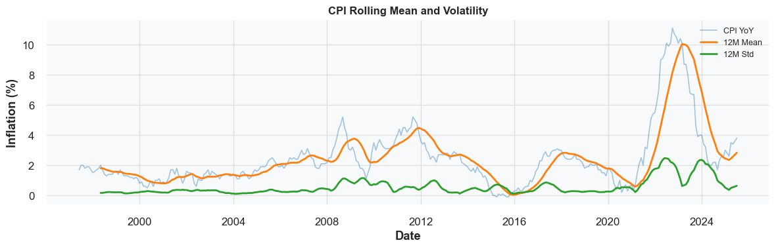

The 12-month rolling volatility metric reveals regime changes. CPI volatility remained stable (< 0.5%) from 2000–2019, then increased fourfold to > 2% during 2021–2023, representing unprecedented uncertainty in the inflation process.

5.3 Lead-Lag Relationships
Figure 14: Lead-Lag Analysis - Petrol & Oil (t-1) → CPI (t)
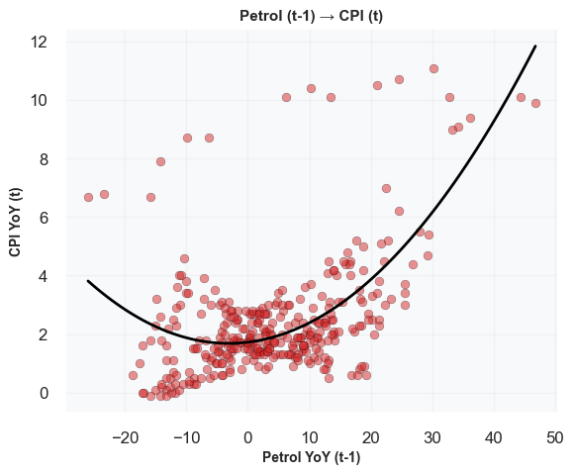

Figure 15: Lead-Lag Analysis - GBP/USD (t-1) → CPI (t)
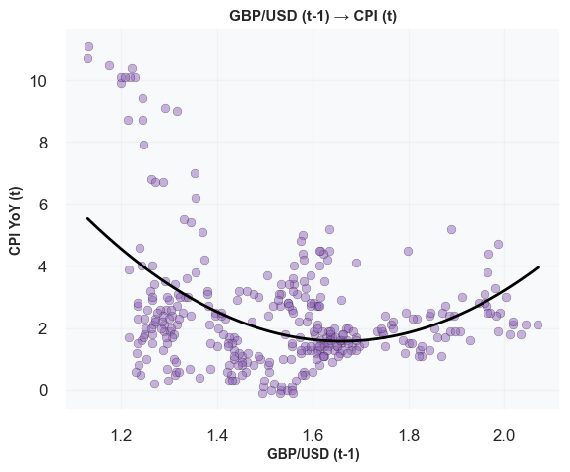

Lagged energy prices (t-1) exhibit significant predictive power for current CPI (r = 0.45), confirming cost-push transmission mechanisms. Similarly, lagged exchange rate depreciation predicts higher inflation 3–6 months ahead, though the relationship is weaker (r = -0.26).

6. Interpretation of Visualizations

6.1 Time-Series Analysis Summary
The temporal evolution plots reveal three major structural shocks affecting UK inflation dynamics. CPI exhibits clear regime-dependent behaviour, violating stationarity assumptions. Energy prices demonstrate extreme volatility, acting as a leading indicator. Monetary policy operates with significant lags, complicating real-time inflation control. Exchange rate pass-through effects are observable but gradual (3–6 month lag).

6.2 Correlation and Relationship Findings
The moderate-to-weak correlations (0.2–0.5 range) indicate that no single variable dominates inflation dynamics. Multi-variate models incorporating several drivers are necessary for robust forecasting performance. Non-linear relationships, particularly U-shaped patterns, suggest threshold effects requiring advanced modelling architectures.

6.3 Volatility Regime Changes
Rolling statistics reveal dramatic increases in CPI volatility post-2021, representing a fourfold increase in uncertainty. This volatility clustering suggests the need for adaptive models or regime-switching frameworks capable of adjusting to changing economic conditions.

7. Structural Break Detection and Diagnostics
Quantitative techniques were applied to detect and visualize structural breaks in the inflation process. Rolling statistics, normalized z-scores, and regime-specific annotations provide empirical evidence for the temporal instability observed in earlier visualizations.

7.1 Rolling Z-Score Analysis
Figure 16: CPI Structural Break Detection with Rolling Statistics
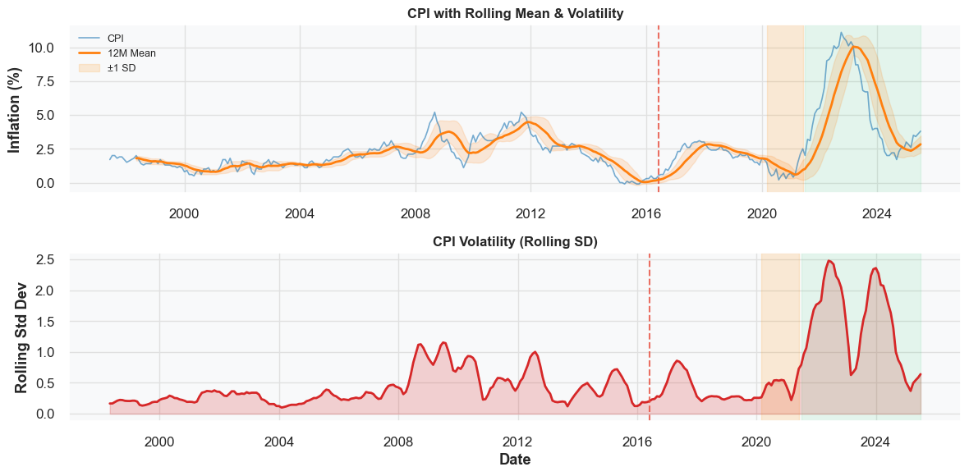

Custom rolling z-score calculations identify periods where variables deviate significantly from historical norms (|Z| > 1.5). High volatility periods are concentrated around Brexit (2016), COVID onset (2020), and the inflation surge (2022).

7.2 Multi-Series Comparison
The structural break analysis confirms synchronized shifts across all series, suggesting common underlying economic shocks rather than isolated variable-specific disturbances. The visual evidence demonstrates clear regime changes at Brexit, COVID-19, and the post-pandemic inflation surge periods.

7.3 Key Structural Breaks Identified
Brexit (June 2016): GBP weakened sharply from 1.6 to 1.2 USD/GBP, making imports more expensive and triggering imported inflation.
COVID-19 (March 2020): Immediate shock to all variables; Bank Rate cut to near-zero; unemployment spike followed by rapid recovery.
Post-COVID Inflation Surge (July 2021 onwards): Inflation reached 11%+ in 2022; aggressive rate hikes from ~0% to 5.25% in fastest tightening cycle in decades.

8. Conclusions and Implications

8.1 Summary of EDA Findings
This exploratory analysis has revealed several critical insights for UK inflation forecasting:
1. Structural Instability: Brexit (2016), COVID-19 (2020-2021), and the energy crisis (2022-2023) represent distinct regime changes in inflation dynamics, invalidating stationary modelling assumptions.
2. Multi-Variate Dependencies: No single predictor dominates inflation behaviour. Energy prices exhibit the strongest relationship (r ≈ 0.45), but exchange rates, monetary policy, labour market conditions, and economic activity all contribute meaningfully.
3. Non-Linear Relationships: U-shaped functional forms in scatter plots indicate threshold effects and non-linearities that linear models cannot capture adequately.
4. Volatility Clustering: CPI volatility increased fourfold during 2021-2023, creating unprecedented forecasting uncertainty and highlighting the need for adaptive or regime-aware modelling approaches.
5. Leading Indicators: Energy prices and exchange rates exhibit 1-6 month lead times, providing valuable signals for nowcasting and short-term forecasting applications.

8.2 Implications for Model Development
Based on these findings, the forecasting phase will implement:
- Non-linear architectures: XGBoost and LSTM models to capture complex variable interactions
- Feature engineering: Lagged variables (t-1, t-3, t-6) for energy prices and exchange rates
- Temporal validation: Rolling window cross-validation to account for regime changes
- Uncertainty quantification: Probabilistic forecasts rather than point estimates
- Explainability mechanisms: SHAP values and attention weights to interpret model decisions

8.3 Limitations and Future Work
Data Limitations:
- Monthly frequency limits short-term nowcasting capabilities
- Missing variables (e.g., inflation expectations, global supply chain indices) may improve accuracy
- Recent regime (2022-2023) has limited historical observations for training
Methodological Extensions:
- Regime-switching models explicitly modelling structural breaks
- Incorporation of text data (central bank communications, news sentiment)
- Multi-horizon forecasting (1, 3, 6, 12 months ahead)
- Ensemble methods combining multiple model architectures

Summary Table: EDA Findings and Modelling Implications
Analysis Component | Key Finding | Modelling Implication
Temporal evolution | Three structural breaks identified | Regime-switching or adaptive models required
Correlations | Moderate strength (0.2–0.5), multi-variate | Ensemble approach with multiple features
Functional form | U-shaped, non-linear relationships | Tree-based or neural network architectures
Distributions | Heavy tails, skewness, bimodality | Robust loss functions, quantile regression
Volatility regimes | Dramatic increase post-2021 | Rolling validation, uncertainty quantification
Lead-lag structure | Energy and FX are leading indicators | Include lagged features (t-1, t-3, t-6)

Conclusion
This exploratory data analysis has established a rigorous empirical foundation for UK inflation forecasting. The identification of structural breaks, non-linear relationships, and regime-dependent volatility provides clear justification for employing advanced machine learning techniques rather than traditional linear models. The evidence of multi-variate dependencies with moderate correlations indicates that ensemble approaches incorporating diverse features will likely outperform single-variable models.
The presence of leading indicators (energy prices and exchange rates) with 1-6 month lead times offers promising opportunities for nowcasting and short-term forecasting applications. However, the dramatic increase in volatility post-2021 necessitates careful attention to temporal validation strategies and uncertainty quantification to ensure model robustness across different economic regimes.
The next phase of this research will focus on feature engineering, model development (XGBoost and LSTM), hyperparameter optimization, and explainability analysis using SHAP values and attention mechanisms to provide interpretable insights into inflation forecasting dynamics.

