PROYECTO PHP
Daniel Gómez Sánchez

The webpage will be inspired in a summer camp, it’s represented in the usage of nice warm colors that will remind the user about summer and in the corner it will be displayed the camp mascot a playful fox.

The page will be divided in different sections: Main, Form, Info and Photos and the user can travel the pages with the menu bar in the top of the page

In the Main page it will show a welcome message and show the newest camp news:

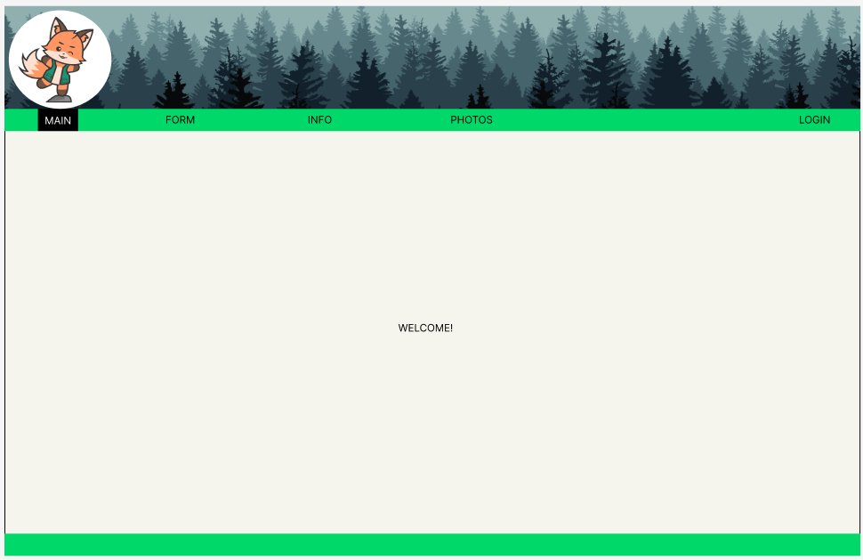

In the form page it will show an opinion form about last year camp but to access this form you need to be Loged in, if you are not Log in it will show a link that redirects you to the Log in page

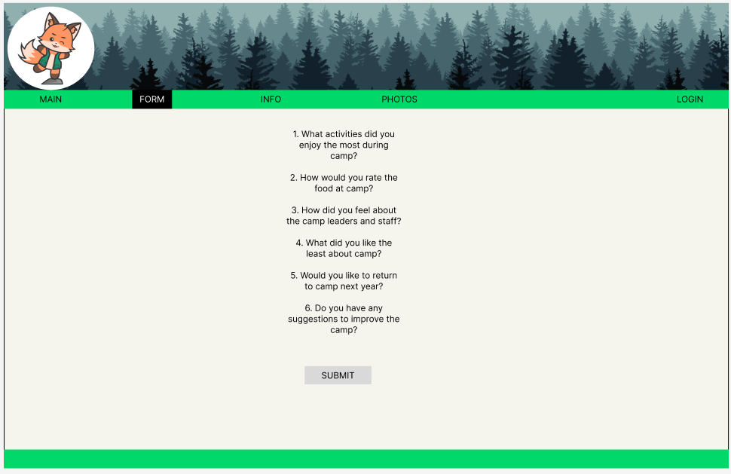
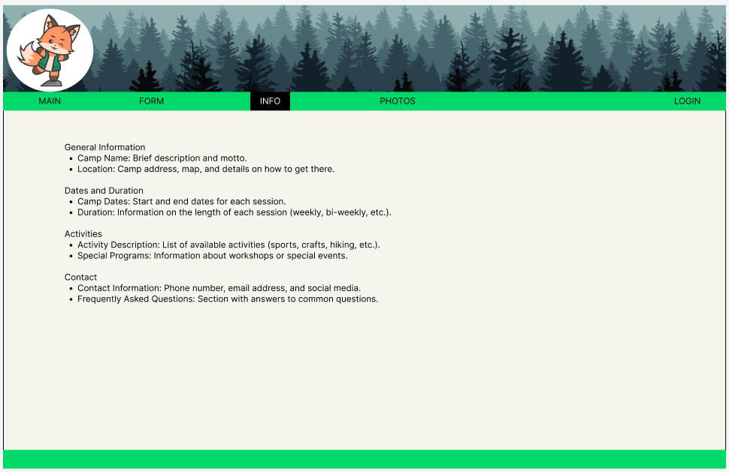
In the info page it shows information about dates, activities and what numbers and emails the camp has

In the photos page it will show photos of the camp
