Homework 3

Q5 Revised

108B (5403) Machine Learning　王傳鈞　0416047

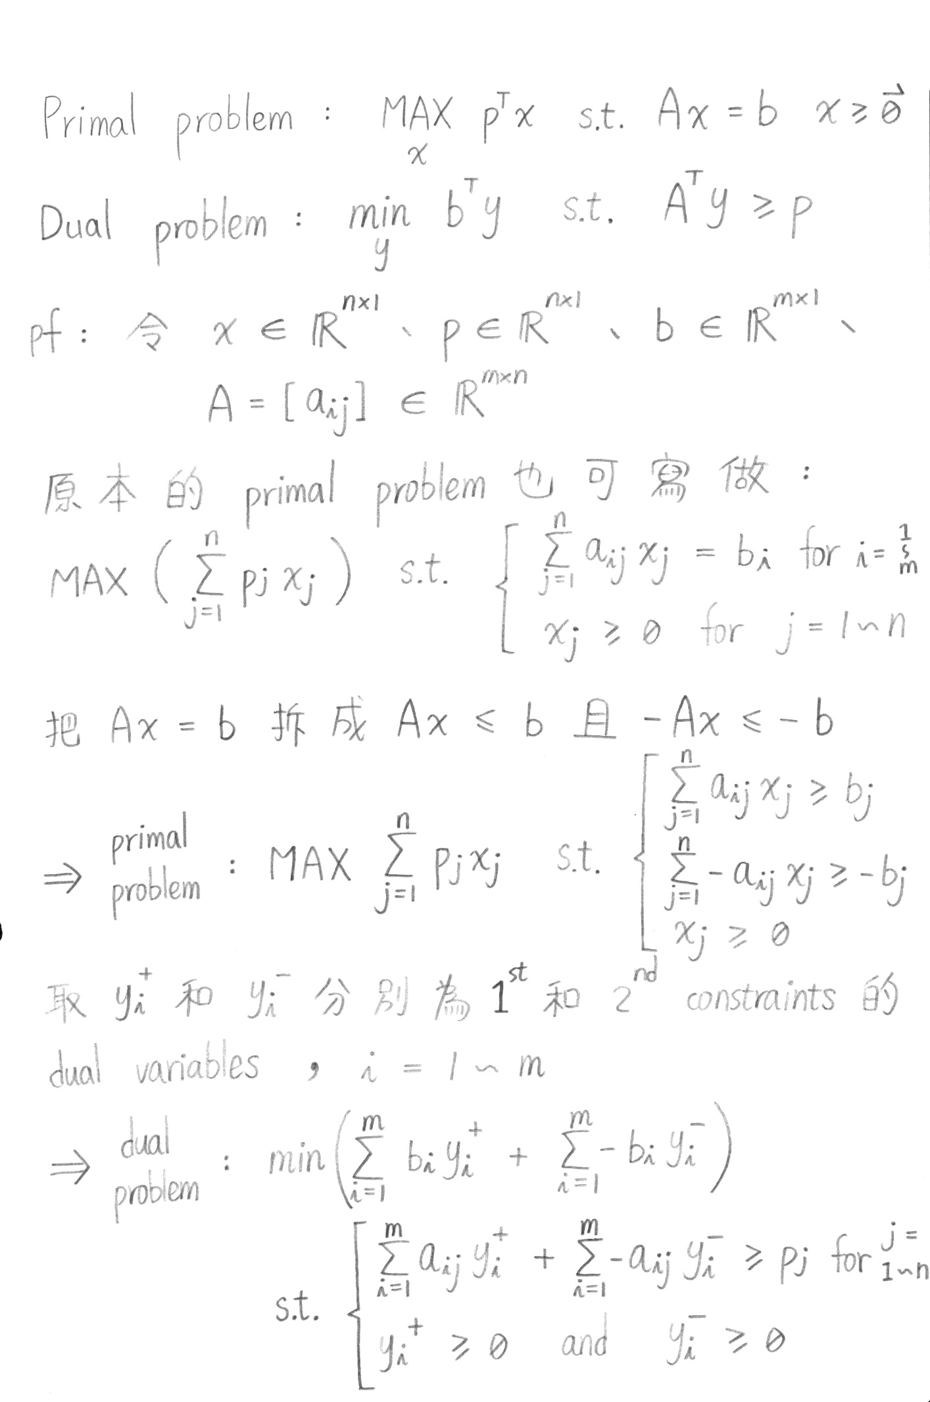第五題

