Sdufgiasufguiasfuiuifgydsdfsd
f
sd
f

sd
f
sd

sd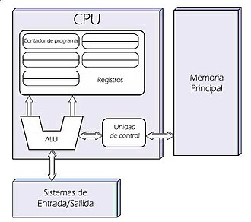
sdf
xdfjkgbaibgibs

fefdg

https://circuitverse.org/simulator
https://cpuvisualsimulator.github.io/
