DNLAT — NDC Message Decoder
Technical Module Documentation
May 2026 | Diebold Nixdorf | Internal

1. Overview
The NDC (NCR Direct Connect) Message Decoder is a module within DNLAT that intercepts chat questions about raw ATM protocol messages and decodes them directly — without sending them to the LLM. It reads 41004/41005 CCProtFW1 log lines from the raw .jrn file, decodes each NDC field, and returns a structured breakdown to the engineer.

This avoids increasing the LLM token count and response time for protocol-level questions, while providing accurate field-by-field decoding of what the ATM and host exchanged.

2. Module Flow
The diagram below shows the complete flow from a user typing in chat to the decoded NDC output being returned.

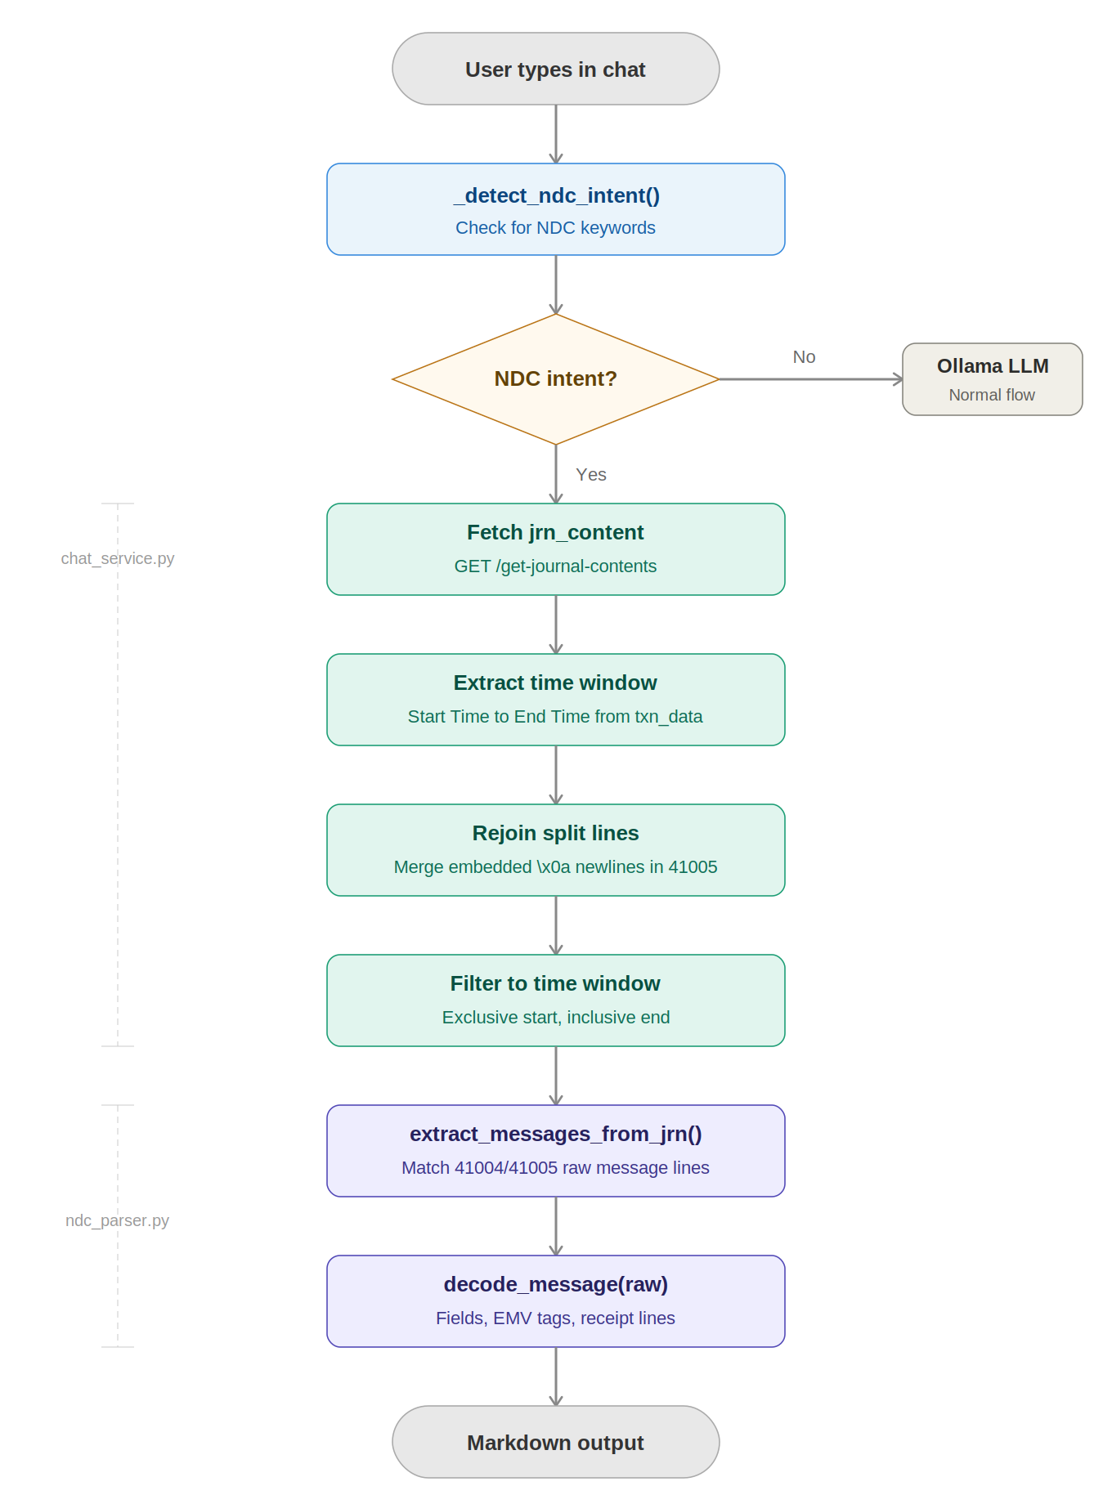

3. Architecture

3.1 Files Involved

File | Role
modules/ndc_parser.py | Core decoder — parses raw NDC strings, decodes all message classes, extracts EMV tags and receipt lines
modules/chat_service.py | Chat intercept — detects NDC intent, extracts messages from session, formats output
api/routes.py | GET /get-journal-contents endpoint — returns raw .jrn content from FastAPI session to Streamlit
streamlit_app.py | Calls /get-journal-contents at analysis time and stores result in chat_context['jrn']

3.2 Data Flow

When a user uploads a ZIP file and clicks Analyze Transaction, the following happens:

- FastAPI extracts the ZIP and reads all .jrn files into session memory (ui_journal_contents, journal_llm_contents). Raw file content is stored unmodified — 41004/41005 lines are not stripped at this stage.
- Streamlit calls GET /get-journal-contents to fetch the raw .jrn content across the process boundary (Streamlit and FastAPI run as separate processes and do not share memory).
- The combined journal dict is stored in st.session_state.chat_context['jrn'] alongside the analysis result and txn_data.
- When the user types a chat message containing NDC keywords, chat_service.py intercepts before calling Ollama.
- _extract_ndc_from_sources() filters the .jrn content to the transaction time window, rejoins any split lines, and passes to extract_messages_from_jrn().
- Decoded messages are formatted as markdown and returned directly — zero LLM tokens used.

4. Key Components

4.1 Intent Detection
_detect_ndc_intent() in chat_service.py checks if the user's question contains any of these keywords:

ndc, 41004, 41005, ccprotfw1, ccprot, raw message, \1c, \x1c,
field separator, ndc message, ndc messages, decode ndc, parse ndc, show ndc

If matched, the LLM is bypassed entirely and the NDC decoder is called instead.

4.2 Source Extraction
_extract_ndc_from_sources() in chat_service.py locates 41004/41005 lines by:

- Taking all text sources: jrn_content (dict of .jrn files), ej_content, txn_data['Transaction Log'], txn_data['prompt']
- Extracting the transaction time window from txn_data['Start Time'] / txn_data['End Time'], with fallback to ts_start/ts_end in the prompt JSON
- Rejoining continuation lines — 41005 lines can contain embedded \x0a newline bytes from receipt data that split the line
- Filtering each source to only lines within (start_time, end_time] — exclusive start prevents previous chained transaction messages appearing
- Calling extract_messages_from_jrn() on each filtered source and deduplicating by raw string

4.3 Line Parsing (ndc_parser.py)
extract_messages_from_jrn() scans for lines matching:

\b(41004|41005)\b.*raw message

For each matching line, the raw NDC string is extracted by finding 'raw message' first, then the colon after it — this avoids rfind() picking up ': ' inside rejoined receipt text. The raw string is then passed to decode_message() which dispatches to a class-specific decoder.

5. Supported NDC Message Classes

Class | Direction | Name | Key Fields Decoded
11 | ATM -> HOST | Transaction Request | LUNO, Track 2, Op Code, Amount, PIN Buffer, EMV data, Last Status
22 | ATM -> HOST | Transaction Acknowledge | LUNO, Next State, Transaction Serial, Cryptogram Type, EMV tags
12 | ATM -> HOST | Status / Ready | LUNO, Subtype (P/E/F/S), Device states, Cassette counts, Supply levels
40 | HOST -> ATM | Transaction Reply | LUNO, Next State, Function ID, Notes to dispense, Receipt text
30 | HOST -> ATM | Go In Service / Screen Load | LUNO, Sequence, Function Code, Screen data
61 | HOST -> ATM | Extended Transaction Reply | LUNO, Next State, extended fields
10 | HOST -> ATM | Go Out of Service | LUNO, Reason
80 | HOST -> ATM | Unsolicited Status | LUNO, Status data
23 | ATM -> HOST | Send Config Info | LUNO, Config data

6. Known Edge Cases

6.1 Embedded Newlines in 41005 Lines
41005 HOST->ATM Transaction Reply messages embed the full receipt text inline using \x0a (newline) bytes. When the .jrn file is read with latin-1 encoding, these become actual newlines and split the 41005 log line. The rejoin logic in _filter_by_window() handles this by concatenating all non-timestamped continuation lines back onto their parent.

6.2 Chained Transactions
When an ATM chains from a Balance Inquiry into a Cash Withdrawal, the 22 (Acknowledge) message from the previous transaction leg may share the same timestamp as the new transaction start. The time window filter uses an exclusive lower bound (start_time < ts) to prevent these messages appearing in the next transaction's decode output.

6.3 Multiple .jrn Files in Session
A ZIP upload may contain .jrn files from multiple days (e.g. 20250908.jrn through 20250916.jrn). All files are searched but each is filtered to the transaction time window before extraction, so only messages from the correct transaction are returned.

6.4 Process Boundary (Streamlit vs FastAPI)
Streamlit and FastAPI run as separate OS processes. In-memory session data (including raw .jrn file content) is stored in FastAPI's process and is not accessible from Streamlit directly. The GET /get-journal-contents endpoint crosses this boundary — called once at analysis time and stored in Streamlit's session state for subsequent chat calls.

7. Output Format
Each decoded message is shown as a markdown section with the following fields:

- Message number, class, direction, and timestamp
- Raw NDC string (first 120 characters)
- Decoded fields (LUNO, operation code, amount, next state, etc.)
- EMV tags if present (decoded from CAM/5CAM TLV data)
- Receipt lines if present (from \x0a-delimited receipt text in 41005 messages, first 8 lines shown)

Messages are sorted chronologically by timestamp. The LLM is not involved — decoding is done entirely in Python by ndc_parser.py.

8. How to Trigger
After running an LLM analysis on a transaction, type any of the following in the chat input:

- ndc
- 41004 or 41005
- decode ndc
- show ndc messages
- parse ndc
- ccprot or ccprotfw1

The decoder will return all raw NDC messages found in the transaction's time window, decoded field by field.

