Directory Structure

file system Directories

1. Main application fun2learn directory will contain the sub directories resources and source
2. Resources will contain the sub directories which are named after the topics generated. It will also contain the index file which contains the list of all the topics generated.
3. Each of the topic specific directories will have the images falling into that topic and a text file which will have one to one mapping between the images and the keyword describing it.
4. The source directory will have the source code pertaining to this application.

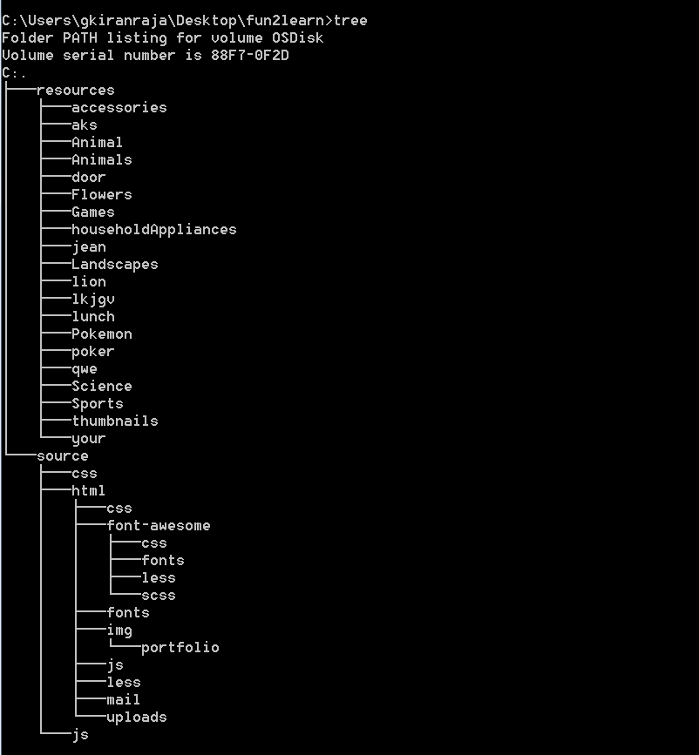

Content reusability

The content is transferrable to the other machine and can be easily merged with some other existing directory. It is very easy for the beginners to move around the content.

1. Copy the contents from the topic specific directories as discussed above in the directory structure into the destination directory.
2. Merge the new contents.
3. Update the new content in the text file named after the topic in the destination topic directory.
4. If a new topic directory is copied to the destination resource directory of the application. Make sure the topic name is appended in the index.txt

The content is transferrable to the other machine and can be easily merged with some other existing directory. It is very easy for the