参数一共有以下几种：

$R^{A}{ Q}_{A}$ ${ R}^{B}{ Q}_{B}$ $α$ $ε_{A}$ $ε_{B}$ $n$

**重要发现：随着演化时间t的变化，最终点的演化结果是会变动的，即随着时间t的变化，最终点会改变，以下实验都是基于t在(0, 10, 0.1)的变化内进行演化。**

1、固定部分参数并调整其他参数，查看E6点和阶段演化结果

r1, q1, r2, q2, alpha, ea, eb = 2, 20, 1, 15, 3.2, 0.8, 0.8

|  |  |  |
| --- | --- | --- |
| N | E6 | 结束点 |
| 2 | [0.52, 0.48, 0.23, 0.77] | [0.52, 0.48, 0.23, 0.77] |
| 3 | [0.29, 0.26, 0.45, 0.17, 0.57, 0.27] | [1, 0, 0, 1, 0, 0] |
| 4 | [0.2, 0.19, 0.32, 0.29, 0.09, 0.3, 0.14, 0.47] | [0, 1, 0, 0, 0, 1, 0, 0] |
| 5 | [0.14, 0.12, 0.21, 0.19, 0.33, 0.07, 0.25, 0.12, 0.38, 0.18] | [0.14, 0.12, 0.21, 0.19, 0.33, 0.07, 0.25, 0.12, 0.38, 0.18] |
| 6 | [0.1, 0.1, 0.16, 0.15, 0.26, 0.23, 0.05, 0.15, 0.07, 0.24, 0.11, 0.38] | [0, 0, 0, 1, 0, 0, 0, 0, 0, 1, 0, 0] |
| 7 | [0.07, 0.07, 0.12, 0.11, 0.18, 0.17, 0.29, 0.04, 0.13, 0.06, 0.2, 0.1, 0.32, 0.15] | [0, 1, 0, 0, 0, 0, 0, 0, 1, 0, 0, 0, 0, 0] |
| 8 | [0.06, 0.05, 0.09, 0.08, 0.15, 0.13, 0.23, 0.21, 0.03, 0.09, 0.04, 0.14, 0.06, 0.21, 0.1, 0.33] | [0, 1, 0, 0, 0, 0, 0, 0, 0, 1, 0, 0, 0, 0, 0, 0] |
| 9 | [0.04, 0.04, 0.07, 0.06, 0.11, 0.1, 0.17, 0.15, 0.26, 0.02, 0.08, 0.04, 0.12, 0.06, 0.18, 0.09, 0.29, 0.13] | [0, 0, 0, 1, 0, 0, 0, 0, 0, 0, 0, 0, 1, 0, 0, 0, 0, 0] |
| 10 | [0.04, 0.03, 0.06, 0.05, 0.09, 0.08, 0.14, 0.12, 0.21, 0.19, 0.02, 0.05, 0.02, 0.08, 0.04, 0.13, 0.06, 0.2, 0.09, 0.31] | [0, 0, 0, 1, 0, 0, 0, 0, 0, 0, 0, 0, 0, 1, 0, 0, 0, 0, 0, 0] |

1. 固定其他参数，查看随着 ${ R}^{B}$ 增大E6结束点的演化情况

r1, q1, , q2, alpha, ea, eb = 14, 20, , 15, 15, 0.8, 0.8

N = 4

|  |  |  |
| --- | --- | --- |
| $${ R}^{B}$$ | E6 | 结束点 |
| 3 | [0.34, 0.05, 0.54, 0.07, 0.04, 0.35, 0.07, 0.54] | [0, 1, 0, 0, 0, 1, 0, 0] |
| 4 | [0.34, 0.05, 0.53, 0.08, 0.06, 0.33, 0.09, 0.52] | [0, 0, 1, 0, 0, 0, 1, 0] |
| 5 | [0.33, 0.06, 0.52, 0.09, 0.07, 0.32, 0.11, 0.5] | [0.33, 0.06, 0.52, 0.09, 0.07, 0.32, 0.11, 0.5] |
| 6 | [0.33, 0.06, 0.51, 0.1, 0.08, 0.31, 0.12, 0.49] | [0.33, 0.06, 0.51, 0.1, 0.08, 0.31, 0.12, 0.49] |
| 7 | [0.32, 0.07, 0.5, 0.11, 0.09, 0.3, 0.14, 0.47] | [0.32, 0.07, 0.5, 0.11, 0.09, 0.3, 0.14, 0.47] |
| 8 | [0.32, 0.08, 0.49, 0.12, 0.1, 0.29, 0.16, 0.45] | [0.32, 0.08, 0.49, 0.12, 0.1, 0.29, 0.16, 0.45] |
| 9 | [0.31, 0.08, 0.48, 0.13, 0.11, 0.28, 0.17, 0.44] | [0.31, 0.08, 0.48, 0.13, 0.11, 0.28, 0.17, 0.44] |

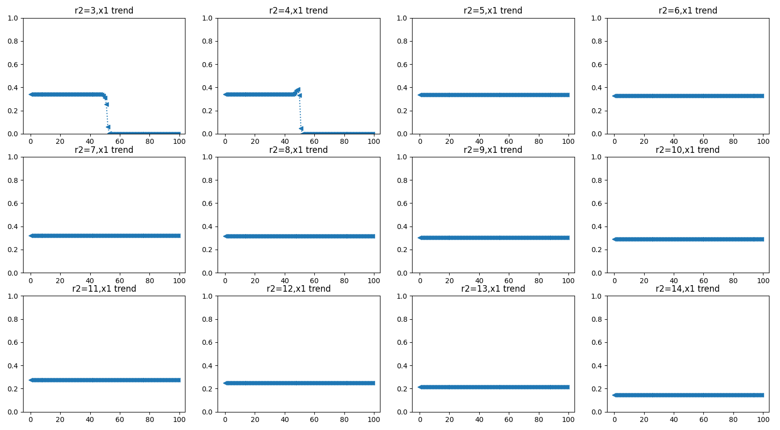

1. 固定其他参数，查看随着 $R^{A}$ 增大E6结束点的演化情况

, q1, r2, q2, alpha, ea, eb = , 20, 1, 15, 15, 0.8, 0.8

N = 4

|  |  |  |
| --- | --- | --- |
| $$R^{A}$$ | E6 | 结束点 |
| 3 | [0.16, 0.23, 0.25, 0.36, 0.07, 0.33, 0.1, 0.51] | [0.16, 0.23, 0.25, 0.36, 0.07, 0.33, 0.1, 0.51] |
| 4 | [0.17, 0.22, 0.26, 0.35, 0.05, 0.34, 0.08, 0.53] | [0.17, 0.22, 0.26, 0.35, 0.05, 0.34, 0.08, 0.53] |
| 5 | [0.18, 0.21, 0.28, 0.33, 0.04, 0.35, 0.07, 0.54] | [0.18, 0.21, 0.28, 0.33, 0.04, 0.35, 0.07, 0.54] |
| 6 | [0.19, 0.2, 0.29, 0.32, 0.04, 0.35, 0.06, 0.55] | [0.19, 0.2, 0.29, 0.32, 0.04, 0.35, 0.06, 0.55] |
| 7 | [0.2, 0.19, 0.31, 0.3, 0.03, 0.36, 0.05, 0.56] | [0.2, 0.19, 0.31, 0.3, 0.03, 0.36, 0.05, 0.56] |
| 8 |  |  |
| 9 |  |  |
| 10 |  |  |
| 11 |  |  |
| 12 |  |  |
| 13 | [0.32, 0.08, 0.49, 0.12, 0.02, 0.37, 0.03, 0.58] | [0, 0, 1, 0, 0, 0.0, 1, 0] |
| 14 | [0.35, 0.04, 0.54, 0.06, 0.02, 0.37, 0.03, 0.58] | [0, 1, 0, 0,0, 1, 0, 0] |

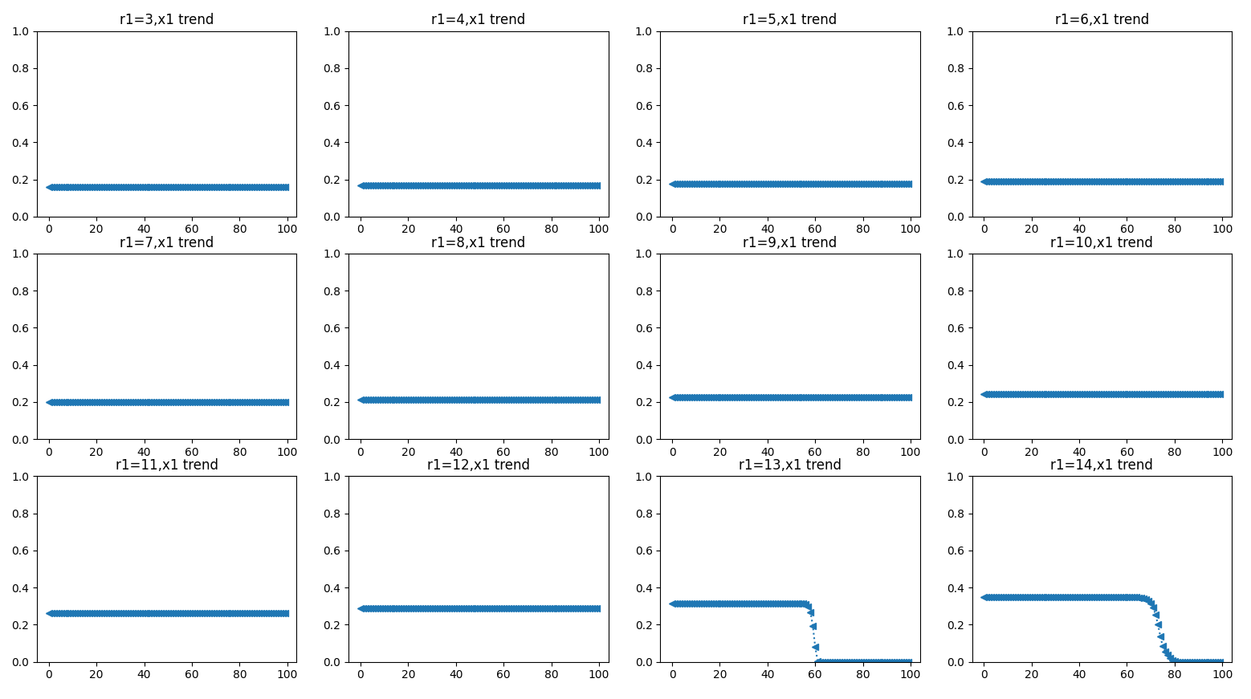

1. 固定其他参数，查看随着 ${ Q}_{A}$ 增大E6结束点的演化情况

r1, , r2, q2, alpha, ea, eb = 14, , 1, 15, 15, 0.8, 0.8

N = 4

|  |  |  |
| --- | --- | --- |
| $${ Q}_{A}$$ | E6 | 结束点 |
| 3 | [0.38, 0.01, 0.6, 0.01, 0.09, 0.3, 0.14, 0.47] | [0.38, 0.01, 0.6, 0.01, 0.09, 0.3, 0.14, 0.47] |
| 4 | [0.38, 0.01, 0.6, 0.01, 0.07, 0.32, 0.11, 0.5] | [0.38, 0.01, 0.6, 0.01, 0.07, 0.32, 0.11, 0.5] |
| 5 | [0.38, 0.01, 0.59, 0.02, 0.06, 0.33, 0.09, 0.52] | [0.38, 0.01, 0.59, 0.02, 0.06, 0.33, 0.09, 0.52] |
| 6 | [0.38, 0.01, 0.59, 0.02, 0.05, 0.34, 0.08, 0.53] | [0.38, 0.01, 0.59, 0.02, 0.05, 0.34, 0.08, 0.53] |
| 7 |  |  |
| 8 |  |  |
| 9 |  |  |
| 10 |  |  |
| 11 | [0.37, 0.02, 0.57, 0.04, 0.03, 0.36, 0.04, 0.57] | [0.35, 0.08, 0.54, 0.03, 0.01, 0.72, 0.02, 0.25] |
| 12 | [0.36, 0.03, 0.57, 0.04, 0.03, 0.36, 0.04, 0.57] | [0.93, 0.07, 0.0, 0.0, 0.07, 0.93, 0.0, 0.0] |
| 13 | [0.36, 0.03, 0.57, 0.04, 0.02, 0.37, 0.04, 0.57] | [0.9, 0.0, 0.01, 0.09, 0.05, 0.0, 0.0, 0.95] |
| 14 |  |  |

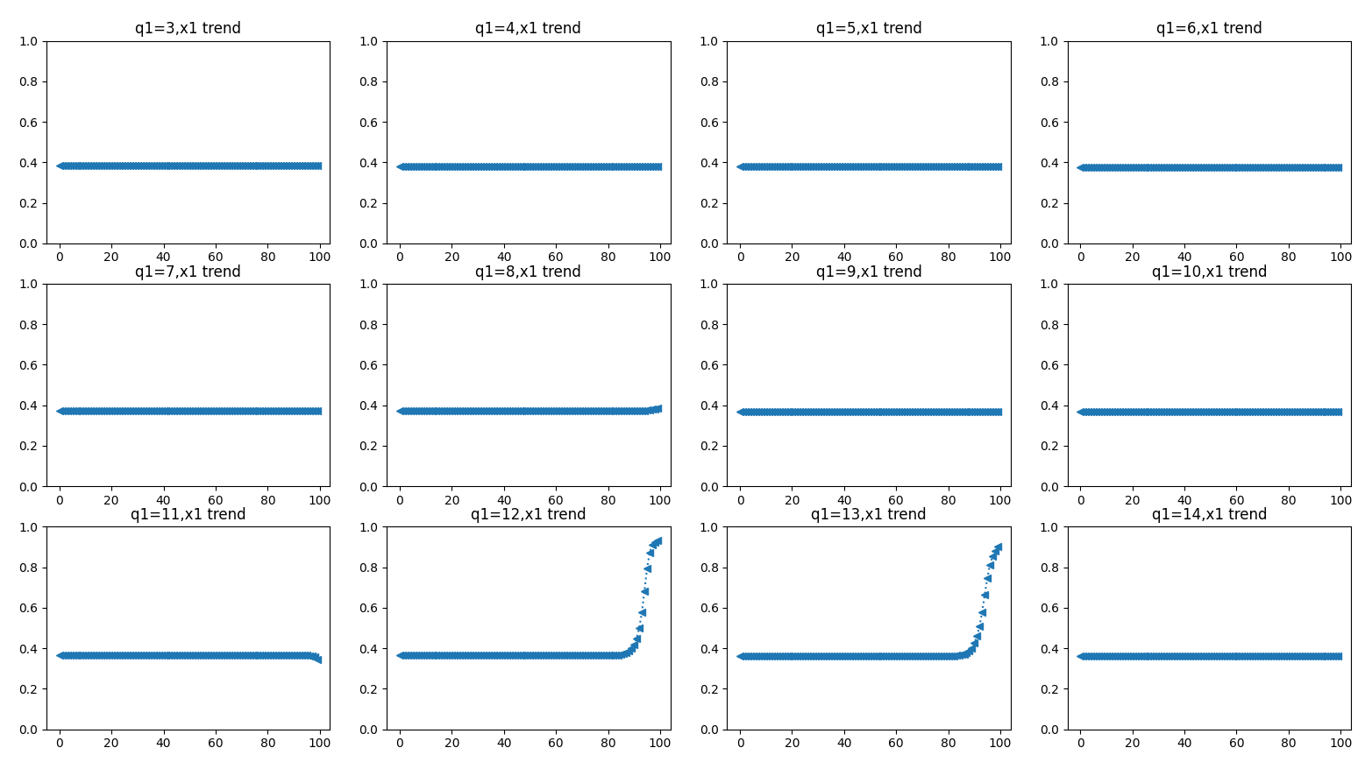

1. 固定其他参数，查看随着 ${ Q}_{B}$ 增大E6结束点的演化情况

r1, , r2, q2, alpha, ea, eb = 14, , 1, 15, 15, 0.8, 0.8

N = 4

|  |  |  |
| --- | --- | --- |
| $$Q_{B}$$ | E6 | 结束点 |
| 3 | [0.24, 0.15, 0.38, 0.23, 0.0, 0.39, 0.01, 0.6] | [0.24, 0.15, 0.38, 0.23, 0.0, 0.39, 0.01, 0.6] |
| 4 | [0.27, 0.12, 0.42, 0.19, 0.0, 0.39, 0.01, 0.6] | [0.27, 0.12, 0.42, 0.19, 0.0, 0.39, 0.01, 0.6] |
| 5 | [0.29, 0.1, 0.45, 0.16, 0.01, 0.38, 0.01, 0.6] | [0.29, 0.1, 0.45, 0.16, 0.01, 0.38, 0.01, 0.6] |
| 6 | [0.3, 0.09, 0.47, 0.14, 0.01, 0.38, 0.01, 0.6] | [0.3, 0.09, 0.47, 0.14, 0.01, 0.38, 0.01, 0.6] |
| 7 | [0.31, 0.08, 0.49, 0.12, 0.01, 0.38, 0.01, 0.6] | [0.31, 0.08, 0.48, 0.13, 0.01, 0.38, 0.01, 0.6] |
| 8 | [0.32, 0.07, 0.5, 0.11, 0.01, 0.38, 0.01, 0.6] | [0.32, 0.06, 0.52, 0.09, 0.01, 0.4, 0.02, 0.57] |
| 9 | [0.33, 0.06, 0.51, 0.1, 0.01, 0.38, 0.02, 0.59] | [0.51, 0.04, 0.32, 0.12, 0.02, 0.17, 0.01, 0.8] |

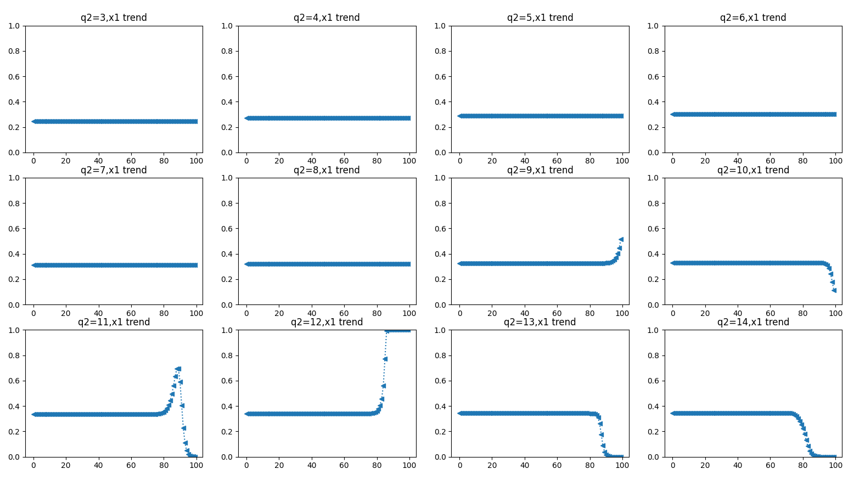

1. 固定其他参数，查看随着 ${ Q}_{B}$ 增大E6结束点的演化情况**(增大时间步长t(0,20,0.1))**

r1, , r2, q2, alpha, ea, eb = 14, , 1, 15, 15, 0.8, 0.8

N = 4

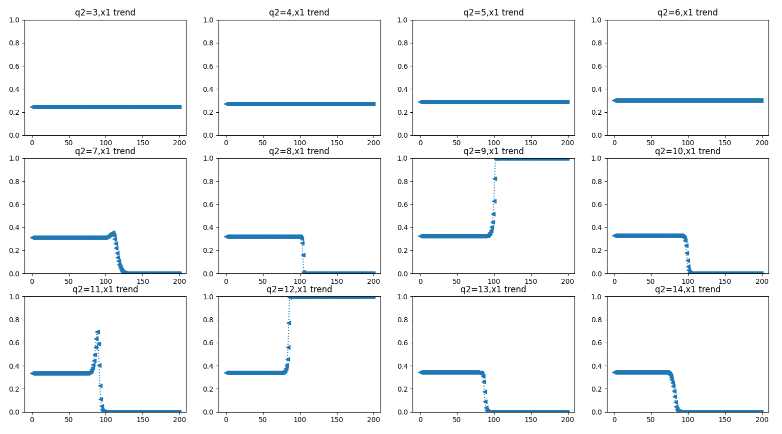

1. 固定其他参数，查看随着 $α$ 增大E6结束点的演化情况

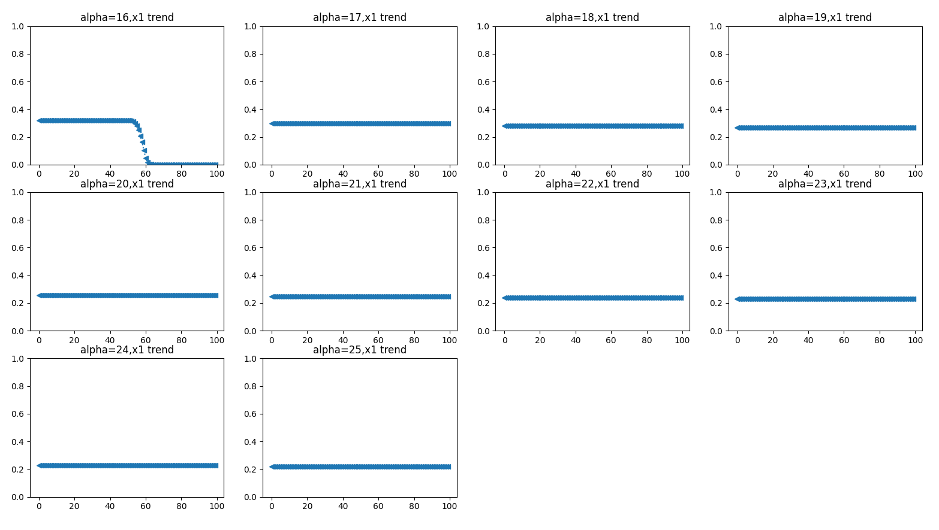

1. 固定其他参数，查看随着 $ε_{A}$ 增大E6结束点的演化情况

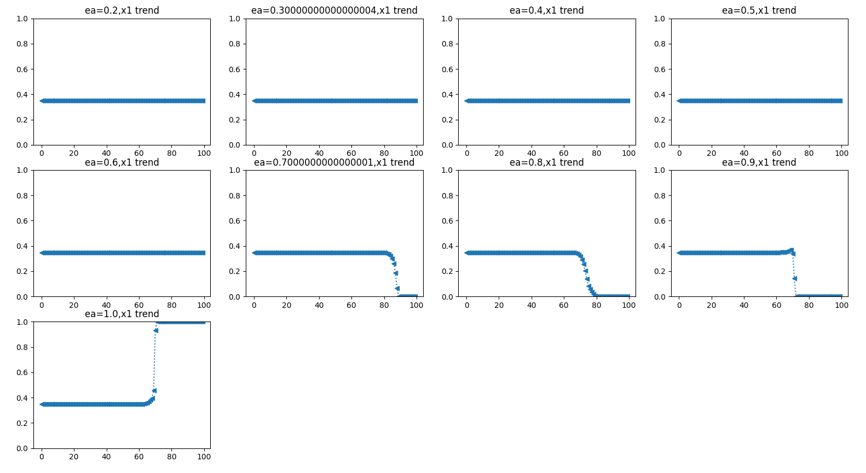

1. 固定其他参数，查看随着 $ε_{B}$ 增大E6结束点的演化情况

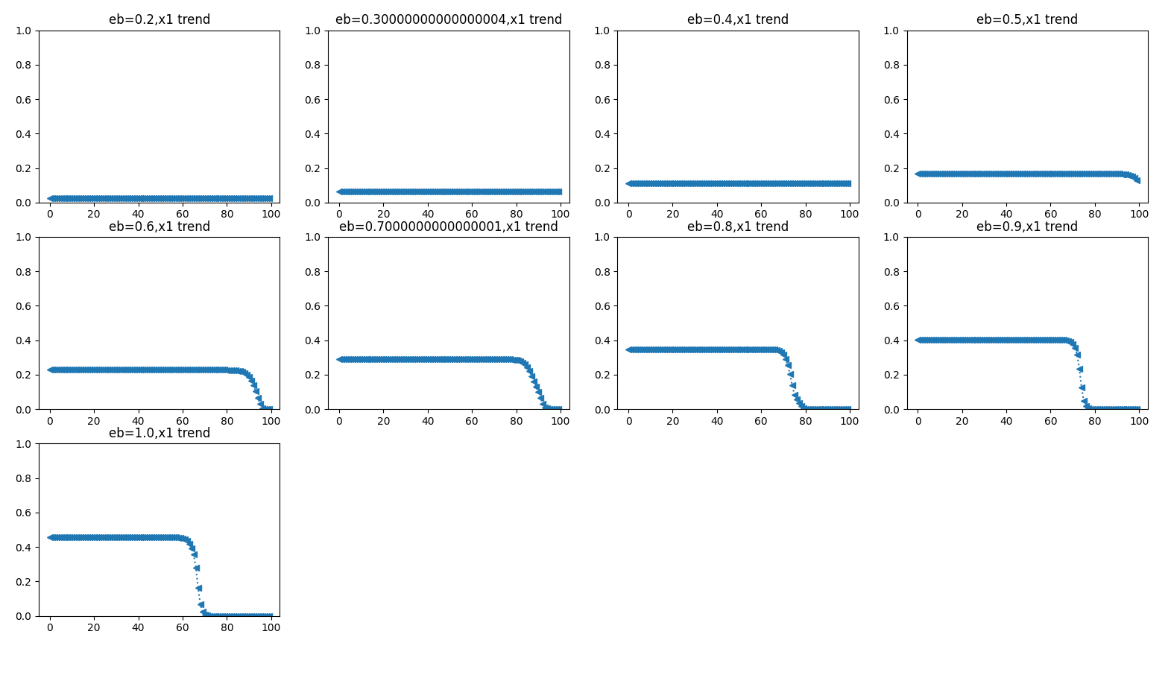

1. 固定所有参数，查看随着 $阶段n$ 增大E6结束点的演化情况

|  |  |  |
| --- | --- | --- |
| $$N$$ | E6 | 结束点 |
| 2 | [0.52, 0.48, 0.23, 0.77] | [0.52, 0.48, 0.23, 0.77] |
| 3 | [0.29, 0.26, 0.45, 0.17, 0.57, 0.27] | 1阶段 |
| 4 | [0.2, 0.19, 0.32, 0.29, 0.09, 0.3, 0.14, 0.47] | 2阶段 |
| 5 | [0.14, 0.12, 0.21, 0.19, 0.33, 0.07, 0.25, 0.12, 0.38, 0.18] | E6 |
| 6 | [0.1, 0.1, 0.16, 0.15, 0.26, 0.23, 0.05, 0.15, 0.07, 0.24, 0.11, 0.38] | 4阶段 |
| 7 | [0.07, 0.07, 0.12, 0.11, 0.18, 0.17, 0.29, 0.04, 0.13, 0.06, 0.2, 0.1, 0.32, 0.15] | 2阶段 |
| 8 | [0.06, 0.05, 0.09, 0.08, 0.15, 0.13, 0.23, 0.21, 0.03, 0.09, 0.04, 0.14, 0.06, 0.21, 0.1, 0.33] | 2阶段 |
| 9 | [0.04, 0.04, 0.07, 0.06, 0.11, 0.1, 0.17, 0.15, 0.26, 0.02, 0.08, 0.04, 0.12, 0.06, 0.18, 0.09, 0.29, 0.13] | 4阶段 |
| 10 | [0.04, 0.03, 0.06, 0.05, 0.09, 0.08, 0.14, 0.12, 0.21, 0.19, 0.02, 0.05, 0.02, 0.08, 0.04, 0.13, 0.06, 0.2, 0.09, 0.31] | 4阶段 |

1. 固定所有参数，查看随着 $阶段n$ 增大($\frac{1}{n}$, $\frac{1}{n}$,.....)的演化快慢情况（n为15时演化到最终结果最快）

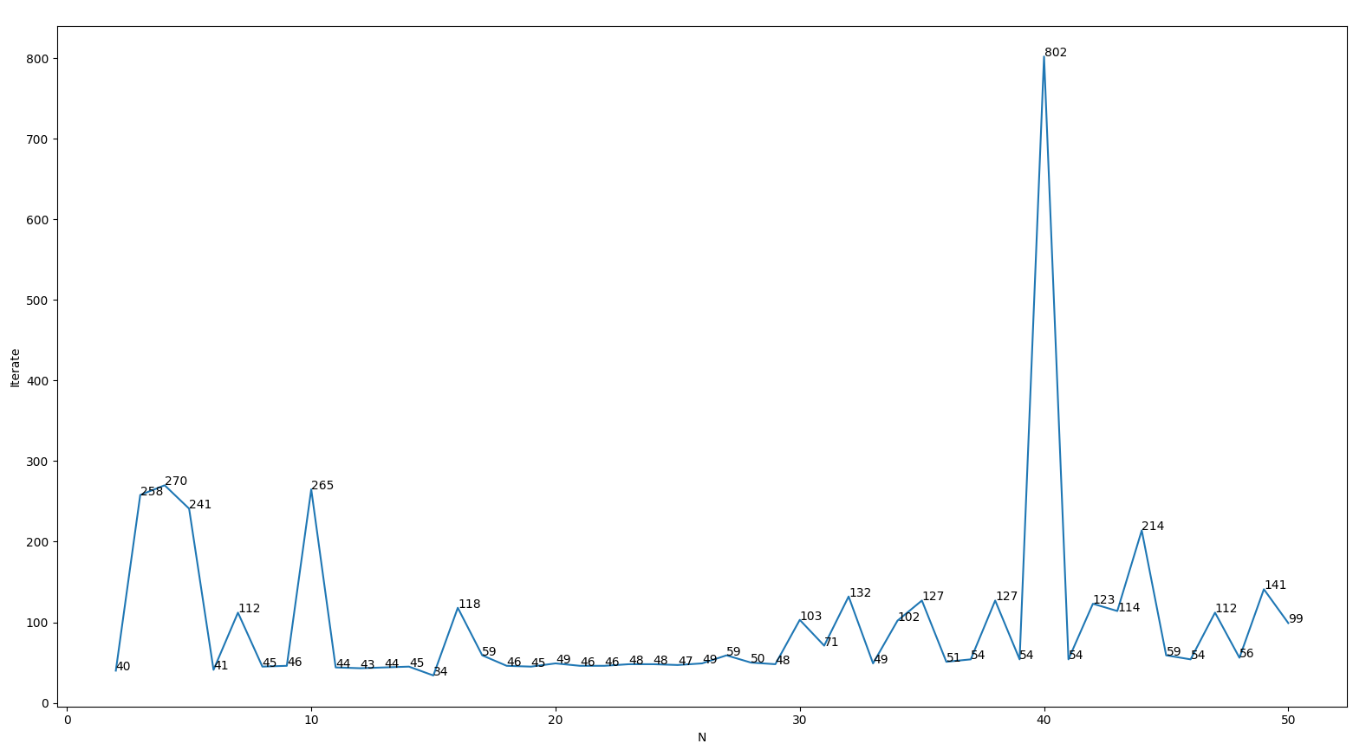

1. 固定所有参数，在初始点不同的情况下，演化结果变化

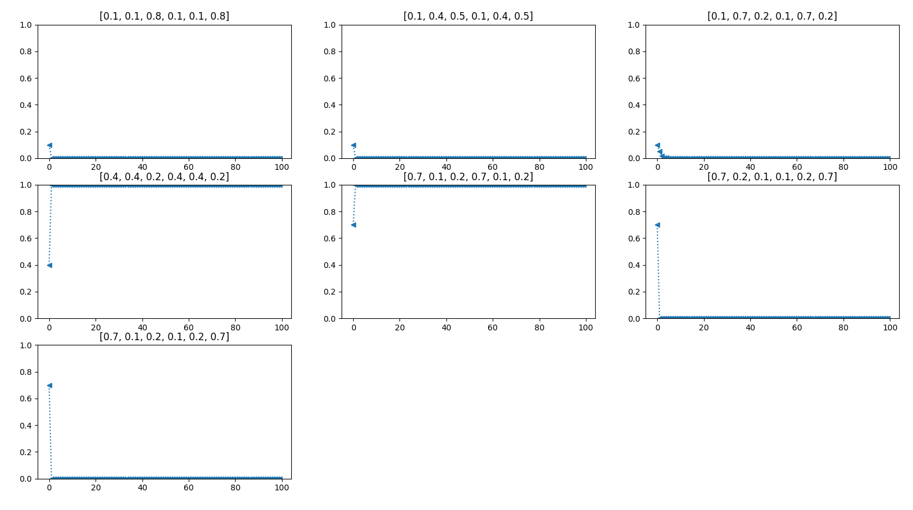

|  |  |
| --- | --- |
| E6 | 结束点 |
| [0.1, 0.1, 0.8, 0.1, 0.1, 0.8] | [0, 0, 1, 0, 0, 1] |
| [0.1, 0.4, 0.5, 0.1, 0.4, 0.5] | [0, 0, 1, 0, 0, 1] |
| [0.1, 0.4, 0.5, 0.1, 0.5, 0.4] | [0, 0, 1, 0, 0, 1] |
| [0.1, 0.7, 0.2, 0.1, 0.7, 0.2] | [0, 1, 0, 0, 1, 0] |
| [0.4, 0.4, 0.2, 0.4, 0.4, 0.2] | [1, 0, 0, 1, 0, 0] |
| [0.4, 0.2, 0.4, 0.4, 0.2, 0.4] | [1, 0, 0, 1, 0, 0] |
| [0.4, 0.1, 0.5, 0.4, 0.5, 0.1] | [1, 0, 0, 1, 0, 0] |
| [0.7, 0.1, 0.2, 0.7, 0.1, 0.2] | [1, 0, 0, 1, 0, 0] |
| [0.7, 0.2, 0.1, 0.1, 0.2, 0.7] | [0, 0, 1, 0, 0, 1] |
| [0.7, 0.1, 0.2, 0.1, 0.2, 0.7] | [0, 0, 1, 0, 0, 1] |