Skip List Applet
User Documentation:

- Introduction:

Skip list is a type of data structure that can be used as an alternative to balanced (binary) trees or B-Trees. As compared to a binary tree, skip lists allow quick search, insertions and deletions of elements with simple algorithms. This is achieved by using probabilistic balancing rather than strictly enforce balancing as done in B-trees. Skip lists are also significantly faster than equivalent algorithms for B-Trees.

A skip list is basically a linked list with additional pointers that allow intermediate nodes to be skipped, hence the name skip list. In a simple linked list that consists of ‘n’ elements, to perform a search ‘n’ comparisons are required in the worst case. If a second pointer pointing two nodes ahead is added to every node, the number of comparisons goes down to n/2+1 in the worst case. Adding one more pointer to every fourth node and making them point to the fourth node ahead reduces the number of comparisons to ceil(n/2) + 2. If this strategy is continued so that every node with ‘i’ pointers points to 2^{i-1} nodes ahead, O(log n) performance is obtained and the number of pointers has only doubled (n + n/2 + n/4 + n/8 + n/16 + .... = 2n).
As mentioned previously, skipped lists are most often used as an alternative to B-Trees. B-Trees work well when the elements are inserted in a random order. However, if the elements of B-Trees are inserted in order, they generate very poor data structures that give very poor performance. To improve the efficiency, B-Trees most often are required to be re-balanced which is one of the most significant drawbacks of the B-Trees. A skip list on the other hand, uses a probabilistic approach to balance the nodes. Balancing a data structure probabilistically is easier than explicitly maintaining the balance. The simplicity of skip list algorithms makes them easier to implement and provides significant speed improvements over balanced tree and self-adjusting tree algorithms. Skip lists are also very space efficient. They can easily be configured to require an average of 1 1/3 pointers per element (or even less) and do not require balance or priority to be stored with each node.
The creation of skip lists is very simple. Each node in a skip list has an array of several 'forward pointers' that link to nodes further along in the list. The number of forward pointers in a particular node are also known as the level of nodes and are determined by a probability function that is applied during insertion, and that serves to create a few 'tall' nodes, more 'medium size' nodes and lots of 'small' nodes. The distribution of the node heights is random and hence the name probabilistic data structure.
The Skip List applet animates the Skip List data structure and illustrates step-by-step how an element is inserted in the list and how an element is searched.
The user interface is shown below:

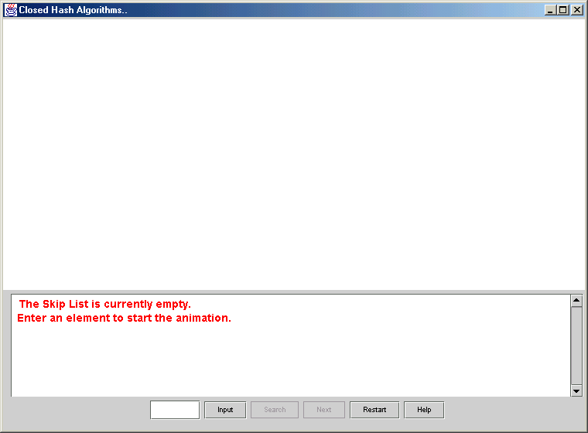
Figure: User interface.

Users interact with the system using push buttons and a text input field.
The controls provided are:
- Text Input Field: This allows users to enter an element in the skip List.
- Input: This button is used to animate the insertion of the element entered in the text field.
- Search: This button is used to animate the search operation of the element entered in the text field.
- Next: This button controls the algorithm animation. It is used to trace through the steps to insert/search the element entered in the text field.
- Restart: Allows you to restart the applet. It gets rid of the old list and starts with an empty list once again.
- Help: This button explains to users the interface of the system in brief.

User feedback is given, using the display and the text field.
As shown in the figure above, the display is initially blank and the list is empty. The user needs to enter an element to start the animation as instructed in the figure.
A detailed description of the tasks that a user needs to perform and the applet animation is given below.

- Applet Animation and User Tasks:

When a user starts the applet, the text display, instructs the user to enter an element in the text field to start the animation. When the user enters an element and clicks on the ‘input’ button the skip List gets formed as shown below.
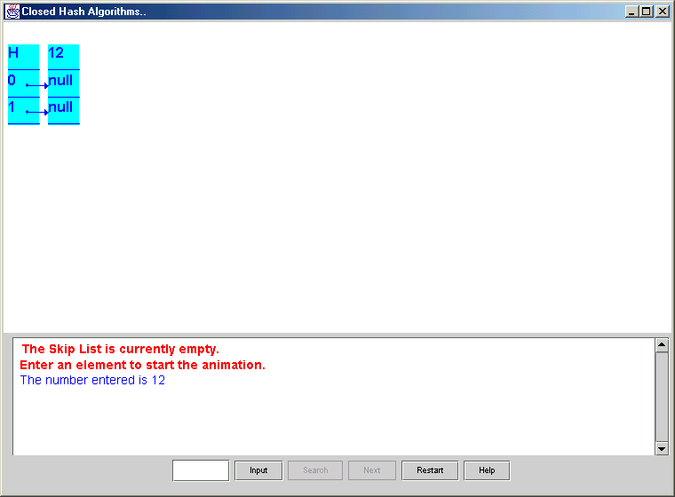
Figure: Shows a skip list created by entering a number in the text field and pressing Input.

As the user enters more elements, the Skip List is formed as shown below.
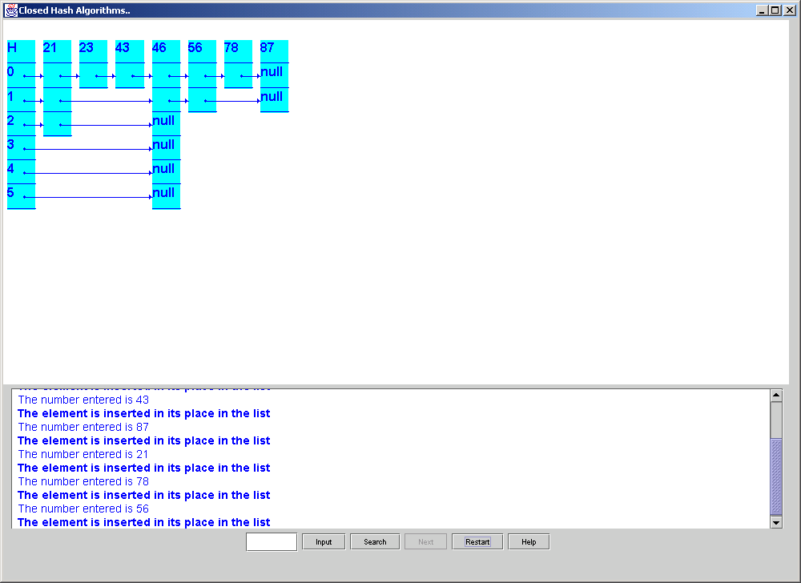
Figure: Shows the skip List drawn and text messages that are provided.
Besides the visual feedback, the users are also provided with text feedback at the bottom.
Once the user enters an element in the text input field, the element can either be inserted into the skip list by clicking the input button or searched in the skip list by pressing the Search Button. Once the user presses the Input/Search button all the controls except the Next button are disabled. The user can trace or animate the insertion or search by pressing the Next button.

Highlighting pointers that are followed while inserting an element performs the animation.
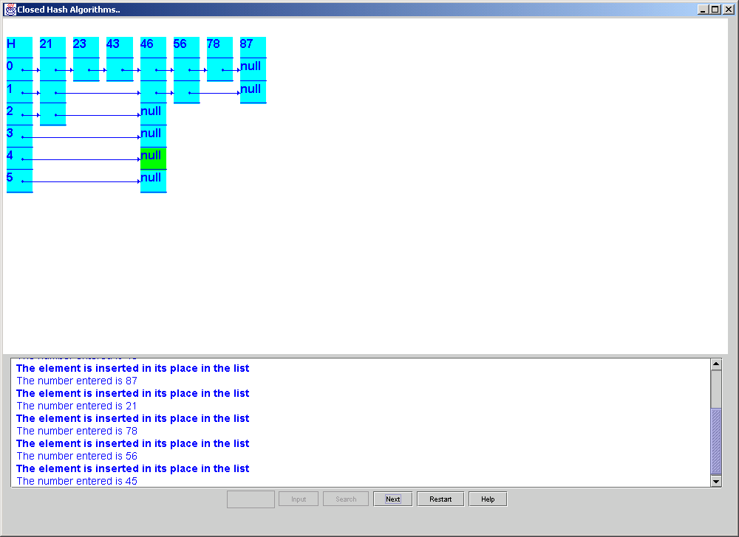
Figure: Shows a pointer highlighted, to give an idea of the animation

As shown in the figure below, the pointers are highlighted one by one using green color. The place where the element is to be inserted is highlighted using a red arrow as shown.

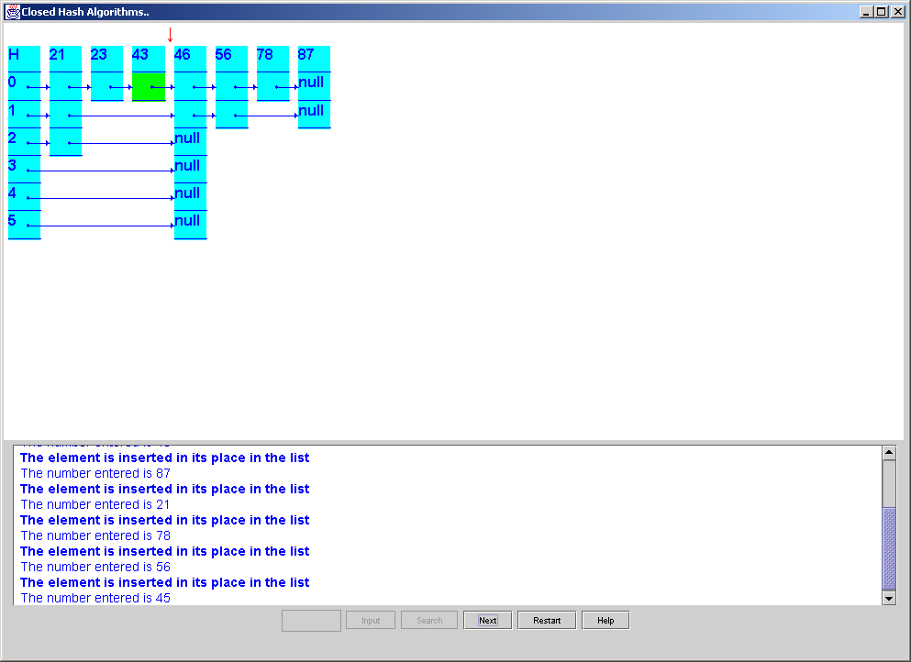
Figure: Shows the red arrow that is used to denote the place where the next element will be inserted.
The animation for the search operation is identical to that of inserting an element in the skip list. The user enters the element that is to be searched in the Text field, and presses the search button that will disable all other controls. The Next button is then pressed repeatedly to trace through the algorithm.
The pointers that are followed to search an element are highlighted in the same way as the pointers that are followed to insert an element using green color. If the element is found in the skip List it is highlighted using pink color.
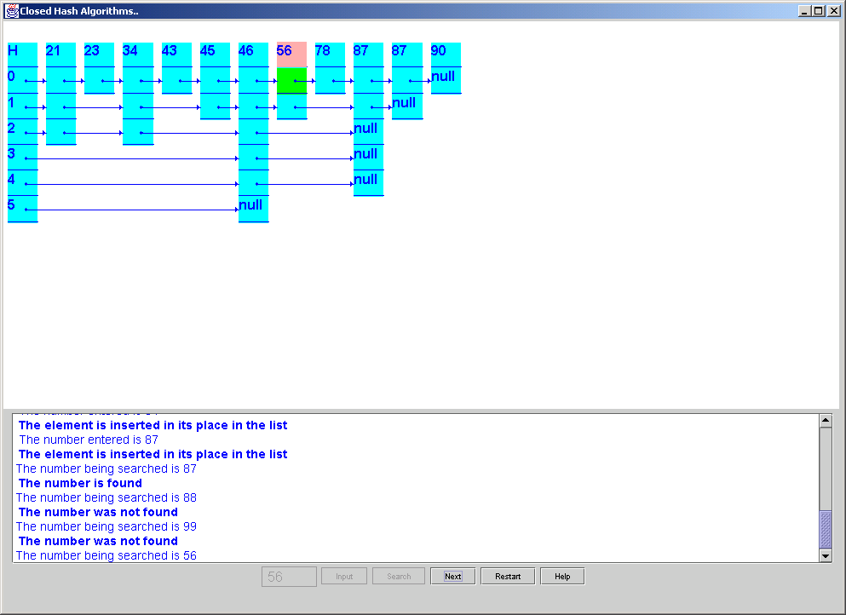
Figure shows the result of the search operations, if the element being searched is in the skip list it is highlighted in pink, if the element is not in skip list, a feedback message as shown in the text field is given.
If the number that is being searched does not exist in the Skip List, then a message displaying that the number was not found is displayed.

In addition to the instructions in the text area and the feedback messages, the user can also refer to the help manual if there is any confusion with the interface and the graphical display
The help manual is displayed when the help button is clicked.
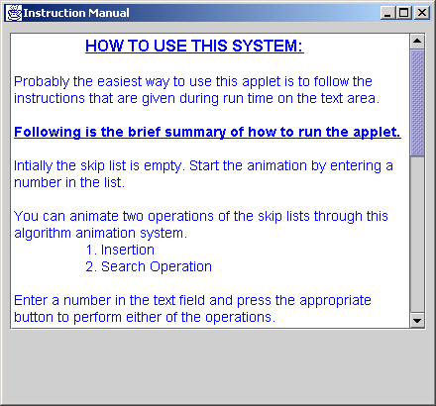
Figure shows the help manual.
Software Documentation:
- Code Explanation:

The following classes are used to implement this applet. The explanation for each of the classes is given below.
  - skipMain:

The skipMain class is written in the skipMain.java file. This class contains the main () function.
To compile the system the user needs to type in the following command:
javac skipMain.java
To run the system the user needs to type in the following command:
java skipMain
The class skipMain calls the setUp class.
The control flow is shown below.

skipMain

setUp
Calls

The skipMain has only one function main () where the program execution begins.

  - setUp:

The setUp class written in skipMain.java file, controls the user interface and interaction of the entire system.
Java swing classes were used to create the user interface. The swing classes that were used are as follows:
- JFrame
- JPanel
- JTextPane
- JScrollPane
- JButton
- JComboBox
- JtextField
- Container
Other java classes used are as follows:
- String
- Style
- StyleConstants
Besides java classes, the following classes that were written as a part of this thesis are also imported to create the user interface and show graph animation.
- drawSkip
- Instructions
Apart from these classes, Java Action Listeners have been used for creating the buttons, text field and the combo box. Document interface has been used for the JTextPane class.
The constructor of the class i.e. setUp () creates the display area that draws the skip list, the text area that displays the messages during run time and the buttons and text field that allows the user to interact with the system.
The method summary of the BufferPool class:

- actionPerformed ():
This is called when the user presses any of the buttons, combo box or enters a number in the text field. Depending on the button pressed appropriate action is taken.

- Message ()
This method is called to display a message in the text field.

The control flow for the setUp class is given below:

setUp

External Classes

Instructions

drawSkip

  - drawSkip:

The drawSkip class written in drawSkip.java file performs the graphics operation for the animation.
The class inherits its method from the swing class JComponent.
The drawskip class draws the skip list and highlights the pointers using green color as the algorithm runs to perform animation.
The method summary for the drawBuffer class:
- Paint ()
This function performs all the graphics operation for the system.
- drawSkipList ()
This function receives the skiplist that is painted on the display area by the paint method.
- drawSearch ()
This function sets the parameters used by the paint method to highlight the pointers while animating the search operation.

- drawNext ()
This function is called everytime the user presses the ‘Next’ button. It keeps track of the next step in the animation, to update the display.
- ResetSearchValues ()
This function is called to reset the variables used by the search operation, so that previous search operations doesnot affect the next one.
- ReturnValueIsFound ()
To determine if the value entered to be searched is present in the skip list.

The control flow for drawSkip is shown below:

drawSkip

setUp

External Classes

  - Instructions:
This class is used to display the help manual. It is called when the user clicks the help button.
The constructor of the class creates the interface for the help manual and adds text to it.

The method summary for the Instructions class:
- Message ()
This function is used to display a string in the text area.
- getrid ()
This function disables more than one help manual open at a time. It will destroy the old manual window before displaying the new one.

Control flow for the Instructions class is as follows:

setUp

Instructions
Calls

Besides the above classes the following classes were also used to animate this system but were not written as a part of this thesis.

- SkipList
- SkipNode
- Elem
- IElem
- Dsutil

Source:
"A Practical Introduction to Data Structures and Algorithm Analysis"
By Clifford A. Shaffer, Prentice Hall, 1998.

Copyright 1998 by Clifford A. Shaffer

The control flow of the system is as follows:

skipMain

setUp
External Classes

drawSkip

Instructions

