Honeypot-based Cyber Attack Detection

Mrs. M Karthigha1, Abishek PS2, Hari Kishore VP3, Kugaanesen S4

1-4 Sri Ramakrishna Engineering College / Department of Computer Science and Engineering, Coimbatore, India

1-4 Email: {karthiga.m@srec.ac.in, abishek292001@gmail.com, hari.1901043@srec.ac.in, kugaanesen.1901068@srec.ac.in}

Abstract — **Cyber Intrusion is the most threatening expression in the cyber world, and it is a dangerous crime that many corporations and individuals who are a part of the Cyber World are horrified of. It results from not only a financial loss but also includes personal data which is impacted as a flooded river when the data is exposed in a data breach. Cyber Intrusion Detection System is a technology used to identify and alert unauthorized access to a network system or a network device. It analyses network traffic and logs files maintained by a device and reports or alerts when an outsider is trying to gain access to a network. Honeypot is a technology that acts as a catchy pot of honey for an attacker. When an attacker tries to catch the pot, the Honeypot system will alert the administrator and block it. Both technologies can be combined with Machine Learning to automate and improve the prediction rate so that attackers will be prevented. The use of Machine Learning algorithms detects the type of attacks. Further research should be conducted for the results to use the combination of honeypots, Cyber Intrusion, and Machine Learning to detect Cyber Attacks and the advancements, efficiency, and correctness of the prediction.**

Index Terms**— Honeypot, Machine Learning, Cyber Attack, Data Breach, Attack Prevention.**

I. Introduction

The world is evolving with cutting-edge technology, and people around the world are interconnected with each other through the internet with the help of electronic devices and smart gadgets. There are about 5 billion active internet users worldwide. A major threat to Internet users is cyberattacks. Cyber-attacks may lead to any risk which includes financial losses, personal data leaks, business-related problems, corporate security, and mainly personal data security. Data Breach sometimes lights up a few corporate secret crimes which are more commonly found these days. Though it lights up crimes, Data Breach is a crime that involves one’s or some personal details.

A honeypot is a cybersecurity mechanism used to detect, deflect, or counteract unauthorized use of information systems. A honeypot is essentially a decoy system that is designed to attract and trap potential attackers by imitating a vulnerable system or application.

The idea behind a honeypot is to give attackers a fake system to attack instead of the real one, allowing security researchers to observe the attacker's techniques and tactics without risking damage to real systems. When an attacker interacts with a honeypot, the honeypot captures information about the attack, including the attacker's IP address, methods, and tools used in the attack. There are various types of honeypots, including high-interaction and low-interaction honeypots. High-interaction honeypots are designed to provide a realistic environment for attackers to operate in, whereas low-interaction honeypots simulate only certain aspects of a system. Honeypots can be used as a proactive security measure to detect and prevent attacks, as well as a research tool to study and understand attackers' behaviour and motives.

The global average cost of a Data breach is about 4.35 USD. Verizon’s 2022 Data Breach Investigation Report (DIBR) states that about 62% of incidents are of System Intrusion patterns involving threat actors compromising partners. 13% increase in Ransomware which is more than the combined past 5 years. Avoiding such attacks for an individual is impossible since targeted attacks are more common these days where the data of high-powered people are not safe. To avoid such attacks in a network, the use of new technologies is a must to get more secure. The attackers are smarter as there are a few ways to bypass the honeypots.

Data can be secured in many ways, but the most efficient in terms of power consumption, data consumption, and quick response is more important. The combination of Honeypot and Cyber Intrusion Detection ways using Machine Learning Algorithms can predict almost every input data frame in less time with a high prediction rate which can stop the attacker from accessing the data.

II. Proposed Methodology

Machine learning approaches with a change in the network setup can be used to predict the Honeypot log data and whether any attacker is trying to gain access or not in an efficient way. It is achieved by using the required data from the honeypot log files. It requires a few features which are extracted from the generated log report from the Honeypot. The main purpose of this methodology is to obtain high accuracy and low processing power.

The prediction accuracy of an output of a Machine Learning algorithm is strongly related to the quality of its dataset. The proposed methodology uses the “KDDCUP99” dataset provided by Fifth International Conference on Knowledge Discovery and Data Mining. The KDDCUP99 dataset is used with ML models directly from the honeypot logs. The dataset has labels and hence it is a supervised model, we test its accuracy with all suitable Machine Learning Algorithms.

1. Network Design

The network design is designed in such a way that all the data is the hidden backside of a honeypot server divided by firewalls. Multiple layered designs are required to attract more attackers and it helps in identifying attackers which use honeypot bypass techniques. It is explained well in the following figure with network design designed using Cisco Packet Tracer.

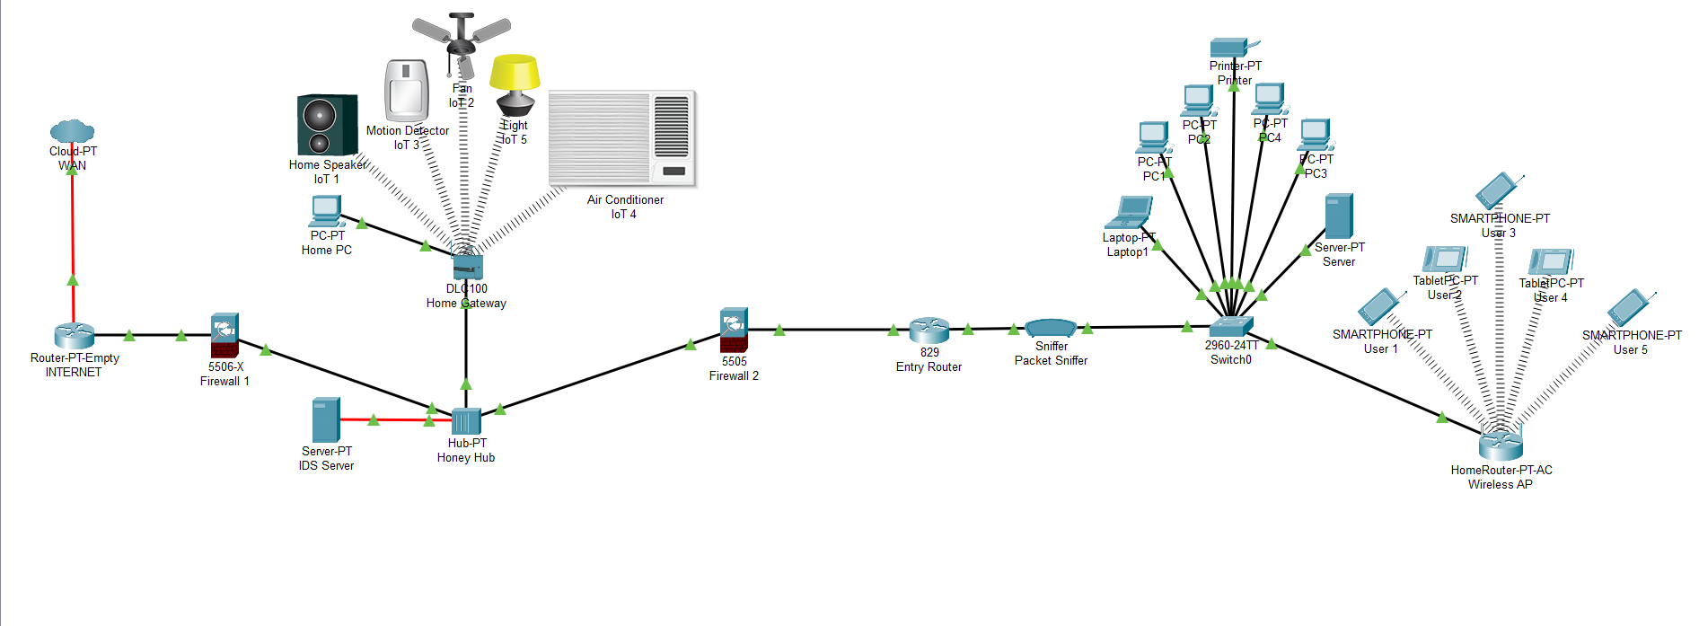

*Fig. 2.1 Network Design*

1. The whole network is entered directly through the Internet router from the Internet Service Provider (ISP) or the outer network.
2. All the traffic from the Internet Service Provider enters the Internet Router and the data packets are sent over Firewall 1 to filter the usual unwanted packets from the internet or the outer network.
3. Filtered packets then enter the Honey Hub. The honey Hub is connected to a home gateway that is fully connected with more devices using the internet (IoT Devices), this may be physical devices or may be virtual devices running old or vulnerable operating systems. Old and vulnerable software versions for IoT devices are the 1st layer of trap for attackers. Since the software is vulnerable by nature, they are more likely to act as a natural honeypot.
4. The role of the Honey HUB is to transmit all packets to the IDS server since HUB broadcasts every packet detail to every device connected to it.
5. The honeypot server which is connected via optical fiber receives data more quickly since they are much faster than the normal twisted pair of Cat 5, Cat 6, Cat 7, and Cat 7E cables.
6. IDS server analyses the network and uses Machine Learning Algorithm that predicts the packet's nature and collects all required details for the prediction and sends the report to Firewall 2 via Honey Hub with an encrypted secured channel.
7. Entry Router receives packets that are filtered by Firewall 2 as directed by the honeypot server. The packets move via a packet sniffer which collects all data for future study purposes since “Nothing in the internet is 100% safe”.
8. Finally, the Switch0 and the Home Router or the regular network is connected and can be used normally.
9. Dataset

The dataset used is the one released by The Third International Knowledge Discovery and Data Mining Tools Competition, which was held in conjunction with KDD-99 The Fifth International Conference on Knowledge Discovery and Data Mining. The task was to build a network intrusion detector, a predictive model capable of distinguishing between “bad'” connections, called intrusions or attacks, and “good” normal connections. The dataset has 42 columns which are the main features that determine the prediction. The most important field mainly consists of attack type and type of connection are as follows:

* ‘Normal’ for regular data.
* ‘dos’ type of attack for ‘Neptune, smurf, land, back, pod, teardrop’.
* ‘probe’ type of attack for the type ‘ipsweep, satan, port sweep or nmap’.
* ‘r2l’ type of attack for type ‘ftp_write, guess_passwd, imap, phf, spy, warezclient, warezmaster or multihop’,
* ‘u2r’ for ‘Perl, loadmodule, buffer_overflow or rootkit’

The database contains a standard set of data to be audited, which includes a wide variety of intrusions simulated in a military network environment, but the combination of honeypots with a 2 layered intrusion model using different ML Algorithms helps in identifying more efficiently and with low processing power. The following figure 2.2 shows the heatmap of all the features of DKK99 dataset for all 42 features.

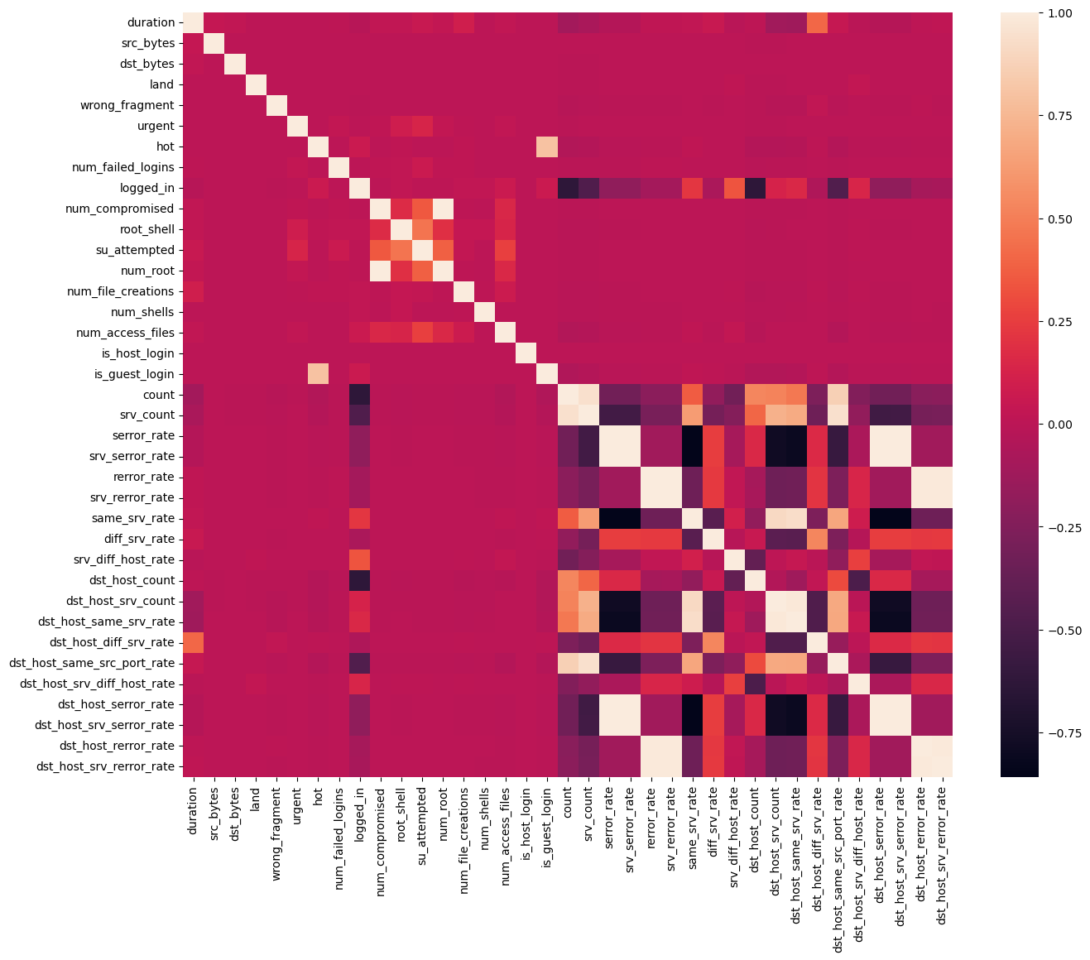

*Fig, 2.2 KDD99 Heatmap*

1. Intrusion Detection System by Machine Learning

The common packets which are filtered by Firewall are almost safe from regular intrusions and regular web traffic. The firewall may be a hardware firewall or else a software-based firewall to filter the packets. All the data together come to the HUB and are broadcasted to every device. A smart attacker can sense the use or any other mode of packet sniffing, and even the intruder can modify or destroy log files and reports generated by the Honeypot Server, but the use of Hub makes it look like a natural device used for connecting devices. The possibility of identifying IoT devices is very high because of the vulnerable software running in them. All the data is monitored by software or hardware in the Honeypot server. The figure 2.3 explains well as a block diagram.

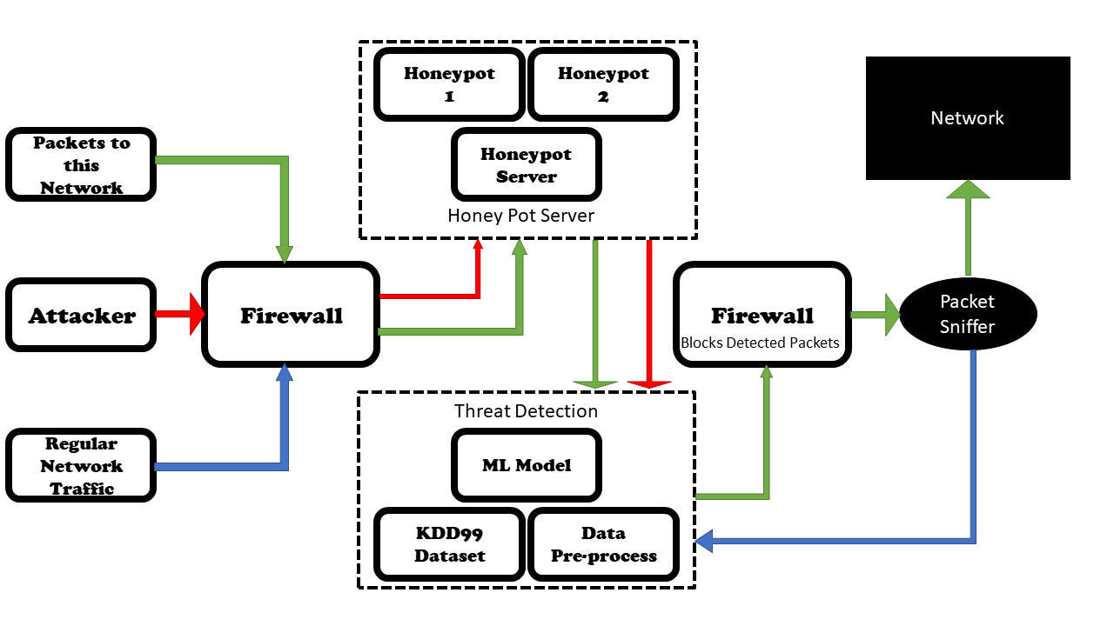

*Fig, 2.3 Block diagram*

Honeypot Server is the main part that determines whether the packets are safe or not. It analyses every single packet in detail and gives predictions using Machine Learning Algorithm. Every machine learning model has its specific type of processing method. Every classifier has its working algorithms. As the desired output is a prediction of type “intruder” or “Normal” type, a proper machine learning model is to be selected for the required output. A set of ML classifiers are taken to test the dataset. The dataset is having a label column which is suitable for supervised machine-learning algorithms. The machine learning algorithms used are Gaussian Naive Bayes, Decision Tree, Random Forest, Gradient Boosting, Extreme Gradient Boosting, Generative adversarial network, Linear Regression, Logistic Regression, Long Short-Term Memory, and Deep Belief Network.

1. Threat Detection

Different Machine Learning algorithms are used to determine whether the connection is good or it is an intruder. The data from the honeypot is analysed well by the Machine Learning model which has about 42 features used for prediction. There are tested using various Machine Learning models such as Gaussian Naive Bayes, Decision Tree, Random Forest, Gradient Boosting, Extreme Gradient Boosting, Generative adversarial network, Linear Regression, Logistic Regression, Long Short-Term Memory, and Deep Belief Network as mentioned above. The one which is suitable for intrusion detection gives a high accuracy value and the high accuracy model is selected for the detection.

Generative Adversarial Networks (GANs) are a class of deep learning algorithms used to generate new and synthetic data by pitting two neural networks against each other in a zero-sum game framework. There are two main components: a generator and a discriminator. The generator takes a random noise vector as input and maps it to an output that is meant to resemble the target data distribution. The discriminator takes in both real samples from the target data distribution and fake samples generated by the generator and tries to distinguish between the two, they are trained in an adversarial manner, generator creating samples that are realistic to the discriminator, the discriminator tries to classify the samples as either real or fake. Over time, the generator improves its ability to create realistic samples, and the discriminator improves its ability to identify fake samples.

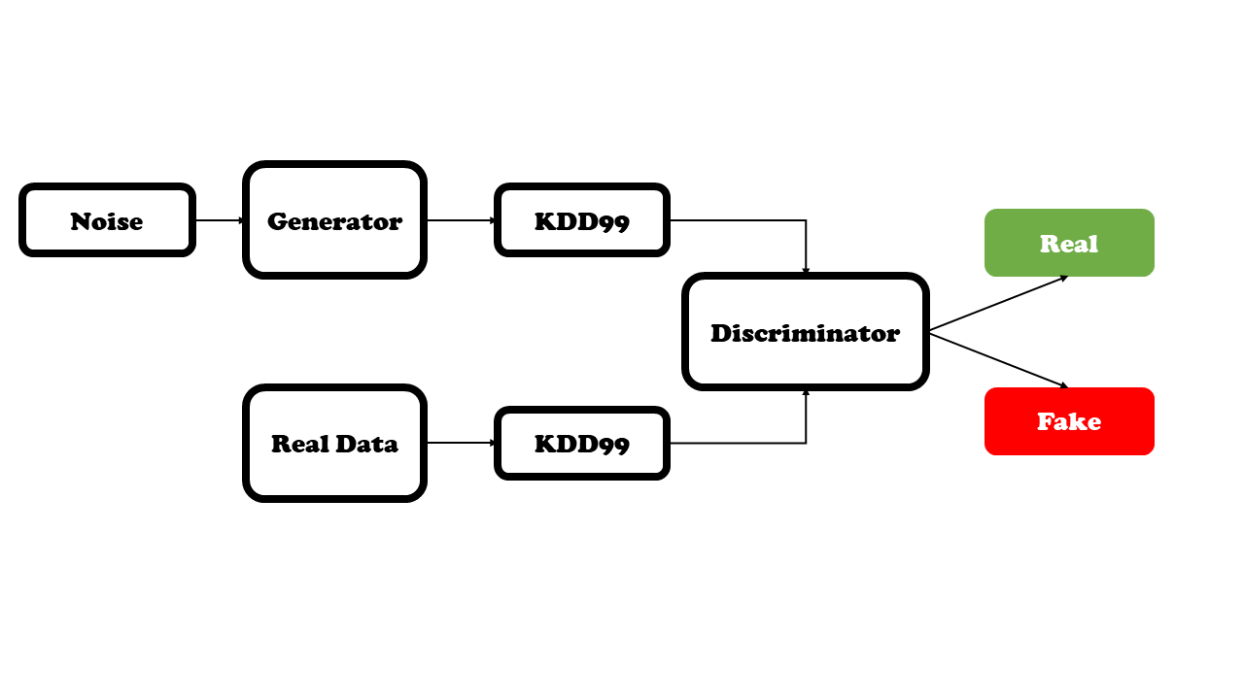

*Fig, 2.4 GAN Block Diagram*

Since all the classifiers perform well for the used dataset, we need to consider some other factors as the prediction is used for security purposes and threat detection. The dataset has 48,98,430 columns and 42 Rows with different features. As the predictions are used in security and threat detection applications, we need to take care more of the input dataset. Generative Adversarial Networks can be used if their accuracy is good enough compared to other classifiers.

III. Results

Realtime Honeypots capture intruders by various methods and the data required for the prediction is generated by it. As a whole, it is passed to the various Machine Learning models to get its performance and accuracy. Test and train time is also considerable for power-efficient working.

The Decision Tree algorithm shows a test accuracy of 99.62% and a training time of 10.85s. The Linear Regression algorithm shows a test accuracy of 97.75% and a training time of 5.99s. The Gaussian Naive Bayes algorithm shows a test accuracy of 93.21% and a training time of 3.74s. The Logistic Regression algorithm shows a test accuracy of 1.41% and a training time of 376.92s. The Random Forest algorithm shows a test accuracy of 99.92% and a training time of 495.71s. The Gradient Boosting algorithm shows a test accuracy of 95.94% and a training time of 6372.18s. The Extreme Gradient Boosting algorithm shows a test accuracy of 98.93% and a training time of 443.02s. The Long Short-Term Memory algorithm shows a test accuracy of 97.87% and a training time of 7966.02s. The Deep Belief Networks algorithm shows a test accuracy of 79.84% and a training time of 819.10s. The Generative Adversarial Networks algorithm shows a test accuracy of 99.99% and a training time of 130.02s. The table 3.1 shows the results of all the classifiers and its training time with testing accuracy of each.

|  |  |  |
| --- | --- | --- |
| **Classifier** | **Test Accuracy** | **Training Time** |
| Decision Tree | 0.9962 | 10.846 |
| Linear Regression | 0.9775 | 5.988 |
| Navie Bayes | 0.9321 | 3.739 |
| Logistic Regression | 0.0141 | 376.921 |
| Random Forest | 0.9992 | 495.712 |
| Gradient Boost | 0.9594 | 6372.185 |
| XG Boost | 0.9893 | 443.016 |
| LSTM | 0.9787 | 7966.016 |
| Deep BN | 0.7984 | 819.102 |
| GAN | 0.9999 | 130.016 |

*Table, 3.1 Classifiers Performance*

|  |  |  |  |
| --- | --- | --- | --- |
| **Epoch** | **Discriminator Loss** | **Generator Loss** | **Accuracy** |
| 1 | 38.05141 | 0.689847 | 42.19 |
| 100 | 0.131214 | 1.496475 | 100 |
| 200 | 0.096201 | 1.761345 | 100 |
| 300 | 0.025205 | 3.041839 | 100 |
| 400 | 0.011418 | 3.800014 | 100 |
| 500 | 0.005777 | 4.490452 | 100 |
| 600 | 0.00349 | 4.992599 | 100 |
| 700 | 0.002289 | 5.401649 | 100 |
| 800 | 0.001711 | 5.725489 | 100 |
| 900 | 0.001114 | 6.107335 | 100 |
| 1000 | 0.000896 | 6.343067 | 100 |

*Table, 3.2 GAN Results*

The graph 3.1 and 3.2 specifies the testing accuracy and the training time of the different classifiers as bar graph. In testing accuracy, Logistic Regression has performed the least and almost all other classifiers scores more than 80. The bar graph says more about the training time required by all the classifiers.

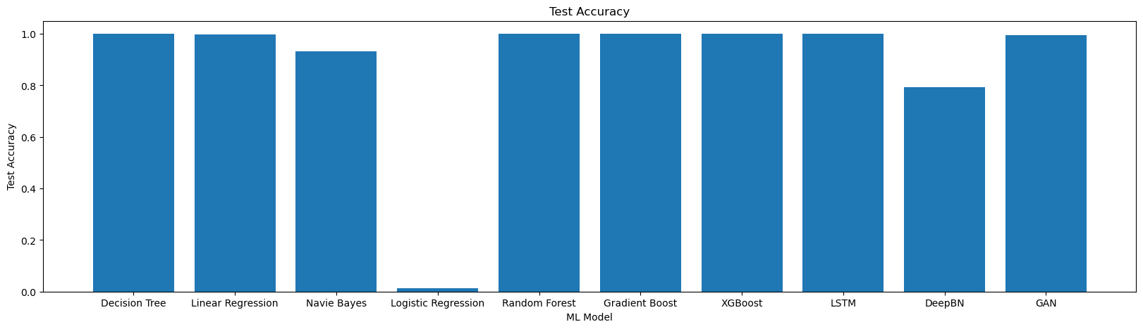

*Fig, 3.1 Testing Accuracy*

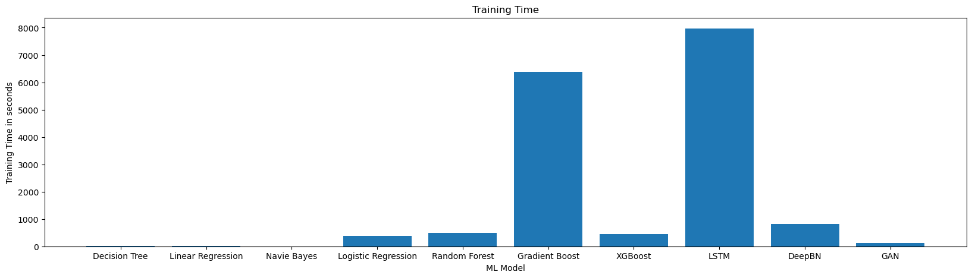

*Fig, 3.2 Training Time (in seconds)*

IV. Conclusions

The use of Generative Adversarial Networks is used for intrusion detection. The maximum-performing algorithm exists but it is limited by the size of the dataset. Since Generative Adversarial Networks are trained using synthetically generated values, their prediction and accuracy are still high. Other models have been trained with just the input dataset of size 48,98,430 columns. The GAN gives accurate results, compared to all other algorithms GAN is trained with a high number of inputs with about 1000 epochs. The use of network design is to reduce the regular traffic and to catch the attackers. Future research should verify the new methods of attackers and include more features for advanced attacks.

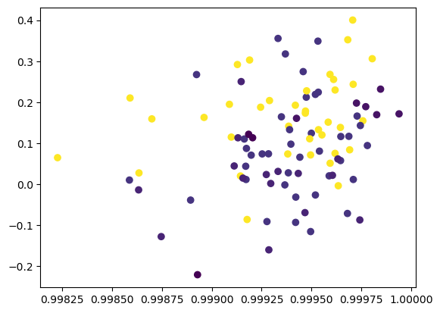*Fig, 4.1 GAN Generated Data 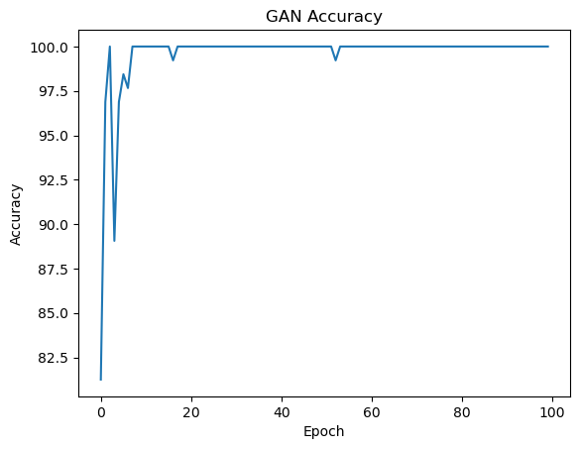Fig, 4.2 GAN Accuracy*

The Generative Adversarial Network gives the most accurate result for the KDD99 dataset with almost more accuracy that, most of the accuracy plot in the graph falls within 1 and 0.99825 as shown in the figure 4.1 and figure 4.2. Since synthetic data is used to train it, it is more accurate than any classifiers used for the same dataset. Thus, Generative adversarial network has been selected for the Intrusion Detection System.

References

1. Mr. Mohit Tiwari, Raj Kumar, Akash Bharti, Jai Kishan (2017) Intrusion Detection System, International Journal of Technical Research and Applications e-ISSN: 2320-8163.
2. Gozde Karatas, Onder Demir, Ozgur Koray Sahingoz, "Deep Learning in Intrusion Detection Systems", *2018 International Congress on Big Data, Deep Learning and Fighting Cyber Terrorism (IBIGDELFT)*, pp.113-116, 2018.
3. Nilesh Kunhare, Ritu Tiwari, "Study of the Attributes using Four Class Labels on KDD99 and NSL-KDD Datasets with Machine Learning Techniques", *2018 8th International Conference on Communication Systems and Network Technologies (CSNT)*, pp.127-131, 2018.
4. Basant Subba, "A Neural Network based NIDS framework for intrusion detection in contemporary network traffic", *2019 IEEE International Conference on Advanced Networks and Telecommunications Systems (ANTS)*, pp.1-6, 2019.
5. Mridula Sharma, Haytham Elmiligi, Fayez Gebali, Abhishek Verma, "Simulating Attacks for RPL and Generating Multi-class Dataset for Supervised Machine Learning", *2019 IEEE 10th Annual Information Technology, Electronics and Mobile Communication Conference (IEMCON)*, pp.0020-0026, 2019.
6. Sun N, Zhang J, Rimba P, Gao S, Zhang LY, Xiang Y, Data-driven cybersecurity incident prediction: A survey, IEEE Commun. Surv. Tutor. 21 (2) 1744–1772 (2019)
7. Akshat Divya, Anchit Bhushan, Nihal Anand, Rishabh Khemka, Sumithra Devi K.A.H (2020) HONEYPOT: Intrusion Detection System. International Journal of Education, Science, Technology, Engineering vol. 3, no. 1, pp. 13-18, June 2020.
8. Husak M, Bartos V, Sokol P, Gajdos A, Predictive methods in cyber defense: Current experience and research 43 challenges, Future Generation Computer Systems, Volume 115, 517-530 (2021)
9. Philip Wester, Fredrik Heiding, Robert Lagerström, "Anomaly-based Intrusion Detection using Tree Augmented Naive Bayes", *2021 IEEE 25th International Enterprise Distributed Object Computing Workshop (EDOCW)*, pp.112-121, 2021.
10. Ritu Bala, Ritu Nagpal, "Intrusion Detection Based on Decision Tree Using Key Attributes of Network Traffic", *Applications of Artificial Intelligence and Machine Learning*, vol.778, pp.583, 2021.
11. Aakash Singh, Parth Kitawat, Shubham Kejriwal, Swapnali Kurhade, "Intrusion Detection System Using Homomorphic Encryption", *Intelligent Data Communication Technologies and Internet of Things*, vol.101, pp.505, 2022.
12. Bo-Xiang Wang, Jiann-Liang Chen (2022): An AI-Powered Network Threat Detection System Doi 10.1109/ACCESS.2022.3175886
13. Ruizhe Zhao, Yingxue Mu, Long Zou, Xiumei Wen, "A Hybrid Intrusion Detection System Based on Feature Selection and Weighted Stacking Classifier", *IEEE Access*, vol.10, pp.71414-71426, 2022.
14. Zebin, Tahmina; Rezvy, Shahadate; Luo, Yuan (2022): An Explainable AI-based Intrusion Detection System for DNS over HTTPS (DoH) Attacks. TechRxiv. Preprint.