A2CPS Release 3.0 Notes - Imaging

Key Changes in 3.0
- Additional subjects: this release includes all A2CPS subjects who had surgery on or before Feb 28, 2025. There are a total of 1935 subjects (1364 TKA and 530 Thoracic), of whom 1417 have pre-surgery (V1) imaging (1103 TKA, 314 Thoracic)
Table of Contents
Key Changes in 3.0 1
1. Summary of Imaging Data 2
Data Collection 2
Key points 2
Data Derivatives 2
Data Contents 3
2. Summary of Site Information 4
3. Quality Measures and Ratings 6
Raw Data 6
Derived Data 7
Phantom QA Data 7
4. fMRI Protocol Issues 8
fMRI Slice Packets 8
B0 Distortion Correction Scans 9
5. DWI Protocol Issues 10
DWI Protocol Variations 10
GE Specific DICOM Problems 10
6. T1W Protocol Issues 11
7. Acquisition Issues 12
8. Incomplete Scan Sessions 12
9. Release Changes 13
Release 3.0 13
Release 2.1 13
Release 2.0 13
Release 1.1 14
10. References 14
11. Frequently Asked Questions (FAQ) 15
This release is an A2CPS Consortium Internal Release. For public releases of this dataset, refer to NIH NDA project 5121 (see https://a2cps.org/researchers/accessing-our-data/).
This document provides background and commentary on the release, and is an interim product bundled with internal releases. The final destination for the information herein is the A2CPS “For Researchers” web page (apart from consortium specific notes, e.g. related to Confluence, Slack, etc.).

1. Summary of Imaging Data

Data Collection
MRI scans were collected prior to a surgery (knee or thoracic) and, in roughly half of all cases, again 3 months post surgery. In Releases 1 and 2, only pre-surgery scan data is included.
The scan protocol consists of T1-weighted (1), diffusion weighted (1), and fMRI (4) scans, with susceptibility distortion correction B0 images also acquired. A schematic of the acquisition is shown in Figure 1.
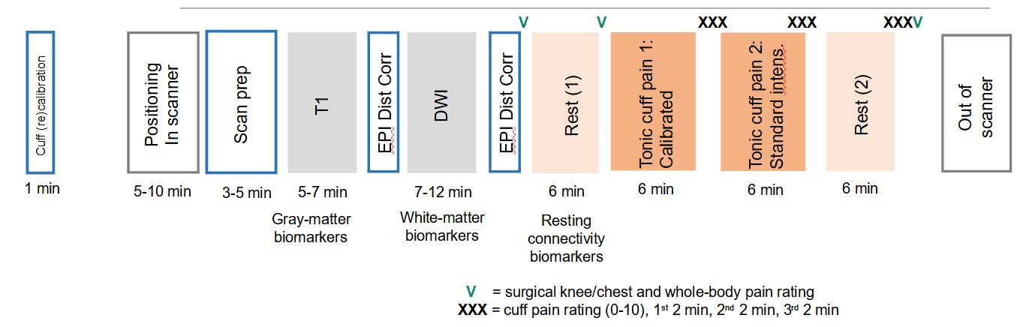
Figure 1: A2CPS scan session layout. The short names of the scans are T1, DWI, REST1, CUFF1, CUFF2, and REST2.

Key points
- An inflatable cuff was placed on the subject’s leg prior to the fMRI scans
- CUFF scans were done with administration of pain via a constant pressure – though in some cases CUFF scans were skipped if cuff inflation or the required pressure were contraindicated
- CUFF1 scans use a patient-calibrated constant pressure (to level rated as pain 40), and CUFF2 pressures are standard (120 mm Hg); pressures are recorded in BIDS events.tsv files for Cuff scans
- In most cases, REST2 was not acquired if neither CUFF scan was, though there are exceptions (these exceptions are flagged as “Red” – see Assigned Quality Ratings)

Data Derivatives
This release includes results of an A2CPS Pipeline that consists of several standard tools, as well as custom processing:
- Individual pipeline outputs (MRIQC, fMRIPrep, CAT12, FreeSurfer)
  - fMRIPrep 24.0.1 results
  - FreeSurfer 7 (run by fMRIPrep 24.0.1)
  - CAT12 v12.9/r2556
  - MRIQC 24.0.2
  - QSIprep 0.21.4
  - brainageR 2.1
  - GIFT 4.0.5.0 with NeuroMark 2.0/2.1
- FSL FIRST volumes and label maps (FSL 6.0.6.5)
- Functional images with nuisance regression applied (custom)
- Connectivity matrices (custom)
- Pain signature responses (custom)
Data derivatives only appear in this release if the entire A2CPS pipeline completed on all available scans. This is meant to ensure that no incomplete products or cases without a complete set of expected derivatives will be included. See also “Incomplete Scan Sessions” below for notes on unavailable scans for some sessions.

Data Contents
Where currently available, links to Starter Kits corresponding to each directory are provided.

Top level: /corral-secure/projects/A2CPS/products/consortium-data/pre-surgery-release-2-1-0

Main directories:
- /imaging
  - Imaging CRFs from REDCap, in /raw and /reformatted versions
  - Info: https://a2cps.github.io/starterkits/ImagingCRF_data_quality_checks_and_reformat.html
- /mris
  - Imaging data, and (internal releases only) this "Release Notes" document

MRI contents:
- /mris/rawdata
  - BIDS format scan data, across all sites, limited to pre-surgery ("ses-V1")
  - Info: https://a2cps.github.io/starterkits/raw-mri.html
- /mris/derivatives
  - Images derived using A2CPS pipelines

MRI derivative contents:
- /mris/derivatives/bedpostx
  - FSL BEDPOSTX results for estimating fibre orientations (DWI)
- /mris/derivatives/brainager
  - Products of brain age estimation pipeline (T1w)
  - Info: https://a2cps.github.io/starterkits/brainager.html
- /mris/derivatives/cat12
  - Products of CAT12, the Computational Anatomy Toolkit (T1w)
  - Info: https://a2cps.github.io/starterkits/cat12.html
- /mris/derivatives/dwi_biomarker1
  - Primary biomarker measuring structural connectivity (DWI)
- /mris/derivatives/eddyqc
  - Products of eddyqc, an automated quality control tool (DWI)
- /mris/derivatives/eddyqc_nodenoise
  - Products of eddyqc using QSIprep data with denoising steps skipped (DWI)
- /mris/derivatives/fcn
  - Functional connectivity products (fMRI)
  - Info: https://a2cps.github.io/starterkits/fcn.html
- /mris/derivatives/fmriprep
  - Products of fMRIPrep (fMRI, T1w)
- /mris/derivatives/freesurfer
  - Iimage and tabular outputs from the FreeSurfer pipeline (T1w)
  - Info: https://a2cps.github.io/starterkits/freesurfer.html
- /mris/derivatives/fslanat
  - Products of the FSLanat pipeline (T1w)
- /mris/derivatives/gift
  - Independent component analysis (ICA) products from GIFT/NeuroMark (fMRI)
- /mris/derivatives/mriqc
  - Products of the MRIQC automated quality control pipeline (T1w, fMRI, DWI)
- /mris/derivatives/postdtifit
  - Measures derived from FSL dtifit outputs, e.g. FA and MD regional values (DWI)
- /mris/derivatives/postgift:
  - Measures derived from GIFT/NeuroMark outputs, such as amplitudes (fMRI)
- /mris/derivatives/qc
  - Database of results from manual reviews of derivative quality (T1w, fMRI, DWI)
- /mris/derivatives/qsiprep-V1
  - Products of the QSIprep pipeline (DWI)
- /mris/derivatives/qsiprep_nodenoise-V1
  - Products of the QSIprep pipeline with denoising steps skipped (DWI)
- /mris/derivatives/qsirecon_fsl_dtifit
  - Results from FSL’s ‘dtifit’ on QSIrecon processed data (DWI)
- /mris/derivatives/signatures
  - Pain signatures calculated with Neural Pain Signature (fMRI)
  - Info: https://a2cps.github.io/starterkits/neural-pain-signatures.html
- /mris/derivatives/synthstrip
  - Skull stripping results from the SynthStrip tool (T1w)

2. Summary of Site Information
Table 1: Scanners by site. Notes: RU began acquisition in 2024. WS switched scanners in September 2024. Some scanners have been upgraded over the course of the study.
Group | Site | Manufacturer | Model | Bore | Gradients | Latest Version
MCC1 | UI: U. Illinois Chicago (UIC) | GE | Discovery 3T MR750 | 60cm | 50/200 | MR30.1_R04_2421.a
MCC1 | NS: Endeavor Health | Siemens | Skyra_fit | 70cm | 45/200 | syngo MR E11 (VE11C)
MCC1 | UC: U. Chicago | Philips | Ingenia dStream | 70cm | 80/200 | 5.6.1.0
MCC1 | RU: Rush University | Siemens | Prisma | 60cm | 80/200 | XA30A
MCC2 | UM: U. Michigan | GE | Discovery 3T MR750 | 60cm | 50/200 | LX1.MR30.1_R01_2322.c
MCC2 | UM: U. Michigan | GE | Signa UHP | 60 cm | 100/200 | MR30
MCC2 | WS: Wayne State | Siemens | Verio | 70cm | 45/200 | syngo MR B17
MCC2 | WS: Wayne State | Siemens | Cima.X | 60cm | 200/200 | XA61
MCC2 | SH: Corewell Health/MSU - Grand Rapids | Siemens | Prisma | 60cm | 80/200 | XA60
Gradients: Maximum mT/m amplitude and T/m/s slew rate
Corewell Health began the study as Spectrum Health, and thus has the designation “SH”, and likewise Endeavor Health began as “NorthShore”.
Table 2: Headcoils and multiband implementations by site.
Group | Site | Head Coil | Multiband
MCC1 | UI | Nova Medical 32ch | ABCD
MCC1 | NS | 64ch | MGH
MCC1 | UC | Philips 32ch dStream | Philips product sequence
MCC1 | RU | 64ch | CMRR
MCC2 | UM | 32ch | ABCD
MCC2 | WS | 32ch | CMRR
MCC2 | SH | 64ch | Siemens product sequence
Site specific imaging protocols were adapted from the ABCD study's published imaging protocol (https://abcdstudy.org/images/Protocol_Imaging_Sequences.pdf) and at some sites ABCD sequences were available and used. Most sites follow ABCD’s T1w, DWI, and fMRI specification exactly, but fMRI and DWI protocols required alternate parameters on older scanners. Specific sequence parameter information is available in the BIDS .json files for each scan.
Table 3: Scanner serial numbers.
Group | Site | Serial Number
MCC1 | UI | 000000312996MR3T
MCC1 | NS | 70032
MCC1 | UC | 71399
MCC1 | RU | 166295
MCC2 | UM1 | 000000000UM750MR
MCC2 | UM2 | 0007347633TMRFIX
MCC2 | WS (old) | 40292
MCC2 | WS (new) | 213020
MCC2 | SH | 66022
Scanner serial numbers are the intended way to distinguish sites and scanners. They are found in BIDS “sessions” files.
Note that internally the Imaging CRF in REDCap uses codes “1” and “2” for the “Scanner Name” field to refer to what are designated “UM2” and “UM1” here, respectively.

3. Quality Measures and Ratings
Through all releases, including this one, a quality rating scheme has been applied to all raw data except DWI (ratings assignment for DWI data is expected in the next release). In this release, we have introduced an initial trial of quality guidance on some key aspects of derivative outputs (such as masks).

Raw Data
To facilitate monitoring of the success of image acquisitions across sites and to aid in recording problematic cases, we devised a simple “traffic light” rating scheme that is used to assign images a color code:
- Green: no known issues
- Yellow: minor variations/issues; may be correctable
- Red: significant variations/issues; not expected to be comparable
Note that these ratings were designed to indicate the presence and severity of data issues and are not necessarily recommendations for inclusion/exclusion decisions. For example,
- a Red rating does not mean that data are unusable, but simply that a scan has been judged to be different from other scans of its type in a non-correctable way (this can be relatively minor; e.g., if the scan was truncated, even if only by a few TRs, it will be coded Red)
- Yellow scans should always be used with caution as their variations may be of different types, and some may make them undesirable for some purposes
- a Green scan simply indicates a lack of the issues flagged by our specific QC procedures – but, of course, some analyses may be susceptible to issues overlooked by those procedures
We expect that a final decision on the usability of scans will always need to be made by experimenters using a more detailed assessment in comparison to the actual needs of a specific analysis, and we therefore caution against taking these quality assessments as final usability evaluations. That said, we expect that many analyses will be able to use all green and yellow scans.

Derived Data
No significant issues are known to affect the outputs of any of the A2CPS imaging derivative pipelines, and in the event of pipeline failures for any reason on individual cases, those results are omitted unless they can be corrected.
In this release, an initial set of quality ratings is provided for the derived data. These ratings are the result of manual reviews of the images, and are relatively “raw”, in that they have not been summarized with a traffic light scheme. Currently, there are two kinds of ratings: local and global. The local ratings pinpoint specific spatial regions of a derivative that exhibit issues (e.g., areas where a mask is not placed correctly, or an estimated surface is misaligned). The global ratings are used in cases where the local ratings are not meaningful and correspond to an overall judgement about whether the target was generated correctly (e.g., whether a coregistration was successful).
- MRIPrep Masks (local)
- fMRIPrep T1w Spatial Normalization (local)
- FreeSurfer Surface Localization (local)
- fMRIPrep Fieldmap<->functional coregistration (global)
- Diffusion Tensor Fitting (global)
The database containing results can be found in the ‘qc’ directory (see Data Contents).

Phantom QA Data
In the next release, we plan to include data collected under the MCC1 phantom QA protocol, which was run on all MCC1 scanners as well as most of those at MCC2 (excluding UM). See the following figure for the scan sessions that are available. An anticipated use of this phantom data is the generation of measures of long term trends in scanners (e.g. for scanner aging and seasonal variations that occur due to factors like ambient temperature and humidity), which may be useful for certain analyses.
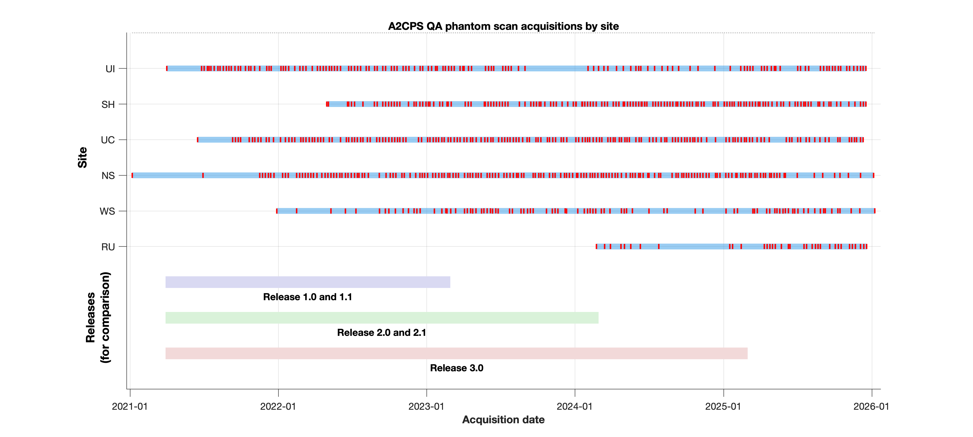Figure 2: A2CPS QA phantom sessions by site code, with surgery date ranges of releases for comparison.

4. fMRI Protocol Issues
There were compromises needed to run the ABCD protocol successfully on some scanners.
MCC1/NS fMRI scans have a TE of 32 ms, versus 30 ms in the ABCD protocol.
MCC1/UC fMRI scans use a reconstruction matrix of 96x96, versus 90x90 in the ABCD protocol, and an FOV of 213 instead of the 216 specified. This results in a voxel resolution of 2.22 x 2.22 x 2.4 mm instead of the target 2.4 mm isotropic resolution. The acquisition matrix is set to 88x89, which does result in a 2.4 mm isotropic acquisition voxel size. Variations were required because Philips scanners cannot set arbitrary in-plane matrix size on reconstructed EPI images.
The number of slices for both MCC1/NS and MCC1/UC fMRI scans is 54 versus 60 in the ABCD protocol, which means that coverage is 10% less than in the ABCD protocol (54 x 2.4 = 129.6 mm versus 144 mm in ABCD).

fMRI Slice Packets
In principle, when using a multiband acquisition with the most basic sequential ordering of slices care should be taken in choosing the number of slices in relation to the multiband acceleration factor, as some choices can result in spatially adjacent slices being excited in rapid succession, leading to slice cross talk (Barth et al. 2016). In practice, since this issue was highlighted, individual vendors have developed slice ordering strategies that avoid this issue, and although the ABCD fMRI sequence used in A2CPS is in theory susceptible to this issue, we have found no evidence of signal loss in the slices identified as potentially vulnerable. See the document A2CPS fMRI Slice Packets for further notes on this issue and how it applies to ABCD/A2CPS scans.

B0 Distortion Correction Scans
The A2CPS project uses the (Holland et al. 2010) method of acquiring spin echo images with opposite phase encoding direction and using them to construct fieldmaps for susceptibility distortion correction.
The ABCD protocol followed by A2CPS does not specify what should be done for distortion correction, though it is possible that ABCD sites are following unpublished advice on this.
In common practice, B0 scans for constructing fieldmaps match the geometry of the target scans (the ones to be distortion corrected) by matching field of view, acquisition matrix, and shimming. In some cases in A2CPS, the geometry will be slightly different.
The target ABCD FMRI protocol specifies the following: 90x90, 2.4x2.4x2.4, FOV 216x216.
- The NS Siemens fMRI B0 (“GE_EPI_B0”) matches this, as does its fMRI, except that the number of slices is different (60 for AP/PA GE_EPI_B0, vs. 54 for fMRI). The number of fMRI slices was reduced to allow the scanner to match the other details of the ABCD protocol, and this had the side effect of mitigating slice packet issues (see fMRI Slice Packets section).
- The UC Philips fMRI B0 has a different setup for both fMRi and B0: 96x96, 2.2x2.2x2.4, implying FOV of 213x213.
- The UIC GE fMRI B0 is different from fMRI: 128x128, 1.69x1.69x2.4, implying FOV of 216x216. This setup also has other differences, as explained in the next section.

GE B0 Scans
The GE setup is different from other sites in that AP and PA are not separate acquisitions. The single "FMRI_B0" scan packs AP and PA spin echo scans together with a front-back flip on alternate brains with order AP-PA-AP-PA. The GE "DWI_B0", in contrast, has 8 images in the same orientation (no front/back flip), of which only the first two have the desired b=0 (the other six have b=3000). This is because a 6 direction DWI with one phase encoding direction had to be used as it was not possible to collect unweighted images only with opposite phase encoding.
The intention is that the two b=0 images (phase encoding PA) should be combined with the b=0 images from the A2CPS DWI (phase encoding AP) to create a fieldmap. Accordingly, we build "DWI_B0_PA" and "DWI_B0_AP" images to match the other scanners:
DWI_B0_PA is the first 2 volumes (determined from the bvals) of the acquired DWI_B0 image
DWI_B0_AP is a copy of the first 2 volumes (determined from the bvals) of the acquired dwi image
For both the UIC FMRI_B0 and the UIC DWI_B0, the BIDS JSON files are adjusted to ensure opposite phase encoding directions are recorded properly.
When GE v. 28 and v. 29 acquisitions were acquired for the UM site, a slightly different setup from UIC was used that resulted in the same output data. Specifically, an opposite phase DWI is acquired as part of the DWI acquisition and exported as a DWI derived series, matching the DWI_B0 for UIC GE scans.

5. DWI Protocol Issues

DWI Protocol Variations
The DWI matrix dimensions per the ABCD protocol that A2CPS adopted are 140x140, with FOV of 240x240 and resulting 1.7 mm isotropic voxel dimensions. In practice the Philips setup (UChicago) has a matrix of 144x144 and all sites deviate slightly on voxel dimensions (1.67x1.67x1.70 for Philips, 1.71x1.71.x1.70 for GE/Siemens).
The number of b=0 volumes used for GE scanners was increased by two in the ABCD protocol in an update for scanner version DV26, resulting in 104 volumes total (versus 102 at other sites).
All scanners have DWI B0 scans with dimensions corresponding to the DWIs.

GE Specific DICOM Problems
Incorrect DWI information was stored in DWI sequences in GE software versions up to DV26 (this seemingly was improved in DV27 and finally corrected in DV28). Thus we do not have the ability to automatically extract the right information from MCC1/UIC scans, and must rely on the assumption of correct b-values and b-vectors.
GE engineers worked with dcm2niix’s team to improve the dcm2niix handling of GE DWI DICOMs. The version of dcm2niix used for this data should be the Fall 2021 release or later to benefit from these improvements.

MCC1/UC b-Value Variations
UC DWI “b=0” images actually have very low but nonzero b-values (e.g. 0.01). This appears to be a Philips encoding decision to support custom gradient tables. Tools like QSIprep (used in the A2CPS imaging pipeline) handle this kind of variation by treating everything below a given threshold as b=0 (by default --b0-threshold is set to 100: see https://qsiprep.readthedocs.io/en/latest/usage.html#workflow-configuration).

MCC2/WS b-Value Variations
The b-values on the MCC2/WS Wayne State Siemens Verio scanner have an imprecision of about 0.5% in many of the values relative to the MCC1/NS NorthShore values, from which they were set using a Siemens b-matrix file. For example, the first ten NorthShore b-values are
0 3000 3000 2000 3000 1000 3000 3000 2000 3000
and the corresponding values as recorded at Wayne State become
5 2995 3000 2000 2995 1000 2995 3005 1995 3000
This is believed to be a rounding issue – the Siemens b-matrix format encodes each bvec as a unit vector scaled according to b-value. This was judged to be an acceptable variation. Though the examples here have deviations of at most 5, the maximum deviation that has been seen is 15 on b=3000.

MCC2/SH b-Vector Variations
The b-vectors from MCC2/SH Corewell Health (formerly Spectrum Health) do not match the MCC1/NS Endeavor Health (formerly NorthShore) reference values. Also, the SH setup has 103 volumes vs. 102 at NS (SH has two b=0 volumes at the start vs. one at NS).
First 5 bvecs (SH), including initial b=0 volumes:
0 0 -0.3563 -0.9345 -0.1869
0 0 -0.6561 -0.2721 0.9566
0 0 0.6653 0.2293 -0.2234
Corresponding first 5 bvecs from NS:
0 0.3563 0.9346 0.1869 0.1108
0 0.6563 0.2722 -0.9565 -0.1193
0 0.6651 0.2290 -0.2238 0.9867
Both NS and SH use versions of the ABCD fMRI sequences, but they are believed to differ in version. The alternate vectors would be geometrically equivalent, and will not affect processing if as intended individual bvec/bval files are always used for each scan.

MCC2/WS b-Vector Variations
The b-vectors from the MCC2/WS Wayne State Siemens Verio scanner do not match the MCC1/NS NorthShore values, from which they were set using a Siemens b-matrix file. The first five vectors are as follows at Northshore,
0 0.3563 0.9346 0.1869 0.1108
0 0.6563 0.2722 -0.9565 -0.1193
0 0.6651 0.2290 -0.2238 0.9867
and at Wayne State,
0 0.6555 0.2720 -0.9571 -0.1188
0 0.3559 0.9342 0.1870 0.1107
0 -0.6661 -0.2306 0.2214 -0.9867
The Siemens vector input file is interpreted differently by the two scanners so that (x, y, z) at NorthShore becomes (y, x, -z) at WSU. The spatial coverage is identical. (Note that in the WSU case, there will be the appearance of 6 extra vectors because the "b=0" images, which have (0,0,0) vectors in the NorthShore case, are assigned actual vectors due to having b=5 in the WSU setup due to the previous issue above.)

6. T1W Protocol Issues
The ABCD protocol document specifies a TR of 2500 ms for the T1 scan on GE scanners. Despite this, and despite the fact that UIC reports they are running ABCD study sequences unmodified, the UIC TR = 6.952 ms for T1 scans.

7. Acquisition Issues
In rare cases, individual runs can be affected by a variety of issues. For details of known issues and specific scans they affect, please see the A2CPS Confluence page on “Problem Cases” (https://a2cps.atlassian.net/wiki/spaces/DOC/pages/5406735/Imaging+Log+-+Problem+Cases); currently version 119 (11-Aug-2025) as of this release. Notable issues listed there included
- Occasional mis-acquisition of PA scans on Siemens due to an interface issue.
- Changes to the partial Fourier fraction (PFF) setting
- Interruption of scan session, resulting in subject repositioning before resumption.
- Truncated scans (these are also flagged with a Red quality rating).
There were also a few issues worth noting that occurred during the initial setup period (first 100 scans, through August 2021).
- Face masking was not initially recorded on an individual basis (this begin in Fall 2021). Prior to that, in some cases the information on Confluence on site policies during this period will provide sufficient information to infer mask use.
- There are a small number of “pressureless cuff” scans. These are instances of the CUFF1 and CUFF2 scans with no inflation applied, and can be identified by checking the events.tsv files of Cuff scans for “applied_pressure” values of 0.
- In very early scans, prior to protocol clarification there might have been instances in which “pressureless cuff” or “cuff contraindicated” subjects were run without the cuff deployed.

8. Incomplete Scan Sessions
In some cases, scan sessions were terminated early, usually at the request of the research participant, resulting in an incomplete set of scans. In rare cases, technical issues such as scan reconstruction failure on the scanner also reduced scan availability.
The following are notes on specific cases of particular interest:
- There are several cases in which only the T1w scan (the first in the session) is available: 10005, 10245, 10553, 20311, and 15001.
- There are two cases in which no T1w scan is available: 10205, a reconstruction failure on the scanner, and 25012, a case where severe dental artifact led to the T1w not being saved. These scans will appear in the BIDS dataset but not in the derivatives, since all A2CPS pipelines require T1w images.
- There are a small number of cases with REST2 but no Cuff scans, violating the "pain bracketing" expectation for Rest scans. These have been flagged as “Red” quality to distinguish them as incomparable to other REST2 scans.
Note that imaging products are included in each release only if the A2CPS pipeline completed successfully – thus, there may sometimes be cases for which BIDS data exists but no products are yet available.

9. Release Changes
These are details related to derivatives that are release-specific. Note that the BIDS dataset also includes a CHANGES file with information on changes to the imaging dataset (though not its derivatives). See the sections below for Release 3.0 changes relative to Release 2.1, as well as earlier changes relative to each prior releases.

Release 3.0
- Manual QC review data is now available

Release 2.1
- DTI products are calculated on each shell of the multishell DWI data, as well as on the complete multishell data
- An additional skull stripping step is no longer performed on the various pipeline outputs derived from T1-weighted images (or on the T1w images in BIDS)
- Biomarker updates: gray matter density (secondary biomarker 68)

Release 2.0
- Several pipelines have been upgraded. For changes associated with these updates, please seem the pipeline documentation.
  - fMRIPrep: 20.2.x LTS → 24.0.1
  - FreeSurfer: 6 → 7
  - CAT12: 12.8.1 (r2042) → 12.9 (r2556)
  - MRIQC: 0.15.1 → 24.0.2
  - Functional Connectivity: A2CPS Pipeline 1.0/1.1 → A2CPS Pipeline 2.0
  - MRI Signatures: A2CPS Pipeline 1.0/1.1 → A2CPS Pipeline 2.0
- In addition, outputs that are downstream from these upgraded pipelines have been rerun
  - GIFT: 4.0.5.0/NeuroMark 2.x
- Subject 10478 withdrew from the study. Although the subject did not request removal of collected data, there were enough omissions in baseline demographic information that it was judged best to omit this ID from the Release 2 freeze list.
- In Release 1, UC100491V1’s CUFF1 scan is truncated (20% size). Prior to Release 2.0, a review identified a full replacement CUFF1 scan that was not initially processed because of a scan labeling issue. As of Release 2.0, this replacement scan is included (both rawdata and Derivatives).
- No longer providing multiple copies of minimally preprocessed anatomical results, as produced by fmriprep
  - Previously, rfMRI and tfMRI scans were processed by fmriprep separately from the anatomical scans, and each produced a set of minimally preprocessed anatomical files. As of Release 2, fmriprep is run once per participant, resulting in a single set of preprocessed anatomical scans
- Improved masking in fMRIPrep
  - The default masking routine for fMRIPrep has been replaced with mri_synthstrip
- In fMRIPrep processing, bold-anat coregistration has been reduced from 9 → 6
- New output spaces are included in fMRIPrep. The current list is
  - MNI152NLin2009cAsym:res-native
  - MNI152NLin2009cAsym:res-2
  - MNI152NLin6Asym:res-native
  - MNI152NLin6Asym:res-2
  - space-fsLR_den-91k
- Parcellated timeseries from functional connectivity now included
- GIFT processing is now performed on CUFF data

Release 1.1
- Documentation improvements (these Release Notes have been added, and the BIDS README.MD has updated contents)
- Updates in BIDS (InstitutionName now fixed for all scans from a site, "scanner" column now moved from participants.tsv to scans.tsv, and other additions to scans.tsv)
- Changes and additions in derivatives (principally, the addition of processed diffusion MRI data and standardized ICA results for fMRI from the NeuroMark package)
- New “Frequently Asked Questions” (see end of this document)

10. References
[Barth et al. 2016] Barth M, Breuer F, Koopmans PJ, Norris DG, and Poser BA. Simultaneous multislice (SMS) techniques. Magn Reson Med 2016 Jan; 75(1):63-81. [doi: 10.1002/mrm.25897]
[Casey et al. 2018] B.J. Casey, Tariq Cannonier, May I. Conley, Alexandra O. Cohen, Deanna M. Barch, Mary M. Heitzeg, Mary E. Soules, Theresa Teslovich, Danielle V. Dellarco, Hugh Garavan, Catherine A. Orr, Tor D. Wager, Marie T. Banich, Nicole K. Speer, Matthew T. Sutherland, Michael C. Riedel, Anthony S. Dick, James M. Bjork, Kathleen M. Thomas, Bader Chaarani, Margie H. Mejia, Donald J. Hagler, M. Daniela Cornejo, Chelsea S. Sicat, Michael P. Harms, Nico U.F. Dosenbach, Monica Rosenberg, Eric Earl, Hauke Bartsch, Richard Watts, Jonathan R. Polimeni, Joshua M. Kuperman, Damien A. Fair, Anders M. Dale, The Adolescent Brain Cognitive Development (ABCD) study: Imaging acquisition across 21 sites, Developmental Cognitive Neuroscience, Vol 32, 2018, pg 43-54, ISSN 1878-9293. https://doi.org/10.1016/j.dcn.2018.03.001. (https://www.sciencedirect.com/science/article/pii/S1878929317301214)
[Holland et al. 2010] Dominic Holland, Joshua M. Kuperman, Anders M. Dale, Efficient correction of inhomogeneous static magnetic field-induced distortion in Echo Planar Imaging, NeuroImage, Vol 50, Issue 1, 2010, pg 175-183, ISSN 1053-8119, https://doi.org/10.1016/j.neuroimage.2009.11.044. (https://www.sciencedirect.com/science/article/pii/S1053811909012294)
[Setsompop et al. 2012] Setsompop K, Cohen‐Adad J, Gagoski BA, Raij T, Yendiki A, Keil B, Wedeen VJ, Wald LL. Improving diffusion MRI using simultaneous multi‐slice echo planar imaging. Neuroimage 2012;63:569–580. [PMC free article]

11. Frequently Asked Questions (FAQ)
This section may duplicate other material – it exists to give simple, concise answers.

Q1. What is the plan for releases?
A1. Major releases (such as 1.0 and 2.0) define the pool of subjects for subsequent minor releases. Minor releases (such as 1.1) add to, or change, derivatives and documentation, and bug fix releases (e.g. x.y.1), if they become necessary, will provide faster updates in the event issues requiring correction are detected. We anticipate yearly major releases.

Q2. Each release is described as including subjects based on a date interval for surgeries, but I noticed a subject included/omitted in a release had a surgery that should have excluded/included them. Is this expected?
A2. Each release is based on a master participant list that is intended to include all A2CPS participants who had surgery by a cutoff date, and which is frozen after an initial review period. Due to later corrections in record keeping for surgery dates, in rare cases subjects can end up included or omitted from a release list in contradiction to their actual surgery date. The master freeze lists can be found at https://github.com/a2cps/DataFreeeze.

Q3. I noticed that a subject in Release 1 is not in Release 2. Shouldn’t releases be cumulative?
A3. Although releases are generally cumulative, there are special cases where participants that appeared one release may be excluded from subsequent ones. For example, participants may request to have their data withdrawn from the study. For a list of expected cases, see 9. Release Changes.

Q4. What other documentation of A2CPS imaging is available?
A4. The ongoing documentation of the A2CPS project has been carried out on the A2CPS Confluence website (https://a2cps.atlassian.net/), with imaging related information found specifically under the Imaging space. Please contact support@a2cps.org or your site PI to get access if you do not yet have it. One particularly useful section for users of A2CPS releases is the “Starter Kits”: https://a2cps.github.io/starterkits/.

Q5. How can I determine surgery type/cohort for a scan?
A5. The surgery type (knee or thoracic) is encoded in the second digit of the A2CPS ID, but must be interpreted in conjunction with the site group (MCC) where the scan occurred. See the README for more details.

Q6. How do I download the data?
A6. Several options exist. First, there are multiple access options.
- Access through the Data Portal (this is the easiest to try first unless you know you prefer one of the others, but may not be suited for some large scale downloads) – see separate “How do I access the Data Portal” item
- Access through the secure.corral.tacc.utexas.edu server (this would allow rsync/SFTP type access, and is usually the best option for large scale downloads once you know what you want)
- Access via Frontera (this TACC server allows SSH access via login8.frontera.tacc.utexas.edu, and you can submit jobs via Slurm to run there, if you want to process within TACC)
- Access via Tapis (this would do processing on TACC, using apps controlled under the Tapis APIs; the DIRC runs processing this way, and can offer some setup help if you want this option)
Second, there are several versions of the dataset, which are located at TACC below the /corral-secure/projects/A2CPS/products/consortium-data directory:
- The full dataset (pre-surgery)
- The MRI dataset part (mris)
- The BIDS dataset (mris/bids)
- The derivatives (mris/derivatives/[pipeline])
For most purposes, the mris/bids dataset is likely of interest to most imaging users – this is a "curated" version of the MRI data in the rawest available form, converted to NIfTI and formatted according to the BIDS specification.
The folder pre-surgery always contains the latest release. Older releases are available underneath the consortium-data directory, as zip archives. For example, the first release is /corral-secure/projects/A2CPS/products/consortium-data/pre-surgery-release-1-0-0.zip.
Downloading of all contents is a significant undertaking, and so users are encouraged to (a) consider doing data processing on TACC (using Jupyter, R, and MATLAB notebooks available through the portal, or using Slurm jobs) and (b) target downloads to specific contents.

Q7. What are the “rawdata” and “Derivatives” folders in the imaging portion of the release? Which should I download?
A7. Both these folders have contents of potential interest and usefulness. Refer to the BIDS standard (see Key Points and the link to the BIDS standard there) for an explanation of why these particular terms are used.
The “rawdata” is the raw DICOM data converted to NIfTI format and a layout under the BIDS standard, so this is the data you'd use for any processing “from scratch”. The "Derivatives" are results derived from the raw data by various components of the A2CPS pipeline, including biomarkers and other end results you could analyze directly (e.g., cortical thickness or regional connectivity values) and also other products that would be useful as inputs for further analysis (ICA components of fMRI, various preprocessed files for fMRI, DWI, and T1w scans — such as realignments to standard spaces — and so on).
See the Data Contents section for a list of the top level folders that exist.

Q8. How do I access the A2CPS Data Portal?
A8. You must first have a TACC account (see the A2CPS Confluence page https://a2cps.atlassian.net/wiki/spaces/DAS/pages/5080604/How+do+I+get+added+to+the+A2CPS+Intranet).
When this is completed, there is a one time requirement to “push keys” to enable portal access: you would log in to the portal, choose “push keys” to your “My Data” system and then to the “Community Data” system, in the process giving your MFA token when prompted on login and when pushing keys.
The Data Portal is ideal for “browsing” the data, and also supports analysis via Jupyter, R, and MATLAB notebooks. For some limited multi-file downloads you can use the “compress” option to create an archive (see Figure 2 – the option for “Compress” appears when multiple qualifying files are selected), though this is not a viable option for more than a few items. For bulk downloads, e.g. of data for all subjects, refer to the alternatives mentioned above in an earlier FAQ item.
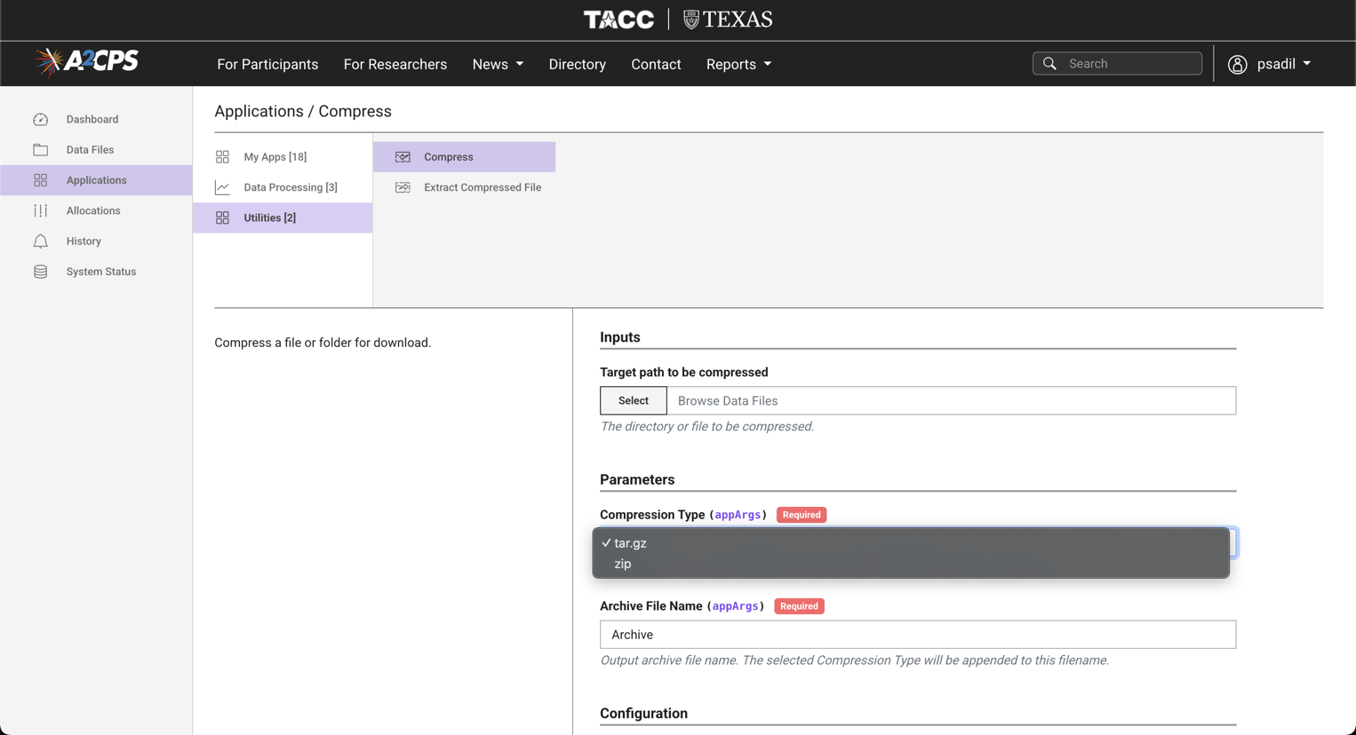
Figure 3: Data Portal interface showing the "Compress" option.

Q9. I have questions about the dataset, or feedback (e.g. identified issues or requests for specific outputs). Is there a contact address?
A9. All problem reports, questions, and feedback can be sent to the A2CPS DIRC imaging group, a2cps-dirc-report-imaging@a2cps.org or to the #help-imaging channel in the A2CPS Slack workspace.
Siemens
Reference site: MCC1/Northshore, Alternate: MCC2/Wayne State
 | Matrix | Slices | FOV | % FOV phase | Resolution (mm) | TR (ms) | TE (ms) | TI (ms) | Flip Angle (deg) | Parallel Imaging | MultiBand Acceleration | Phase partial Fourier
T1 | 256x256 | 176 | 256x256 | 100% | 1.0x1.0x1.0 | 2500 | 2.84 | 1060 | 8 | 2x | Off | Off
Diffusion | 140x140 | 81 | 240x240 | 100% | 1.7x1.7x1.7 | 8000/5500 | 105/112 | N/A | 90 | Off | 3 | 6/8 (both)
fMRI | 90x90 | 54/60 | 216x216 | 100% | 2.4x2.4x2.4 | 800 | 30/32 | N/A | 52 | Off | 6 | Off

Philips
Reference site: U of Chicago
 | Matrix | Slices | FOV | % FOV phase | Resolution (mm) | TR (ms) | TE (ms) | TI (ms) | Flip Angle (deg) | Parallel Imaging | MultiBand Acceleration | Half Scan Factor
T1 | 256x240 acq, 256x256 rec | 225 | 256x240 | 93.75% | 1.0x1.0x1.0 | 6.66 | 3.0 | 1060 | 8 | 2x1 | Off | N/A
Diffusion | 140x141 acq, 144x144 rec | 81 | 240x240 | 100% | 1.67x1.67x1.7 | 8093.6 | 103 | N/A | 78 | Off | 3 | 0.6
fMRI | 88x89 | 54* | 216x216 | 100% | 2.22x2.22x2.4 | 800 | 30 | N/A | 52 | Off | 6 | 0.9

GE
Reference site: UIC
 | Matrix | Slices | FOV | % FOV phase | Resolution (mm) | TR (ms) | TE (ms) | TI (ms) | Flip Angle (deg) | Parallel Imaging | MultiBand Acceleration | Phase partial Fourier
T1 | 256x256 | 208 | 256x256 | 100% | 1.0x1.0x1.0 | 6.952 | 2.92 | 1060 | 8 | 2x | Off | Off
Diffusion | 140x140 | 81 | 240x240 | 100% | 1.7x1.7x1.7 | 4100 | 81.7 | N/A | 90 | Off | 3 | 5.5/8
fMRI | 90x90 | 60 | 216x216 | 100% | 2.4x2.4x2.4 | 800 | 30 | N/A | 52 | Off | 6 | Off

Diffusion Weight Imaging (all platforms)

Diffusion directions: 96
b-values: 500 (6-dirs) 1000 (15-dirs) 2000 (15-dirs) 3000 (60-dirs)

https://abcdstudy.org/wp-content/uploads/2021/05/ABCD_Website_MRI_Acq.pdf
See “Site Specific Information”, https://a2cps.atlassian.net/wiki/spaces/DOC/pages/5406782/Site+Specific+Information

