E-commerce application
ESTORE

Technical Solution Description
by Andrei Sidorov

Saint-Petersburg 2019
Contents

1. Overview 3
2. List of used technologies 3
3. Additional features 3
4. Database scheme 4
5. Application modules 5
6. UI description 5
7. Business logic 5
8. Entities and DAO 6
9. Application screenshots 7
10. Unit tests 14
11. Sonar report 19
12. Ideas for further development 19
1. Overview

ESTORE is an e-commerce web application for companies that sells electrical equipment to end consumers. It implements B2C model and allows customers to buy products via the Internet from a company who, in turn, integrates the application in its business process providing all necessary information of their products in the application. The main goal of this web application is to provide effective sale process between a company and its clients. The application is designed for clients and managers of a company: clients can view products, and buy them, managers can add and edit products, see reports and control the selling process.

2. List of used technologies

Java SE/EE 8
Maven 3.1.0
WilfFly 16.0.0
Spring Framework 5.1.5.RELEASE
Hibernate 5.4.1.Final
MySQL 5.7
ActiveMQ 5.15.8
Opencsv 4.5
iText PDF 5.5.13
Apache Log4j
JUnit 5.4.0
Mockito 2.23.0
H2 database 1.4.198
JSP
CSS
JavaScript

3. Additional features

Dynamic product attributes. Product attributes and their values can be created, edited or deleted by the managers of a company. Therefore, a company may add and sell various types of products.
Dynamic product filter. Dynamically created product attributes and their values are processed into the product filter that may be applied during the product search.
Order reservation. Before check out, products get reserved for a specified time to allow customers be sure that their orders will be completely fulfilled after the payment process is finished.
Automatically generated invoices. After a purchase is complete, the invoice is generated with all information and sent to the buyer’s email.
Multiple user addresses. Users may have many addresses and choose one during the check out process.
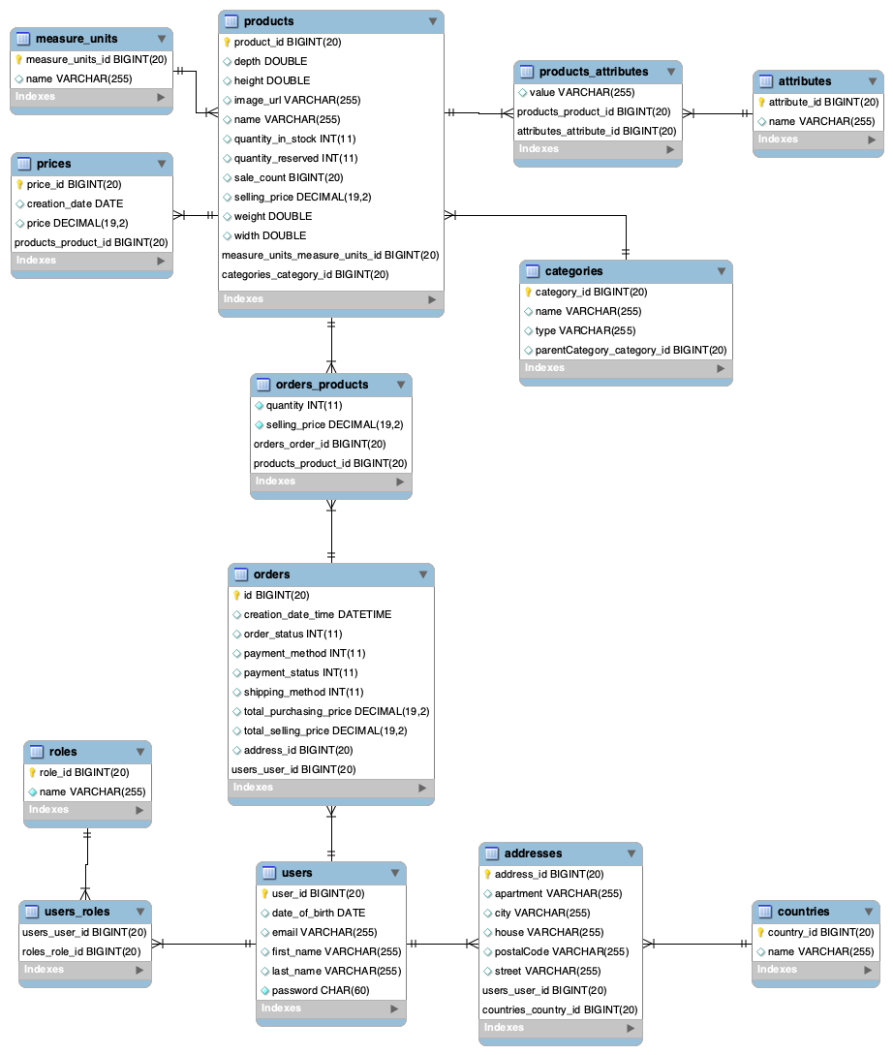
4. Database scheme
5. Application modules

There are two modules in the application: ESTORE is a main application and BILLBOARD is an application whose sole purpose is to display top-selling-products of the main application. The interaction between applications is implemented via JMS and REST. Initially BILLBOARD requests data at REST endpoint ‘/api/top-products’ of ESTORE. When there is a change in the list of top products, ESTORE sends updated data to BILLBOARD via JMS.

6. UI description

The ESTORE Web UI offers an easy to use web experience. The main template for all pages consists of a top navigation bar with links to all main pages, a page content and a footer with information about a company. Also an additional left side bar appears at some pages.
Main pages:
Page ‘Home’ is the first page of the application. It displays products and allows users search through them using different filters such as the category tree, the search bar and the attribute filter. All these filters can be used simultaneously.
Page ‘Order’ is essentially a shopping cart.
Page ‘Orders’ displays users’ orders and provides filtering and sorting by tables columns.
Page ‘Profile’ displays user information and provides an easy editing that allows to make changes and commit or discard them.
All pages use JSP, JavaScript and CSS.

7. Business logic

All business logic is positioned in the service layer of the application and contains following services.
AttributeService manages product attributes.
CategoryService manages product categories.
CountryService manages countries that used in the address model.
EmailService is responsible for sending email to users.
JmsService is responsible for sending messages via JMS.
MeasureUnitsService manages product measure units.
OrderService manages orders.
PaymentService is responsible for payment transactions.
PdfService is responsible for generating invoices for orders.
ProductService manages products.
RoleService manages user roles such as ADMIN, MANAGER and CLIENT.
UserService manages user accounts.

8. Entities and DAO

Address entity represents a user address and has following attributes: country, a city name, a postal code, a street name, a house number, an apartment number.
Country entity represents a country and has single attribute the name of a country.
Attribute entity represents a product attribute and has single attribute an attribute name.
Category entity represents a product category and has attributes: a category name, a parent category, sub-categories and a category type. The last three are used for displaying categories as a tree structure.
MeasureUnits entity represents the units of measurement for products and has single attribute the name of units.
Order entity represents an order and has following attributes: the data and time of creation, a payment method, a shipping method, a payment status, an order status, the total selling price of the product in an order, a total buying price of the product in an order, a user who made an order, an address where to deliver products.
OrderProduct entity is an intermediate entity between the order entity and the product entity and has following attributes: an order, a product, the quantity of a product, the selling price of a product.
Price entity represents a price and has following attributes: a creation date, the value of a price. This entity keeps track of the purchasing prices of a product.
Product entity represents a product and has following attributes: the name of a product, a selling price, a category, a weight, a height, a width, a depth, the available quantity in stock, a reserved quantity, the units of measurement, an image url, a sale count.
ProductAttribute entity is an intermediate entity between the product and its attributes.
Role entity represents user roles such as CLIENT, MANAGER and ADMINISTRATOR.
User entity represents a user and has attributes: first name, last name, email, date of birth and password.

This application uses declarative transaction management.

9. Application schreenshots

Main page

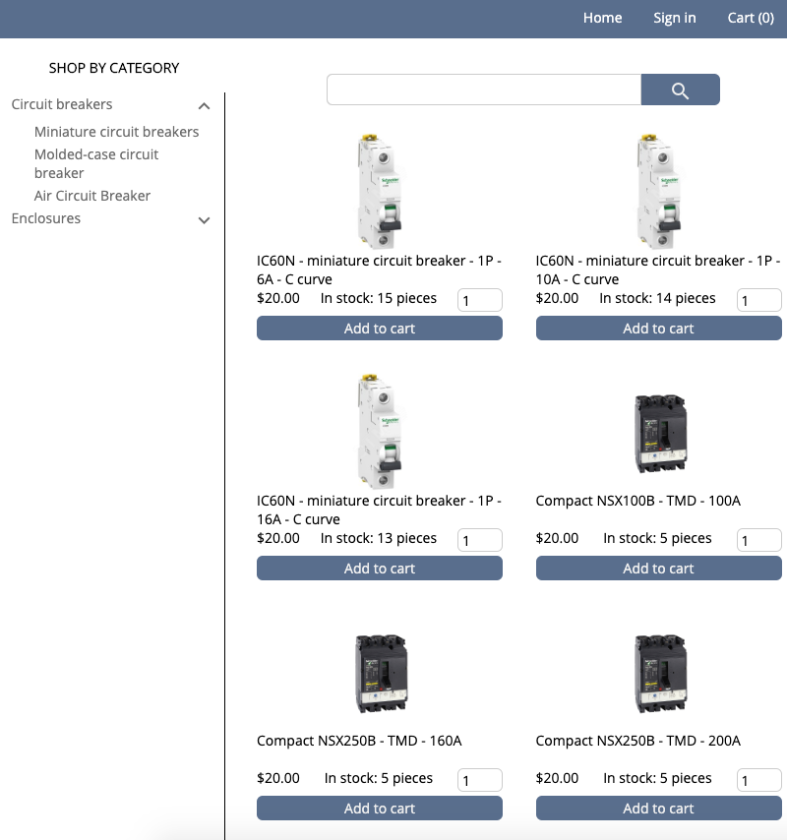
User-profile page

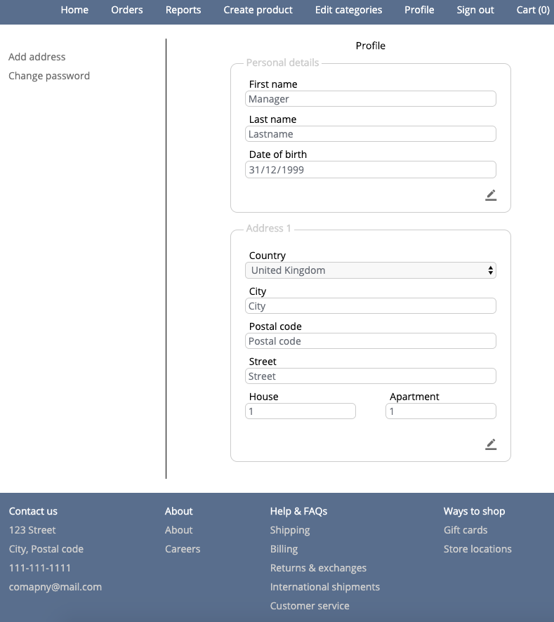

Shopping cart

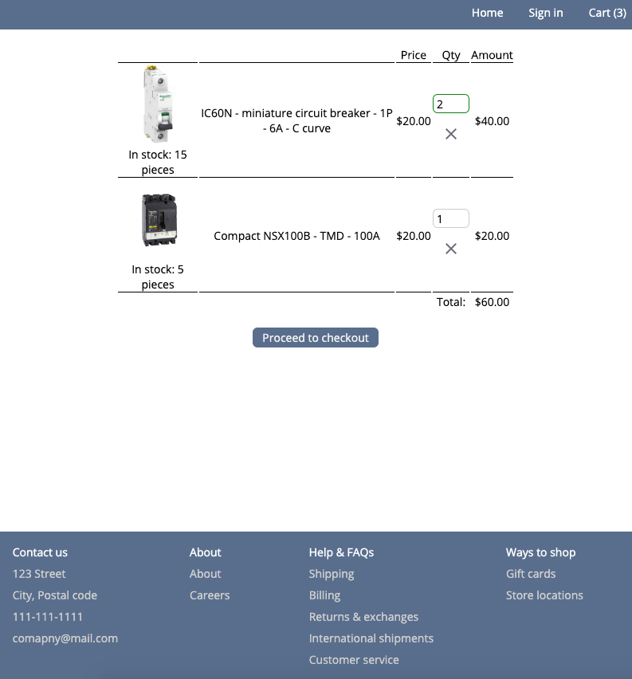
Checkout page

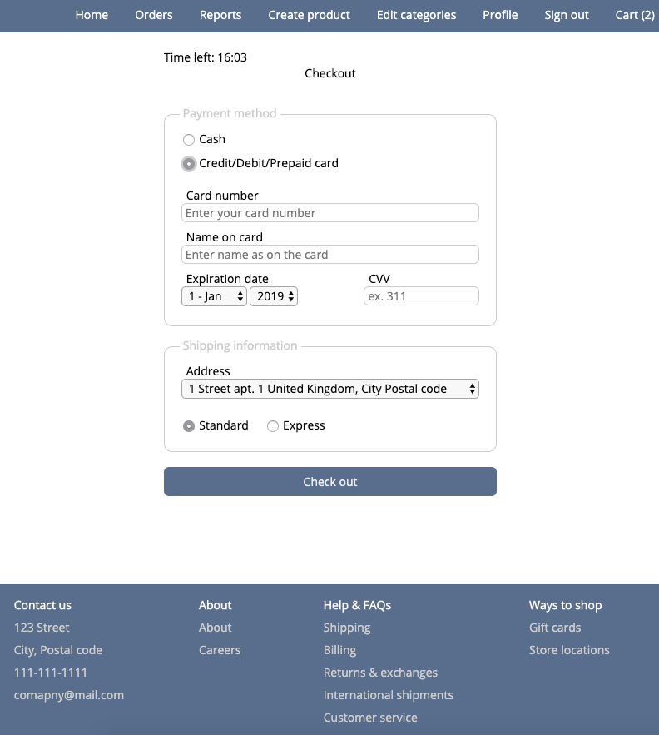
My-orders page

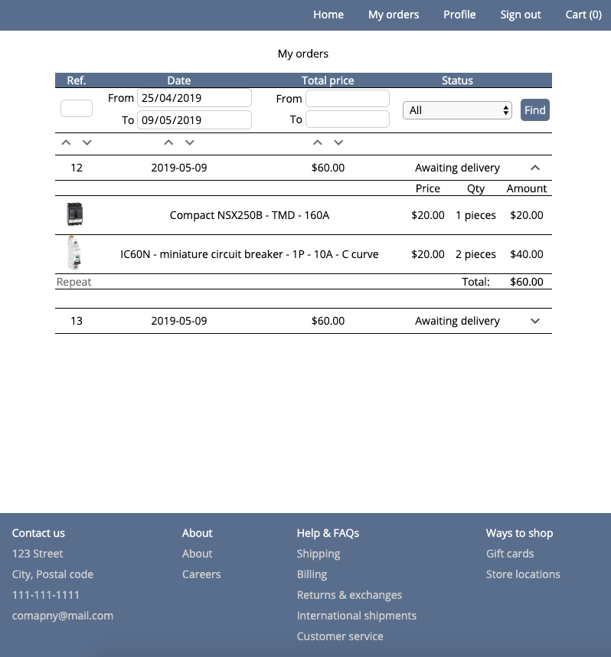
Edit-categories page

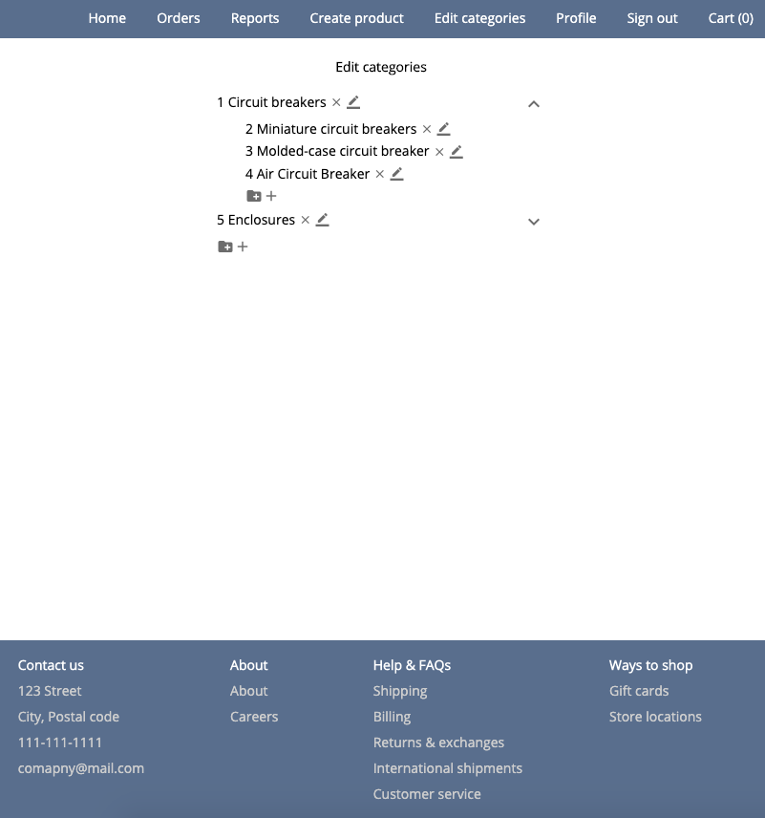
Create-product page

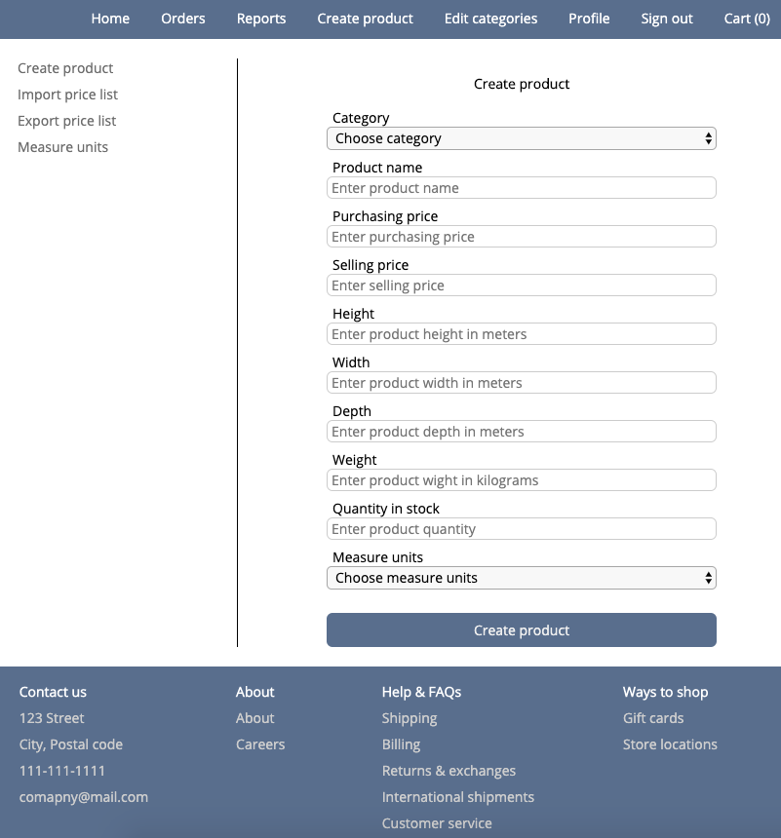
10. Unit tests

Testing AttributeService
Testing getAttributeValues method
when there are equal attribute values then they are merged and returned
passed
when the second argument is a list of categories' ids then the overloaded method is called
AttributesWithValues method
when this method is called then attributes of products of a specified category are returned
Testing updateAttributes method
when this method is called then the values of a product's attributes are updated
Testing getAllProductAttributes method
when this method is called then method attrbiuteDao.getAllProductAttributes() is called
Testing save method
when an attribute does exist then an attrbute and a ProductAttribute are created and saved
when an attribute exists then only a ProductAttribute is created and saved

Testing CategoryService
Testing getSubCategoriesIds method
when this method is called then the all ids of all sub-categories are returned
Testing renameCategory method
when this method is called then a category gets renamed
Testing deleteCategory method
when a category has no products then this category gets deleted
when a category has products then exception CategoryDeleteException gets thrown
when a category is a folder that has no sub-categories then method productDao.getProductsByCategoriesIds is not called
Testing getTopLevelCategories method
when this method is called then methodcategoryDao.getTopLevelCategories gets called
Testing findById method
when this method is called then method categoryDao.findById gets called
Testing getAllCategories method
when this method is called then method categoryDao.getAllCategories gets called
Testing save method
when this method is called then category is created and saved

4 Testing CountryService
Testing getAllCountries method
when this method is called then method countryDao.getAllCountries() gets called
Testing findById method
when this method is called then method countryDao.findById() gets called

Testing JmsService
Testing send method
when this method is called then the top-selling products are sent
Testing MeasureUnitsService
Testing findById method
when this method is called then method measureUnitsDao.findById() gets called
Testing getAllMeasureUnits method
when this method is called then method measureUnitsDao.getAllMeasureUnits() gets called
Testing save method
when this method is called then new measure units are created and saved

Testing OrderService
Testing getWeeklyRevenues method
when a start date is not before an end date then exception TimePeriodException is thrown
when this method is called then the list of weekly revenues are returned
Testing getMonthlyRevenues method
when this method is called then the list of monthly revenues are returned
when a start date is not before an end date then exception TimePeriodException is thrown
Testing updateOrderStatus method
when this method is called then an order's status gets updated
Testing getOrderProducts method
when this method is called then method orderDao.getOrderProducts gets called
Testing findById method
when this method is called then method method orderDao.findById gets called
Testing findOrdersByCriteria method
when this method called then method OrderDao.findOrdersByCriteria gets called
Testing save method
when this method is called then an order gets saved

Testing PdfService
Testing createInvoice method
when this method is called then a pdf file with an invoice is created

Testing ProductService
Testing deleteProductAttribute method
when this method id called then method productDao.deleteAttribute is called
Testing processPriceListFile method
when a product has no id then this product gets saved
when a product has id then this product gets updated
when one of the values is invalid then exception PriceListException is thrown
when one of the values is missing then exception PriceListException is thrown
Testing createPriceListFile method
when this method is called then a price list file is created
Testing getTopSellingProducts method
when this method is called then top selling products are returned
when there are products with sale count zero then they are ingnored
Testing searchByCriteria method
when criteria have the empty input and the empty category id then method productDao.findByPartialName is called
when criteria have only a partial name then products are searched by this partial name
when criteria have a partial name and a category id then products are searched by the partial name and the category id
when criteria have a partial name and a category id of type folder then products are searched by the partial name and the all sub-categories of the category
when attributes and values of a product match searched criteria then this product gets returned
when attributes and values of a product do not match searched criteria then this product gets ignored
when criteria have a product attribute with value 'All' then all products with this attribute are returned
Testing update method
when a dto has a new price then the price of a product is updated
when a dto has the same price as the current price of a product then the price of this product is not updated
when a dto has a new product name then the name of a product is updated
Testing buyProducts method
when this method is called then products get bought
Testing unreserveProduct method
when this method is called then products get unreserved
Testing reserveProducts method
when an available quantity for each product is equal or greater than required then all products get reserved
when an available quantity for one of the products is less than required then none of the products get reserved
Testing getProductsByCategory method
when a category has type folder then the all products of sub-categories are returned
when a category has type category then products of this category are returned
Testing getAllProducts method
when products are found then products are returned
when products are not found then empty list is returned
Testing save method
when this method is called then a product is saved
Testing findById method
when a product is found then this product is returned
when a product is not found then null is returned

Testing RoleService
Testing findByName method
when this method is called then methid roleDao.findByName() gets called
Testing save method
when this method is called then method roleDao.save() gets called

Testing UserService
Testing loadUserByUsername method
when a user is found then this user is returned
when a user is not found then exception UsernameNotFoundException is thrown
Testing getTopClients method
when this method is called then the list of top clients is returned, limited to a specified number
when clients have no purchases then those clients are ignored
when there are no clients then an empty list is returned
Testing updateUserDetails method
when this method is called then a user's details are updated
Testing removeUserAddress method
when this method is called then an address is removed
Testing updateUserAddress method
when this method is called then an address is updated
Testing addUserAddress method
when this method is called then a new address is added
Testing changePassword method
when this method is called then a password is changed
Testing checkIfOldPasswordValid method
when a password is valid then true is returned
when a password is invalid then false is returned
Testing findByEmail method
when a user is found then this user is returned
when a user is not found then null is returned
Testing save method
when this method is called then a user is created and saved

11. Sonar report
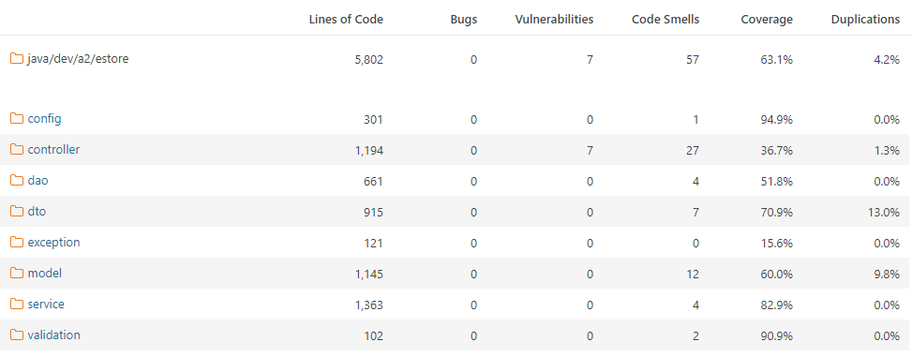

12. Ideas for further development
First of all, UI might be adapted for tablet and mobile screens. This is essential as more and more users prefer portable devices to shop online.
Secondly, add more technical information about products, it might be pdf pages from a manufacture’s catalogue uploaded to each product.
Next is to provide coupling between products and their accessories for their easy selection.

