Power Supply

Input

Poti

Notes
- The caps are a good idea. You might try putting a small one between the slider and ground.
- Setting REFS0 uses AVCC as the reference. I would set both REFS1 and REFS0 to zero and connect the top of the pot to AREF.
- Two fixed resistors is a good idea to rule out the pot's as the problem.
- Atmel recommends a max of 10K source impedance for 10 bit accuracy. A cap can help with this if the impedance is higher than 10K.10k impedance is what you would get when a 40k pot is in the middle position - 20k to VCC and 20k to GND makes 10k.
- So if you use pots lower than 40k in value, you might not need the caps.

Encoder

Schematic
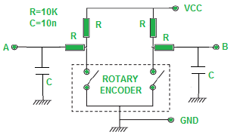
https://www.electroschematics.com/rotary-encoder-arduino/
with Hardware denoising.
But We will try without and go with software denoising
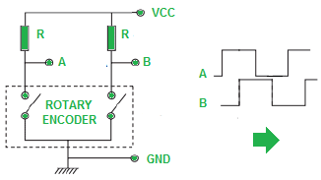

Buttons

LEDs

TPIC6C595 (LED driver)

Notes
- https://www.ti.com/lit/ds/symlink/tpic6c595.pdf?HQS=dis-mous-null-mousermode-dsf-pf-null-wwe&ts=1638055290255&ref_url=https%253A%252F%252Fwww.mouser.ph%252F

Overview
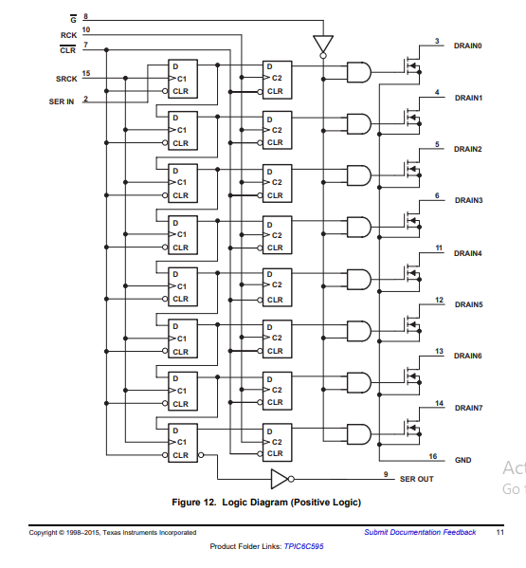

Serial-In Interface
This device contains an 8-bit serial-in, parallel-out shift register that feeds an 8-bit D-type storage register. Data transfers through both the shift and storage registers on the rising edge of the shift register clock (SRCK) and the register clock (RCK), respectively. The storage register transfers data to the output buffer when shift register clear (CLR) is high.

Clear Register
A logical low on (CLR) clears all registers in the device. TI suggests clearing the device during power up or initialization.

Output Control
Holding the output enable (G) high holds all data in the output buffers low, and all drain outputs are off. Holding (G) low makes data from the storage register transparent to the output buffers. When data in the output buffers is low, the DMOS transistor outputs are off. When data is high, the DMOS transistor outputs have sink-current capability. This pin can also be used for global PWM dimming.

Cascaded Application
The serial output (SER OUT) allows for cascading of the data from the shift register to additional devices. Connect the device (SEROUT) pin to the next device (SERIN) for daisy Chain.

Daisy Chain
The typical application of TPIC6C595 is automotive cluster driver. In this example, two TPIC6C595 power shift registers are cascaded and used to turn on LEDs in the cluster panel. In this case, the LED must be updated after all 16 bits of data have been loaded into the serial shift registers. MCU outputs the data to the serial input (SER IN) while clocking the shift register clock (SRCK). After the 16th clock, a pulse to the register clock (RCK) transfers the data to the storage registers. If output enable (G) is low, then the LEDs are turned on corresponding to the status word with ones being on and zeros off. With this simple scheme, MCU can use the SPI interface to turn on 16 LEDs using only two ICs as illustrated in the image
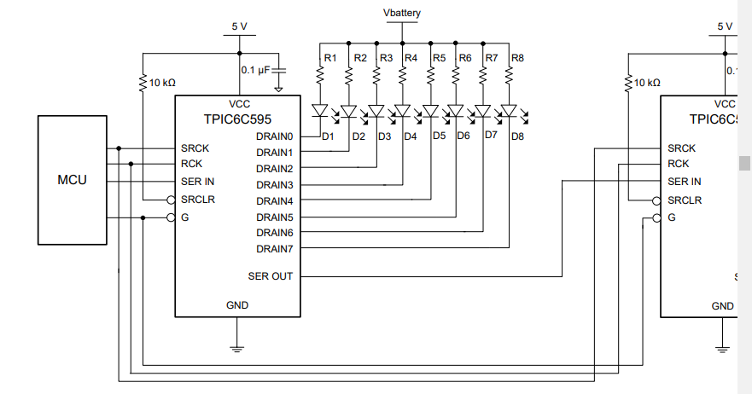

Atmega

ADC

Notes
- The AVR has a neat feature... you use the internal 2.5V reference for the a/d, and hang a cap on the aref pin to suck up the ripple.
- The reference voltage is just the voltage at the top of the pot. It has a 100n cap to ground.
- I use the ADC Noise Reduction sleep during the conversion. or is this only available on the Atmega169?
- tried the ADC Noise Reduction on the 169, and found it didn't reduce the noise at all,
- siehe seite 196 für noise cancelation https://ww1.microchip.com/downloads/en/DeviceDoc/Atmel-2486-8-bit-AVR-microcontroller-ATmega8_L_datasheet.pdf

design notes
Aref
- 100nF or 10nF on Aref. Other end on GND.
- Wenn man saubere Spannung hat kann man die auch da als Referenz anlegen
Vcc und Avcc (ADC supply) an 5V.

I2C

General IO

Components

TPIC6C595
- 1.3$ for DIP
- https://www.mouser.ph/ProductDetail/Texas-Instruments/TPIC6C595N?qs=%2Fha2pyFadug91V9e4me3FMtOvUZWEPEa3gNUlDxpgbA%3D

Socket
- 0.37$
- https://www.mouser.ph/ProductDetail/FCI-Amphenol/DILB16P-223TLF?qs=sGAEpiMZZMtneIuP4Zx3qQDrmajaGEu5

Ceramic Capacitor 100nF
- 0.13$
- https://www.mouser.ph/ProductDetail/Vishay/K104M15X7RF53H5?qs=sGAEpiMZZMskC5GgilGuvlka1JhNGdVz

Ceramic Capacitor 22pf
- 0.21$
- https://www.mouser.ph/ProductDetail/Vishay/K220J10C0GF5UH5?qs=sGAEpiMZZMvfWfew95%2FxXKwIr%252BteGxkk

Electrolytic Capacitor 10uF
- 0.083$
- https://www.mouser.ph/ProductDetail/KEMET/ESC106M035AC3AA?qs=%2Fha2pyFaduiKSNHn%252ByUccFkJcUDKSzqHUpDMXgf6drrWRcJQEoaZIw%3D%3D

Tactile Switches
- 2.79$
- https://www.mouser.ph/ProductDetail/CTS/228CMVARGBFR?qs=sGAEpiMZZMv0NwlthflBi6d2CTj%2FILa2s1KfV6ahLRE%3D

Inductor
- 0.33$
- https://www.mouser.ph/ProductDetail/Bourns/78F100J-TR-RC?qs=%2Fha2pyFadugLsbWz%2F4Y%252BIAa9UaKYD3%2FzdtNV3VUdm%252B7jPstOX5IZPQ%3D%3D

Header PIN Connector
- Don’t buy at distributor by pack somewhere else
- pitch 2.54mm x and y
- 1 2x2 male
- 1 1x6 female
- 1 1x5 female right angle
- 1 1x5 male right angle
- 2 1x2 female right angle
- 2 1x2 male right angle

Poti Connector 1x5

Mini-Lock Wire-to-Board
- Example: https://www.mouser.ph/ProductDetail/Molex/53426-0510?qs=%2Fha2pyFadug4mlQjak2wMEL0%252BrYN7cmY1nwSl1aF83P5sjpAJffACz7NzQmesmAv

Crystal 16mhz
- https://www.mouser.ph/ProductDetail/IQD-Frequency-Products/LFXTAL036391Bulk?qs=sGAEpiMZZMsKEdP9slC0YcD6j7boKuvwLRuybBiiPkk%3D

Encoder 24ppr
- 1.68$

