**数据库Project说明文档**

张斐然 18307110244 徐杉杉

**一、ER图**

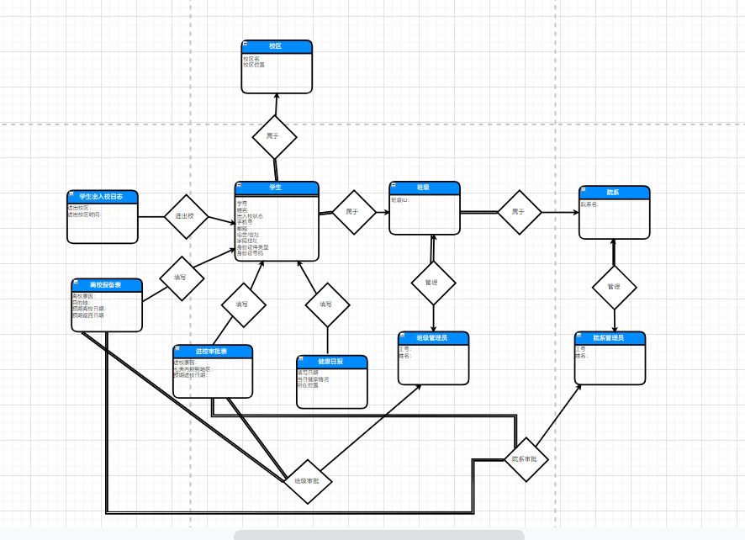

**二、表结构说明**

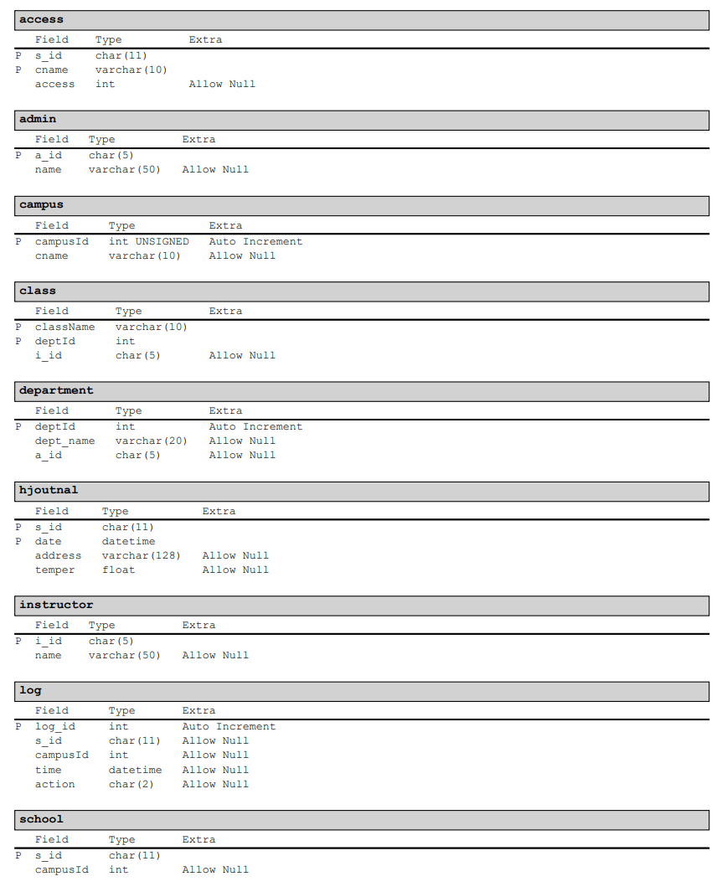

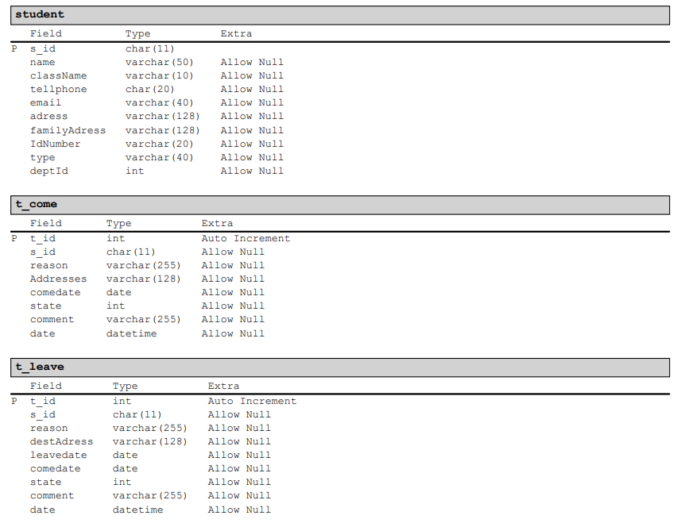

如图，本次PJ共有12张表。

其中access表存储学生权限信息，admin表存储管理员账号信息，campus表存储校区名称信息，class表存储班级信息，department表存储院系信息，hjoutnal表存储平安复旦信息，instructor表存储辅导员账号信息，log表存储出入校记录信息，school存储学校共有哪些校区。

t_come表存储入校申请表信息，t_leave表存储出校申请表信息。其中state属性取值为1、2、3、4，分别代表该申请表待辅导员审批、待管理员审批、已通过、已被拒绝。

**三、关键SQL语句说明**

**1、 查询前n个提交入校申请最多的学生**

SELECT

t_come.s_id,

student.name

FROM

t_come

NATURAL JOIN student

WHERE

student.className = ? AND

student.deptId = ?

GROUP BY

t_come.s_id

ORDER BY

COUNT(*) DESC

LIMIT ?

查询t_come表，得到前N个记录最多的s_id，再查询student表得到相关信息。

**2、 查询未提交出校申请但离校状态超过24h的学生数量、个人信息。**

SELECT DISTINCT

ss1.s_id,student.name

FROM

student_state AS ss1

NATURAL JOIN student

WHERE

student.deptId = ? AND

student.className = ? AND

ss1.action = "离校" AND

ss1.time1 <= ? AND

ss1.s_id NOT IN

(

SELECT

student_state.s_id

FROM

student_state

NATURAL JOIN t_leave

WHERE

t_leave.state = 3 AND

student_state.action = "离校" AND

student_state.time1 >= t_leave.leavedate AND

t_leave.comedate >= ?

)

查询student_state视图，得到离校状态超过24h的学生s_id，再从中去除掉已经提交出校申请并被批准的部分。

**3、 查询已提交出校申请但未离校的学生数量、个人信息**

SELECT DISTINCT

student_state.s_id,student.name

FROM

student_state

NATURAL JOIN student

NATURAL JOIN t_leave

WHERE

student.deptId = ? AND

student.className = ? AND

student_state.action = "入校" AND

t_leave.state = 3 AND

t_leave.leavedate <= ?

查询student_state视图与student表、t_leave表，得到已提交出校申请但未离校的学生s_id。