MW3 環境
文件 : http://172.28.251.30/mw3/swagger
服務端口80
正式:
VIP : 172.30.1.139 (nginx)
Server 1 : 172.30.1.137 / 172.28.243.137
Server 2 : 172.30.1.147 / 172.28.243.147
Server 3 : (未確認)
Server 4 : (未確認)

測試 :
VIP : 172.28.251.30 (nginx)
Test Server : 172.28.251.30

API
設定 : 將允許通過所有服務器證書驗證，即不會對服務器證書的有效性進行檢查。
Transport Layer Security : TLS1.2
Api Router: http://172.28.251.30/mw3/AP/API
Method : post
Header : api-version: 2
Body:
{
"apiName": "ECardActivityQry",
"mediaType": "application/json",
"headers": {
"accept": "text/plain"
},
"info": {
"sid": "R120667319",
"born": "19820817"
}
}
apiName : 權限名稱。 由MW3提供 ，所有權限會依照此設定。
mediaType : Service Provider mediaType
headers : Service Provider headers (允許空物件但不允許Null)
info : Service Provider Request body

DB (DataBase)
Api Router: http://172.28.251.30/mw3/DB/PROC
Method : post
Header : api-version: 2
Body:
{
"info":"加密電文"
}

加密電文內容: (加密方式請至MW3加密規格查詢)
Info:
{
"spName": "T1080002_2019happinessfood",
"info": {
"note2": "",
"channel": "KITTY",
"rtnCode": ""
}
}

spName : 權限名稱。由MW3提供，所有權限會依照此設定。
Info : 上行電文，依照執行的sp 給予不同的info

IBM
Api Router: http://172.28.251.30/mw3/DB/{交易名稱}/
Method : post
Header : api-version: 2
Body:
{
"info":"加密電文"
}

加密電文內容(加密方式請至MW3加解密規格查詢) :
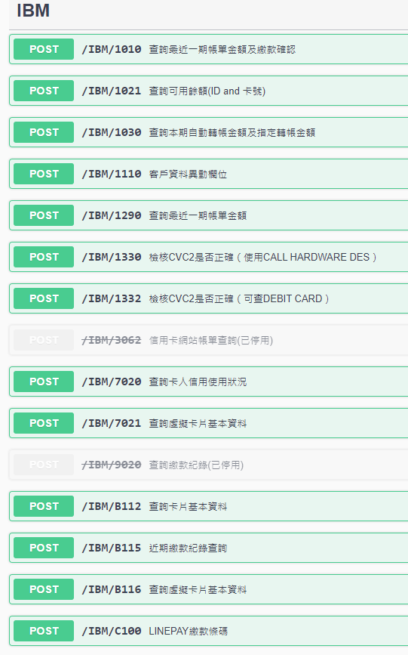
Info: 請依照主機電文或至MW3 Swagger查詢

MS
Api Router: http://172.28.251.30/mw3/MS/API
Method : post
Header : api-version: 2
Body:
{
"method": "get",
"ms_Headers": {},
"ms_Provider": "sso-ups",
"ms_APIRouter": "Company/Get",
"ms_Info": ""
}

method: Service Provider Method
ms_Headers: Service Provider Headers
ms_Provider: Service Provider (CCMS)
ms_APIRouter: Service Provider Router
ms_Info: Service Provider Request Body

加解密方式(AES)
Key = (請至系統管理人詢問)
Iv = "172E27B1C6C3CA5F" (固定)
CipherMode : CBC;
PaddingMode:PKCS7;
驗測方式:
- 電文加密 (以DB為例):
curl -X 'POST' \
'http://172.28.251.30/mw3/api/MW3AES/Encrypt' \
-H 'accept: */*' \
-H 'api-version: 2' \
-H 'Content-Type: application/json-patch+json' \
-d '{
"revE_CODE": "1110",
"revE_TERM_ID": "0000",
"revE_ID_NO": "A100057573",
"revE_FILLER": ""
} '

Response Body:
u1eymdAbMpZs4kTdM/0Ha3Kma9NrFMyvvO3VSCdUGahvLv0sWNDep1m7bAsaxB3zj8oTzSVkXkG9oGPJUvDNsUDGxszi72RT8WVnmAIOU44K5SeFwDTTB/vcZRx2wOhZf5ugiz+RVtwop1vn3Is1rg==
- 電文解密 (以上面 Response Body 為例):
curl -X 'POST' \
'http://172.28.251.30/mw3/api/MW3AES/Decrypt' \
-H 'accept: */*' \
-H 'api-version: 2' \
-H 'Content-Type: application/json-patch+json' \
-d '"u1eymdAbMpZs4kTdM/0Ha3Kma9NrFMyvvO3VSCdUGahvLv0sWNDep1m7bAsaxB3zj8oTzSVkXkG9oGPJUvDNsUDGxszi72RT8WVnmAIOU44K5SeFwDTTB/vcZRx2wOhZf5ugiz+RVtwop1vn3Is1rg=="'

