Something you might want to try later carefully:

1. Modify $CATALINA_HOME/conf/server.xml for international character support

Add URIEncoding="UTF-8" to the Connector element

<Connector port="8080" URIEncoding="UTF-8" ..

1. 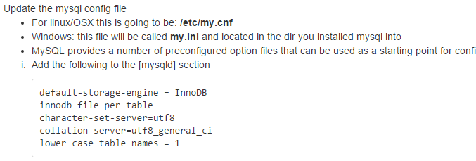
2. Speed up tomcat
   1. 