[**https://www.youtube.com/watch?v=dWSJW-FB2ZU&t=173s**](https://www.youtube.com/watch?v=dWSJW-FB2ZU&t=173s)

[**https://www.youtube.com/watch?v=XU0yW8MyJkg&t=522s**](https://www.youtube.com/watch?v=XU0yW8MyJkg&t=522s)

**https://www.youtube.com/watch?v=vjCsTsFnNqo**

**Reflection Diffraction and Scattering in wireless communication**

When any new site has been planned then it should be such a way the effect of Reflection, Diffraction, Scattering and Multipath should be Balance.

**Reflection in wireless communication**

* Reflections Occurs when a wave impinges upon a smooth surface.
* Dimensions of the surface are large relative to l.
* Reflections occur from the surface of the earth and from buildings and walls.

**Diffraction in wireless communication**

* Diffraction Occurs when the path is blocked by an object with large dimensions relative to l and sharp irregularities (edges).
* Secondary “wavelets” propagate into the shadowed region.
* Diffraction gives rise to bending of waves around the obstacle.

**Scattering in wireless communication**

* Scattering Occurs when a wave impinges upon an object with dimensions on the order of l or less, causing the reflected energy to spread out or“scatter” in many directions.
* Small objects such as street lights, signs, & leaves cause scattering

**MultiPath in wireless communication**

* Multiple Waves Create “Multipath”
* Due to propagation mechanisms, multiple waves arrive at the receiver
* Sometimes this includes a direct Line-of-Sight (LOS) signal

[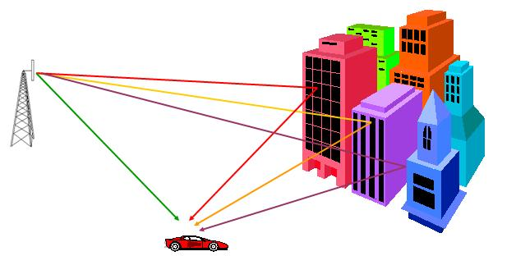](http://www.teletopix.org/wp-content/uploads/2013/01/reflection-diffraction-and-scattering-in-wireless-communication.jpg)

**Multipath Propagation in wireless communication**

* Multipath propagation causes large and rapid fluctuations in a signal
* These fluctuations are not the same as the propagation path loss.

**Multipath causes three major things in wireless communication**

* Rapid changes in signal strength over a short distance or time.
* Random frequency modulation due to Doppler Shifts on different multipath signals.
* Time dispersion caused by multipath delays
* These are called “fading effects
* Multipath propagation results in small-scale fading.