Wireless Local Area Network (LAN) with a number of variants is currently one of the most popular Internet access methods. The base for the WLAN solutions is formed by the development of Wi-Fi, that is, IEEE 802.11. The main categories of wireless networks are seen especially via IEEE 802.11, 802.16 and 802.20 systems. Similarly as with the mobile networks, the security is an important aspect also for WLAN environment both in household and business use. Worldwide Interoperability for Microwave Access (WiMAX), that is, IEEE 802.16 is a wireless communications standard defined by IEEE. The current limitations of the WLANs are solved by the deployment of smart antennas or adaptive active antennas (AAS). AAS systems provide highly advanced methods for enhancements of coverage areas, minimizing interference levels, which increase capacity accordingly.

**1.5 Wireless LANs (WLANS)**

Wireless LAN technology has evolved to extend to existing wired networks. Local area networks (LANs) are mostly based on Ethernet media access technology that consists of an interconnection of hosts and routers. LANs are restricted by distance. They are commonly found in offices and inside buildings. Interconnection using wires can be expensive when it comes to relocating servers, printers, and hosts.

Now, more wireless LANs (WLANs) are being deployed in offices. Most WLANs are compatible with Ethernet, and hence, there is no need for protocol conversion. The IEEE has standardized 802.11 protocols to support WLANs media access. A radio base station can be installed in a network to serve multiple wireless hosts over 100-200 m. A host (for example, a laptop) can be wirelessly enabled by installing a wireless adapter and the appropriate communication driver. A user can perform all network-related functions as long as he or she is within the coverage area of the radio base station. This gives the user the capability to perform work beyond his or her office space.

As shown in [Figure 1.4](javascript:popUp('/content/images/chap1_0130078174/elementLinks/01fig04.gif')), several overlapping radio cells can be used to provide wireless connectivity over a desired region. If a wireless host migrates from one radio cell to another within the same subnet, then there is no handoff. It is basically bridging, since the host's packet will eventually be broadcast onto the same Ethernet backbone.

[**Figure 1.4**](javascript:popUp('/content/images/chap1_0130078174/elementLinks/01fig04.gif'))**. A WLAN with an Ethernet wired backbone.**

WLANs support existing TCP/IP-based applications. There has been considerable debate in the past as to the low throughput WLANs provide compared to high-speed wired networks. It was not long ago that switched Ethernet technology[8](javascript:popUp('/content/images/chap1_0130078174/elementLinks/ch01fn08.html')) evolved, bringing the communication throughput of Ethernet into the gigabit range.

The desire to support higher throughput and ad hoc mobile communications has prompted the ETSI (European Communications Standard Institute) to produce a standard for high-performance Radio LAN (HIPERLAN), at 20Mbps throughput with a self-organizing and distributed control network architecture. HIPERLAN II is a wireless ATM system operating at the 17GHz band.

IEEE 802.11 Architecture

The components of an IEEE 802.11 architecture are as follows −

* **Stations (STA)** − Stations comprises of all devices and equipment that are connected to the wireless LAN. A station can be of two types−
  + Wireless Access Point (WAP) − WAPs or simply access points (AP) are generally wireless routers that form the base stations or access.
  + Client. Clients are workstations, computers, laptops, printers, smartphones, etc.
* Each station has a wireless network interface controller.
* **Basic Service Set (BSS)** − A basic service set is a group of stations communicating at the physical layer level. BSS can be of two categories depending upon the mode of operation−
  + Infrastructure BSS − Here, the devices communicate with other devices through access points.
  + Independent BSS − Here, the devices communicate in a peer-to-peer basis in an ad hoc manner.
* **Extended Service Set (ESS)** − It is a set of all connected BSS.
* **Distribution System (DS)** − It connects access points in ESS.

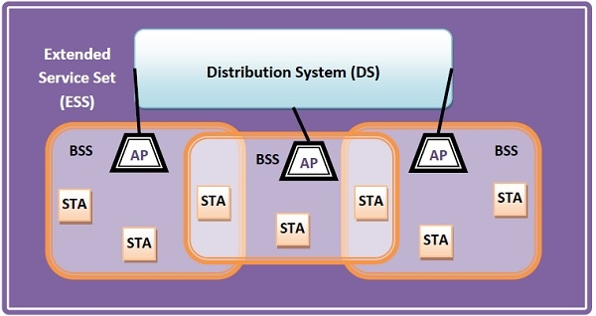

Frame Format of IEEE 802.11

The main fields of a frame of wireless LANs as laid down by IEEE 802.11 are −

* **Frame Control** − It is a 2 bytes starting field composed of 11 subfields. It contains control information of the frame.
* **Duration** − It is a 2-byte field that specifies the time period for which the frame and its acknowledgment occupy the channel.
* **Address fields** − There are three 6-byte address fields containing addresses of source, immediate destination, and final endpoint respectively.
* **Sequence** − It a 2 bytes field that stores the frame numbers.
* **Data** − This is a variable-sized field that carries the data from the upper layers. The maximum size of the data field is 2312 bytes.
* **Check Sequence** − It is a 4-byte field containing error detection information.

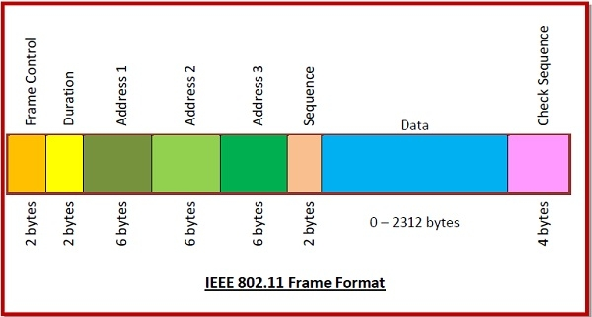

Top of Form

Top of Form

Bottom of Form