
Carahsoft Microsite
Content & Asset Reference Document
Prepared for: Carahsoft Technology Corp.
Prepared by: Perspective Tester
Date: March 2026
Repository: github.com/a3s-app/Carasoft-microsite-dummy

Table of Contents

1. Site Overview & File Structure
2. Global Elements (Header, Navigation, Sidebar)
3. Homepage (index.html)
4. Products Page (solutions.html)
5. A3S Product Page (a3s.html)
6. P15R Product Page (p15r.html)
7. Services Page (services.html)
8. Contracts Page (contracts.html)
9. Clients Page (clients.html)
10. About Page (about.html)
11. Schedule Demo Page (schedule-demo.html)
12. Assets & Images
13. Stylesheets & Scripts
14. Contact Information

1. Site Overview & File Structure

This document contains the complete text content, structure, and asset references for the Perspective Tester microsite built in the Carahsoft vendor page format. The site replicates the exact layout and color theme of the Carahsoft Adobe vendor microsite.

File Structure
File | Description
index.html | Homepage - Perspective Tester Overview
solutions.html | Products page - A3S & P15R product cards
a3s.html | A3S dedicated product page - Accessibility as a Service
p15r.html | P15R dedicated product page - Accessibility Ops Platform
services.html | Professional services catalog
contracts.html | Government procurement contracts
clients.html | Client list, testimonials, and industry breakdown
about.html | About Perspective Tester
schedule-demo.html | Demo request form with contact info
styles.css | Main stylesheet - Carahsoft blue theme (#3155A4)
pages.css | Sub-page component styles
script.js | JavaScript for navigation, carousel, interactions

2. Global Elements

Top Bar Navigation
Centered links displayed across all pages:
- JOIN OUR TEAM
- ABOUT CARAHSOFT
- AWARDS
- NEWS
- ADVANCED SEARCH (with search icon)

Carahsoft Header
- Logo: carahsoft. The Trusted IT Solutions Provider®
- AVAILABLE 24X7 - (888) 66CARAH (red label)
- FAST & ACCURATE - Request A Quote (red label)

Main Navigation Bar
White background bar with dropdown menus:
- SOLVE (dropdown)
- LEARN (dropdown)
- BUY (dropdown)
- PARTNER (dropdown)

Vendor Sub-Header (Sticky)
Uses the official Perspective Tester logo from Carahsoft CDN:
- Logo: perspective-tester-logo.png (from static.carahsoft.com)
- Main: (888) 662-2724
- PerspectiveTester@carahsoft.com
- Live Chat
- REQUEST A QUOTE button (blue)

Vendor Navigation Tabs
Blue navigation bar (#3155A4) with tabs:
- Perspective Tester Overview
- Products (dropdown: A3S, P15R)
- Services
- Contracts
- Clients
- About
- Schedule Demo

Color Theme
- Primary Blue: #3155A4 (nav bars, buttons, links)
- Dark Navy: #1a1a2e (headings, footer)
- Red Accent: #CC0000 (AVAILABLE 24X7, support headers)
- Light Blue: #E3F2FD (icon backgrounds, badges)
- Background Gray: #f8f9fa (section backgrounds)

3. Homepage (index.html)

Compliance Banner
ADA Title II Compliance Deadline - April 24, 2026
Is Your Organization Ready for Digital Accessibility?
CTA Button: Check Compliance

Hero Section
Brand: Perspective Tester | Badge: WCAG 2.2 AA
Label: ENGINEERING EQUITY FOR THE DIGITAL WORLD
Heading: Accessibility Testing & Compliance at Scale
Achieve and maintain WCAG 2.2 compliance with enterprise-grade tooling
Standards: WCAG 2.2 | SECTION 508 | ADA TITLE II
CTA: Get a Free Audit

Main Description

Let The Leaders in ADA Web Compliance Solve Your Accessibility Issues!
Make your websites and digital assets accessible with Perspective Tester's industry-leading approach to ADA Web compliance. Meet all federal and state requirements, including the newly-updated ADA Title II rules published in April 2024! Perspective Tester utilizes manual testing with assistive technologies - the ONLY method approved by both the Department of Justice and the World Wide Web Consortium (the creators of the WCAG standards).
We also provide full remediation services - a complete turn-key solution for accessibility compliance. Achieve compliance for your websites, web systems, payment portals, mobile apps, custom software applications, documents, video content and more! Perspective Tester is your one-stop shop for all things related to digital accessibility.

Product Offerings

How Perspective Tester Ensures Digital Accessibility Through Two Core Products:
- A3S (Accessibility as a Service) - managed accessibility service for local and county governments, featuring a 4-phase workflow with VPAT reports and continuous monitoring.
- P15R Platform - accessibility operations platform that helps teams track, assign, and resolve accessibility issues with real-time collaboration and developer integrations.
Together, these solutions help organizations build accessible digital experiences, achieve compliance, and protect against legal risk.

Expert Section

Connect with an Accessibility Specialist
Whether you need a full-site accessibility audit, ongoing compliance monitoring, or help building an accessibility operations program, our IAAP-certified specialists are ready to help. Connect with a Perspective Tester expert to discover how your organization can achieve and maintain digital accessibility compliance.
CTA: Request a Demo

Sidebar Content
- Carousel: Engineering Equity - Lead the future of digital accessibility
- Newsletter signup
- Accessibility Resources: A3S Product Overview, P15R Platform Demo, WCAG 2.2 Quick Guide, VPAT Request Form
- Accessibility Support: Info@perspectivetester.com, Submit a Support Ticket
- Contact: Perspective Tester at Carahsoft

4. Products Page (solutions.html)

Perspective Tester Products
Two powerful products designed to solve accessibility compliance from different angles. Use A3S when you need a fully managed service, or P15R when you need an operations platform for your internal team.

Product Card: A3S
A managed accessibility service for local and county governments. Ensuring legal compliance and reducing barriers to digital accessibility services. Features a 4-phase workflow: Initial Assessment, Audit & Remediation, Final Validation & VPAT, Optimization & Monitoring. $1,500/month per website, no hidden fees.
CTA: LEARN MORE (links to a3s.html)

Product Card: P15R
An accessibility operations platform that helps teams track, assign, and resolve accessibility issues across websites and applications. Features audit intake, real-time dashboards, vendor collaboration, and bidirectional Jira, Slack, and Teams integrations. $99/month per seat with unlimited uploads and issues.
CTA: LEARN MORE (links to p15r.html)

5. A3S Product Page (a3s.html)

A3S - Accessibility as a Service
Our A3S program was born to facilitate two things: ensuring legal compliance and reducing barriers to digital accessibility services. We developed these pillars after learning about the needs of municipalities in Colorado facing compliance standards from House Bill HB21-1110.
This program gained traction with municipalities limited by budget constraints and manpower. We now proudly serve several clients with a high degree of satisfaction.

Hero Banner
Heading: Continuous Compliance Made Simple
Pricing: $1,500/mo per website | No Hidden Fees | WCAG 2.2 AA compliance
CTA: Request a Demo

Key Features
- $1,500 a month per website
- No hidden fees
- WCAG 2.2 AA compliance
- Full manual testing
- Turnkey remediation
- Required accessibility documentation
- Monthly reporting
- Prioritization of critical issues
- Best-in-class customer service
- Legal defensibility

4-Phase Workflow
Phase 1 - Initial Assessment: Updated accessibility statement, site complexity assessment, technical architecture review, project scope documentation.
Phase 2 - Audit & Remediation: Issue identification, comprehensive remediation, monthly progress reports, updated accessibility statements, third-party blocker documentation.
Phase 3 - Final Validation & VPAT: Complete site validation, official VPAT certification, updated accessibility statement.
Phase 4 - Optimization & Monitoring: Continuous site monitoring, proactive issue prevention, best practice implementation, monthly accessibility statement updates.
Note: Phases 2 & 4 run continuously for ongoing compliance.

Additional Benefits
Accessibility Statement, Workflow Integration, Flexible Remediation Models, Legal Protection (ADA Title II, Section 504, Section 508, state laws, EN 301 549), Defensible Documentation.

6. P15R Product Page (p15r.html)

P15R - Accessibility Ops Platform
A complete toolkit for managing accessibility compliance from audit to resolution. Built to keep every issue accountable, traceable, and report-ready.

Hero Banner
Heading: Everything You Need, Nothing You Don't
Stats: Audit to Issues < 60s | Integrations: Jira, Slack, Teams | Vendor Access: Scoped & Secure | Pricing: $99/mo per seat
CTA: Request a Demo

Platform Workflow
1. Upload (Import audits) > 2. Triage (Prioritize issues) > 3. Remediate (Fix and verify) > 4. Report (Share progress)

Core Capabilities (9 Features)
Smart Upload: Upload Excel audit reports (.xlsx, .xls, .csv) with auto-column mapping, domain-aware merge detection, and bulk upload workflow. Files must be in a specific format.
Issue Tracking: Severity + SLA enforcement, WCAG refs linked per issue, saved filters and quick search.
Analytics: Resolution trend tracking, risk distribution by severity, exportable progress reports.
Team Collaboration: RBAC with granular roles, one-click team invites, saved views per team member.
Document Remediation: Version history on every file, vendor upload tracking, compliance-ready audit trail.
Compliance Calendar: Kanban + list views, drag-and-drop status updates, deadline alerts and reminders.
Jira Integration: Auto-create Jira tickets, two-way status sync, priority-to-severity mapping.
Slack & Teams Alerts: Per-channel event routing, rich message formatting, incoming webhook setup.
Secure by Design: Password-protected links, granular share controls, encrypted credentials at rest.
CTA: $99/month per seat with unlimited uploads and issues. Schedule a Demo.

7. Services Page (services.html)

Services Beyond The Platform
In addition to software, we provide audit, remediation, training, and advisory services to help teams plan, execute, and sustain accessibility outcomes.
Service Tags: Audit, Remediation, Training, Program Advisory, Verification

Service Catalog
Accessibility Audits - Baseline and recurring audits. Manual + assistive technology testing, WCAG 2.2/ADA/508 alignment, prioritized findings.
Remediation Delivery Support - Issue triage, developer-ready recommendations, progress tracking through closure.
Accessibility Training - Developer, QA, design, and content tracks. Role-specific labs, leadership briefings.
Program Governance Advisory - Policy design, ownership models, SLA and reporting framework setup.
Validation and Verification - Regression testing, evidence packs, release-readiness checks.
Vendor and Team Enablement - Vendor handoff templates, cross-team cadences, communication workflows.

Engagement Model
1. Discovery and Scope > 2. Assessment and Prioritization > 3. Delivery and Enablement > 4. Verification and Reporting

Service Packages
Audit-Only | Audit + Remediation | Training + Governance | Full Program Partnership

8. Contracts Page (contracts.html)

Government Procurement Contracts

Federal
NASA SEWP V - NNG15SC03B / NNG15SC27B - May 01, 2015 to Apr 30, 2026

State and Local (11 contracts)
Clark County SD (Cobb County) - PUR-F0024 - Apr 15, 2025 to Apr 15, 2026
Cobb County, GA - OMNIA Partners - 23-6692-01 - May 01, 2023 to Apr 30, 2026
Dallas ISD (Region 4) - 207331 - Feb 02, 2025 to Dec 31, 2027
Fairfax County (Cobb County) - 4400012235 - Nov 15, 2023 to Apr 30, 2026
Frisco ISD (Cobb County) - 23-6692-01 - Mar 10, 2025 to Apr 30, 2026
NASPO ValuePoint - AR2472 - Oct 14, 2016 to Sep 15, 2026
RCA - Orange County - Region 4 - RCA-017-25010020 - Jan 01, 2025 to Dec 31, 2027
Richardson ISD (Region 4) - #R240303 - Sep 18, 2025 to Dec 31, 2027
Software Solutions - OMNIA Partners - R240303 - Jan 01, 2025 to Dec 31, 2027
State of Florida (Cobb County) - 43210000-23-OMNIA-ACS - Feb 13, 2024 to Apr 30, 2026
WSSC (Cobb County) - 48531 - Mar 05, 2025 to Apr 30, 2026

9. Clients Page (clients.html)

Trusted by Organizations Across Industries
From local government agencies to universities and healthcare organizations, we help teams achieve and maintain digital accessibility compliance.
30+ Active Clients | 6 Industries

Testimonials
T. Holmes, IT Director, Kit Carson County, CO: Continuous monitoring & compliance
M. Bleyler, Community Engagement Officer, Gilpin County, CO: Legal protection & compliance
J. Stanley, Communications Manager, El Paso County, CO Public Health: Complex PDF remediation

Client List by Industry
Government & Public Services (6): El Paso County, El Paso County Health, El Paso County Sheriff's Office, Gilpin County, Kit Carson County, Saguache County
Education (2): Concorde Career College, Portland State University
Business & Technology (7): EdCount, Jackson Healthcare, MRO Corp, SubItUp, Visability, Vertex Systems, Wilftek
Real Estate & Property Management (15): 280 Gramercy Place, Bayonne Bay, Best Rent NJ, Condo Central NJ, Ewing Town Center, Hallmark Homes, Live at RVR, Live at Woodlands Square, Live Beekman, Ready NJ Apartments, Stratford at Monroe, The Continental, Tower 31, Woodhaven at Old Bridge, Xchange NJ

10. About Page (about.html)

Engineering Equity for the Digital World
Perspective Tester is a digital accessibility consultancy helping organizations create inclusive digital experiences. We work to ensure your online presence fosters inclusivity while protecting you from legal liabilities.

Stats
2B+ people impacted by digital accessibility | WCAG 2.2 AA standards-first delivery model | IAAP Team certified specialists and real-user testers

What Drives Us
Accessibility for Everyone - We build for the 2 billion people who need support accessing the web.
Real-User Testing - Native assistive technology users test against real-world usage patterns.
WCAG 2.2 AA Standards - Manual testing as primary approach, backed by IAAP-certified professionals.
Building for the Real User - Relationships with accessibility attorneys and advocacy groups.

CTA
Ready to Make Your Digital Products Accessible? Talk to Sales | View Products

11. Schedule Demo Page (schedule-demo.html)

Connect with an Accessibility Specialist
Whether you need a full-site accessibility audit, ongoing compliance monitoring, or help building an accessibility operations program, our IAAP-certified specialists are ready to help.

Form Fields
First Name (required) | Last Name (required) | Email (required) | Phone (optional) | Organization (required) | Job Title (optional) | Product Interest (dropdown: A3S, P15R, Both, Services Only, Other) | Comments (textarea)
Submit Button: SUBMIT REQUEST

12. Assets & Images

File | Type | Usage
perspective-tester-logo.png | PNG (261x80) | Vendor sub-header logo (from static.carahsoft.com)
a3s-logo.png | PNG (859x866) | A3S product logo - square circle mark, used in nav dropdown, product cards, A3S page hero
p15r-logo.png | PNG | P15R product logo - target/click mark, used in nav dropdown, product cards, P15R page hero
capitol-dome.png | PNG | Capitol dome illustration used alongside hero banner on homepage

Logo Previews
Perspective Tester Logo (from Carahsoft CDN):

A3S Logo:
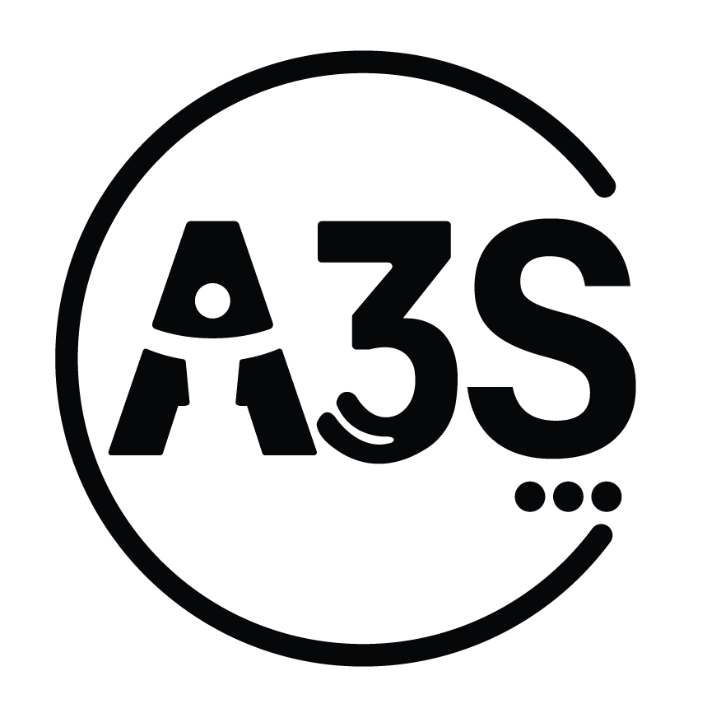

13. Stylesheets & Scripts

styles.css - Main stylesheet with Carahsoft blue theme (#3155A4). Contains all global layout, header, navigation, footer, hero banner, sidebar, and card styles.
pages.css - Sub-page component styles for product cards, feature grids, phase cards, benefit cards, workflow strips, about page sections, key features, and responsive breakpoints.
script.js - JavaScript for carousel, navigation dropdowns, sticky vendor header, and hamburger menu interactions.
External Dependencies:
- Font Awesome 6.5.1 (icons)
- Google Fonts: Open Sans (300, 400, 600, 700, 800 weights)

14. Contact Information

Displayed on Microsite
Phone: (888) 662-2724
Email: PerspectiveTester@carahsoft.com
Support Email: Info@perspectivetester.com
A3S Support: a3s@perspectivetester.com
P15R Support: support@p15r.com
Live Chat: Available via vendor header

GitHub Repository
https://github.com/a3s-app/Carasoft-microsite-dummy
End of Document

