Game Design Document

Fill up the following document

1. Write the title of your project.

Alien Hunters

1. What is the goal of the game?

To defeat all the aliens without taking too much damage from them (which will result in a death)

1. Write a brief story of your game.

Hunters b-15 and b-20 are on a mission to research about space and nearby planets, when their ship gets destroyed. They are on a mission to defeat the hostile aliens and repair their ship before their oxygen runs out (the oxygen doesn’t run out, it is a motivation for the player to defeat the game quickly)

1. Which are the playing characters of this game?

* Playing characters are the ones who respond to the user based on the input from the user.
* Cars, monkeys, dinos, wizards, etc., are the playing characters in the game.

|  |  |  |
| --- | --- | --- |
| Number | Character Name | What can this character do? |
| 1 | Hunter B-15 | Can shoot individual bullets which do a lot of damage |
| 2 | Hunter B-20 | Shoots several bullets in a rapid fire motion (the bullets don’t do as much damage) |
| 3 |  |  |
| 4 |  |  |
| 5 |  |  |
| 6 |  |  |
| 7 |  |  |
| 8 |  |  |

1. Which are the Non-Playing Characters of this game?

* Non-Playing characters are the ones that don't have an action or behavior when the user interacts with the game.
* Hurdles, stones, bananas, coins, etc., are non-playing characters in the game.

|  |  |  |
| --- | --- | --- |
| Number | Character Name | What can this character do? |
| 1 | Alien-1 | Does not do any damage ( acts as an active shield for other aliens) |
| 2 | Alien-2 | Does little damage ( acts like a tank (to draw enemy fire)) |
| 3 | Alien-3 | Does medium damage (shoots rapidly and does most of the damage) |
| 4 | Alien-4 | Shoots a laser which can instantly kill the player and the obstacle |
| 5 | Shield/cover | A medium sized platform made of spaceship debris (used by the hunters to hide behind) |
| 6 | Mechanical part | A collectible item that reinforces the sheild and upgrades the hunter’s armour and damage output (collecting 50 mechanical parts will be enough to allow the hunters to return to earth) |
| 7 |  |  |
| 8 |  |  |

Draw your imagination of this game. What does this game look like?

* Draw the game either on your computer or on paper.
* Add images of the game scenes to show each of the playing and non-playing characters at least once.

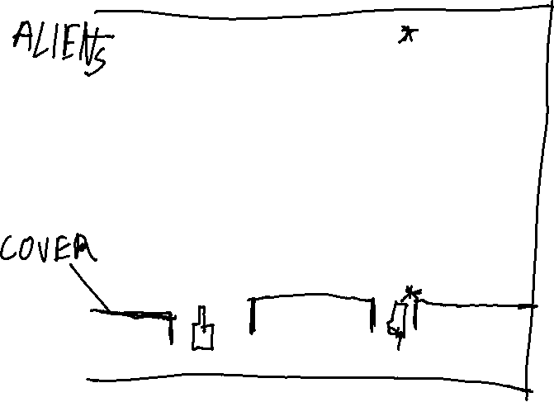

*sprite designs are subject to change



How do you plan to make your game engaging?

The level of the aliens will change depending on the level the game is on. In the more challenging and difficult levels, a high level alien will appear which will shoot a laser beam toward the hunters.