## 前置工作

wget http://nginx.org/packages/centos/7/noarch/RPMS/nginx-release-centos-7-0.el7.ngx.noarch.rpm

rpm -ivh nginx-release-centos-7-0.el7.ngx.noarch.rpm

yum install nginx

systemctl start nginx.service

systemctl enable nginx.service

nginx -t

vim /etc/nginx/conf.d/default.conf

server {

listen 80;

server_name localhost;

#access_log /var/log/nginx/host.access.log main;

location / {

root /usr/project/react-app/build;#主要修改这一行，打包命令npm run build

index index.html index.htm;

}

#error_page 404 /404.html;

# redirect server error pages to the static page /50x.html

#

error_page 500 502 503 504 /50x.html;

location = /50x.html {

root /usr/share/nginx/html;

}

# proxy the PHP scripts to Apache listening on 127.0.0.1:80

#

#location ~ \.php$ {

# proxy_pass http://127.0.0.1;

#}

# pass the PHP scripts to FastCGI server listening on 127.0.0.1:9000

#

#location ~ \.php$ {

# root html;

# fastcgi_pass 127.0.0.1:9000;

# fastcgi_index index.php;

# fastcgi_param SCRIPT_FILENAME /scripts$fastcgi_script_name;

# include fastcgi_params;

#}

# deny access to .htaccess files, if Apache's document root

# concurs with nginx's one

#

#location ~ /\.ht {

# deny all;

#}

}

nginx -s reload

systemctl stop nginx

systemctl start nginx

## React 发布到nginx

React 执行 npm run build 打包



根目录Build路径下有上图所示文件

把整个build文件放入服务器某个目录下

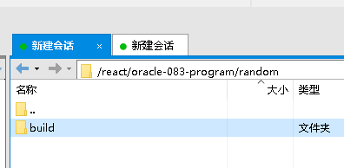

然后输入nginx -t，找到配置文件路径



去这个路线下修改nginx.conf文件

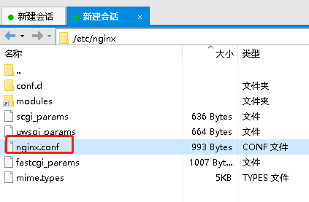

在括号内添加

http {

……

server {

listen 8001; # 新的端口号

server_name xxx.xxx.xxx.xxx; # 替换为你的域名或 IP 地址

location / {

root /react/migration-app/build; # 替换为你的React项目的构建文件夹路径

index index.html;

try_files $uri /index.html;

}

}

}

端口号使用lsof -i :8001查看是否被占用，以及安全组放开端口

修改完毕重启

nginx -s reload

systemctl stop nginx

systemctl start nginx

打开网页，输入ip:8001，正常显示

如果要发布多个服务，新增server块就可以，示例代码如下

http {

server {

listen 80;

server_name app1.example.com;

location / {

proxy_pass http://localhost:8000;

proxy_set_header Host $host;

proxy_set_header X-Real-IP $remote_addr;

}

}

server {

listen 80;

server_name app2.example.com;

location / {

proxy_pass http://localhost:8001;

proxy_set_header Host $host;

proxy_set_header X-Real-IP $remote_addr;

}

}

}

注意下面的是反向代理设置，因为后端服务已经添加跨域，可以不加

proxy_pass http://localhost:8080;

proxy_set_header Host $host;

proxy_set_header X-Real-IP $remote_addr;