**PART I. general PT overcrowding experience**

**[Q1] How often do you experience on-board overcrowding in your public transport (PT) trips in Krakow?**

|  |  |  |  |  |
| --- | --- | --- | --- | --- |
| [1] NEVER | [2] rarely | [3] sometimes | [4] often | [5] ALWAYS |

**[Q2] How often do you experience the following PT crowding conditions in your urban PT trips in Krakow?**

*(these questions were complemented with drawings, like in Q9 – Q10 further below, plus short text description)*

**[Q2a] fully overcrowded, was denied the boarding**

|  |  |  |  |  |
| --- | --- | --- | --- | --- |
| [1] NEVER | [2] rarely | [3] sometimes | [4] often | [5] ALWAYS |

**[Q2b] high overcrowding – had to stand uncomfortably, no grip, no freedom of movement**

|  |  |  |  |  |
| --- | --- | --- | --- | --- |
| [1] NEVER | [2] rarely | [3] sometimes | [4] often | [5] ALWAYS |

**[Q2c] moderate crowding – had to stand, but ‘comfortably’ – grip, free movement**

|  |  |  |  |  |
| --- | --- | --- | --- | --- |
| [1] NEVER | [2] rarely | [3] sometimes | [4] often | [5] ALWAYS |

**[Q2d] last few seats available, managed to get one of them**

|  |  |  |  |  |
| --- | --- | --- | --- | --- |
| [1] NEVER | [2] rarely | [3] sometimes | [4] often | [5] ALWAYS |

**[Q2e] empty trip – multiple seats available**

|  |  |  |  |  |
| --- | --- | --- | --- | --- |
| [1] NEVER | [2] rarely | [3] sometimes | [4] often | [5] ALWAYS |

**PART II. current trip context**

*i.e. characteristics of the trip being currently made by passenger*

**[Q3] Trip purpose (motivation)?**

|  |  |  |  |
| --- | --- | --- | --- |
| [Home] -> Work* | [Home] -> Education | [Home] -> Other** | [Non-Home]-Based |
| Work* -> [Home] | Education -> [Home] | Other** -> [Home] |

*\* incl. business trips etc.*

*\*\* e.g. leisure, shopping…*

**[Q4] Is your trip time-critical?**

|  |  |
| --- | --- |
| [1] YES – I’m in a hurry | [0] NO – I do not need to arrive on-time |

**[Q5] How often do you use this PT route?**

|  |  |  |  |
| --- | --- | --- | --- |
| [5-7] days a week | [2-4] days a week | [1] a week | [less] than once a week |

**[Q6] Trip duration (journey time)?**

|  |  |
| --- | --- |
| ……………… | [mins] |

**[Q7] Service frequency?**

|  |  |
| --- | --- |
| ……………… | [mins] |

**[Q8] What on-board conditions do you expect?**

|  |  |  |
| --- | --- | --- |
| [a] will not be able to board the 1st departure | [c] will stand ‘comfortably’* | [e] don’t know |
| [b] will have to stand uncomfortably* | [d] will get a seat* |

*\* for the most of my current PT trip*

**PART III. SP experiment – RTCI and willingness-to-wait**

*Assume now that you would have RTI on what would be crowding conditions on-board the next departures of your PT route…*

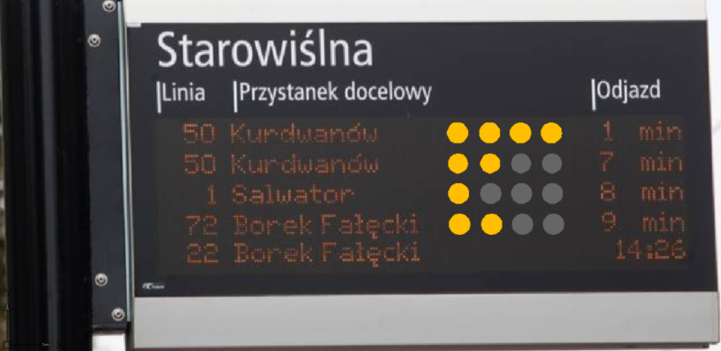

*translation (PL to English) for pics below 😊: odjazd -> departure, TERAZ -> NOW*

**[Q9a] Which departure would you choose? – case (1.)**

|  |  |  |
| --- | --- | --- |
|  | no seats, but can stand comfortably |  |
| ***less-crowded***  - seats available |  |

**[Q9b] Which departure would you choose? – case (1.)**

|  |  |  |
| --- | --- | --- |
|  | no seats, but can stand comfortably |  |
| ***less-crowded***  - seats available |  |

**[Q10a] Which departure would you choose? – case (2.)**

|  |  |  |
| --- | --- | --- |
|  | overcrowded, can barely board |  |
| ***less-crowded***  - can stand comfortably |  |

**[Q10b] Which departure would you choose? – case (2.)**

|  |  |  |
| --- | --- | --- |
|  | overcrowded, can barely board |  |
| ***less-crowded***  - can stand comfortably |  |

**[Q11a] Which departure would you choose? – case (3.)**

|  |  |  |
| --- | --- | --- |
|  | overcrowded, can barely board |  |
| ***MUCH less-crowded***  - seats available |  |

**[Q11b] Which departure would you choose? – case (3.)**

|  |  |  |
| --- | --- | --- |
|  | overcrowded, can barely board |  |
| ***MUCH less-crowded***  - seats available |  |

**[Q12] Do you think you might need such real-time crowding information for your PT trips in Krakow?**

|  |  |  |  |  |
| --- | --- | --- | --- | --- |
| [1] definitely NOT | [2] rather not | [3] neutral | [4] rather yes | [5] definitely YES |

**PART IV. sociodemographic data**

*only 2 questions here since our PT users are reluctant to answer this kind of questions…*

**[Q13] Age?**

|  |  |  |
| --- | --- | --- |
| [< 18] y/old | [26 – 40] y/old | [51 – 65] y/old |
| [18 – 25] y/old | [41 – 50] y/old | [> 65] y/old |

**[Q14] Gender?**

|  |  |
| --- | --- |
| [F]emale | [M]ale |