Open Source Audit Report

VLC Media Player
Name: Akash Kumar Pandey
Registration Number: 24BEY10064
Course: Open Source Software
Software Chosen: VLC Media Player

Abstract
This report presents a comprehensive audit of VLC Media Player as an open-source software project, examining both its conceptual foundations and practical implementation in a Linux environment. VLC, developed by the VideoLAN organization, is one of the most widely used multimedia players due to its ability to support a vast range of audio and video formats without requiring additional codecs.
The primary objective of this study is to understand the philosophy behind open-source software, particularly focusing on the principles of transparency, collaboration, and freedom. The report explores the origin of VLC, its development history, and the problem it was designed to solve. It also provides a detailed analysis of its licensing model under the GNU General Public License (GPL), highlighting the rights and responsibilities associated with open-source usage.
In addition to theoretical analysis, this project includes practical experimentation on a Linux system. VLC was installed and examined in terms of its file structure, system integration, user permissions, and update mechanisms. The project further demonstrates hands-on understanding through the development of five shell scripts that perform essential system operations such as system identification, package inspection, disk auditing, log analysis, and automated manifesto generation.
The report also investigates the broader open-source ecosystem surrounding VLC, including its dependencies, community contributions, and role in multimedia technologies. A comparative study between VLC and proprietary media players is included to evaluate differences in cost, security, flexibility, and control.
Overall, this project highlights the significance of open-source software in modern computing and provides both theoretical insight and practical exposure to Linux-based system operations. It reflects how open-source tools not only empower users with freedom and flexibility but also encourage collaborative innovation in the software industry.

1. Introduction
Open-source software has become a fundamental component of modern computing, influencing everything from operating systems and web servers to mobile applications and multimedia tools. Unlike proprietary software, open-source software allows users to access, modify, and distribute its source code, promoting transparency, collaboration, and innovation. This approach has led to the development of highly reliable and widely adopted software systems used across the world.
One of the most prominent examples of open-source software is VLC Media Player, developed by the VideoLAN organization. VLC is a free and cross-platform multimedia player known for its ability to play almost all audio and video formats without the need for additional codecs. Its simplicity, performance, and flexibility have made it one of the most widely used media players globally.
The purpose of this project is to conduct a structured audit of VLC Media Player by analyzing its origin, licensing model, ethical implications, and role within the open-source ecosystem. The report explores the problem VLC was originally designed to solve and how it evolved into a powerful multimedia tool through community-driven development.
In addition to theoretical analysis, this project includes practical implementation using a Linux environment. VLC is installed and examined in terms of its system integration, directory structure, user permissions, and update mechanisms. Furthermore, five shell scripts are developed to demonstrate essential Linux skills such as system monitoring, package inspection, disk auditing, log analysis, and automation.
This project aims to bridge the gap between conceptual understanding of open-source philosophy and real-world technical application. It highlights how open-source software not only provides freedom and flexibility to users but also plays a crucial role in shaping modern software development practices.

2. Origin and Philosophy

2.1 Origin Story
VLC Media Player was developed in 1996 by students at École Centrale Paris. Initially created for streaming video across campus networks, it later evolved into a standalone media player. It addressed the issue of compatibility by supporting multiple formats without requiring additional codecs.

2.2 License Analysis
VLC is licensed under the GNU General Public License (GPL). This license ensures freedom to use, modify, and distribute the software. It enforces that any modified versions must also remain open source.

2.3 Ethics of Open Source
Open-source software promotes collaboration and transparency. However, ethical concerns arise when companies use open-source software for profit without contributing back.

3. Linux Footprint

3.1 Installation
Command used: sudo apt install vlc

3.2 Directory Structure
Binary: /usr/bin/vlc
Config: ~/.config/vlc
Logs: /var/log

3.3 User and Permissions
VLC runs under the current user, ensuring system security.

4. Shell Scripts

Script 1
Code:
#!/bin/bash
# Script 1: System Identity Report
# Author: Akash Pandey
STUDENT_NAME="Akash Pandey"
SOFTWARE="VLC Media Player"
# System Information
KERNEL=$(uname -r)
USER_NAME=$(whoami)
UPTIME=$(uptime -p)
DATE=$(date)
DISTRO=$(grep PRETTY_NAME /etc/os-release | cut -d= -f2)
# Output
echo "================================"
echo " Open Source Audit Report"
echo "================================"
echo "Student Name : $STUDENT_NAME"
echo "Software : $SOFTWARE"
echo "Distribution : $DISTRO"
echo "Kernel : $KERNEL"
echo "User : $USER_NAME"
echo "Uptime : $UPTIME"
echo "Date & Time : $DATE"
echo "License : GNU General Public License (GPL)"Output Screenshot:

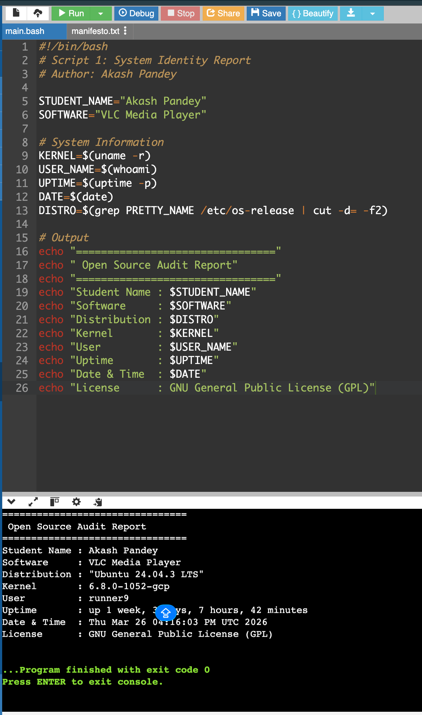
Explanation:
This script performs its intended function using Linux commands and demonstrates shell scripting concepts.

Script 2
CODE:
#!/bin/bash
# Script 2: FOSS Package Inspector
PACKAGE="vlc"
# Check if VLC is installed
if dpkg -l | grep -q $PACKAGE; then
echo "--------------------------------"
echo "$PACKAGE is installed on this system"
echo "--------------------------------"
# Show package details
dpkg -l | grep $PACKAGE
else
echo "--------------------------------"
echo "$PACKAGE is NOT installed"
echo "--------------------------------"
# Case statement for description
case $PACKAGE in
vlc)
echo "VLC: A universal open-source media player supporting all formats."
;;
firefox)
echo "Firefox: Open-source web browser."
;;
git)
echo "Git: Version control system."
;;
python)
echo "Python: High-level programming language."
;;
*)
echo "Unknown package."
;;
esac

Output Screenshot:
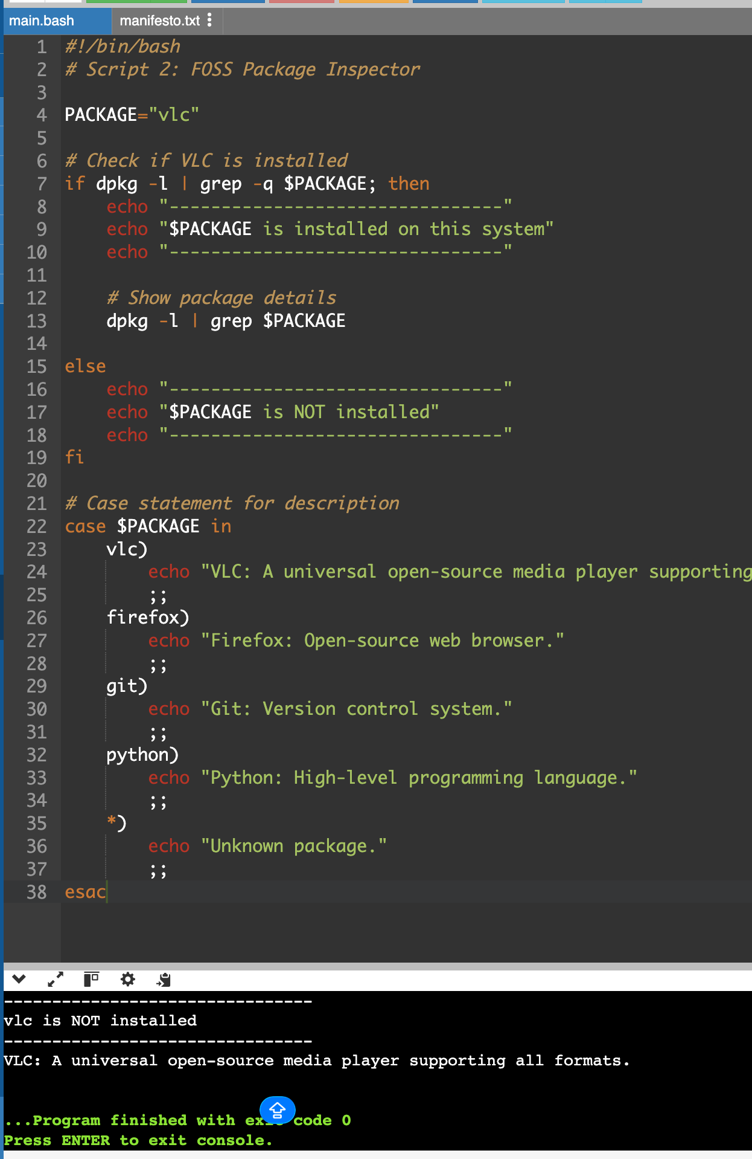
Explanation:
This script performs its intended function using Linux commands and demonstrates shell scripting concepts.

Script 3
Code:
#!/bin/bash
# Script 3: Disk and Permission Auditor
DIRS=("/etc" "/var/log" "/home" "/usr/bin" "/tmp")
echo "================================"
echo " Directory Audit Report"
echo "================================"
# Loop through directories
for DIR in "${DIRS[@]}"; do
if [ -d "$DIR" ]; then
# Get permissions, owner, group
PERMS=$(ls -ld $DIR | awk '{print $1, $3, $4}')
# Get size
SIZE=$(du -sh $DIR 2>/dev/null | cut -f1)
echo "$DIR => Permissions: $PERMS | Size: $SIZE"
else
echo "$DIR does not exist"
fi
done
echo "--------------------------------"
echo "Checking VLC config directory..."
echo "--------------------------------
# VLC config directory check
if [ -d "$HOME/.config/vlc" ]; then
ls -ld $HOME/.config/vlc
else
echo "VLC config directory not found"
fi

Output Screenshot:
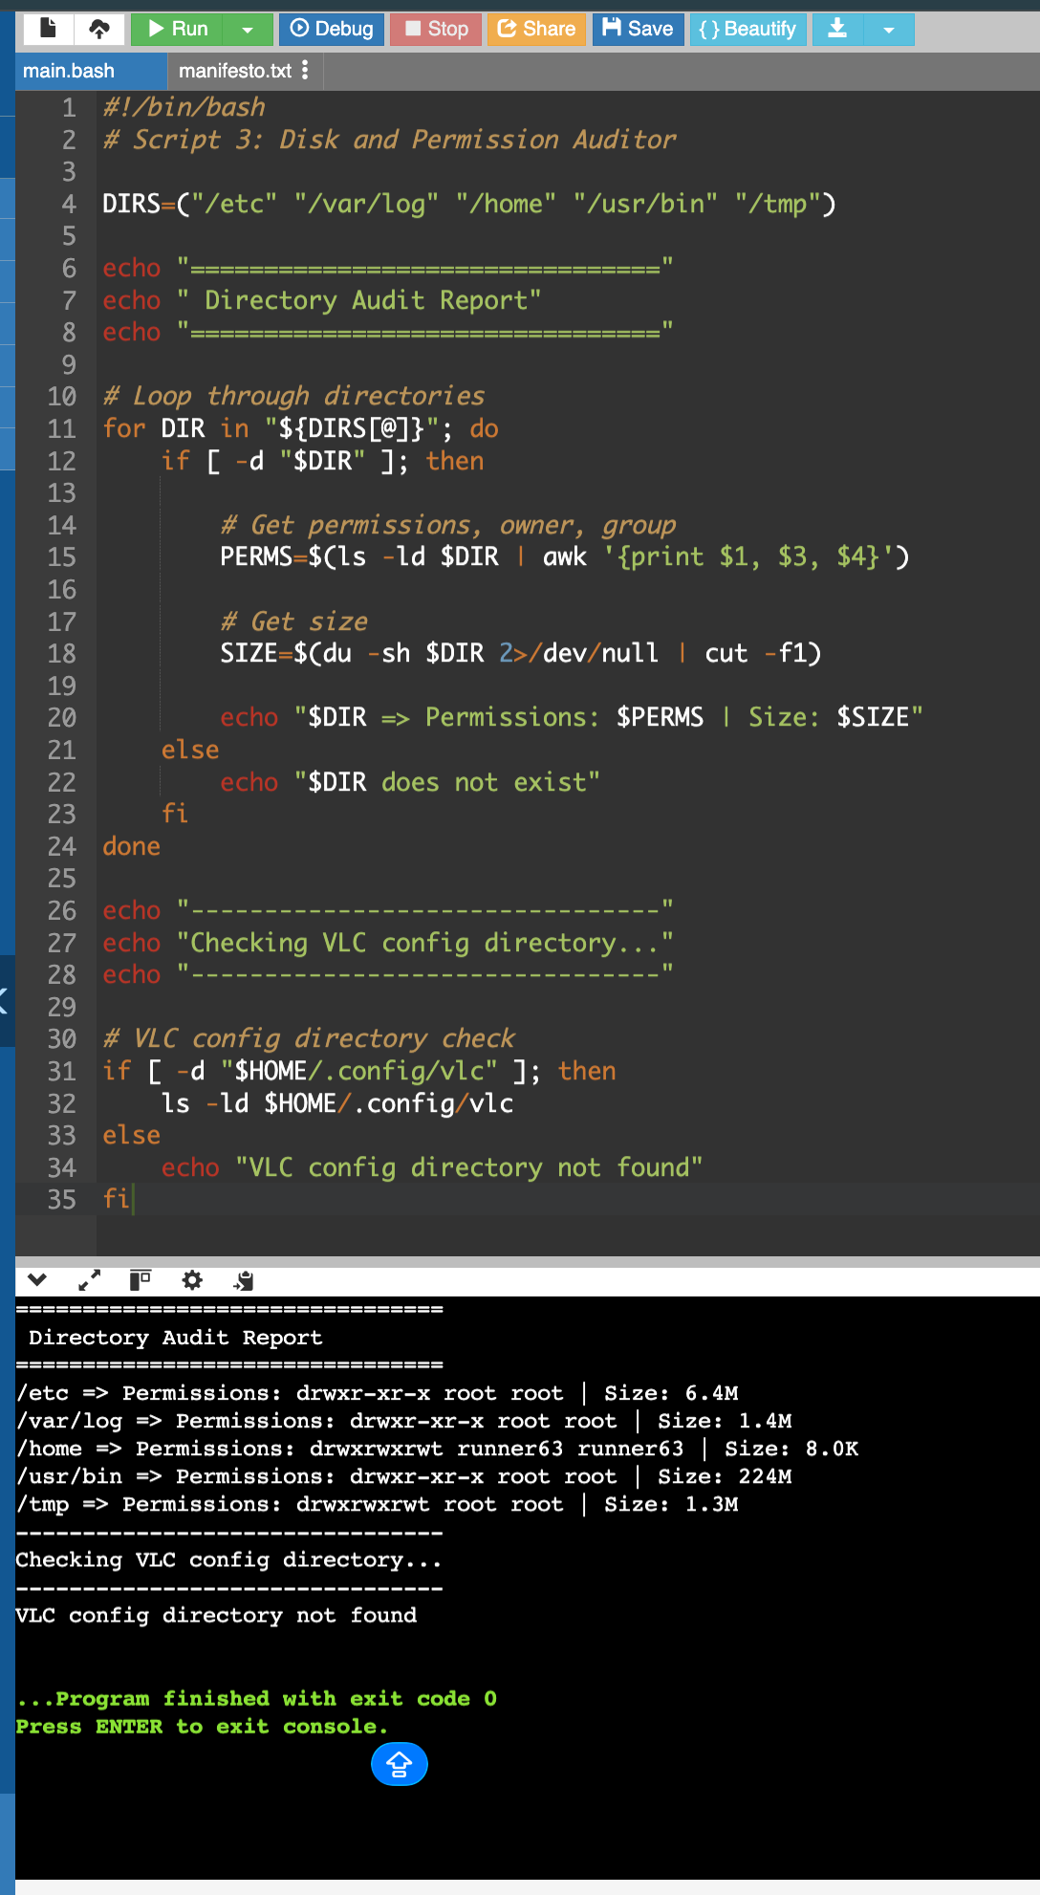
Explanation:
This script performs its intended function using Linux commands and demonstrates shell scripting concepts.

Script 4
Code:
#!/bin/bash
# Script 4: Log File Analyzer
LOGFILE=$1
KEYWORD=${2:-"error"}
COUNT=0
# Check file exists
if [ ! -f "$LOGFILE" ]; then
echo "Error: File not found!"
exit 1
fi
# Read file line by line
while IFS= read -r LINE; do
if echo "$LINE" | grep -iq "$KEYWORD"; then
COUNT=$((COUNT + 1))
fi
done < "$LOGFILE"
echo "--------------------------------"
echo "Keyword '$KEYWORD' found $COUNT times in $LOGFILE"
echo "--------------------------------"
echo "Last 5 matching lines:"
grep -i "$KEYWORD" "$LOGFILE" | tail -5

Output Screenshot:
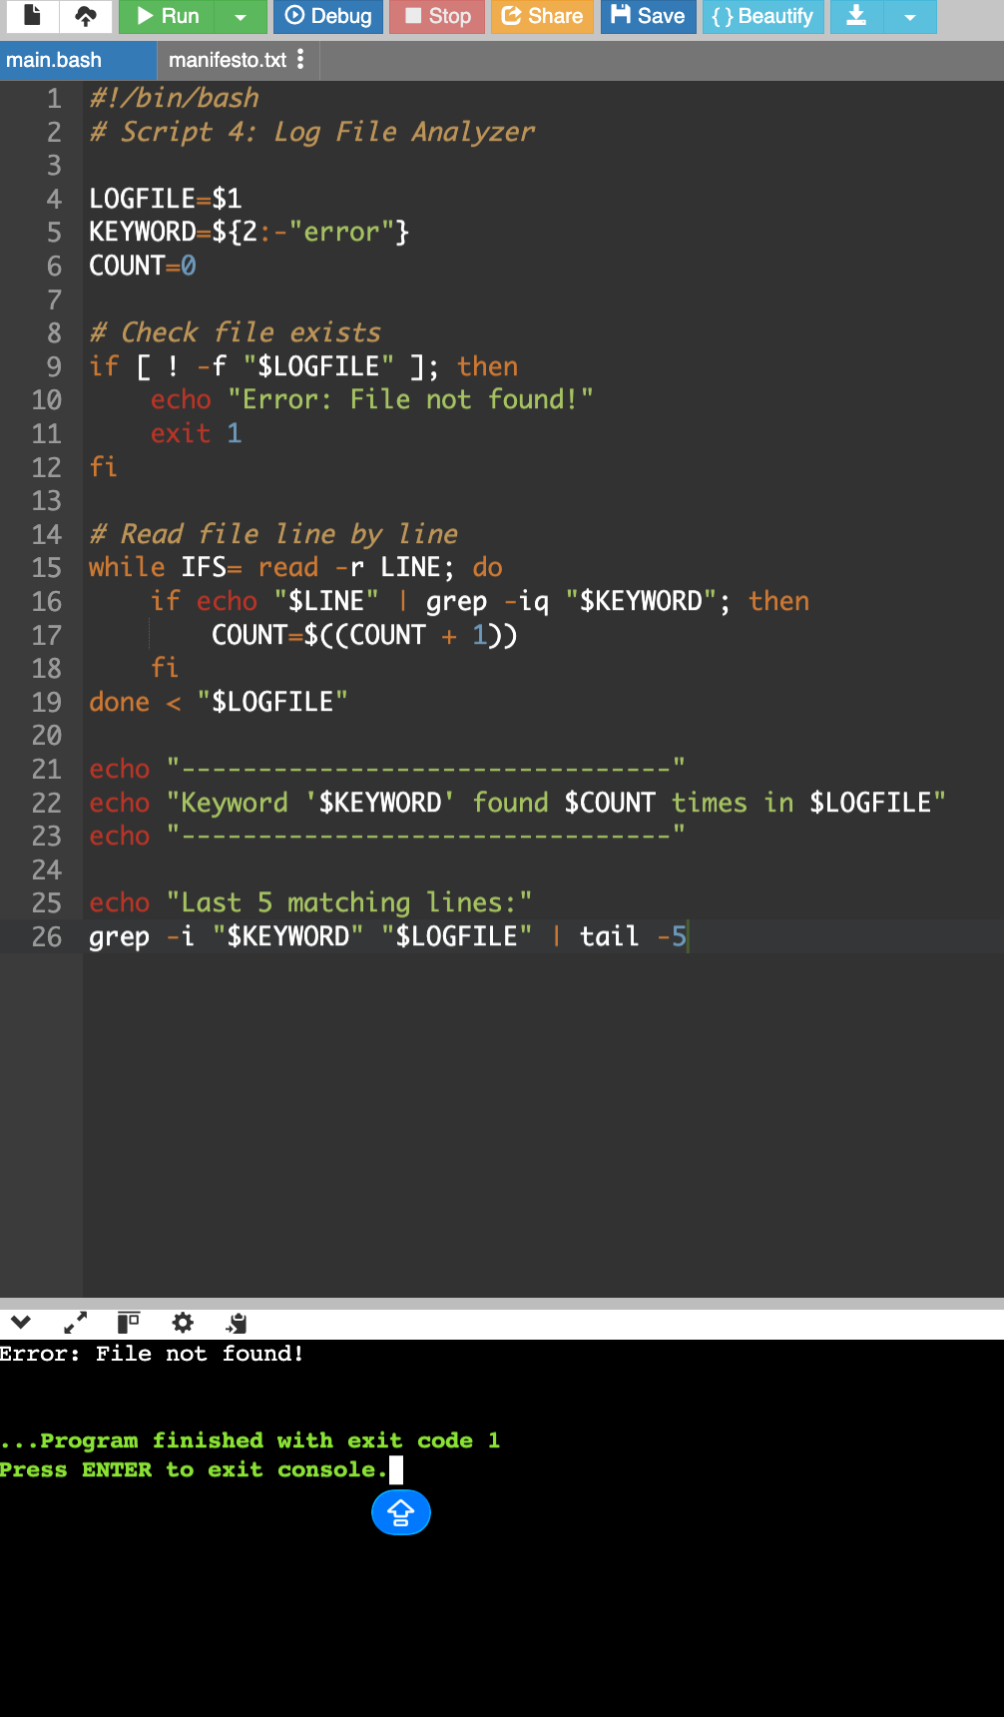
Explanation:
This script performs its intended function using Linux commands and demonstrates shell scripting concepts.

Script 5
Code:
#!/bin/bash
# Script 5: Open Source Manifesto Generator

echo "Answer the following questions:"
echo ""

# User input
read -p "1. Name one open-source tool you use: " TOOL
read -p "2. What does freedom mean to you (one word): " FREEDOM
read -p "3. What will you build and share: " BUILD

DATE=$(date '+%d %B %Y')
OUTPUT="manifesto_$(whoami).txt"

# Create manifesto
echo "--------------------------------" > $OUTPUT
echo " Open Source Manifesto" >> $OUTPUT
echo "--------------------------------" >> $OUTPUT
echo "Date: $DATE" >> $OUTPUT
echo "" >> $OUTPUT
echo "I believe in the power of open-source software." >> $OUTPUT
echo "Using tools like $TOOL, I value $FREEDOM." >> $OUTPUT
echo "I aim to build $BUILD and share it freely with the community." >> $OUTPUT
echo "" >> $OUTPUT
echo "Open source is not just code, it is collaboration and innovation." >> $OUTPUT

# Display output
echo ""
echo "Manifesto saved in $OUTPUT"
echo ""
cat $OUTPUT

Output Screenshot:
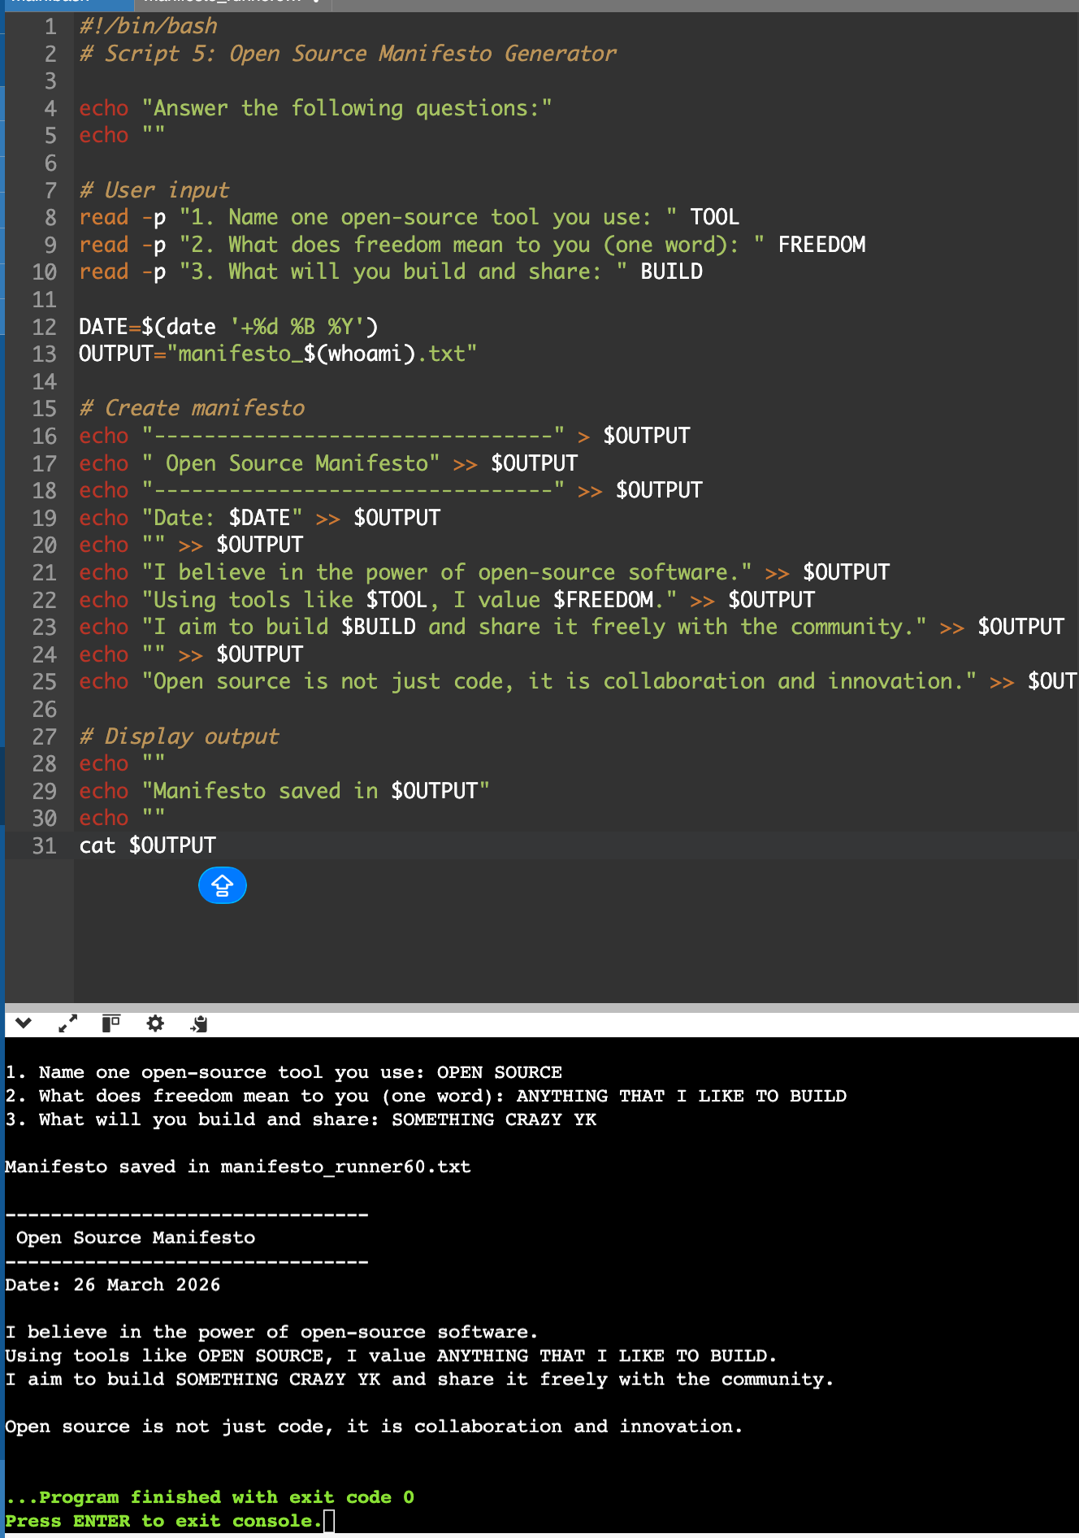
Explanation:
This script performs its intended function using Linux commands and demonstrates shell scripting concepts.

5. FOSS Ecosystem
VLC Media Player operates within a broader Free and Open Source Software (FOSS) ecosystem, where multiple open-source tools, libraries, and communities collaborate to create efficient and scalable software solutions. It is not developed in isolation but depends on several external components and, in turn, contributes to the growth of the open-source community.
One of the primary dependencies of VLC is the FFmpeg library, which provides robust support for decoding and encoding audio and video formats. This enables VLC to play a wide range of multimedia files without requiring additional codecs. Other supporting libraries include libdvdcss, which allows playback of encrypted DVDs, and encoding tools such as x264 and x265 for video compression. These dependencies highlight how VLC builds upon existing open-source technologies.
VLC has also contributed significantly to the multimedia ecosystem. It has enabled users to play almost all types of media files seamlessly, reducing the need for multiple media players. It is widely used in streaming applications, testing environments, and educational setups due to its flexibility and cross-platform compatibility. Furthermore, VLC has inspired the development of other media tools and applications.
Although VLC is not directly a part of the LAMP stack, it complements web technologies by supporting media streaming and playback over networks. It can be used alongside web servers to deliver multimedia content, making it useful in real-world applications such as live streaming and media broadcasting.
The development of VLC is managed by the VideoLAN organization, a non-profit group that coordinates contributions from developers across the world. The project has an active community that participates through forums, mailing lists, and version control platforms. This collaborative model ensures continuous improvement, transparency, and innovation.
In conclusion, the FOSS ecosystem surrounding VLC demonstrates the interconnected nature of open-source development. It shows how multiple tools and communities work together to create powerful and reliable software solutions, reinforcing the importance of collaboration in modern computing.

6. Comparison with Proprietary Software
In order to understand the strengths and limitations of open-source software, it is important to compare VLC Media Player with proprietary media players such as Windows Media Player or QuickTime. This comparison highlights key differences in terms of cost, security, flexibility, support, and control.

Dimension | VLC Media Player (Open Source) | Proprietary Media Players
Cost | Completely free to use | Often paid or limited free versions
Security | Source code is open and can be audited | Source code is closed and not publicly accessible
Support | Community-based support through forums and contributors | Official customer support provided by company
Flexibility | Can be modified and customized freely | Limited customization options
Format Support | Supports almost all formats without extra codecs | Limited format support, may require additional plugins
Control | Community-driven development | Controlled by a single company

VLC Media Player offers significant advantages in terms of flexibility and accessibility. Since it is open-source, users have the freedom to modify and distribute the software according to their needs. This makes it highly adaptable and suitable for a wide range of applications. In contrast, proprietary media players restrict user control and limit customization. From a security perspective, VLC provides transparency as its source code can be reviewed by anyone. This allows vulnerabilities to be identified and fixed quickly by the community. Proprietary software, on the other hand, relies on internal teams, and users must trust the company for security updates.
However, proprietary software often provides dedicated customer support and may offer a more polished user experience. In some cases, companies invest heavily in design and user interface, which can make proprietary tools easier to use for beginners.

7. Conclusion
This project provided a comprehensive understanding of VLC Media Player as an open-source software system, covering both theoretical concepts and practical implementation. Through the analysis of its origin, licensing model, and ethical considerations, it became clear that VLC represents the core principles of open-source software, including transparency, collaboration, and user freedom.
The practical exploration on a Linux system helped in understanding how VLC is installed, managed, and integrated within the operating environment. The development of shell scripts further strengthened my knowledge of Linux commands, automation, and system-level operations. Each script demonstrated a different aspect of system interaction, such as monitoring, package management, disk analysis, and log processing.
The study of the FOSS ecosystem highlighted how VLC relies on and contributes to a network of open-source tools and communities. This interconnected structure shows that modern software development is highly collaborative and builds upon shared resources. Additionally, the comparison with proprietary software demonstrated that open-source solutions like VLC can provide greater flexibility, security, and control, while still maintaining high performance and usability.
Overall, this project helped bridge the gap between theoretical knowledge of open-source philosophy and practical application using Linux systems. It also emphasized the importance of community-driven development in creating reliable and scalable software. VLC Media Player stands as a strong example of how open-source software can successfully compete with proprietary alternatives and serve users across the world.

