Figure 1: Flowchart of patient inclusion.

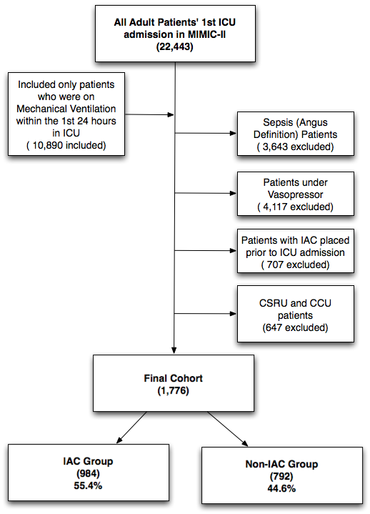

Figure 2: Propensity score distribution plot comparing the IAC and non-IAC groups before and after matching.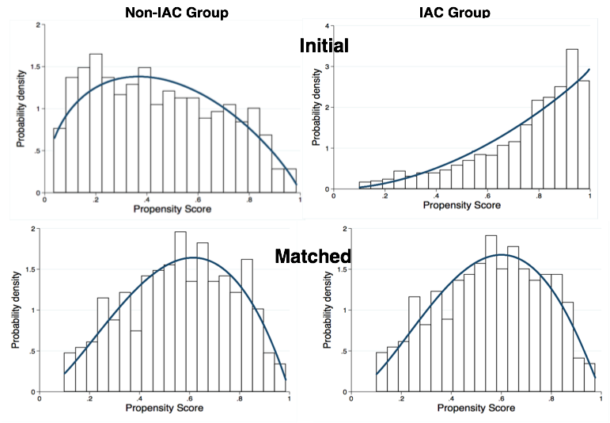

Figure 3. Sensitivity analyses using various matching caliper levels. The derived associations between IAC placement and patients’ 28-day mortality were consistent when patients were matched with various caliper levels. As shown in (a), the derived Odds Ratios were all closely around 1.0. In addition, as shown in (b), the p values for all the analyses were statistically insignificant (p>0.05).

