**Appendix: The Effect of Indwelling Arterial Catheters in Hemodynamically Stable Patients With Respiratory Failure: A Propensity Score Analysis**

**A. Construction of Propensity Score Model**

In this study, a propensity score model was developed to estimate each patient’s likelihood of getting an IAC placement. To construct the model, we first identified an initial set of 60 covariates that we believed to have potential influence on clinicians’ decisions on IAC placement. We then employed a Genetic Algorithm (GA) based method to shortlist a subset of covariates that optimize the performance of the propensity score model.

**A.1 Covariates Identification based on Clinical Knowledge**

The initial set of 60 covariates is as follows.

Demographic information that includes admission age, admission weight, BMI, gender, ethical group, time of admission (whether the patient was admitted to ICU between 7am to 7pm), day of admission and patients’ service unit (Medical or Service ICU).

Co-morbidities that were identified based on ICD-9 codes: Congestive Heart Failure (CHF) 398.91 428.0 428.1 428.20 428.21 428.22 428.23 428.30 428.31 428.32 428.33 428.40 428.41 428.42, 428, 428.2, 428.3, 428.4, 428.43, 428.9; Atrial fibrillation (A-fib) 427.3*; Chronic renal disease 585.*; End stage liver disease 571.*; Chronic Obstructive Pulmonary Disease (COPD) 490-496; Coronary Artery Disease (CAD) 414.*; Stroke 440-434; Malignancy 140-239; Respiratory failure 518.*.

Vital sign data that include patients’ Mean Arterial Pressure (MAP), temperature, heart rate, oxygen saturation (SPO2) and Central Venous Pressure (CVP).

Lab test results that include White Blood Cell (WBC) count, Hemoglobin, Platelets, Sodium, Potasssium, Bicarbonate, Chloride, BUN, Creatinine, Glucose, Calcium, Magnesium, Phosphate, Aspartate Aminotransferase (AST), Alanine Aminotransferase (ALT), Lactic Acid Dehydrogenase (LDH), Bilirubin, Alkaline phosphatase, Albumin, Troponin T, Creatinine kinase, Brain Natriuretic Peptide (BNP), Lactate, pH, Central venous oxygen saturation (ScvO2), Partial Pressure of Oxygen (PO2) and Partial Pressure of Carbon Dioxide (PCO2).

Sedative Medications that include Midazolam, Lorazepam, Fentyanol, Dilaudid, Propafol, Dexmedetomidine, Norepinephrine, Dopamine, Vasopressin, Phenylephrine, Epinephrine.

**A.2 GA-Based Covariates Selection and Model Optimization**

A GA-based algorithm was employed to select the subset of covariates that optimizes the performance of the propensity score model.

The genetic algorithm (GA) is a heuristic algorithm inspired by the natural “Survival of the fittest” selection process. It is commonly adopted for optimization and variable selection problems. It has wide application in computational biology, engineering, economics, manufacturing, physicals, mathematics and so on. It starts with a population of candidate solutions to an optimization problem. It then gradually evolves towards the better solutions through an interactive process. Usually each solution is represented in binary as a string with each bit indicating the “on/off” status of the corresponding variable. In each iteration, the “fitness” of all candidate solutions will be evaluated based on the optimization criteria. The fitter solutions will be selected to survive. The survived solutions will then randomly mutate or breed among each other to generate a new set of candidate solutions for the next iteration. The evolution/optimization process will stop, when the maximum number of iteration or satisfied results has been achieved. A more detailed introduction to GA can be found at [1].

In our study, the GA R package [2] was used to implement the optimization method. We allowed the GA algorithm to evolve over 3000 iterations with 50 candidate solution sets. The GA-based optimization was guided by the following criteria:

* Maximize the average area under the Receiver Operating Characteristic (ROC) curves of the model over a 10-fold cross validation.
* Select a minimum set of covariates for the optimum performance
* Covariates with large amount of missing data are less favorable

**A.3 Finalized Propensity Score Model**

The finalized propensity score model consists of 29 covariates as shown in Table 1. The odds ratios indicate the associations between the covariates and patients’ likelihood of getting IAC placement. Figure 1 demonstrates that, over a 10-fold cross validation, the average area under the ROC curve of the final model is 0.81. This indicates a stable performance of the final model.

Table Finalized Propensity Score Model

|  |  |  |  |  |
| --- | --- | --- | --- | --- |
|  | **Odds Ratio** | **[95% Conf.** | **Interval]** | **p-value** |
| **Age** | 0.997 | 0.988 | 1.005 | 0.426 |
| **Weight\*** | 1.001 | 0.995 | 1.007 | 0.761 |
| **SOFA** | 1.591 | 1.469 | 1.723 | 0.000 |
| **MICU (ref) vs CSRU** | 7.216 | 5.310 | 9.805 | 0.000 |
| **Day-of-ICU-Adm (Sunday as ref.)** |  |  |  |  |
| Monday | 1.504 | 0.923 | 2.450 | 0.101 |
| Tuesday | 1.183 | 0.737 | 1.899 | 0.486 |
| Wednesday | 1.575 | 0.970 | 2.558 | 0.066 |
| Thursday | 1.492 | 0.922 | 2.415 | 0.104 |
| Friday | 1.904 | 1.151 | 3.148 | 0.012 |
| Saturday | 1.128 | 0.710 | 1.793 | 0.611 |
| **Chronic Co-morbidities** |  |  |  |  |
| CHF | 1.780 | 1.091 | 2.904 | 0.021 |
| A-fib | 0.978 | 0.623 | 1.535 | 0.922 |
| Chronic Renal Disease | 1.537 | 0.703 | 3.360 | 0.281 |
| End-stage Liver Disease | 0.360 | 0.192 | 0.676 | 0.001 |
| COPD | 0.784 | 0.488 | 1.259 | 0.314 |
| CAD | 0.958 | 0.544 | 1.688 | 0.883 |
| Stroke | 1.382 | 0.873 | 2.189 | 0.168 |
| Malignancy | 1.160 | 0.785 | 1.713 | 0.456 |
| Respiratory Failure | 1.016 | 0.746 | 1.385 | 0.918 |
| **Vital Signs** |  |  |  |  |
| Mean Arterial Pressure* | 1.007 | 1.000 | 1.015 | 0.054 |
| Heart Rate* | 1.006 | 0.999 | 1.014 | 0.098 |
| SPO2* | 0.974 | 0.947 | 1.001 | 0.063 |
| Temperature* | 1.000 | 0.972 | 1.029 | 0.988 |
| **Lab Tests** |  |  |  |  |
| White Blood Cell* | 1.032 | 1.009 | 1.056 | 0.006 |
| Hemoglobin* | 0.954 | 0.888 | 1.024 | 0.191 |
| Platelet* | 1.000 | 0.998 | 1.001 | 0.726 |
| Sodium* | 0.930 | 0.892 | 0.969 | 0.001 |
| Potassium* | 1.022 | 0.863 | 1.211 | 0.799 |
| Bicarbonate* | 1.023 | 0.990 | 1.058 | 0.177 |
| Chloride* | 1.055 | 1.018 | 1.093 | 0.003 |
| BUN* | 1.006 | 0.993 | 1.019 | 0.376 |
| Creatinine* | 0.763 | 0.637 | 0.915 | 0.003 |
| PO2* | 1.001 | 1.000 | 1.002 | 0.134 |
| PCO2* | 0.996 | 0.984 | 1.007 | 0.462 |

* The first values during patients’ ICU stay of these covariates were used in the final model.

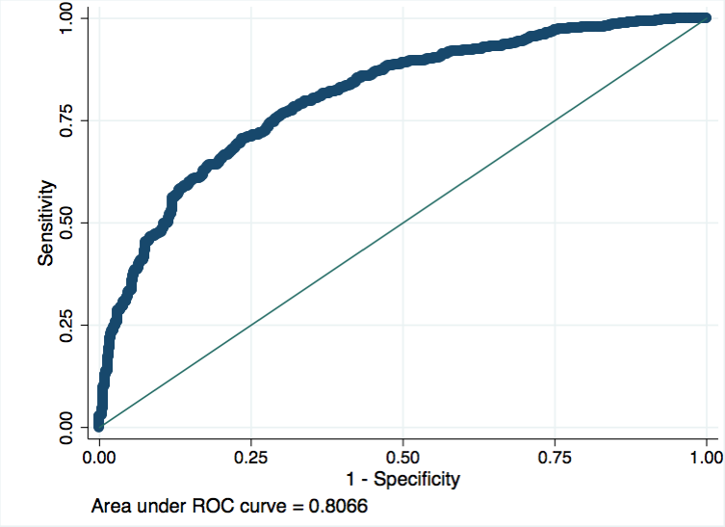

Figure Average ROC curve of the finalized Propensity Score Model over 10-fold cross-validation.

**B. Randomized Sensitivity Analysis**

In the study, 29 covariates were selected to construct the propensity score model, and patients were matched based on the estimated propensity score with a caliper of 0.01. A series of randomized sensitivity studies were conducted to investigate how it might influence our findings if variations were introduced the propensity score model and if a different caliper level was used.

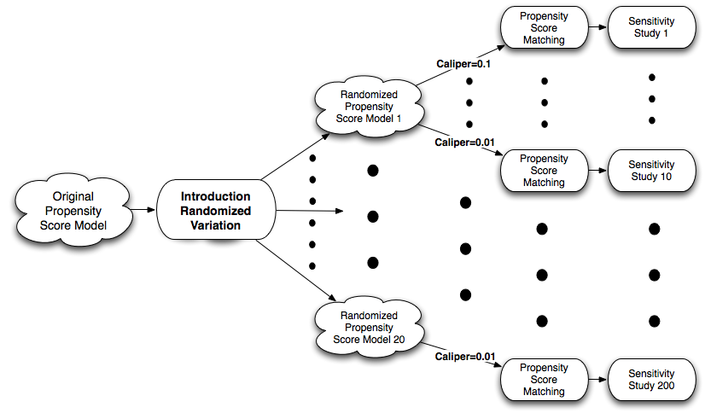

Figure Randomized sensitivity study design.

Figure 2 illustrates the flow of the proposed randomized sensitivity studies. First, variations to the propensity score model were introduced by randomly selecting a subset of covariate from the original model. Based on the selected subset of covariates, a new randomized propensity score model was constructed. The new model was only accepted if its achieved area under ROC curve was above 0.7. The randomization process was repeated until we have 20 new randomized models. For each new propensity score model, patient matching was repeated for 10 different caliper levels, ranging from 0.01 to 0.1 with a step a 0.01. For each matched cohorts, we again assessed the association between IAC placement the primary outcome. As graphically shown in Figure 2, this led to 200 sensitivity studies over various propensity score models and caliper values. Results of the sensitivity studies were discussed in the main manuscript.

**Reference**:

[1] Mitchell, Melanie (1996). An Introduction to Genetic Algorithms. Cambridge, MA: MIT Press.

[2] http://cran.r-project.org/web/packages/GA/index.html