APPLICATION OF ARTIFICIAL INTELLIGENCE IN EDUCATION.

INTRODUCTION

1.1 Background / Problem Context
Education systems worldwide face challenges such as lack of personalisation, increasing administrative workload, accessibility barriers, and delayed feedback mechanisms. Traditional teaching models often follow a one-size-fits-all approach, which fails to accommodate diverse learning styles and individual student needs. Artificial Intelligence in Education (AIEd) addresses these challenges by enabling automation, real-time feedback, adaptive learning pathways, and enhanced accessibility.

1.2 Motivation
The motivation for selecting this topic arises from the rapid integration of AI technologies into modern education systems. As a Computer Science and Artificial Intelligence student, this project provides practical exposure to applying AI concepts to real-world educational problems.

1.3 Objectives
• Study applications of AI in education
• Analyse personalised learning and instructional design
• Understand administrative automation
• Explore inclusive education technologies
• Examine benefits and limitations

1.4 Scope
This project focuses on conceptual and application-level analysis of Artificial Intelligence in Education. It does not involve real-time deployment or hardware-based solutions.

2. LITERATURE REVIEW
The application of Artificial Intelligence in Education (AIEd) has been extensively studied over the past decade, with researchers highlighting its potential to transform traditional teaching and learning processes.

2.1 Existing Systems and Research Work
One of the earliest and most widely researched applications of AI in education is the Intelligent Tutoring System (ITS). ITS platforms are designed to simulate one-to-one human tutoring by continuously analyzing student performance and adapting instructional content accordingly.
Adaptive learning platforms such as Khan Academy, Coursera, edX, and Duolingo utilize AI algorithms to recommend personalized learning pathways. These platforms collect user interaction data, quiz results, and engagement patterns to dynamically adjust content difficulty and suggest relevant learning resources.
Another significant contribution of AI in education is the use of automated assessment and grading systems. Machine learning and NLP-based models are used to evaluate objective tests, short answers, and even descriptive responses such as essays.

2.2 Key Concepts in Artificial Intelligence in Education

Artificial Intelligence in Education (AIEd)
Artificial Intelligence in Education refers to the integration of intelligent systems into educational environments to support teaching, learning, and institutional administration. AIEd systems aim to enhance learning efficiency, improve educational outcomes, and support decision-making through data-driven insights.

Machine Learning
Machine learning is a core component of AIEd systems. It enables models to learn from historical student data such as test scores, learning speed, and interaction behavior. Supervised learning techniques are commonly used for performance prediction and classification, while unsupervised learning methods help identify hidden learning patterns and student clusters.

Natural Language Processing (NLP)
Natural Language Processing allows educational systems to understand, analyze, and generate human language. NLP is widely used in automated essay evaluation, feedback generation, content summarization, and conversational agents.

3. SYSTEM / PROJECT DESIGN

3.1 System Architecture
The Artificial Intelligence in Education (AIEd) system is designed using a layered architecture that integrates data collection, intelligent processing, and actionable output generation. The architecture ensures scalability, adaptability, and efficient interaction between learners, educators, and institutional systems.
At a high level, the system consists of three core layers:
- Input Layer – responsible for collecting and managing diverse educational data
- Processing Layer – responsible for AI-driven analysis and decision-making
- Output Layer – responsible for delivering personalised learning content, feedback, and analytics
This modular architecture allows the system to support personalised and adaptive learning, administrative automation, predictive analytics, and inclusive education technologies, as discussed in the earlier sections.

3.2 Architecture Explanation

3.2.1 Input Layer: Student and Institutional Data Collection
The input layer acts as the foundation of the AIEd system by gathering structured and unstructured data from multiple sources. This data forms the basis for intelligent analysis and personalisation.
Key inputs include:
- Student academic data such as quiz scores, assignments, attendance records, and examination results
- Learning behaviour data including engagement levels, time spent on learning materials, and interaction patterns with digital platforms
- Demographic and accessibility data to support inclusive education for students with disabilities
- Institutional data such as curriculum structure, grading rubrics, course schedules, and admission records
Data is collected through Learning Management Systems (LMS), educational applications, smart classrooms, and digital assessment platforms. Proper data preprocessing, validation, and privacy safeguards are applied to ensure ethical and secure usage.

4. IMPLEMENTATION DETAILS

4.1 Technologies Used
The implementation of the Artificial Intelligence in Education (AIEd) system relies on a combination of programming tools, AI techniques, and data processing frameworks that collectively enable intelligent learning support and automation.
- Python
Python is used as the primary programming language due to its simplicity, flexibility, and extensive ecosystem of AI and data science libraries. It supports rapid development and experimentation, making it suitable for educational AI applications.
- Machine Learning Algorithms
Machine learning techniques are employed to analyse student performance data, identify learning patterns, and predict academic outcomes. Supervised learning algorithms are used to classify student proficiency levels, while unsupervised learning methods help cluster learners based on behaviour and engagement patterns.
- Natural Language Processing (NLP)
NLP enables the system to process and understand textual data such as student responses, essays, feedback, and queries.
- AI-based Recommendation Systems
Recommendation engines personalise learning experiences by suggesting suitable learning materials, practice exercises, and revision content

4.2 Dataset Description
The system uses simulated datasets to model realistic educational environments while avoiding privacy and ethical concerns related to real student data.
The dataset includes:
- Academic Performance Data: Student scores from quizzes, assignments, and examinations across multiple subjects
- Attendance Records: Presence, absence, and punctuality data used to analyse engagement levels
- Interaction Logs: Data capturing student interactions with learning platforms, including time spent on lessons, number of attempts, and resource usage
These datasets are structured in tabular format and preprocessed to remove inconsistencies, handle missing values, and normalise features for AI analysis. The simulated nature of the data allows controlled experimentation, evaluation of AI models, and validation of personalised learning recommendations.

5. RESULTS AND ANALYSIS

5.1 Analysis of Advantages
The results highlight several advantages of integrating AI into education systems:
- Personalised Learning: AI-driven adaptation ensures that learning experiences are tailored to individual needs, learning styles, and pacing, leading to better comprehension and retention.
- Reduced Educator Workload: Automation of grading, reporting, and administrative tasks allows teachers to focus more on mentoring, instruction, and student interaction.
- Improved Accessibility and Inclusion: AI-powered assistive technologies support students with disabilities through features such as text-to-speech, summarisation, and adaptive scheduling.
- Data-Driven Decision Making: Institutions can leverage AI-generated insights to improve curriculum design, student support strategies, and resource allocation.
These advantages collectively contribute to a more efficient, responsive, and inclusive educational environment.

5.1 Limitations
Despite its benefits, the AIEd system also presents certain limitations that must be carefully considered:
- Data Dependency: The effectiveness of AI models is highly dependent on the quality, accuracy, and completeness of input data. Inaccurate or biased data can lead to unreliable recommendations and predictions.
- Ethical Concerns: The use of AI in education raises concerns related to fairness, algorithmic bias, and over-reliance on automated decision-making, which may affect student evaluation and opportunities.
- Privacy and Security Issues: Handling sensitive student data requires strict compliance with data protection regulations. Inadequate security measures may expose personal and academic information to misuse.
- Human Oversight Requirement: AI systems cannot fully replace human judgment, empathy, and pedagogical expertise. Continuous monitoring and involvement of educators remain essential.

6. GITHUB DETAILS

Repository URL:
https://github.com/a4mh25ca034-web/AI_FOR_EVERYONE

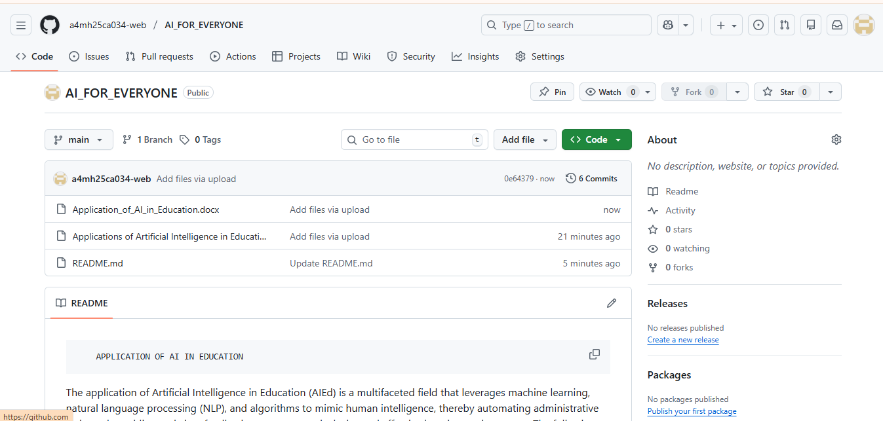

7. CONCLUSION
Artificial Intelligence has significant potential to transform the education system by enhancing efficiency, personalisation, and accessibility across all levels of learning. Through intelligent data analysis, adaptive learning pathways, and automated administrative processes, AI enables educational systems to move beyond traditional one-size-fits-all approaches and address the diverse needs of learners.
The findings of this project demonstrate that AI-driven educational systems can deliver timely feedback, support personalised instruction, and assist educators by reducing administrative workload. Predictive analytics further contribute to early identification of at-risk students, enabling proactive interventions that improve academic outcomes and reduce dropout rates. Additionally, AI-powered assistive technologies play a vital role in promoting inclusive education by supporting learners with disabilities and varying learning capabilities.
However, the successful adoption of AI in education depends on responsible and ethical implementation. Issues related to data privacy, algorithmic bias, and over-reliance on automation must be carefully managed through transparent policies, secure data handling practices, and continuous human oversight. AI should be viewed as a supportive tool that complements educators rather than a substitute for human teaching and mentorship.
In conclusion, when implemented thoughtfully and ethically, Artificial Intelligence can serve as a powerful enabler of high-quality, equitable, and future-ready education, benefiting students, educators, and institutions alike.

REFERENCES
Hallquist, E., Gupta, I., Montalbano, M., & Loukas, M. (2025). Applications of artificial intelligence in medical education: A systematic review. Cureus, 17(3), e79878. https://doi.org/10.7759/cureus.79878
20250302-724738-7f352i
Mahrishi, M., Abbas, A., & Siddiqui, M. K. (2025). Global initiatives towards regulatory frameworks for artificial intelligence (AI) in higher education. Digital Government: Research and Practice, 6(2), Article 20. https://doi.org/10.1145/3672462
3672462
Prasetya, F., Fortuna, A., Samala, A. D., Latifa, D. K., Andriani, W., Gusti, U. A., Raihan, M., Criollo-C., S., Kaya, D., & Cabanillas García, J. L. (2025). Harnessing artificial intelligence to revolutionize vocational education: Emerging trends, challenges, and contributions to SDGs 2030. Social Sciences & Humanities Open, 11, 101401. https://doi.org/10.1016/j.ssaho.2025.101401
1-s2.0-S2590291125001287-main
Wang, C., Li, T., Lu, Z., Wang, Z., Alballa, T., Alhabeeb, S. A., Albely, M. S., & Khalifa, H. A. E.-W. (2025). Application of artificial intelligence for feature engineering in the education sector and learning science. Alexandria Engineering Journal, 110, 108–115. https://doi.org/10.1016/j.aej.2024.09.100
1-s2.0-S1110016824011244-main
Capecchi, I., Borghini, T., Bellotti, M., & Bernetti, I. (2025). Enhancing education outcomes by integrating augmented reality and artificial intelligence for nutrition and food sustainability. Sustainability, 17(5), 2113. https://doi.org/10.3390/su17052113
sustainability-17-02113-v2
Gupta, S. K., Alemran, A., Basha, U. S., Zakari, A. I., Kim, S., Boddu, R. S. K., & Vohra, S. K. (2025). Revolutionizing the way students learn photographic arts through experiential education using AI and AR systems. Scientific Reports, 15, 40705. https://doi.org/10.1038/s41598-025-24415-8
s41598-025-24415-8
Choi, W. C., Choi, I. C., & Chang, C. I. (2025). The impact of artificial intelligence on education: Applications, advantages, challenges, and researchers’ perspectives. Preprints.org. https://doi.org/10.20944/preprints202501.1420.v1
preprints202501.1420.v1
Garzón, J., Patiño, E., & Marulanda, C. (2025). Systematic review of artificial intelligence in education: Trends, benefits, and challenges. Multimodal Technologies and Interaction, 9(8), 84. https://doi.org/10.3390/mti9080084
mti-09-00084-v2

