**ECE 385**

Fall 2024

Experiment #1

**Introductory Experiment**

Xuhang Xiao

Lab Section: AB1

**Purpose of Circuit:**The purpose of this circuit is to

**Written Description of Circuit**

**Truth Table, Karnaugh maps, and Boolean Equations**

**Table 1: 2:1 Mux Truth Table**

|  |  |  |  |
| --- | --- | --- | --- |
| A | B | C | Z |
| 0 | 0 | 0 | 0 |
| 0 | 0 | 1 | 1 |
| 0 | 1 | 0 | 0 |
| 0 | 1 | 1 | 0 |
| 1 | 0 | 0 | 0 |
| 1 | 0 | 1 | 1 |
| 1 | 1 | 0 | 1 |
| 1 | 1 | 1 | 1 |

**Table 2: 2:1 Mux K-Map**

|  |  |  |  |  |
| --- | --- | --- | --- | --- |
| A BC | 00 | 01 | 11 | 10 |
| 0 | 0 | 1 | 0 | 0 |
| 1 | 0 | 1 | 1 | 1 |

Prelab A:

**Figure 1: Derivation of Boolean Equation**

Boolean Equation: Z = B’C + AB

Prelab B:

**Figure 2: Modified Boolean Equation to Remove Static Hazard**

Modified Boolean equation:

Z = B’C + AB + AC = ( (B’C)’ (AB)’ (AC)’ )’

**Logic Diagrams and Circuit Diagrams (schematic)**

**Figure 3: Logic Diagrams**

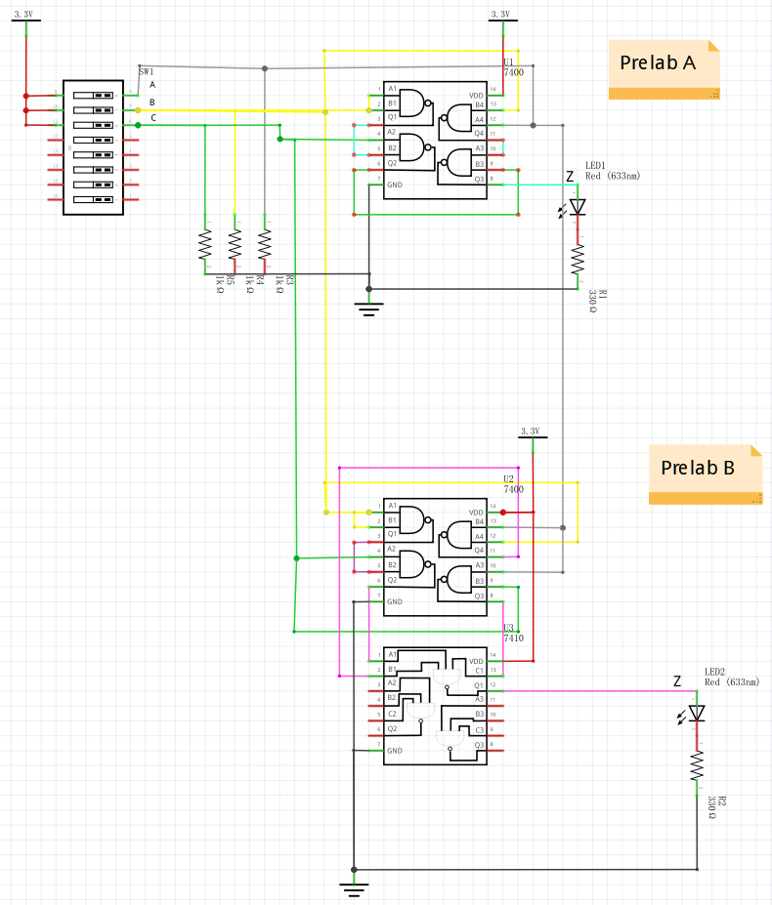

**Figure 4: Circuit Diagrams**

**Component Layout(breadboard):**

**Figure 5: Component Layout**

**Oscilloscope printout**

**Figure 6: Oscilloscope printout for native 2:1 MUX**

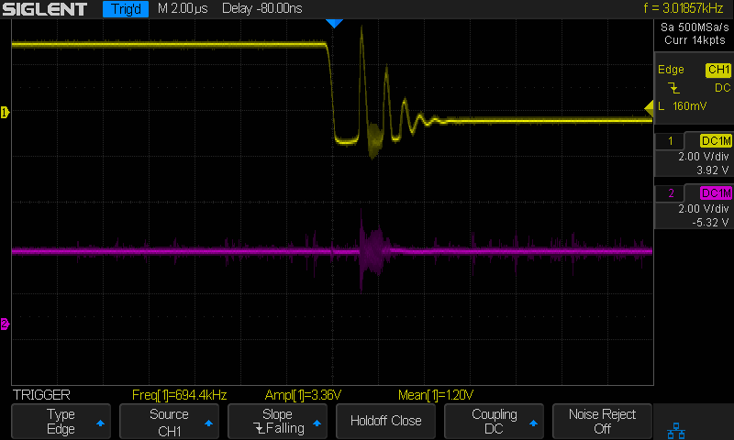

**Figure 7: Oscilloscope printout for modified 2:1 MUX**

**Answers to Pre-Lab Questions:**

*Why not all groups observe static hazards?*

Need this?

*Why does the hazard appear when you do this?*

Both practices increase the propagation delay of signal which makes the static hazard more observable.

**Answers to Lab Questions:**

*Describe and save the output and explain any differences between it and the results obtained in part 2.*

The output of the circuit in part B is steadier than the circuit in part A at the falling edge of the B signal, as shown in Figure7. This is because the new logic (AC)’ is independent of the change in B, it is constant on the rising and falling edge of B signal. In this case it forces the output to be 1 by feeding 0 into the last NAND gate. Adding this redundant term provides extra paths for signals so that any input change would be captured instantly despite the effect of propagation delay.

*For the circuit of part A of the pre-lab, at which edge (rising/falling) of the input B are we more likely to observe a glitch at the output?*The chance of observing glitch is equal.

**Answers to Post-Lab Questions:**

*Given that the guaranteed minimum propagation delay of a 7400 is 0ns and that its guaranteed maximum delay time is 20ns, complete the timing diagram below for the circuit of part A.*

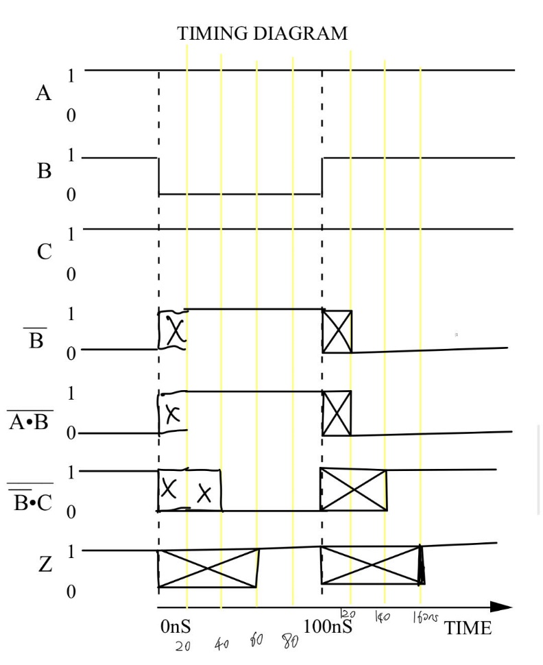

Figure 8: Timing Diagram

*How long does it take the output Z to stabilize on the falling edge of B (in ns)? How long does it take on the rising edge (in ns)? Are there any potential glitches in the output, Z? If so, explain what makes these glitches occur.*

It takes 60ns to stabilize on the falling edge and on the rising edge respectively. There would be potential glitches, Z would be unknown during 0 to 60ns and 100 to 160 ns, due to propagation delay of signal passing through the 4 NAND gates.

Answer:

*Explain how and why the debouncer circuit given in General Guide (Figure 22) works. Specifically, what makes it behave like a switch and how the ill effect of mechanical contact bounces is eliminated?*

Answer:

**Answers to questions from the General Guide (7,23)**

*What is the advantage of a larger noise immunity? Why is the last inverter observed rather than simply the first? Given a graph of output voltage (VOUT) vs. input voltage (VIN) for an inverter, how would you calculate the noise immunity for the inverter?*

*If we have two or more LEDs to monitor several signals, why is it bad practice to share resistors?*

**Conclusions**