The understanding of data:
These data includes ten kinds of items. When I doing statistical calculations there were commas as thousand separators in the attribute. So I have used the argument thousands="," to convert the text attribute to float type. Also, some column names have both leading and trailing spaces, which caused some errors.
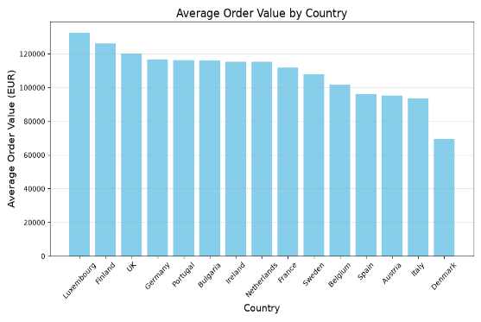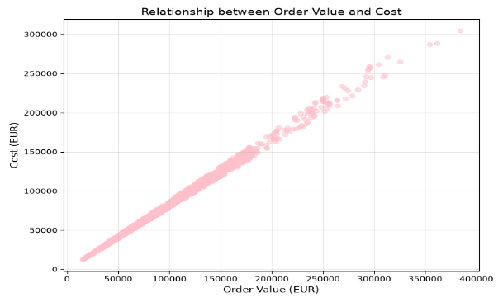
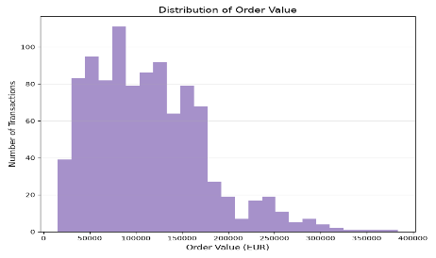
Three Core Patterns
1.The size of orders between different deals really have a big different. The average order size is 113361.74 EUR, the minimum is only 15100.57 EUR, and the maximum is 383996.76 EUR. And 75% of all orders are less than 151192.64 EUR. There is a high imbalance in orders of customers.And it is very interesting that both an order with the largest amount and an order with the biggest cost all comes form the same deal about UK.
2.There are considerable differences in average order size among different countries. Luxembourg have the best performance and Denmark registering is one of the lowest levels of orders. Although France, Portugal, and Sweden register high levels of overall revenue, this is attributed to the high levels of transaction, rather than the average size of the orders. The preferences in procurement processes are therefore country-specific. The customers from Luxembourg and Finland prefer buying in bulk while those from Denmark prefer small orders.
3.Order amount has a positive correlation to the cost of the products. On average, cost for all the samples is 94369.31 EUR. Cost maximum is 304701.43 EUR; Cost minimum is 12113.68 EUR. In each country, those with higher order amounts on average have higher costs on average. High order amounts lead to high product costs and not just profits.
Three recommendations
1.Companies can concentrate on marketing their bulk purchasing services to their important business customers in Luxembourg and Finland. retaining their important high order value customers, discovering new high order value deals, and taking advantage of their high order values.
2. Although the transaction size in Denmark is quite low, the transaction number is rather high. Thus, it is possible to implement special operations targeted at the Danish market. For example, we can introduce bundle offers to motivate consumers to buy more in order to increase the order value.(Implement bundle offers in the Denmark market, assuming a 20% increase in order value and a 12% increase in cost)
3. Because large orders also indicate high cost, then pricing negotiations should be considered in purchasing raw material for large orders or designing products that have high profit margins.(Negotiate better raw material terms for large orders (order_value > 200000 EUR), reducing costs by 8%; revenue remains unchanged)
Issues remaining after this analysis
- The threshold test simply tests the average order value of the whole data set of 113,361.74 EUR against the target figure of 110,000 EUR; there is no way to test each individual country for their business targets.
(why 110000EUR: it is a number between medium and mean.)
2.No outside viewpoint is possible: for example, prices of goods and the competitive environment in each country.
3. There is no information regarding profit or expenses; only date values are available.

