Used Car Price Prediction and Market Segmentation: the Clustering Part
Borislav Čelar (SV 60/2021) – clustering · Dušan Damjanov (SV 68/2021) – regression

Motivation
The used car market is large, fragmented and notoriously opaque: two visually similar cars can differ in price by a factor of two because of mileage, ownership history or condition. Our project approaches this market from two complementary sides using the same dataset. The first part (covered in a separate section by the second team member) predicts the sale price of a car with supervised regression. This report covers the second part: discovering natural market segments among used cars with unsupervised clustering. A good segmentation is useful on its own – online marketplaces can use it for navigation, recommendations and pricing sanity checks, dealers for inventory planning – and it also serves as a sanity check of the whole pipeline: if segments formed without any price information end up with clearly different average prices, the discovered structure is likely to be real rather than an artifact of the algorithm.

Research questions
We wanted to answer three specific questions. RQ1: Do used cars form meaningful groups when clustered only by their age, usage and vehicle-type attributes, with the target variable excluded from the input? RQ2: Which clustering algorithm and which number of clusters describe this dataset best according to internal validation measures? RQ3: Do the discovered clusters differ in average sale price, even though price was never used as an input?
We used the Used Car Price Prediction dataset from Kaggle [10], which contains 7,400 listings of used cars from an Indian marketplace with 29 attributes, including the manufacturing year, kilometres run, fuel type, transmission, body type, number of previous owners, a textual condition rating (great/good/fair/overpriced), the number of times an ad was viewed, and the target variable sale_price (in Indian rupees). Following the project specification we work with a subset of 5,000 rows, sampled stratified by price quantiles so that the price distribution of the subset stays faithful to the original; after removing duplicates and rows with an invalid price, 4,999 listings remain. Columns that are essentially derived from the price itself (broker_quote, original_price, EMI instalments) are dropped in the shared preprocessing, since they would leak the target into both parts of the project.

Related work
Most published work on this dataset family is supervised: used-car price prediction with classical machine learning has been studied, for example, by Pudaruth [7], who compared linear regression, k-nearest neighbours and decision trees on cars from Mauritius, and by Gegic et al. [8], who combined several classifiers on scraped car listings. The unsupervised side is usually framed as market or customer segmentation, where K-Means [1] is the standard workhorse. Hierarchical agglomerative clustering with Ward’s criterion [2] is a common alternative that additionally exposes the merge structure through a dendrogram, while DBSCAN [3] discovers clusters of arbitrary shape and labels low-density points as noise, which makes it attractive for datasets with outliers.
Since ground-truth segment labels do not exist, clustering quality is typically judged by internal validation indices; we follow the standard trio: the silhouette coefficient [4], the Davies-Bouldin index [5] and the Calinski-Harabasz index [6]. For datasets that mix numerical and categorical attributes, Huang [9] proposed k-prototypes as an extension of k-means; the more common pragmatic approach, which we adopt, is one-hot encoding followed by standardisation and dimensionality reduction.

Methodology
The pipeline is implemented in Python with scikit-learn [11] and is fully reproducible (fixed random seed 42); the regression and clustering parts share one preprocessing module so both work on the same cleaned data. From the cleaned dataset we selected nine attributes that describe a car’s age, usage and type and remain easy to interpret: five numerical (car_age, kms_run, km_per_year, total_owners, times_viewed) and four

categorical (fuel_type, transmission, body_type, car_rating). High-cardinality attributes such as city, RTO code or model variant were deliberately left out: they would inflate the one-hot space to hundreds of dimensions and make the resulting clusters very hard to describe. The condition rating deserves a note: although it looks numeric at first glance, it is a textual grade, so we treat it as categorical. The target sale_price is kept aside and used only after clustering, for interpretation.
Because distance-based algorithms are sensitive to attribute scale, preprocessing does the following: missing numerical values are imputed with the median and extreme values are clipped at the 1st/99th percentile; heavily right-skewed attributes (kms_run, km_per_year, times_viewed) are log1p-transformed; all numerical attributes are standardised; categorical attributes are one-hot encoded with rare categories grouped, giving 24 input dimensions in total. Finally, PCA reduces the space to the number of components that keeps 90% of the variance – seven components (91.2% retained). Clustering runs in that 7-dimensional space; the first two components (53% of the variance) are used for 2D visualisation only.
We compared three algorithms: K-Means (n_init = 10) as the baseline, agglomerative hierarchical clustering with Ward linkage, and DBSCAN. The number of clusters for K-Means was chosen by combining the elbow method on inertia with silhouette analysis over k = 2–10; the same k was used for the hierarchical variant so that the comparison is fair. For DBSCAN, eps was estimated from the k-distance graph (distance to the 10th nearest neighbour, min_samples = 10) and then refined by a small grid search around that estimate.

Discussion
Choosing k. Figure 1 shows the model-selection evidence. The elbow curve has no sharp knee, which is common with real data, but the largest drops in inertia happen up to k = 3–4. The silhouette score peaks at k = 3 (0.217 vs. 0.212 for k = 2 and 0.194 for k = 4), so we fixed k = 3. The dendrogram of the hierarchical variant also splits naturally into three large branches, which supports the same choice. A three-cluster solution is also the easiest to communicate, which matters for a market-segmentation use case.
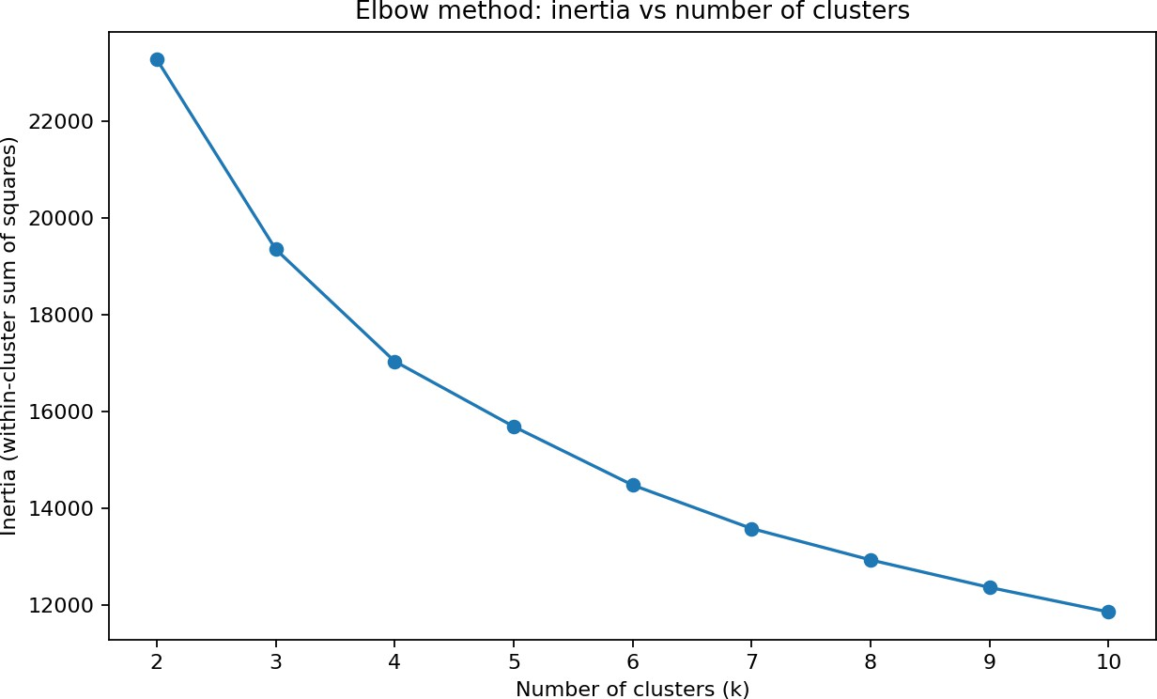
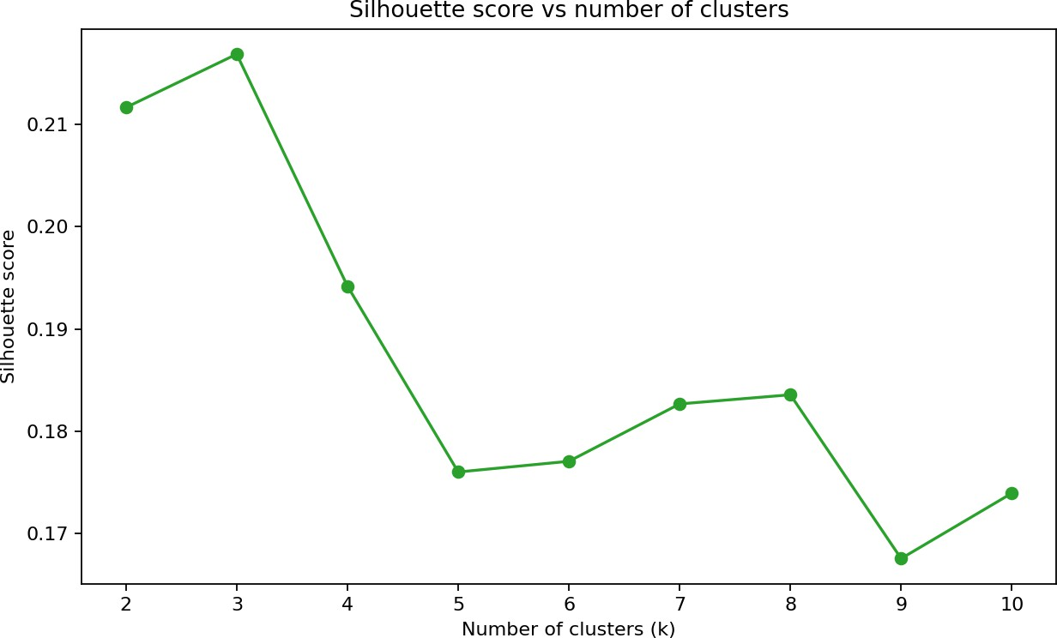
Figure 1. Elbow method (left) and silhouette analysis (right) for choosing the number of clusters
Algorithm comparison. Table 1 compares the three algorithms with internal validation measures (silhouette and Calinski-Harabasz: higher is better; Davies-Bouldin: lower is better). K-Means wins on all three and was selected as the final model. The initial k-distance estimate for DBSCAN (eps ≈ 2.6) merged everything into a single cluster; the grid search found a usable eps = 1.56 with three clusters and 28 noise points, but the solution is still the weakest of the three – the data simply has no dense regions separated by empty space for DBSCAN to exploit. One caveat for fairness: DBSCAN’s scores are computed after excluding its noise points, which slightly favours it, so its actual gap is even larger than the table suggests.
Table 1. Internal validation measures for the three clustering algorithms
Algorithm | Clusters | Noise points | Silhouette | Davies-Bouldin | Calinski-Harabasz
K-Means (k = 3) | 3 | 0 | 0.217 | 1.62 | 1,407
Agglomerative (Ward) | 3 | 0 | 0.189 | 1.72 | 1,193
DBSCAN (eps = 1.56) | 3 | 28 | 0.150 | 2.05 | 577
Resulting segments. Figure 2 shows the final K-Means solution projected onto the first two principal components, and Table 2 summarises the cluster profiles together with the average sale price, which was

computed only after clustering. Since the whole dataset is dominated by petrol cars with manual transmission and hatchback bodies, the per-cluster mode of each categorical attribute is uninformative; Table 2 therefore lists the categories that are over-represented in a cluster relative to the whole dataset.
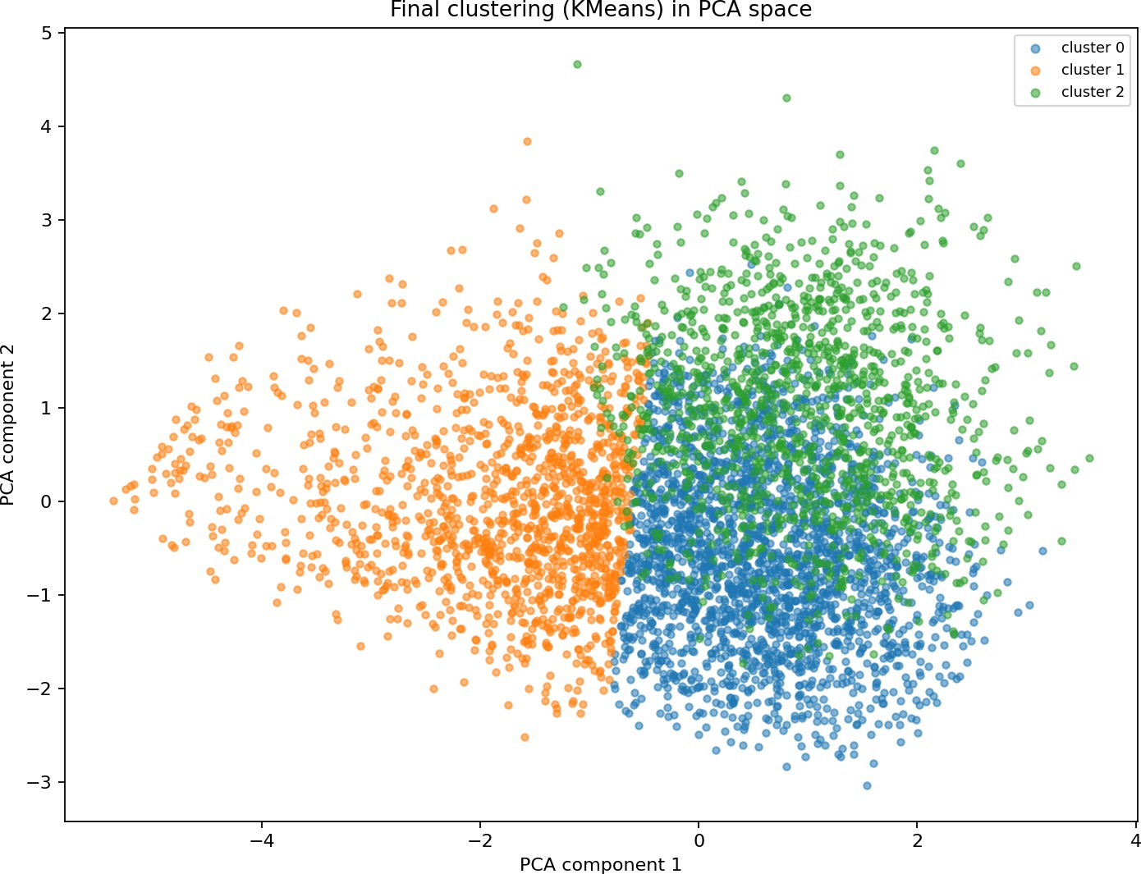
Figure 2. Final K-Means clustering (k = 3) in the PCA projection

Table 2. Cluster profiles (means) and per-cluster sale price, computed after clustering
 | Size | Age (yrs) | Kms run | Km/year | Owners | Ad views | Over-represented categories | Avg. price (INR) | Median price (INR)
C0 | 2,316 | 7.4 | 79,488 | 10,146 | 1.00 | 1,220 | diesel (42%), sedan (24%) | 455,096 | 388,449
C1 | 1,409 | 5.0 | 21,561 | 3,885 | 1.07 | 1,953 | petrol (86%), hatchback (69%), automatic gearbox | 516,005 | 441,899
C2 | 1,274 | 8.8 | 75,351 | 8,035 | 2.17 | 1,433 | rating good or worse (×1.5) | 387,235 | 319,699
The three segments have a clear real-world reading. C1 – younger, well-preserved cars (28%): the youngest cars (5 years on average) with by far the lowest mileage, almost always first-owner, mostly petrol city hatchbacks with an above-average share of automatic gearboxes; they attract the most ad views and have the highest prices. C0 – heavily used first-owner cars (46%): mid-age cars with the highest mileage (over 10,000 km/year), almost exclusively one owner, with diesel engines and sedans over-represented – consistent with regular long-distance use; mid-range prices. C2 – older multi-owner cars (25%): the oldest cars, more than two owners on average, and the only segment where condition ratings below great are over-represented; accordingly the cheapest segment. Figure 3 visualises the profiles and the price ordering.
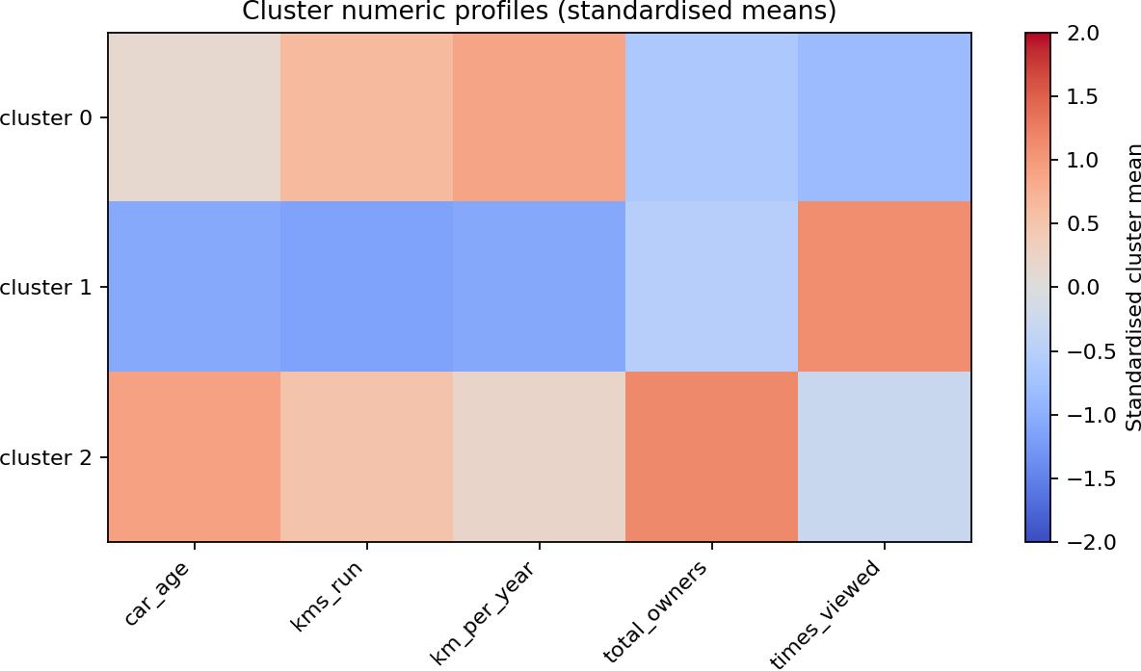
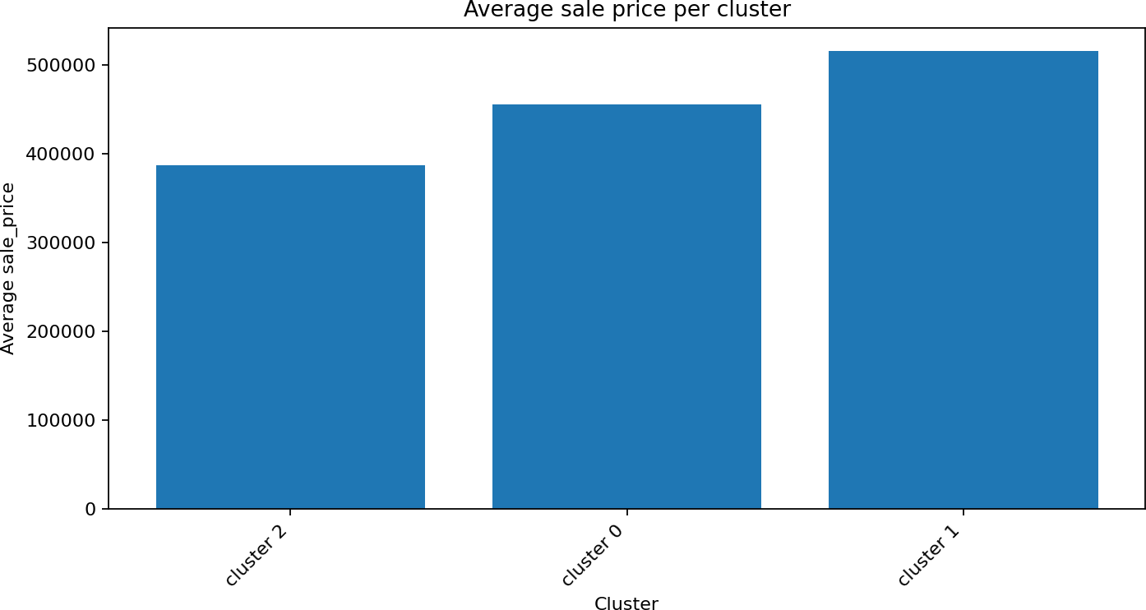
Figure 3. Standardised numeric cluster profiles (left) and average sale price per cluster (right)
Error analysis and limitations. The silhouette of 0.217 is moderate: the segments overlap and the market is better described as a continuum with three recognisable poles than as three sharply separated islands. This is expected for mixed numerical/one-hot data, and the 2D scatter must be read with care since the projection

keeps only 53% of the variance. The answer to RQ3 is nevertheless clearly positive: mean prices differ by about 33% between the cheapest and the most expensive segment (387k vs. 516k INR, medians 320k vs. 442k) with a consistent ordering, although price never entered the model. Known limitations: the one-hot/Euclidean treatment of categorical attributes is a pragmatic compromise (k-prototypes or Gower distance would be a principled alternative [9]); the condition rating is missing or uninformative for a small part of listings; and a single erroneous listing with a price of 35 INR survives cleaning, which is why we report medians alongside means.

References
- J. MacQueen, “Some methods for classification and analysis of multivariate observations,” in Proc. 5th Berkeley Symp. on Mathematical Statistics and Probability, 1967, pp. 281–297.
- J. H. Ward, “Hierarchical grouping to optimize an objective function,” Journal of the American Statistical Association, vol. 58, no. 301, pp. 236–244, 1963.
- M. Ester, H.-P. Kriegel, J. Sander, and X. Xu, “A density-based algorithm for discovering clusters in large spatial databases with noise,” in Proc. KDD-96, 1996, pp. 226–231.
- P. J. Rousseeuw, “Silhouettes: a graphical aid to the interpretation and validation of cluster analysis,” Journal of Computational and Applied Mathematics, vol. 20, pp. 53–65, 1987.
- D. L. Davies and D. W. Bouldin, “A cluster separation measure,” IEEE Transactions on Pattern Analysis and Machine Intelligence, vol. PAMI-1, no. 2, pp. 224–227, 1979.
- T. Caliński and J. Harabasz, “A dendrite method for cluster analysis,” Communications in Statistics, vol. 3, no. 1, pp. 1–27, 1974.
- S. Pudaruth, “Predicting the price of used cars using machine learning techniques,” International Journal of Information & Computation Technology, vol. 4, no. 7, pp. 753–764, 2014.
- E. Gegic, B. Isakovic, D. Keco, Z. Masetic, and J. Kevric, “Car price prediction using machine learning techniques,” TEM Journal, vol. 8, no. 1, pp. 113–118, 2019.
- Z. Huang, “Extensions to the k-means algorithm for clustering large data sets with categorical values,” Data Mining and Knowledge Discovery, vol. 2, no. 3, pp. 283–304, 1998.
- V. Sharma, “Used Car Price Prediction” dataset, Kaggle. [Online]. Available: https://www.kaggle.com/datasets/vrajesh0sharma7/used-car-price-prediction
- F. Pedregosa et al., “Scikit-learn: machine learning in Python,” Journal of Machine Learning Research, vol. 12, pp. 2825–2830, 2011.

