# **ABSTRACT**

This project has been developed to fulfill the registered course, "Project for the Bachelor degree of Computer Science and Information Technology in Tribhuvan University”. It has been submitted to Bsc.CSIT department of Mount Annapurna College.

We use Flutter with Dart for developing the Pet Adoption App and Firebase for storing the data. It is a complete Customer to Customer based e-commerce app.

Many people face different problems like difficulty in raising pets or rescuing a pet. So, keeping these problems in mind we as CSIT student decided to develop a Pet Adoption App which can be which make easier for people to be able to adopt a pet online. For our project, we aim to develop a pet adoption app, an android app, which provides people a better way to find pets. It is important to let people find available listed pets effectively. This app helps to reduce the gap between needy pets and people. In the future we aim to release our application on different platform and serve other users too.

***Keywords:*** *AdoptMe, Pet Adoption App, Pets, Dogs*

**Table of Contents**

**ABSTRACT** i

**LIST OF FIGURES** v

**LIST OF TABLES** vi

**CHAPTER 1 : INTRODUCTION** 1

**1.1. Project Background** 1

**1.2. Problem Statement** 1

**1.3. Objectives** 1

**1.4. Application** 1

**1.5. Project Features** 2

**1.6. Feasibility Study** 2

**1.6.1. Economic Feasibility** 2

**1.6.2. Technical Feasibility** 2

**1.6.3. Operational Feasibility** 2

**1.6.4. Schedule Feasibility** 3

**1.7. Requirements Analysis** 3

**1.7.1. Hardware Requirements** 3

**1.7.2. Software Requirements** 3

**CHAPTER 2 : LITERATURE REVIEW** 4

**2.1. Existing System** 4

**2.1.1. Hamrobazaar** 4

**2.1.2. Various Rescue and Adoption Organizations** 4

**2.2. Our Proposed System** 4

**CHAPTER 3 : Methodology** 5

**3.1. System Development Methodology** 5

**3.2. Flowchart** 6

**3.2.1. Overall System Flowchart** 6

**CHAPTER 4 : EPILOGUE** 7

**4.1. Expected Output** 7

**4.2. Budget Analysis** 7

**REFERENCES** 8

# **LIST OF FIGURES**

Figure 2.1.2.1 Agile Method for Software Development 5

Figure 3.2.1.1 Flowchart of Overall System 6

# **LIST OF TABLES**

Table 1.6.1 Gantt Chart for Work Schedule 3

Table 4.2.1 Budget Analysis 7

# **INTRODUCTION**

## **Project Background**

“Pet Adoption App” is completely an Android application. With the help of internet, the user can connect to server for accessing the data which will help user to view and contact the owner who has listed their pets for adoption. In recent days, the online service is being more reliable among the users. So, they want various services be available online with portable, easily accessible as well as user friendly UI. So here, we are going to develop an android app having all feature that will make it easily accessible as well as easy to use for any type of user.

## **Problem Statement**

Traditionally, pets are owned via certain stores that sells pets. But while doing so, we have to spend time going to shop, choosing the right pet. Moreover, pets aren’t cheap for everyone to afford and there is less culture of adopting pets. So, it is recommended to have a facility through which adopters can adopt pets from those who are facing difficulty in raising them. Also, there is a problem of overflow of abandoned pets in street. Thus, regarding these problems, we have proposed this project. This will minimize various difficulties and prove to be simple, fast, scientific, user-friendly and inexpensive.

## **Objectives**

The major objective of this app is to create a people friendly online platform where people come to know about various pet that require their help, so they can adopt them and take their pain away.

The main objectives of the app include:

* To provide the easier, faster and user-friendly way to adopt a pet online,
* To get good homes quickly as possible for every deserving pets.

## **Application**

* It is applicable in Customer to Customer (C2C) sector.
* It is applicable in various NGOs and INGOs that are working in animal rescue sector.
* It is also applicable in pet stores as well as shelter homes to list out available pets with their information.

## **Project Features**

* **User entered data**

The users are able to enter their own data themselves. They can control what types of data they enter. This makes the app self-running with nearly zero Superuser interactions.

* **List accessible to everyone**

The list of available pets is accessible by everyone that are verified in the app. There will be no hiding of any kind of information from user.

* **E-mail Verification**

This feature enables user to verify their email and lets only genuine users enter into the app environment. Verification is provided by Firebase Authentication which is secure, fast and very reliable.

* **Password Reset Feature**

This feature will enable user to reset their password in only few clicks. An email will be sent via Firebase Authentication Module that will assist user in changing password for his/her account.

## **Feasibility Study**

A project always continues based on the feasibility analysis. There are various factors that make a project feasible. The four major analysis that major concerns for feasibility study were conducted as follows:

### **Economic Feasibility**

Economic analysis is the most frequently used method for evaluating the effectiveness of the new system. The project is economically feasible as it only requires android mobile phone and a laptop/computer.

### **Technical Feasibility**

The hardware feasibility is android mobile and a computer. The technical requirements for the app are economic and doesn’t use any other additional hardware and software. The current project is technically feasible as it mostly uses open source IDE and languages.

### **Operational Feasibility**

The app is easy to use and learn due to its simple but attractive interface. User doesn’t require any type of additional special training for operating the app.

### **Schedule Feasibility**

The schedule time for the accomplishment of the project was three month and was enough to finalist the project. However, examination and other activities can sometime make us bustle which obstacle on project completion beside of that project is feasibility on schedule.

Table 1.6.1 Gantt Chart for Work Schedule

## **Requirements Analysis**

A Requirements Analysis minimizes the time and effort required by developers to achieve desired goals and also minimizes the development cost. A good software requirement specification defines how an application will interact with system hardware, other programs and human users in a wide variety of real-world situations.

### **Hardware Requirements**

* Processor: Intel core i3 equivalent or higher
* RAM: 4 GB minimum
* Hard Disk: 50 GB
* An Android phone with Android version 8(API level 26) or higher

### **Software Requirements**

* Frontend: Flutter with Dart
* Backend: Firebase
* Tools: Visual studio Code, Android Emulator, Flutter SDK, Android SDK

# **LITERATURE REVIEW**

AdoptMe is an android based app which will be developed to provide people a platform for adopting pets. It helps user to post the available pet for adoption and also to view the list of available pets that are put for adoption. The coding is done through Visual Studio Code using Dart programming language and using Firebase as backend and database support.

## **Existing System**

### **Hamrobazaar**

[1]Hamrobazar.com is FREE online classified which enables individuals as well as companies to list wide variety of new or used product online. Although there is a Pet Adoption category, it doesn’t focus purely on pets. It mainly focuses on second hand electronic and automobile sections. Also the list is not filtered well with other categories item also being displayed in pets section.

### **Various Rescue and Adoption Organizations**

There are a number of organizations and websites that are working in this field. However, they are limited to website only which makes a bit difficult for users to interact. Sites like [2]Sneha Care, [3]Animal Nepal, etc. are operating in Nepalese context. However, they are mostly working in dog’s field and are only rescuing the street animals. In adoption program they mainly lack a problem. Listing of available pets are not done properly which ultimately creating low adoption chances.

## **Our Proposed System**

Pet Adoption App is an android based application which is connected to a complete database. The database includes information about pets, color, age, weight, owner contact details and picture of the animal. There won’t be any kind of billing or checkout section as the system main purpose is to create a platform for two customers to meet together.

The information entry is done by the owner and is also be able to see other listings as well. The database updates quickly after user adds new entry also every 15 minutes the page gets refreshed automatically or user can refresh list with the help of dedicated button.

# **Methodology**

## **System Development Methodology**

For any project to be successful, it has to go through various stages known as Development Life Cycle. System Development Life Cycle (SDLC) is the process of understanding how an Information System (IS) can support business needs, designing the system, building it and delivering it to users. The SDLC composes of four phases: Planning, Analysis, Design and Implementation. In order for this project to be successful, we have decided to use Agile Software Development Methodology. [4]Agile Software Development is a practice where the members meet up, self-organize, collaborate amongst the cross-functional teams and clients while they progressively evolve in the project development process. It is an iterative process where the requirements and the solution keep evolving through several stages and delivers faster and qualitative results.

**Uses:** Agile is particularly well-suited for large and complex projects; those that can be easily divided into smaller parts. It’s also useful for mid-size custom software development projects where business requirements cannot be easily translated into detailed requirements.

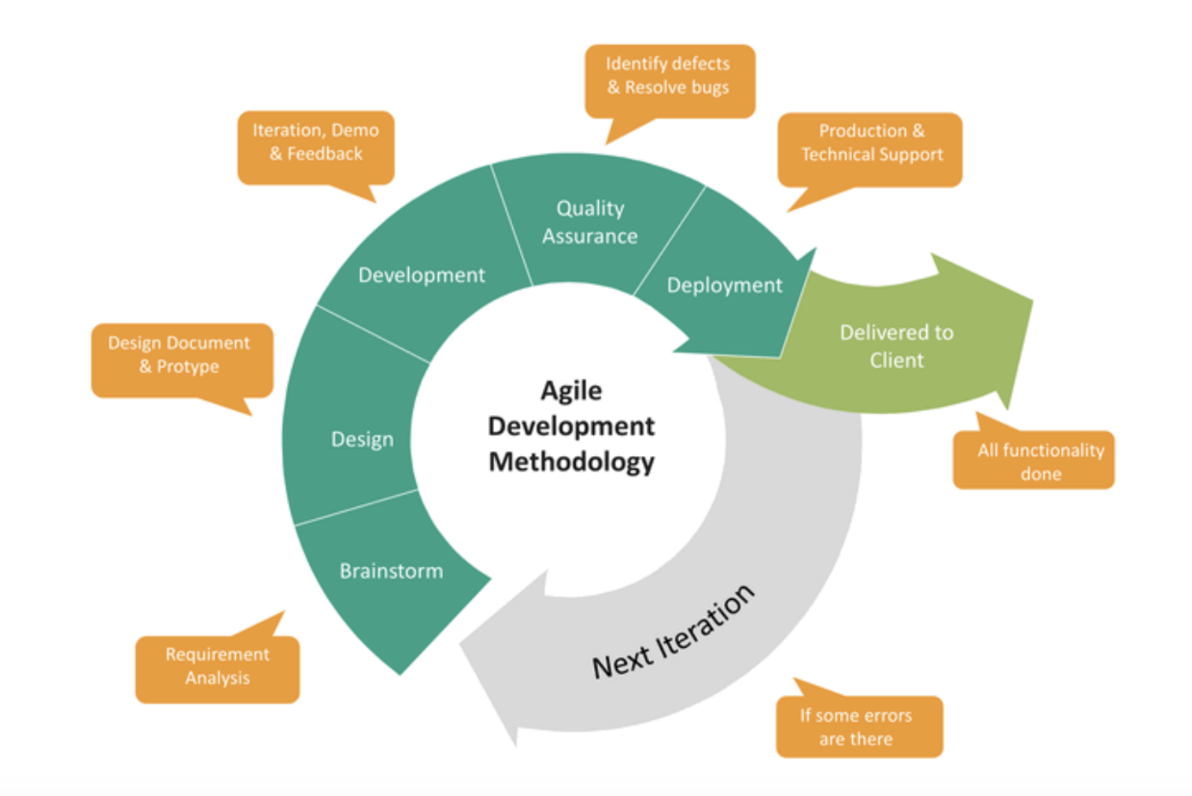

Figure 2.1.2.1 Agile Method for Software Development

## **Flowchart**

### **Overall System Flowchart**

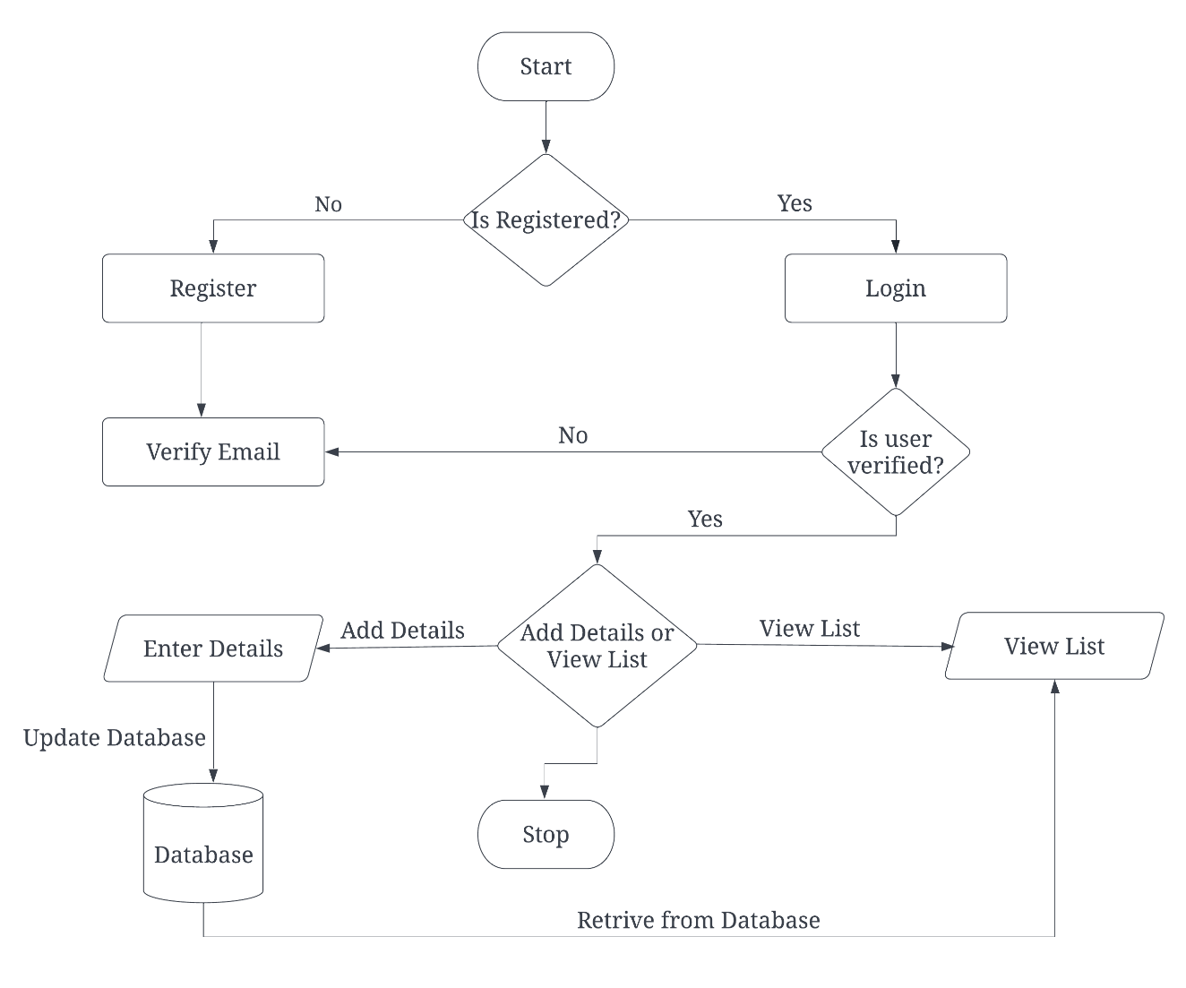

Figure 3.2.1.1 Flowchart of Overall System

# **EPILOGUE**

## **Expected Output**

After completing the project and developing a fully functional system, we overcome the problem of existing system. From the project we can achieve the new technology for pet adoption system. The main aim of this project is to provide an easier, faster and user-friendly way to adopt a pet by the use of internet.

## **Budget Analysis**

|  |  |  |
| --- | --- | --- |
|  | Resources | Cost(Rs) |
| 1 | System Analysis | 8,000 |
| 2 | System Design | 12,000 |
| 3 | System Coding, testing and implementation | 45,000 |
| 4 | Documentation | 5,000 |
|  | Total | 70,000 |

Table 4.2.1 Budget Analysis

# **REFERENCES**

|  |  |
| --- | --- |
| [1] | "Frequently Asked Questions," [Online]. Available: https://www.hamrobazaar.com. |
| [2] | S. Care. [Online]. Available: http://www.snehacare.com/. |
| [3] | A. N. A. V. F. Voiceless. [Online]. Available: https://www.animalnepal.org.np/. |
| [4] | P. Shah, "Guidelines: Use Agile for Flutter App Development," 23 09 2020. [Online]. Available: https://medium.com/flutter-community/guidelines-of-agile-usage-for-flutter-app-development-586c8b55ef1. |