Output Devices

The output device displays the result of the processing of raw data that is entered in the computer through an input device. There are a number of output devices that display output in different ways such as text, images, hard copies, and audio or video.

Some of the popular output devices are:

1. Monitor
2. Printer
   * Impact Printers
     1. Character Printers
        1. Dot Matrix printers
        2. Daisy Wheel printers
     2. Line printers
        1. Drum printers
        2. Chain printers
   * Non-impact printers
     1. Laser printers
     2. Inkjet printers
3. Projector

The monitor is the display unit or screen of the computer. It is the main output device that displays the processed data or information as text, images, audio or video.

## **Printer**

A printer produces hard copies of the processed data. It enables the user, to print images, text or any other information onto the paper.

Based on the printing mechanism, the printers are of two types: Impact Printers and Non-impact Printers.

* **Impact Printers: They are of two types:**
  1. Character Printers
     1. Dot Matrix printers
     2. Daisy Wheel printers
  2. Line printers
     1. Drum printers
     2. Chain printers
* **Non-impact printers: They are of two types:**
  1. Laser printers
  2. Inkjet printers

## **Impact Printer**

The impact printer uses a hammer or print head to print the character or images onto the paper. The hammer or print head strikes or presses an ink ribbon against the paper to print characters and images.

**Impact printers are further divided into two types.**

1. Character Printers
2. Line printers

### **A) Character Printers**

Character printer prints a single character at a time or with a single stroke of the print head or hammer. It does not print one line at a time. Dot Matrix printer and Daisy Wheel printer are character printers. Today, these printers are not in much use due to their low speed and because only the text can be printed. The character printers are of two types, which are as follows:

**i) Dot Matrix Printer**

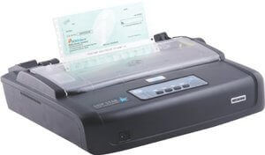

Dot Matrix Printer is an impact printer. The characters and images printed by it are the patterns of dots. These patterns are produced by striking the ink soaked ribbon against the paper with a print head. The print head contains pins that produce a pattern of dots on the paper to form the individual characters. The print head of a 24 pin dot matrix contains more pins than a 9 pin dot matrix printer, so it produces more dots which results in better printing of characters. To produce color output, the black ribbon can be changed with color stripes. The speed of Dot Matrix printers is around 200-500 characters per second.

**ii) Daisy Wheel Printer**

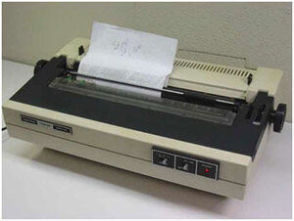

Daisy Wheel Printer was invented by David S. Lee at Diablo Data Systems.It consists of a wheel or disk that has spokes or extensions and looks like a daisy, so it is named Daisy Wheel printer. At the end of extensions, molded metal characters are mounted. To print a character the printer rotates the wheel, and when the desired character is on the print location the hammer hits disk and the extension hits the ink ribbon against the paper to create the impression. It cannot be used to print graphics and is often noisy and slow, i.e., the speed is very low around 25-50 characters per second. Due to these drawbacks,these printers have become obsolete.

### **B) Line Printers:**

Line printer, which is also as a bar printer, prints one line at a time. It is a high-speed impact printer as it can print 500 to 3000 lines per minute. Drum printer and chain printer are examples of line printers.

**i) Drum Printer:**

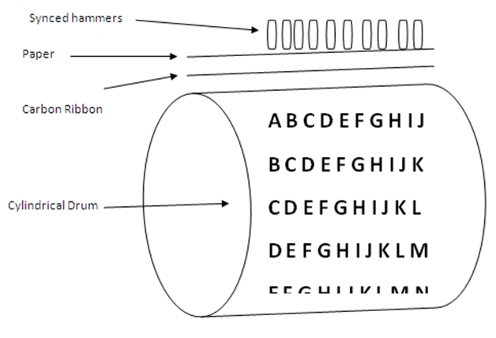

Drum printer is a line printer that is made of a rotating drum to print characters. The drum has circular bands of characters on its surface. It has a separate hammer for each band of characters. When you print, the drum rotates, and when the desired character comes under the hammer, the hammer strikes the ink ribbon against the paper to print characters. The drum rotates at a very high speed and characters are printed by activating the appropriate hammers. Although all the characters are not printed at a time, they are printed at a very high speed. Furthermore, it can print only a predefined style as it has a specific set of characters. These printers are known to be very noisy due to the use of hammering techniques.

**ii) Chain Printer:**

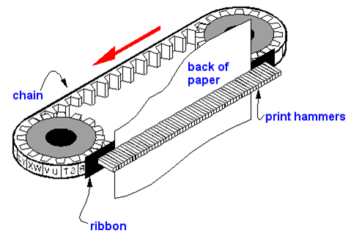

Chain printer is a line printer that uses a rotating chain to print characters. The characters are embossed on the surface of the chain. The chain rotates horizontally around a set of hammers, for each print location one hammer is provided, i.e., the total number of hammers is equal to the total number of print positions.

The chain rotates at a very high speed and when the desired character comes at the print location, the corresponding hammer strikes the page against the ribbon and character on the chain.They can type 500 to 3000 lines per minute. They are also noisy due to the hammering action.

## **Non-Impact Printer:**

Non-impact printers don't print characters or images by striking a print head or hammer on the ink ribbon placed against the paper. They print characters and images without direct physical contact between the paper and the printing machinery. These printers can print a complete page at a time, so they are also known as page printers. The common types of non-impact printers are Laser printer and Inkjet printer:

### **i) Laser Printer:**

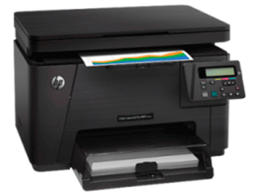

A laser printer is a non-impact printer that uses a laser beam to print the characters. The laser beam hits the drum, which is a photoreceptor and draws the image on the drum by altering electrical charges on the drum. The drum then rolls in toner, and the charged image on the drum picks the toner. The toner is then printed on the paper using heat and pressure. Once the document is printed, the drum loses the electric charge,and the remaining toner is collected. The laser printers use powdered toner for printing instead of liquid ink and produce quality print objects with a resolution of 600 dots per inch (dpi) or more.

### **ii) Inkjet Printer:**

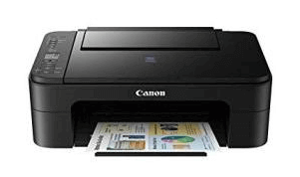

The inkjet printer is a non-impact printer that prints images and characters by spraying fine,ionized drops of ink. The print head has tiny nozzles to spray the ink. The printer head moves back and forth and sprays ionized drops of ink on the paper, which is fed through the printer. These drops pass through an electric field that guides the ink onto the paper to print correct images and characters.

An inkjet printer has cartridges that contain ink. Modern inkjet printers are color printers that have four cartridges containing different colors: Cyan, Magenta, Yellow, and Black. It is capable of printing high-quality images with different colors. It can produce print objects with a resolution of at least 300 dots per inch (dpi).

## Computer Speakers

**Mode:**Sound

**Function:**Computer speakers are hardware devices that transform the signal from the computer's sound card into audio. Speakers create sound using internal amplifiers that vibrate at different frequencies according to data from the computer. This produces sound.

A **plotter** is a computer hardware device much like a printer that is used for printing [vector graphics](https://www.computerhope.com/jargon/v/vector-graphic.htm). Instead of [toner](https://www.computerhope.com/jargon/t/toner.htm), plotters use a pen, pencil, marker, or another writing tool to draw multiple, continuous lines onto paper rather than a series of dots like a traditional printer. Though once widely used for [computer-aided design](https://www.computerhope.com/jargon/c/cad.htm), these devices have more or less been phased out by wide-format printers. Plotters produce a [hard copy](https://www.computerhope.com/jargon/h/hardcopy.htm) of schematics and other similar applications.

## Advantages of plotters

* Plotters can work on very large sheets of paper while maintaining high resolution.
* They can print on a wide variety of flat materials including plywood, aluminum, sheet steel, cardboard, and plastic.
* Plotters allow the same pattern to be drawn thousands of times without any image degradation.

## Disadvantages of plotters

* Plotters are quite large compared to a traditional printer.
* Plotters are also much more expensive than a traditional printer.

## When was the first plotter invented?

The first plotter was invented in [1953](https://www.computerhope.com/history/1953.htm) by Remington-Rand. It was used in conjunction with the [UNIVAC](https://www.computerhope.com/jargon/u/univac.htm) computer to created technical drawings.