OneNote is a digital notebook
that can help you stay organized

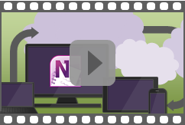

Watch the 2 minute video

Keep tabs on your life at work, home, and school

See the pages on the far right for more tips.

Monday, May 14, 2012
5:12 PM

Super Duper Long Test Page
Thursday, February 16, 2012
5:43 PM

- The importance of usable systems
  - Benefits of designing a usable system:
    - Increased productivity
    - Reduced errors (due to poorly-designed UI)
    - Reduced training and support
    - Improved user acceptance and trust
    - Enhanced reputation (for the developing company)

- Human-centered design
  - Goal of HCD is to incorporate the user's perspective into the software development process in order to make the system more usable.
    - It is a complement to software development methods, not a replacement for them.
  - Key principles of HCD:
    - The active involvement of users and clear understanding of user and task requirements.
      - Incorporates the perspective and domain-specific knowledge of the people who will be using the system.
      - Increases user acceptance of the new software because users will appreciate being involved and will not feel like the new system is being imposed on them.
    - An appropriate allocation of function between user and system.
      - Determine which aspects of a task should be handled by people and which should be handled by software/hardware, based on knowledge of human capabilities and limitations.
    - Iteration of design solutions.
      - Get user feedback early (e.g. using paper prototypes) and iterate on your design many times.
    - Multi-disciplinary design teams.
      - Design team may include managers, usability specialists, end users, software engineers, interaction designers, task specialists, and others.
  - HCD development cycle
    - Five essential processes which should be used to incorporate usability requirements into the software development process:
      - Plan the human-centered design process.
      - Understand and specify the context of use.
      - Specify the user and ohere we arerganizational requirements.
      - Produce designs and prototypes.
      - Carry out user-based assessment.
    - These processes should be used iteratively (as in the following diagram), repeating the cycle until usability objectives have been attained.
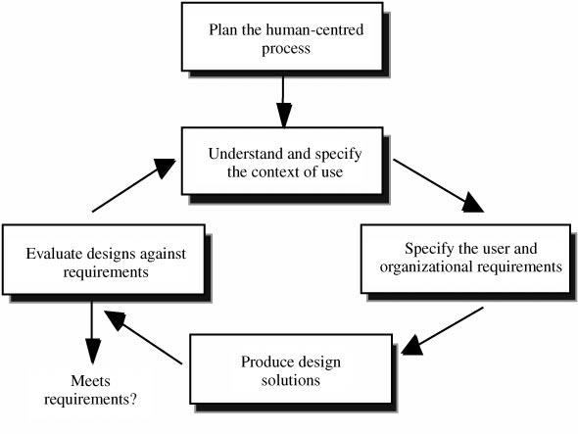

- Planning the HCD process
  - Usability planning and scoping
    - Best performed by holding a meeting with all the product development stakeholders and defining a vision for how usability can support project objectives.
    - Links business goals to usability goals, ensures all factors related to system use are identified before design work begins, and identifies priorities for usability work.
    - Goal is to collect high-level information about the following:
      - Why is the system being developed? What are the overall objectives and success metrics?
      - Who are the intended users and what are their tasks? Why will they use the system? What is their experience and expertise? What other stakeholders will be impacted by the system?
      - What are the technical and environmental constraints? What types of hardware will be used in what environments?
      - What key functionality is needed to support the user needs?
      - How will the system be used? What is the overall workflow? What are the typical scenarios of how and why users will interact with the system?
      - What are the usability goals? How important are ease of use and the learning curve? How long should it take users to complete their tasks? Is minimizing user error important? What GUI style guide should be used?
      - How will users obtain assistance in using the system?
      - Are there any initial design concepts?
    - This meeting should produce a usability plan that specifies who is responsible for performing usability activities, who will represent the users, the lines of communication between usability specialists, users, developers, marketing, etc.
  - Usability cost-benefit analysis
    - Establish the benefits of adopting an HCD approach for the project compared with its costs.
    - Need to find a balance between benefits and the costs of additional HCD work.
      - Also should compare the costs and benefits of different approaches to usability.

- Understand and specify the context of use
  - Important to understand the ways in which the system will be used and what its users need from it. This will help you design the system as well as properly evaluate it later on.
    - Ex: Bank ATMs should be designed for use at night, in bright sunlight, etc.
  - Process of understanding the context of use includes the following stages:
    - Identify stakeholders
      - Allows you to take their needs into account and test the system on them.
    - Context-of-use analysis
      - Structured method for getting detailed information about the context in which the system will be used, so that this can be used later for specifying and evaluating user requirements.
      - Hold a Context Meeting for stakeholders and have them complete a detailed questionnaire regarding the factors described in the table below.

Table: Context-of-use factors
User group | Tasks | Technical environment | Physical environment | Organizational environment
- System skills and experience  - Task knowledge  - Training  - Qualifications  - Language skills  - Age and gender  - Physical and cognitive capabilities  - Attitudes and motivations | - Task list  - Goal  - Output  - Steps  - Frequency  - Importance  - Duration  - Dependencies | - Hardware  - Software  - Network  - Reference materials  - Other equipment | - Auditory environment  - Thermal env.  - Visual env.  - Vibration  - Space and furniture  - User posture  - Health hazards  - Protective clothing and equipment | - Work practices  - Assistance  - Interruptions  - Management andcommunications structure  - Computer use policy  - Organizational aims  - Industrial relations  - Job characteristics

- Survey of existing users
  - Administer a survey to a sample population of existing users to learn their needs, current work practices, and attitudes to new system ideas.
  - Include both "closed" questions with a fixed range of responses and open-ended questions.
- Field study/observation
  - Observe users as they work and take notes on the activity that takes place.
    - Be as unobtrusive as possible during the session and only ask questions if clarification is needed.
    - Cooperation of the users is crucial.
  - Can observe either directly or indirectly (via a video recording, for instance).
- Diary keeping
  - Have users record the activities they are engaged in over the course of a normal day.
  - This information can help identify user requirements for a new system or product.
  - Diaries can contain both structure and open-ended sections, and may be recorded on paper, online, or on video.
- Task analysis
  - Defined as the study of what a user is required to do in terms of actions and/or cognitive processes to achieve a task.
  - Helps understand the current system and the information flows within it.
  - Hierarchical task analysis is one of the most widely-used types of task analysis.
    - High-level tasks are decomposed into more detailed components and sequences.
  - Alternative approach is to create a flow chart showing the sequence of human activities and the associated inputs and outputs.

- Specify the user and organizational requirements
  - The requirements specification should cover the following:
    - Identification of the range of relevant users and other personnel.
    - A clear statement of design goals.
    - Priorities for each of the different requirements.
    - Provision of measurable benchmarks to test the emerging design.
    - Evidence that stakeholders agree with the requirements.
    - Any statutory or legislative requirements (e.g. compliance with health and safety codes).
    - Clear documentation of the requirements and related information.
  - Some general methods that can be used to specify user and organizational requirements:
    - Stakeholder analysis
      - Identify the main roles, responsibilities, and task goals of each user and stakeholder group.
      - Ex: A library computer system must be designed for the needs of the general public, the library staff, and information providers.
    - User cost-benefit analysis
      - Compare the costs and benefits of the new system for different user groups.
      - Gives an indication of how receptive each user group will be to the new system.
    - User requirements interviews
      - Ask questions of users, stakeholders, and domain experts to learn their needs/requirements for the new system.
    - Focus groups
      - Hold a discussion with a cross-section of stakeholders to learn their requirements and generate discussion about issues which need to be addressed.
    - Scenarios of use
      - Give detailed, realistic examples of how users might use the system to accomplish tasks.
    - Personas
      - Create detailed, lifelike caricatures of key user groups in order to represent user needs to the design team.
      - Can associate each persona with one or more usage scenarios.
      - .
    - Task/function mapping
      - Specify the system functions each user will need for the different tasks they perform.
      - Identify the most critical task functions so that more time can be spent on them during the development and usability testing process.

Figure: Functionality matrix chart showing task/function mapping.
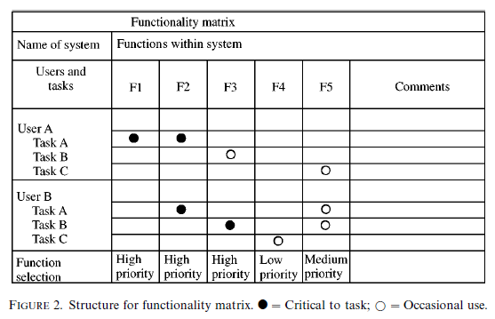

- Allocation of function
  - Divide system tasks into those performed by humans and those performed by the system.

Figure: Allocation of function chart
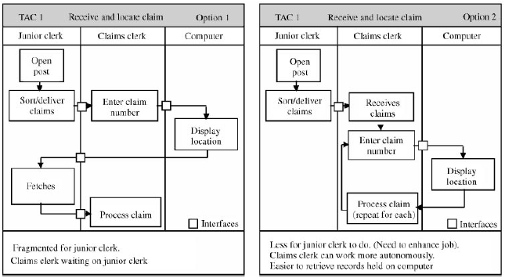

- User, usability, and organizational requirements
  - User requirements
    - Establish and document the user requirements, including summaries of the tasks the system will support and the functions that will be provided to support them.
  - Usability requirements
    - Define the following general usability goals:
      - Effectiveness: The degree of success with which users achieve their task goals.
      - Efficiency: The time it takes to complete tasks.
      - Satisfaction: User comfort and acceptability.
      - Understandability: Whether users understand what the system can do.
      - Learnability: Training, time, and effort needed to learn the system.
      - Operability or supportiveness: Supporting users throughout the interaction and helping them to overcome problems that may occur.
      - Flexibility: Enabling tasks to be carried out in different ways to suit different situations.
      - Attractiveness: Encouraging user interest and motivating them to explore the system.
  - Organizational requirements
    - Specify the organizational requirements that come out of the system being placed into the social context in which it will be used.

- Produce design solutions
  - Brainstorming
    - Bring together design and task experts to generate ideas and inspire each other.
  - Parallel design
    - Several small groups of designers work independently to generate different design concepts in parallel.
  - Design guidelines and standards
    - Use style guides to determine good practice in interface design and enhance consistency throughout the product.
    - Try to follow existing platform style guides when available (e.g. the ones produced by the makers of the operating system your program will run on).
  - Storyboarding
    - Sequences of images which show the relationship between user actions or inputs and system outputs.
  - Affinity diagram
    - Designers or users write down potential screens or functions on sticky notes and then group them by placing closely related concepts near each other.
    - Useful for understanding the structure and relationships in a poorly understood domain.
  - Card sorting
    - Users group items written on a set of cards in order to uncover the hierarchical structure of a set of concepts.
    - Useful for tasks like determining the organization of a web site.
  - Paper prototyping
    - Create a paper-based simulation of user interface elements.
  - Software prototyping

  - Wizard-of-Oz prototyping
    - User interacts with a prototype computer system that's actually operated by a hidden developer who is "the man behind the curtain."
  - Organizational prototyping
    - Simulate a working environment (such as an office) and prototype the communication and information flows between users in different roles.
    - Participants may include potential users/customers and members of the design team.

- Evaluate designs against requirements
  - It's important to periodically evaluate your design against your requirements throughout the system development process in order to determine how well user and organizational objectives are being met.
  - Two main reasons for usability evaluation:
    - Formative testing: To improve the product as part of the development process by identifying and fixing usability problems.
    - Summative testing: To find out whether people can use the product successfully.
  - Can use user-based methods of design evaluation or expert-based methods.
  - Three levels of formality in evaluation:
    - Participative: Least formal. Ask the user for their impressions of a set of designs, what results they expect their actions to achieve, etc.
    - Assisted: Intermediate formality. Ask the user to perform tasks and speak aloud, but the evaluator can intervene if the user gets stuck.
    - Controlled: Most formal. Replicates the real world as closely as possible in the test environment, with the only available user assistance being things the user would have in the real world, such as a user manual or help line. This is a good way to evaluate how successful users will be with a near-finished product in the real world.
  - Metrics
    - Effectiveness
    - Efficiency
    - Satisfaction
  - Methods to evaluate designs against user requirements
    - Participatory evaluation
      - The user works through the system, possibly performing tasks or exploring it freely; prompted and assisted by the evaluator as needed.
      - Provides a way to identify user problems and misunderstandings about the system.
    - Evaluation workshop
      - A participatory form of evaluation where users and developers meet together and users try to use the system to accomplish set tasks.
    - Evaluation walkthrough or discussion
      - Going step-by-step through a system design and getting reactions from users.
    - Assisted evaluation
      - User is invited to perform a series of tasks and is observed by a human factors specialist who records users' problems, events of interest, and comments.
    - Heuristic or expert evaluation
      - One or more usability and task experts will review a system prototype and identify potential problems that users may face when interacting with it.
    - Controlled user testing
      - Users test the prototype system in controlled conditions, performing representative tasks and providing verbal feedback. Performance measures may be taken.
    - Satisfaction questionnaires
      - Questionnaires capture the subjective impressions formed by users, based on their experiences with a system or new prototype.
    - Assessing cognitive workload
      - Assessment of the level of mental effort a user expends whilst using a prototype or deployed system. Used a questionnaire or physiological measures.
    - Critical incidents
      - Critical events that result in errors and user problems are recorded.
      - Highlights system features that may cause errors and problems.
    - Post-experience interviews
      - Users provide feedback on the current system they are using or after system testing.

- System release and management of change
  - It's important to smoothly manage the delivery of the product to end users along with installation and support. Poor delivery on these accounts can render an otherwise-great product unusable and squander the effort spent on UCD.
  - Processes for the system supplier are as follows:
    - Assisting the installation process and training the user to maintain the system
    - Providing effective technical support following implementation
    - Provision of documentation and online help
    - Setting up of User Groups to support the user in initial and continued use of the product
  - Factors related to the system customer management are as follows:
    - Making users aware of the forthcoming system and its impact on their work
    - User involvement
    - Provision of training to support initial and continued learning for users
    - Provision of health, safety, and workplace design activities
    - The working environment
    - Carrying out user audits to capture feedback on the product in use
    - Managing organizational change (if necessary)

Below: Pasted in the contents of another page to extend the length of the original page.

- Principles of User-Centered Design
  - An early focus on users and tasks
    - Users should be involved from the product's inception
    - Gain an understanding of user's mental models of the problem domain
  - Empirical measurement of product usage
    - Do usability testing on prototypes early in the product lifecycle
    - Metrics may include errors, assists, and task completion rates
  - Iterative design
    - Requirements are collected and the product is designed, modified, and tested repeatedly
    - Continue iterating and fine-tuning until you get it right

- The product lifecycle with UCD principles incorporated
  - Ideally, a UCD-based product lifecycle would include the following stages:
    - Concept phase (includes the "early focus on the user" principle of UCD)
    - Design phase (includes the "early focus on the user" and empirical measurement principles)
    - Development phase (focuses on empirical measurement principle)
    - Release phase (focuses on empirical measurement principle)
  - Diagram of the product lifecycle:
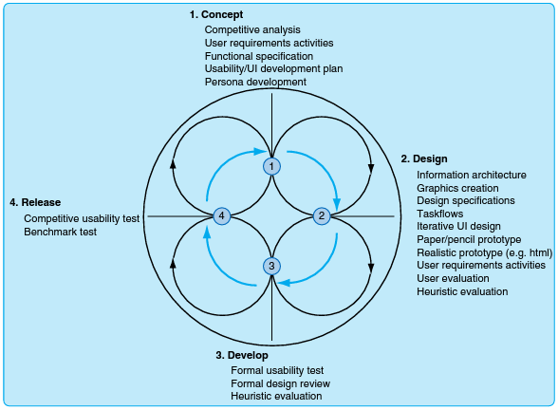

- Requirements
  - A product team typically deals with lots of different requirements from different sources. Some of these are shown in the following diagram:

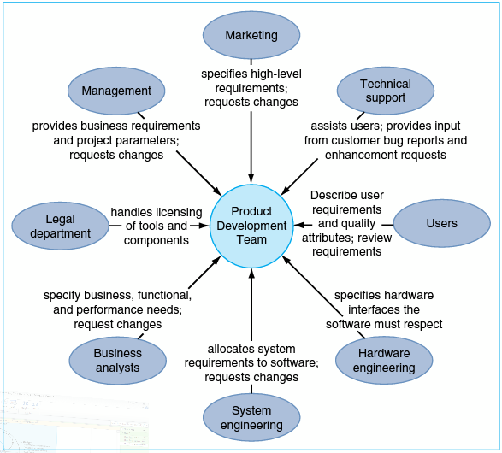

- Business requirements
  - These are the requirements of the decision makers who are considering purchasing your product (e.g. corporate executives) and they often differ from the user requirements of the people who will actually be using your product.
- Marketing and sales requirements
  - Defined by your company's marketing or sales teams based on what they think users want.
  - These are sometimes influenced by what the marketing and sales teams are hearing when talking to potential customers, but keep in mind that they're often talking to decision makers and not to actual end users.
  - Typically not very detailed; these requirements tend to be things fit nicely into bullet points on a slide, like "high performance" or "looks professional."
- User requirements
  - Important to talk to the actual end users of your product to find out what their wants and needs are, which often differ from those of the decision makers and marketing teams.
  - Need to understand their tasks, goals, context of use, and skills.

- How to get buy-in for UCD processes: Common arguments and counter-arguments
  - "We don't have time or money for such a study"
    - Having the right information for your design can help the project move faster and save money.
    - Even if it's too late to use the findings for this cycle, there's always next version.
    - There are data collection and analysis methods that are cheap and fast that you can use.
  - "Sales owns the customers. We don't want to ruin any potential deals. We don't want to make the customer unhappy by pointing out what our product doesn't do."
    - The sales team may not want the design team to go anywhere near customers, but this is typically not risky.
    - You can help understand the root cause of customer problems, since customers often do not understand their own problems fully.
    - Customers will typically be grateful that you are taking the time to try and understand their needs.
  - "You'll make promises we can't keep. You'll let out confidential information."
    - You are simply there to collect data. Don't make promises to customers, even if you know you can keep them.
    - Don't disclose confidential information. If necessary, use a NDAs to protect your intellectual property.
    - Develop a standard script for the customer interactions and circulate it for review to help soothe stakeholders' fears.
  - "We have information already. Why collect more?"
    - Make sure you have the right information and that it was collected in an unbiased fashion.
    - Respond that you just want to collect more information to get a broader perspective.
  - "We are introducing a different process, so don't waste your time studying the current process."
    - Need to understand the pros and cons of the current process and make sure that your replacement fits into the workflow well.
  - "This product/process/service is completely new. There is nothing to observe."
    - There must be an existing process in place. Learn its pros and cons.
  - "Everyone does it differently so there is no point in studying a few users."
    - Study enough people to determine common trends and best practices.
  - "We're changing just one part of the system/product/environment. We don't need to study more than that."
    - You need to understand the context the change fits into and how you can integrate with the broader system or process.
  - "We do not need this method, the product is only for our own organization."
    - Why would you want to make a crappy product that will sap the productivity of your own org?
- Preventing resistance
  - Get stakeholder involvement
    - Involve your product team and stakeholders and make them feel ownership over the activities you are conducting. Start from the very beginning stages.
    - If they don't believe in what you're doing, they will be reluctant to implement your suggestions.

