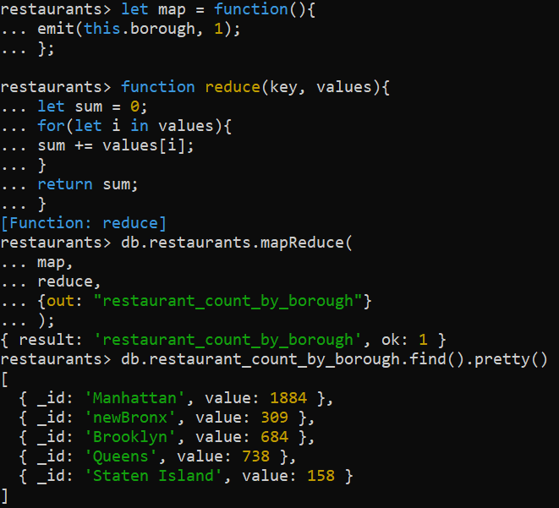

let map = function(){

emit(this.borough, 1);

};

function reduce(key, values){

let sum = 0;

for(let i in values){

sum += values[i];

}

return sum;

}

db.restaurants.mapReduce(

map,

reduce,

{out: "restaurant_count_by_borough"}

);