Appendix A – Code Snippet of Dataset Collection

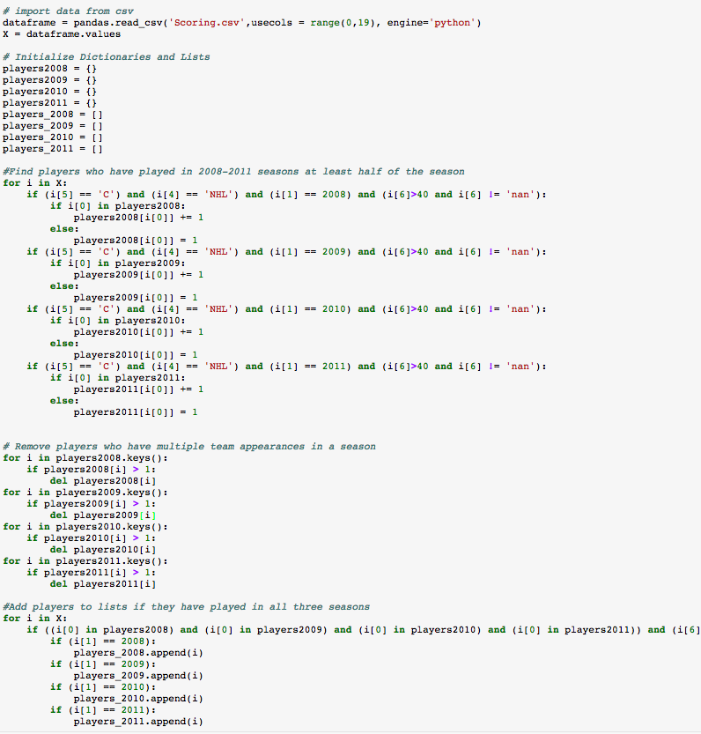

Appendix B - Code Snippet of Regression Models

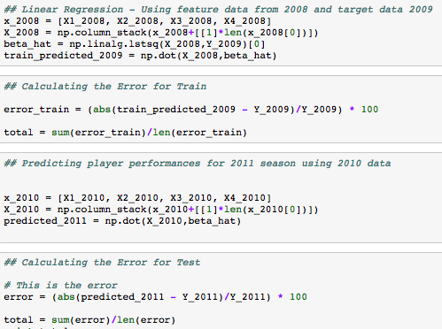

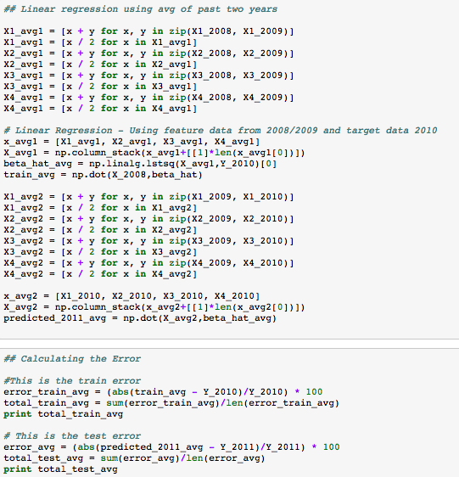

Appendix C – Code Snippet of K-Fold Validation

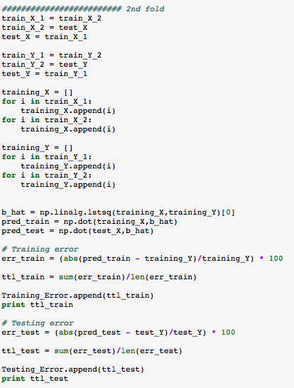

Appendix D – Code Snippet of SVM

