1. 41-55 标签不支持写入
2. 写入数据与读出数据不符，例如：

写入：安良镇卫生院,410425102,20120323,11574629,安良镇卫生院全科,,腹痛,,20120323,沙门氏菌肠炎,D7013,,,,,,,,,,,,,,,,,,,,,,,,,,,,,,,B超常规检查,,,,220201002,血常规（机器五分类）,,,,2501010182,尿常规检查,,,,250102001,,,,,,,,,,,,,,,,,,,,,,,,,,,,,,,,,,,,元胡止痛片,,5,每日三次,p,4.00,300.00,1,人参健脾片,,5,每日三次,g,0.50,37.50,1,吡哌酸,,5,每日三次,g,0.50,37.50,1,盐酸小檗碱,,5,每日三次,g,0.20,15.00,1,参松养心胶囊,,5,每日三次,g,0.80,60.00,1,,,,,,,,,,99,26,99,50.55,08,1.05,01,4,02.00,45.55,08,2.23,,,,,,,,,,,,,,,,,,,

读出：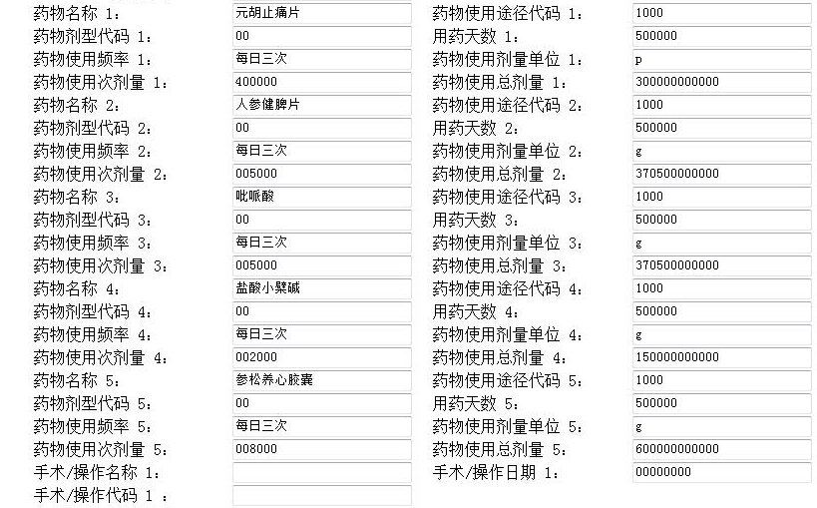

应该读出：