**ASR Belize Project**

Technical Design Document

Phase 1

**Table of Contents**

1.0 Introduction 3

1.1 Purpose 3

1.2 Scope 3

1.4 Version History 4

2.0 Environment Details 4

3.0 Proposed Design 4

3.1 Logical Design: 5

3.2 Entity relationship diagram: 6

3.3 Physical Design: 8

# 

# 1.0 Introduction

This document is designed to be a reference for any person interested in the architecture of the project addressing solutions to support, accelerate, and provide new capabilities around transparency, traceability, accountability across the ecosystem and partners involved in the sugar cane manufacturing/processing (e.g. farmer, Associations, BSI, ASR Group, financial institutions, other entities , etc.). This document describes the architecture approach, associated interfaces, database schemas, and the motivations behind the intended design.

This document should be read by an individual with a technical background and has experience in understanding data flow diagrams (DFDs) and development experience in object-oriented programming.

The purpose of this software design document is to provide an insight into the structure and design of each component required for this project.

## 1.1 Purpose

1. The purpose of this document is to define the architecture design for data sharing among entities (Farmer, Association, Financial Institution & Mill) involved in the project for Phase 1. This phase of the project covers the profile creation of all the entities and loan application workflow between the farmer and the financial institution. This is intended to be a living document. The requirements detailed in this document provide the definition of the project from an infrastructure and design perspective. It includes the functional, security, data integration, data integrity, and performance capabilities that the application must provide in order to meet the project goals.
2. While the software requirement specification document is written more for the general audience, this document is intended for individuals directly involved in developing the ASR Belize project.

## 1.2 Scope

The project is composed of following components

1. All entities (farmer, association, financial institution & BSI) will be able to create their profile.
2. Associations can select farmers that will be part of them, or who they want to part of their association.
3. BSI can select farmers that they are doing business with.
4. Farmers can apply for the loan to financial institutions.
5. Financial Institutions can pass or reject the loan applied by the farmer.
6. Farmers can check the status of their loans, list of loans, amount applied for loan, the amount granted for loan, upload documents for the loan.
7. Financial Institutions can view the loan application and documents shared by the farmer with respect to the application. They will pass or reject the loan and will decide the loan amount granting to the farmer.
8. Financial institutes can able to view the percentage of loans issued to each society.

## 1.4 Version History

|  |  |  |  |
| --- | --- | --- | --- |
| **Version** | **Date** | **Revised by** | **Description of Change** |
| 1.0 | 26-May-2021 |  | Initial Draft |
| 1.1 | June 1, 2021 |  |  |

# 2.0 Environment Details

|  |  |  |  |  |
| --- | --- | --- | --- | --- |
| **#** | **Environment** | **Environment URL** | **Application Installed** | **Owner** |
| 1 |  |  |  |  |

# 3.0 Proposed Design

3.1 Logical Design

3.2 Entity relationship diagram

3.3 Physical Design

**Design Consideration**

## 3.1 Logical Design:

Context Diagram:

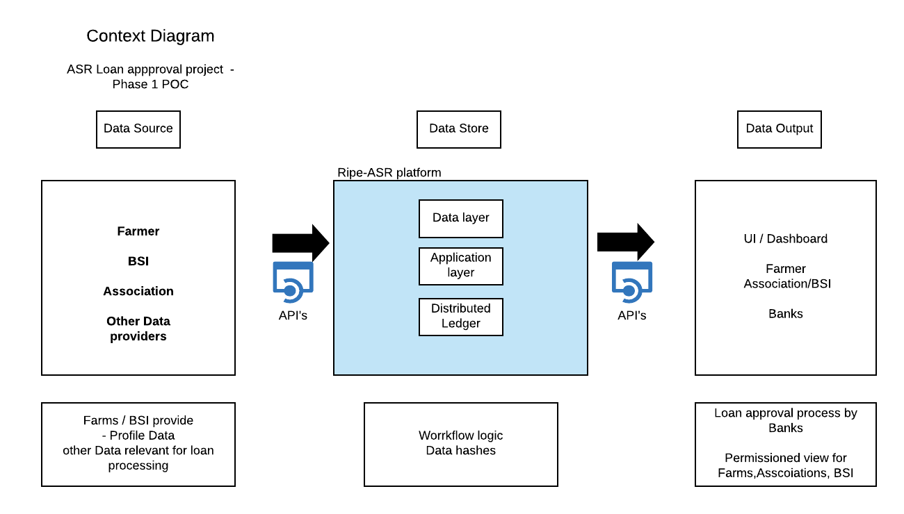

Logical Design:

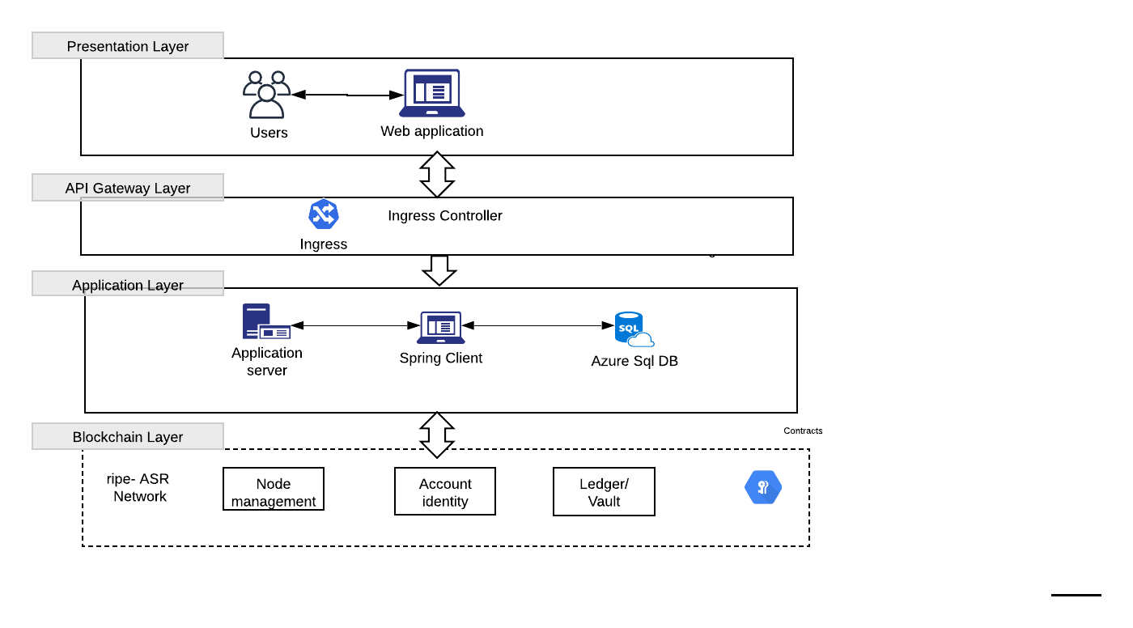

1. Above is a high level Context and logical design diagram of the project.
2. Here is a brief description of the overall Project Architecture. The Project consists of the following modules:
   1. **Clients**: Web client (React) provide an interface for the user to interact with the application and provide inputs and visualize data. These clients communicate with the backend Server using Rest APIs secured within a standard AES256 communication layer.
   2. **Backend Server:** The backend server is hosted on Azure infrastructure. It contains both the backend logic (written in Spring boot running on a JVM instance on Azure Service) and the Authentication server (written in python running on Azure AD). The database used by the backend server is Azure SQL Database.

## 3.2 Entity relationship diagram:

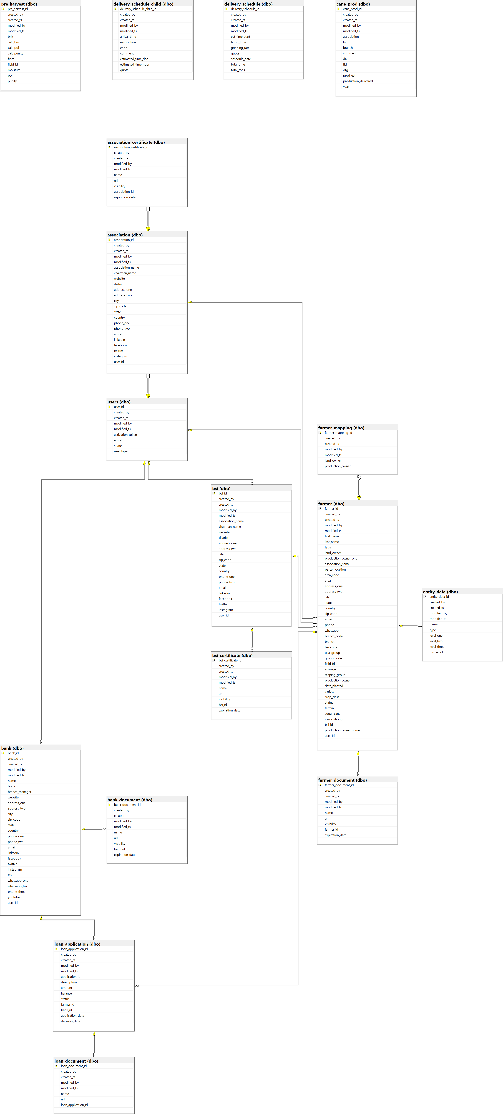

## 3.3 Physical Design:

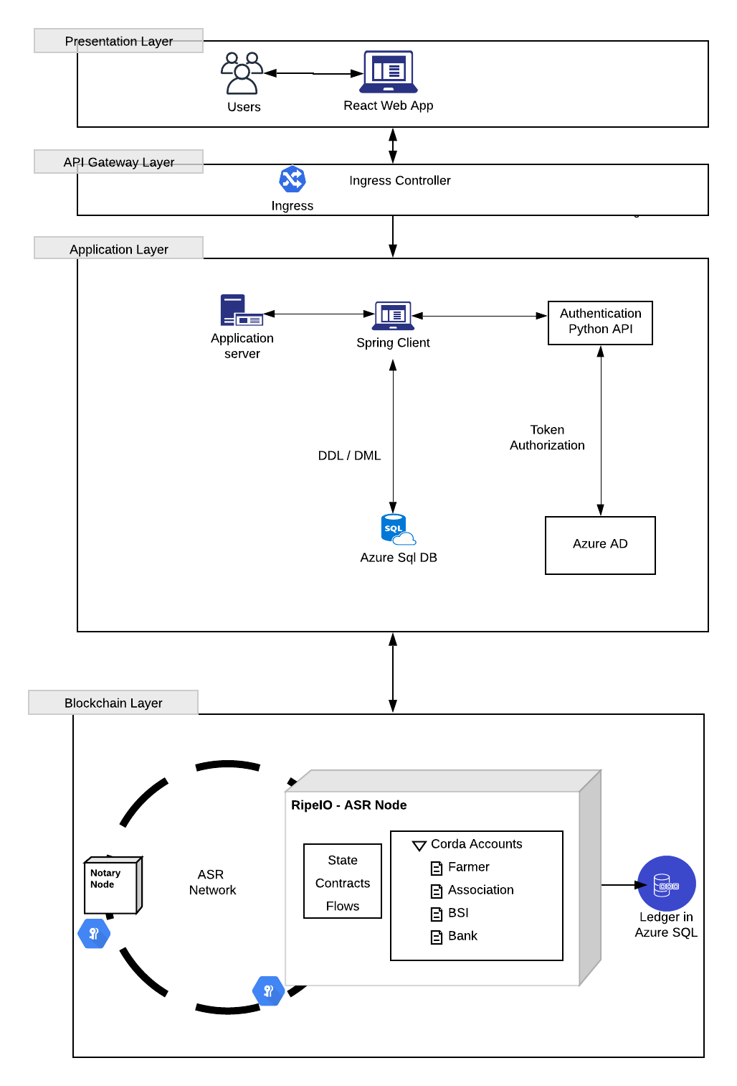

The following are the services created on the Azure platform to realize the system given in the figures.

**1. Azure Web Api** - This service will be used to host Spring Boot API in the cloud.

The Web App interacts with the API to consume and produce data.

**2. Azure SQL Database** - A database is required to store and manage the data.

 In this project, we are using Azure SQL Database.

**3. Web App** - This service will be used to host the react app of the project, which is used to create and manage the profiles by the entities, loan application management, and analytics.

**Design Explanation –**

1. The user will hit the web app URL on the browser and will land on the landing page.
2. Users will enter the credentials and be redirected to the respective profile page based on its user type. When initiating a login request with their credentials, a req will be sent to login API that verifies the credentials from azure active directory and returns an authorization token with user type if it is successful.
3. After login, in every request, an authorization token is sent to create, read, update and delete operation.