目录

webstorm 1

VSCODE 2

快捷键 2

snippets 3

react 3

chrome 4

# webstorm

快捷键

选择多行，批量操作：alt+左键

查找 com+f

替换 com+r

全局： com+shift+f com+shift=r

# VSCODE

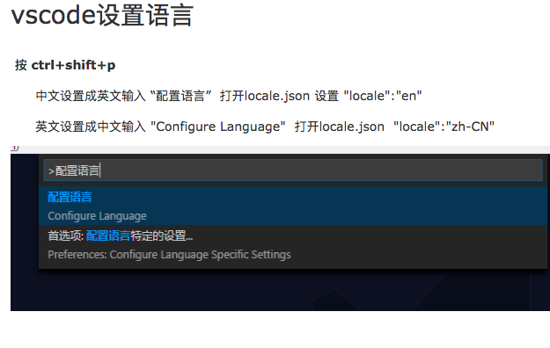

## 快捷键

cmd + b 显示隐藏左边侧边栏

ctrl+shift+v 预览md文件

查找 cmd+F

查找替换 cmd+H

整个文件夹中查找 cmd+Shift+F

同时修改多行 alt + 左键 ,或者cmd+alt+ up/dowm  
cmd+d 匹配下一个被选中的。

alt + delete 删除光标左边的内容

cmd+shift+k 删除

## snippets

Ctrl+Shift+P，将会在编辑器上弹出一个输入框，输入snippets，选择config,选择对应的文件类型

### react

选择javascript

"react template": {

    "prefix": "rbase",

    "body": [

"import React, {PureComponent} from 'react';",

"import PropTypes from 'prop-types';",

"const propTypes = {",

"};",

"const defaultProps = {",

"};",

      "class ${1} extends PureComponent {",

"\tconstructor(props) {",

"\t\tsuper(props);",

"\t}",

"\trender() {",

"\t\t",

"\t}",

"",

"}",

"${1}.propTypes = propTypes;",

"${1}.defaultProps = defaultProps;",

"export default $1;",

    ],

    "description": "react template"

  }

### vue

{

"Print to console": {

"prefix": "vue",

"body": [

"<template>",

"",

"</template>",

"",

"<script type='text/ecmascript-6'>",

" export default {",

" data () {",

" return {",

" }",

" }",

" }",

"</script>",

"",

"<style lang='scss' scoped='' type='text/css'>",

"",

"</style>"

],

"description": "Log output to console"

}

}

# chrome

ctrl+tab向后切换页面

ctrl+shift+tab 向前切换页面