## **1.测试场景构建**

**What is SDF** [**SDF worlds — Gazebo harmonic documentation**](https://gazebosim.org/docs/harmonic/sdf_worlds/)

[SDFormat](http://sdformat.org/) (Simulation Description Format), sometimes abbreviated as SDF, is an XML format that describes objects and environments for robot simulators, visualization, and control.

文本

AI 生成的内容可能不正确。

ros2 launch ros_gz_sim gz_sim.launch.py gz_args:=empty.sdf

测试模型添加[SDF worlds — Gazebo harmonic documentation](https://gazebosim.org/docs/harmonic/sdf_worlds/)

文本

AI 生成的内容可能不正确。 电脑屏幕的手机截图

AI 生成的内容可能不正确。

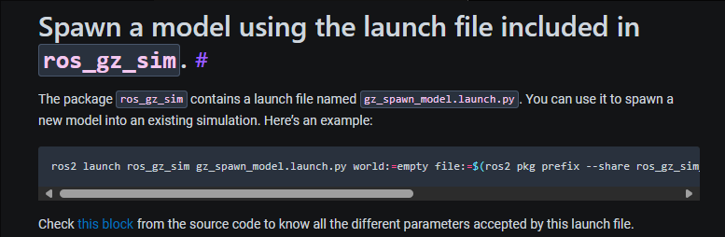

ros2 launch ros_gz_sim gz_spawn_model.launch.py world:=empty file:=$(ros2 pkg prefix --share ros_gz_sim_demos)/models/vehicle/model.sdf entity_name:=my_vehicle x:=5.0 y:=5.0 z:=0.5

## **2.开源测试模型**

[Gazebo - Walking actor](https://app.gazebosim.org/chapulina/fuel/models/Walking%20actor)

游戏机里面的人物

AI 生成的内容可能不正确。

[Gazebo - Ignition ROS 2 CI](https://app.gazebosim.org/chapulina/fuel/worlds/Ignition%20ROS%202%20CI)

图形用户界面, 网站

AI 生成的内容可能不正确。

[Gazebo - Prius on Sonoma Raceway](https://app.gazebosim.org/chapulina/fuel/worlds/Prius%20on%20Sonoma%20Raceway)

图片包含 户外, 路, 建筑, 飞机

AI 生成的内容可能不正确。

[Gazebo - Edifice demo](https://app.gazebosim.org/balookaloo/fuel/worlds/Edifice%20demo)

图形用户界面

AI 生成的内容可能不正确。

## **3.ROS&GAZEBO联合调试**

[Use ROS 2 to interact with Gazebo — Gazebo harmonic documentation](https://gazebosim.org/docs/harmonic/ros2_integration/)

ROS和Gazebo可通过**ros_gz_bridge通信的消息种类：**

[ros_gz/ros_gz_bridge/README.md at jazzy · gazebosim/ros_gz](https://github.com/gazebosim/ros_gz/blob/jazzy/ros_gz_bridge/README.md)

We can initialize a bidirectional bridge so we can have ROS as the publisher and Gazebo as the subscriber or vice versa. The syntax is /TOPIC@ROS_MSG@GZ_MSG, such that TOPIC is the Gazebo internal topic, ROS_MSG is the ROS message type for this topic, and GZ_MSG is the Gazebo message type.

电脑屏幕的截图

AI 生成的内容可能不正确。

案例：\ros\jazzy\share\ros_gz_sim_demos\launch “battery.launch.py”Line 51

# Bridge

bridge = Node(

package='ros_gz_bridge',

executable='parameter_bridge',

arguments=[

'/model/vehicle_blue/cmd_vel@geometry_msgs/msg/Twist@gz.msgs.Twist',

'/model/vehicle_blue/battery/linear_battery/state@sensor_msgs/msg/BatteryState@'

'gz.msgs.BatteryState'

],

output='screen'

)

[ros_gz/ros_gz_bridge/README.md at jazzy · gazebosim/ros_gz](https://github.com/gazebosim/ros_gz/blob/jazzy/ros_gz_bridge/README.md#example-1a-gazebo-transport-talker-and-ros-2-listener)

## **4.GAZEBO robot 模型构建**

[Building your own robot — Gazebo harmonic documentation](https://gazebosim.org/docs/harmonic/building_robot/)

Link for calculate mass and inertia: [Mass Moment of Inertia Calculator](https://amesweb.info/inertia/mass-moment-of-inertia-calculator.aspx)

文本

AI 生成的内容可能不正确。

Gazebo topic info send 7& subscribe test:

文本

AI 生成的内容可能不正确。

More command of Gazebo transport.[Gazebo Transport: Tutorials](https://gazebosim.org/api/transport/13/tutorials.html)

**Appendix A Useful plugin of gz**

Triggered Publisher: [gz-sim/tutorials/triggered_publisher.md at gz-sim7 · gazebosim/gz-sim](https://github.com/gazebosim/gz-sim/blob/gz-sim7/tutorials/triggered_publisher.md)

KeyPublisher