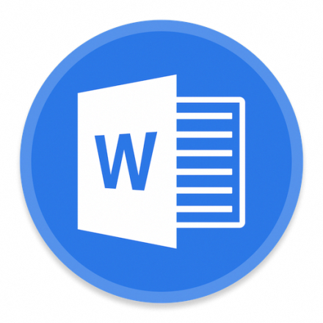
This document created in previous version of Microsoft Office Word.
To view or edit this document, please click “Enable editing” button on the top bar, and then click “Enable content”.

