

**[CPCS403]**

**Homework 1**

Presented By:

**Ahmad Al Shareef 2136080**

**Submitted to Dr. Emad Bassam**

**Website Description:**

Planning sports games with friends should be effortless. SportsFinder simplifies the process of discovering and booking sports fields for various activities like football, tennis, volleyball, and more. Our platform eliminates the hassle of endless phone calls and online searches by offering a straightforward solution. Whether you're organizing a casual match or seeking a place to improve your skills, SportsFinder provides detailed venue information, availability schedules, and easy booking options. Join us to revolutionize your sports experience.

**Functions of the Website:**

* User Registration and Profiles
* Search and Filters for Sports Venues
* Playground Listings with Detailed Information
* Booking and Reservation System
* Ratings and Reviews for Sports Venues
* Notifications and Reminders for Bookings
* Social Features to Connect with Other Sports Enthusiasts
* Map Integration for Venue Location

**Cite Map:**

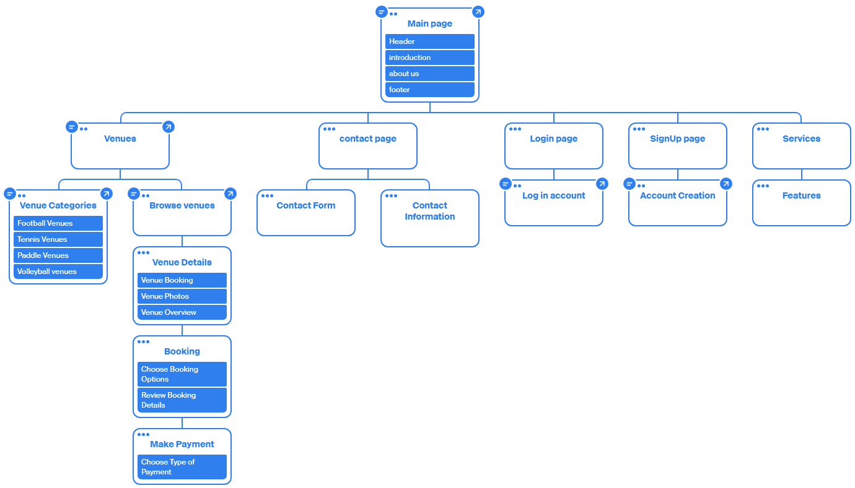

**Story Board:**

