3-bit with .25 sec time sampling

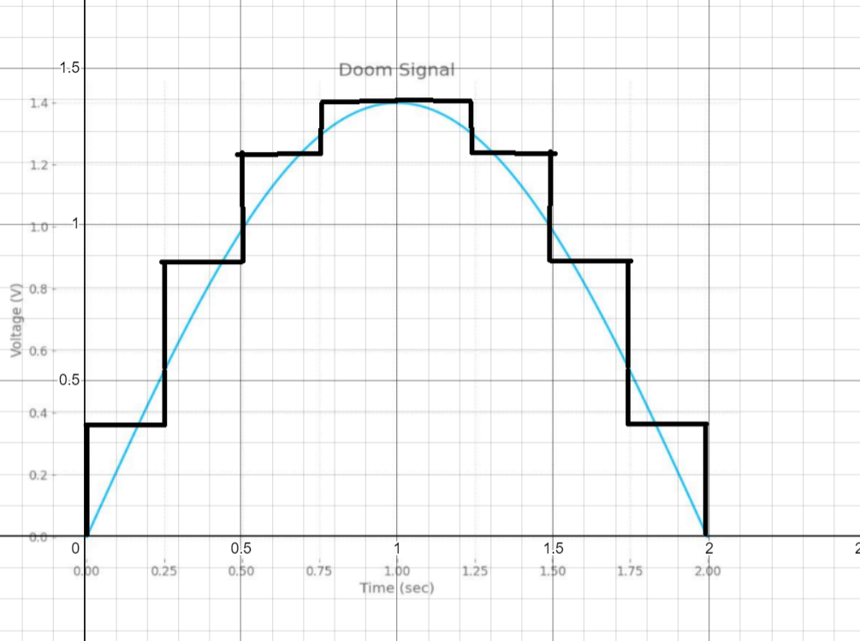

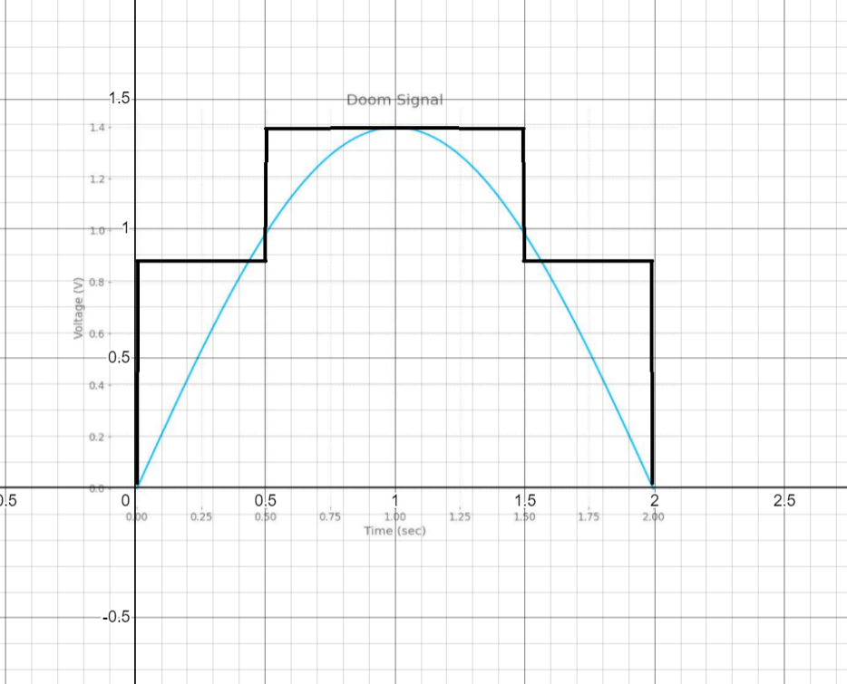3-bit with .5 sec time sampling

3-bit with 1 sec time sampling

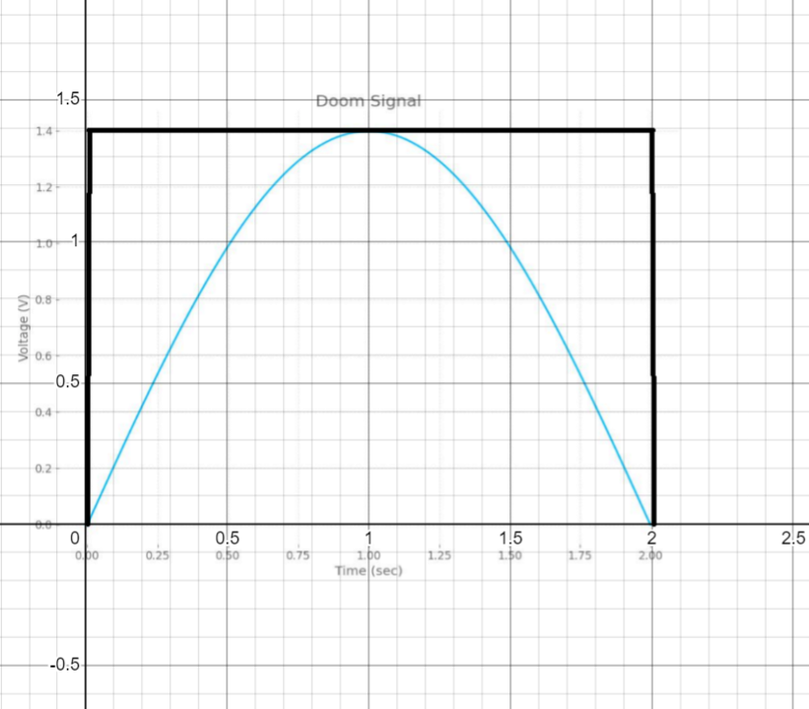

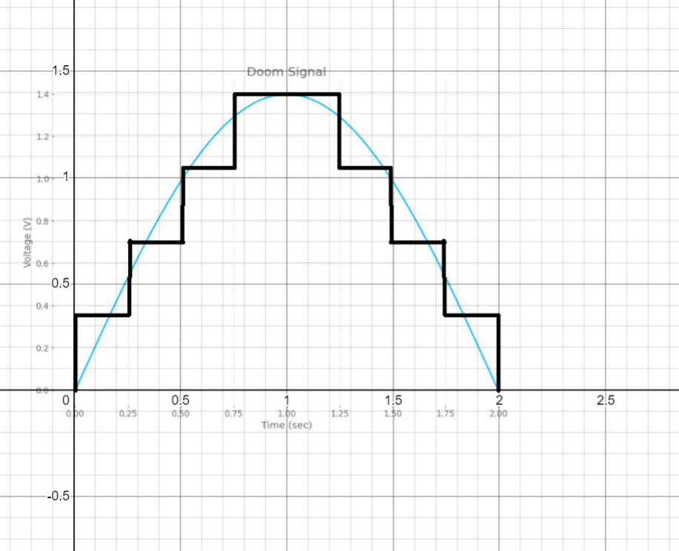2-bit with .25 sec time sampling

The conclusion is that with smaller sampling time and higher bit encoder number gives a high resolution to the converted signal