Menofyia University
System Analysis & design Project
second year
2026-2027

جامعة المنوفية
كلية الحاسبات والمعلومات
2026-2027

Name | Group | ID
Ahmed Mohamed Ahmed Abdelwahed Hassan | 2 | 1202540554
Ahmed Mohamed Abd El Wahab Ahmed Dorgham | 1 | 202440076
Ahmed Serag Eldein Mohamed Elsendiony | 1 | 1202540532
Khalid Waleed Menshawi Eldeep | 2 | 1202540656
Marwan Alaa El-din Ahmed Shehata | 1 | 1202540369

Project Identification

Project Name:
Meeting Room Booking System

Current Problem:
- Difficulty finding available meeting rooms.
- Conflicts between room reservations.
- Difficulty organizing and tracking bookings.
- Wasting time managing meeting schedules manually.

Description About Project:
The system helps users find available meeting rooms by entering the room name or number. It allows users to book rooms for specific dates and times. The system organizes reservations, prevents booking conflicts, and makes it easier to track and manage bookings. It also stores information about meeting rooms, including their capacity, location, and available equipment, saving time and effort.

System Request

Project Sponsor: | Business Need: | Business Requirements: | Business Value: | Special Issues or Constraints:
Ahmed | - Reduce conflicts between meeting room bookings.  - Make it easier to find available meeting rooms.  - Improve the organization of meeting schedules.  - Reduce the time needed to book meeting rooms. | 1- Allow users to view available meeting rooms.  2- Allow users to book rooms for specific dates and times.  3- Provide booking confirmation and reservation details.  4- Allow users to cancel or modify their bookings. | 1- Saving time.  2- Reducing booking conflicts.  3- Improving room utilization.  4- Reducing effort in managing reservations. | 1- Project deadline: 1 November.  2- Room availability must be updated whenever a booking is created, modified, or canceled.

Feasibility Analysis

Technical Feasibility
- We need to design the system using HTML, CSS, and JavaScript.
- We need software development tools such as Visual Studio Code.
- The system should be available online to allow users to book meeting rooms through the internet.
- The system should work on different operating systems, such as Windows and Android.

Economic Feasibility
- The expected benefits of the project will be acceptable.
- The system will reduce the costs of managing meeting room reservations.
- The system can be developed using free development tools to reduce costs.
- The overall development cost is expected to be low.

Organizational Feasibility
Organizational Feasibility Analysis includes the assessment of:
- Management Prowess: The management team should be able to organize meeting room reservations, manage schedules.
- Resource Sufficiency: The project requires employees to manage the system, computers, and suitable software to operate the system efficiently.

Project Plan - Methodology

Selected Methodology: Agile Development

Introduction :-
Agile Development is a software development methodology that divides a project into small parts that can be developed, tested, and improved incrementally. It emphasizes flexibility, teamwork, communication, and continuous feedback.

Why Agile Was Selected ?
Agile Development was selected for the Meeting Room Booking
System for the following reasons:
1. Flexibility: The team can modify system requirements when necessary.
2. Team Collaboration: The five team members can coordinate their work and share responsibilities.
3. Incremental Development: The system can be developed feature by feature.
4. Continuous Testing: Each feature can be tested before moving to the next stage.
5. Feedback and Improvement: Feedback can help the team improve the system during development.

Applying Agile to the Meeting Room Booking System :-
The project will be divided into the following iterations:
Iteration 1: Requirements Analysis
- Identify the needs of employees and administrators.
- Determine the problems with the current meeting room booking process.
- Define the system requirements.
Iteration 2: System Design
- Design the user interface.
- Design the database for rooms, users, and bookings.
- Define the booking workflow.
Iteration 3: Core System Development
- Display available meeting rooms.
- Allow users to book rooms for specific dates and times.
- Prevent overlapping bookings.
Iteration 4: Additional Features
- Allow users to modify or cancel bookings.
- Enable administrators to manage rooms and reservations.
- Display booking details and confirmation.
Iteration 5: Testing and Evaluation
- Test room availability and reservation functionality.
- Check that booking conflicts are prevented.
- Fix errors and improve the system based on feedback.

Advantages of Agile for Our Project :-
Agile Development allows the team to develop the Meeting Room Booking System incrementally, identify problems early, coordinate responsibilities, and improve features throughout development.

Conclusion :-
Agile Development allows the team to develop the Meeting Room Booking System incrementally, identify problems early, coordinate responsibilities, and improve features throughout development.

Time Estimation

 | Standard percentages | Estimated time based on planning time
Planning | 19.05 % | 8 days
Analysis | 21.43 % | 9 days
Design | 21.43 % | 9 days
Implementation  & Testing | 57.14 % | 24 days
Total | 100 % | 50 days

Case Study: Business System Implementation

Background:-
- An organization needs an efficient way to manage its meeting rooms and reservations.
- Employees need to book meeting rooms for meetings, discussions, and training sessions.
- The organization plans to implement a Meeting Room Booking System to improve the reservation process.

Problems Identified:-
- Difficulty checking meeting room availability.
- Double booking of the same meeting room.
- Manual booking procedures that waste time.
- Difficulty managing booking modifications and cancellations.
- Lack of centralized booking information.

Project Objectives:-
- Organize all meeting room reservations in one system.
- Allow users to check room availability.
- Prevent overlapping reservations.
- Simplify booking, modification, and cancellation.
- Help administrators manage rooms and reservations.

System Development Plan:-
The project team plans to follow the System Development Life Cycle (SDLC) to analyze, design, develop, test, and implement the Meeting Room Booking System.

Key SDLC Phases:-
1. Planning – Identify project goals, feasibility, resources, and the project schedule.
2. Analysis – Gather user requirements through interviews and questionnaires.
3. Design – Prepare the Data Flow Diagram (DFD), Entity Relationship Diagram (ERD), database design, and user interface.
4. Implementation – Develop the booking system and its main functions.
5. Testing – Test room availability, reservations, and booking conflict prevention.
6. Deployment – Make the system available to users and provide basic instructions.
7. Maintenance – Fix problems and update the system when necessary.

Questions:-
1. Which SDLC methodology is most suitable for developing the Meeting Room Booking System, and why?
2. How can the proposed system solve the identified problems?

Methodology Options:-
1. Waterfall Method
2. Parallel Method
3. Rapid Application Development (RAD)
4. Iterative Method
5. Agile Development

Project Plan - Methodology

Selected Methodology: Agile Development

Introduction :-
Agile Development is a software development methodology that divides a project into small parts that can be developed, tested, and improved incrementally. It emphasizes flexibility, teamwork, communication, and continuous feedback.

Why Agile Was Selected ?
Agile Development was selected for the Meeting Room Booking
System for the following reasons:
1. Flexibility: The team can modify system requirements when necessary.
2. Team Collaboration: The five team members can coordinate their work and share responsibilities.
3. Incremental Development: The system can be developed feature by feature.
4. Continuous Testing: Each feature can be tested before moving to the next stage.
5. Feedback and Improvement: Feedback can help the team improve the system during development.

Applying Agile to the Meeting Room Booking System :-
The project will be divided into the following iterations:
Iteration 1: Requirements Analysis
- Identify the needs of employees and administrators.
- Determine the problems with the current meeting room booking process.
- Define the system requirements.
Iteration 2: System Design
- Design the user interface.
- Design the database for rooms, users, and bookings.
- Define the booking workflow.
Iteration 3: Core System Development
- Display available meeting rooms.
- Allow users to book rooms for specific dates and times.
- Prevent overlapping bookings.
Iteration 4: Additional Features
- Allow users to modify or cancel bookings.
- Enable administrators to manage rooms and reservations.
- Display booking details and confirmation.
Iteration 5: Testing and Evaluation
- Test room availability and reservation functionality.
- Check that booking conflicts are prevented.
- Fix errors and improve the system based on feedback.

Advantages of Agile for Our Project :-
Agile Development allows the team to develop the Meeting Room Booking System incrementally, identify problems early, coordinate responsibilities, and improve features throughout development.

Conclusion :-
Agile Development allows the team to develop the Meeting Room Booking System incrementally, identify problems early, coordinate responsibilities, and improve features throughout development.

Time Estimation

 | Standard percentages | Estimated time based on planning time
Planning | 19.05 % | 8 days
Analysis | 21.43 % | 9 days
Design | 21.43 % | 9 days
Implementation  & Testing | 57.14 % | 24 days
Total | 100 % | 50 days

Case Study: Business System Implementation

Background:-
- An organization needs an efficient way to manage its meeting rooms and reservations.
- Employees need to book meeting rooms for meetings, discussions, and training sessions.
- The organization plans to implement a Meeting Room Booking System to improve the reservation process.

Problems Identified:-
- Difficulty checking meeting room availability.
- Double booking of the same meeting room.
- Manual booking procedures that waste time.
- Difficulty managing booking modifications and cancellations.
- Lack of centralized booking information.

Project Objectives:-
- Organize all meeting room reservations in one system.
- Allow users to check room availability.
- Prevent overlapping reservations.
- Simplify booking, modification, and cancellation.
- Help administrators manage rooms and reservations.
System Development Plan:-
The project team plans to follow the System Development Life Cycle (SDLC) to analyze, design, develop, test, and implement the Meeting Room Booking System.

Key SDLC Phases:-
1. Planning – Identify project goals, feasibility, resources, and the project schedule.
2. Analysis – Gather user requirements through interviews and questionnaires.
3. Design – Prepare the Data Flow Diagram (DFD), Entity Relationship Diagram (ERD), database design, and user interface.
4. Implementation – Develop the booking system and its main functions.
5. Testing – Test room availability, reservations, and booking conflict prevention.
6. Deployment – Make the system available to users and provide basic instructions.
7. Maintenance – Fix problems and update the system when necessary.

Questions:-
1. Which SDLC methodology is most suitable for developing the Meeting Room Booking System, and why?
2. How can the proposed system solve the identified problems?

Methodology Options:-
1. Waterfall Method
2. Parallel Method
3. Rapid Application Development (RAD)
4. Iterative Method
5. Agile Development

Project Identifications
Name | System Request
ID | 1
Start Date | 18 / 10 / 2026
End Date | 19 / 10 /2026
Person Assigned | Project Manger
Priority | High
Resources Needed | Client Brief
Estimated Time | 2 Days
Actual Time | Not Stated
Predecessors | None
Slack | 0 Days
Name | Feasibility Study
ID | 2
Start Date | 20 / 10 / 2026
End Date | 23 / 10 /2026
Person Assigned | Business Analysis
Priority | High
Resources Needed | Cost Sheet
Estimated Time | 4 Days
Actual Time | Not Stated
Predecessors | 1
Slack | 0 Days

Name | Project Plan (Gantt-Chart)
ID | 3
Start Date | 24 / 10 / 2026
End Date | 26 / 10 /2026
Person Assigned | Project Manger
Priority | Medium
Resources Needed | MS Project
Estimated Time | 3 Days
Actual Time | Not Stated
Predecessors | 2
Slack | 0 Days

Name | Risk Assesment
ID | 4
Start Date | 24 / 10 / 2026
End Date | 25 / 10 /2026
Person Assigned | Project Manger
Priority | Medium
Resources Needed | Risk Register
Estimated Time | 2 Days
Actual Time | Not Stated
Predecessors | 2
Slack | 1 Days

Name | Stakeholder Interviews
ID | 5
Start Date | 27 / 10 / 2026
End Date | 31 / 10 /2026
Person Assigned | Business Analyst
Priority | High
Resources Needed | Interview Guide
Estimated Time | 5 Days
Actual Time | Not Stated
Predecessors | 3 , 4
Slack | 0 Days

Name | User Questionnaire
ID | 6
Start Date | 27 / 10 / 2026
End Date | 30 / 10 /2026
Person Assigned | Business Analyst
Priority | Medium
Resources Needed | Survey Tool
Estimated Time | 4 Days
Actual Time | Not Stated
Predecessors | 3
Slack | 1 Days

Name | Use Casr & Requirements
ID | 7
Start Date | 01 / 11 / 2026
End Date | 04 / 11 /2026
Person Assigned | System Analyst
Priority | High
Resources Needed | UML Modelling Tool
Estimated Time | 4 Days
Actual Time | Not Stated
Predecessors | 5 , 6
Slack | 0 Days
Name | Data Flow Diagram
ID | 8
Start Date | 05 / 11 / 2026
End Date | 08 / 11 /2026
Person Assigned | System Analyst
Priority | High
Resources Needed | Diagraming Tool
Estimated Time | 2 Days
Actual Time | Not Stated
Predecessors | 7
Slack | 5 Days

Name | ER Diagram
ID | 9
Start Date | 05 / 11 / 2026
End Date | 08 / 11 /2026
Person Assigned | Database Designer
Priority | High
Resources Needed | ER Modelling Tool
Estimated Time | 4 Days
Actual Time | Not Stated
Predecessors | 7
Slack | 0 Days

Name | Process Specification
ID | 10
Start Date | 09 / 11 / 2026
End Date | 11 / 11 /2026
Person Assigned | System Analyst
Priority | Low
Resources Needed | Documentation Tool
Estimated Time | 3 Days
Actual Time | Not Stated
Predecessors | 8
Slack | 26 Days

Name | Database Design
ID | 11
Start Date | 09 / 11 / 2026
End Date | 13 / 11 /2026
Person Assigned | Database Designer
Priority | High
Resources Needed | MySQL Server
Estimated Time | 5 Days
Actual Time | Not Stated
Predecessors | 9
Slack | 0 Days

Name | UI Wireframes
ID | 12
Start Date | 05 / 11 / 2026
End Date | 09 / 11 /2026
Person Assigned | UI / UX Designer
Priority | Medium
Resources Needed | Figma
Estimated Time | 5 Days
Actual Time | Not Stated
Predecessors | 7
Slack | 4 Days

Name | Booking Module
ID | 13
Start Date | 14 / 11 / 2026
End Date | 23 / 11 /2026
Person Assigned | Backend Developer
Priority | High
Resources Needed | IDE & DEV Server
Estimated Time | 10 Days
Actual Time | Not Stated
Predecessors | 8 , 11 , 12
Slack | 0 Days

Name | Auth & Admin Module
ID | 14
Start Date | 14 / 11 / 2026
End Date | 19 / 11 /2026
Person Assigned | Backend Developer
Priority | Medium
Resources Needed | IDE &  Auth Library
Estimated Time | 6 Days
Actual Time | Not Stated
Predecessors | 11
Slack | 8 Days

Name | Email Remiders
ID | 15
Start Date | 24 / 11 / 2026
End Date | 27 / 11 /2026
Person Assigned | Backend Developer
Priority | Low
Resources Needed | STMP Mail Service
Estimated Time | 4 Days
Actual Time | Not Stated
Predecessors | 13
Slack | 0 Days
Name | System Testing
ID | 16
Start Date | 28 / 11 / 2026
End Date | 04 / 12 /2026
Person Assigned | QA Engineer
Priority | High
Resources Needed | Test Cases
Estimated Time | 7 Days
Actual Time | Not Stated
Predecessors | 13 , 14 , 15
Slack | 0 Days

Name | Deployment  & Training
ID | 17
Start Date | 05 / 12 / 2026
End Date | 07 / 12 /2026
Person Assigned | DevOps Engineer
Priority | Medium
Resources Needed | Hosting &  User Guide
Estimated Time | 3 Days
Actual Time | Not Stated
Predecessors | 16
Slack | 0 Days

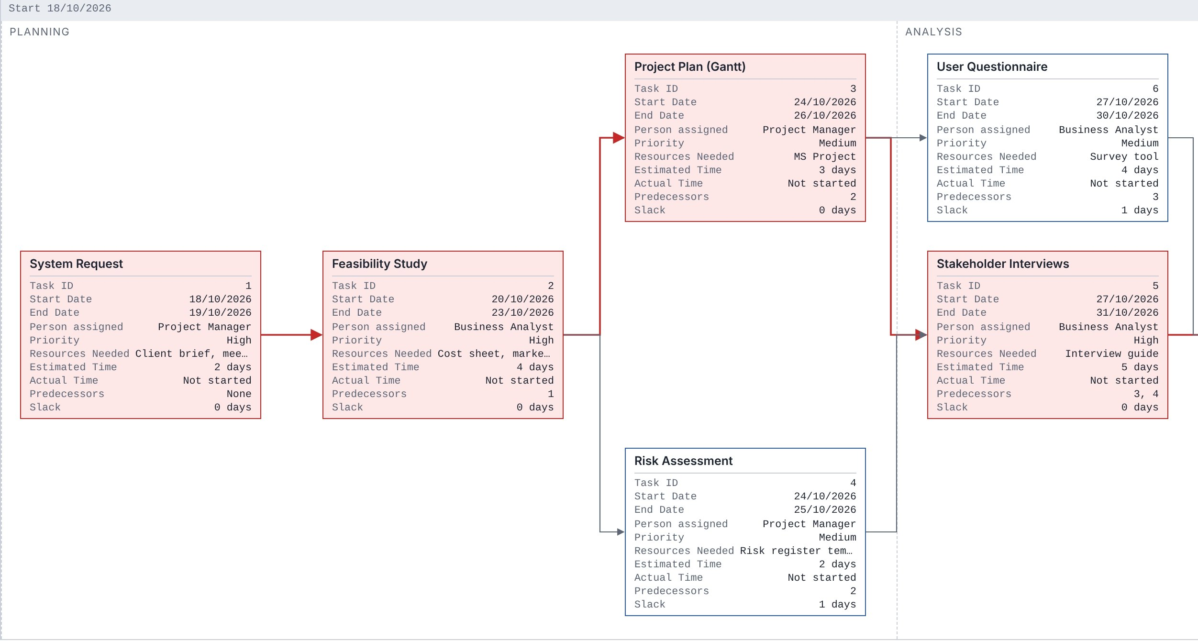
Pert Chart

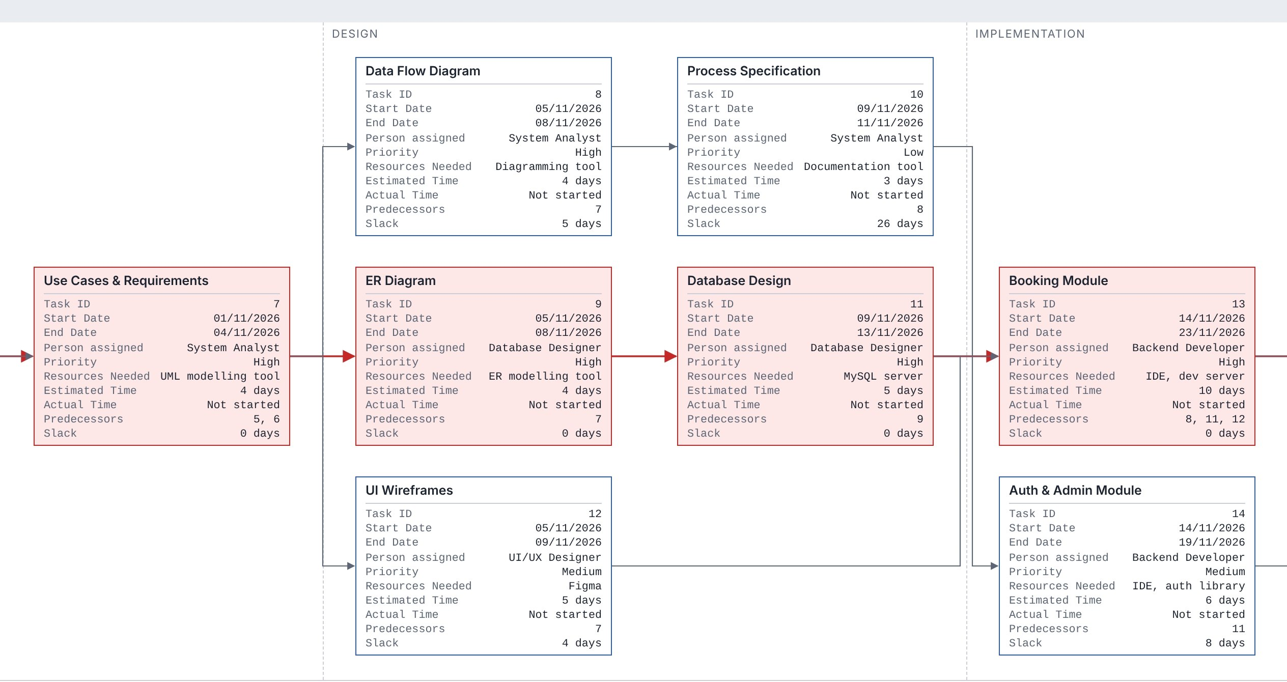

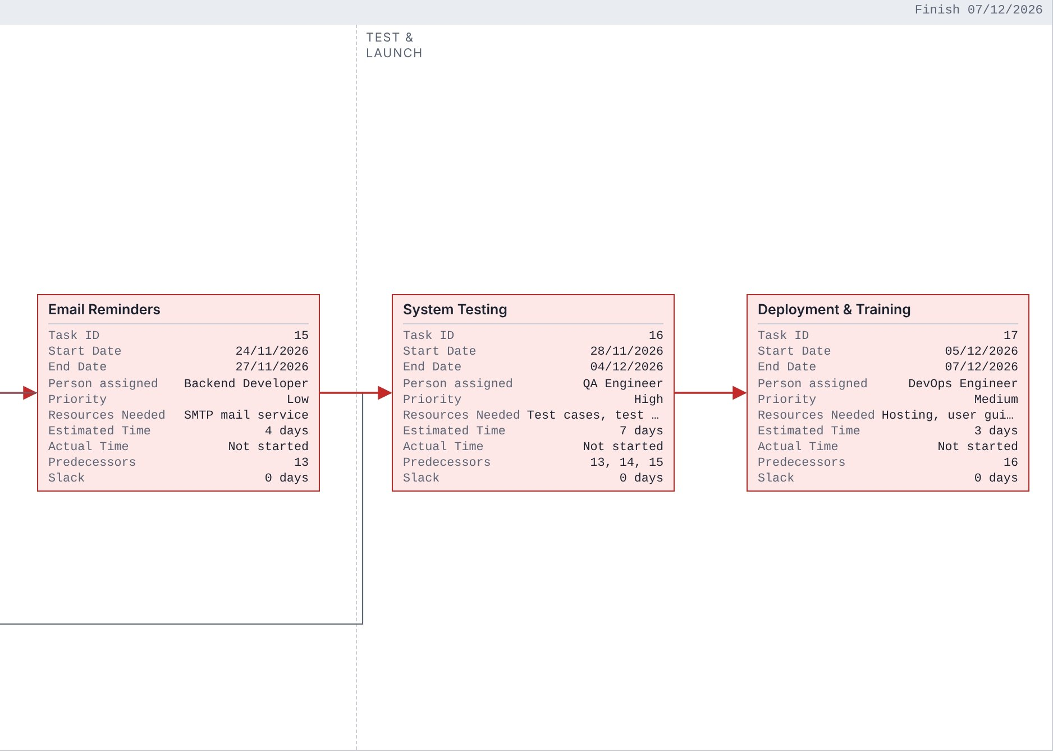

Gantt Chart
