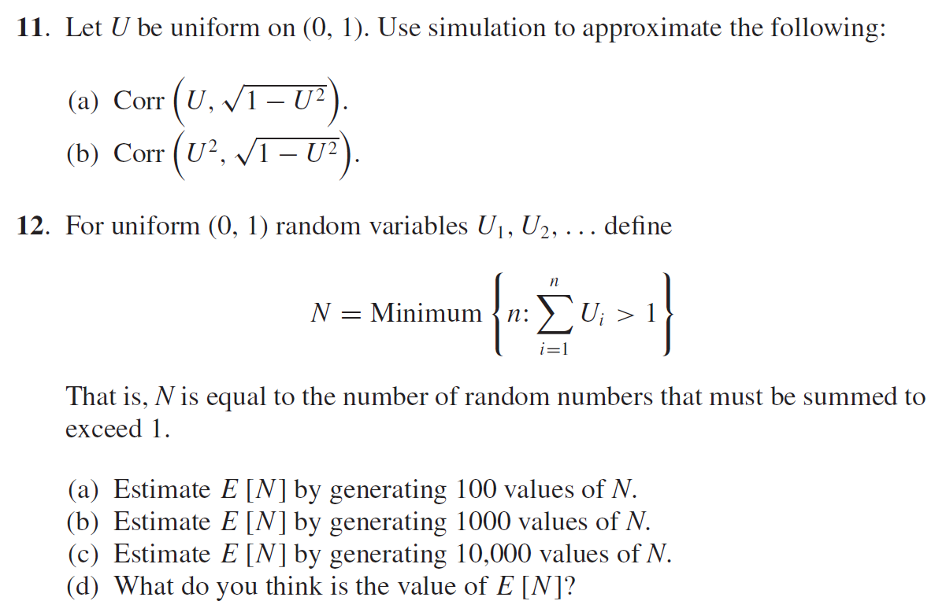

Ans:

11(a): -0.9217748029375138

11(b): -0.9802089544580987

12(a): 2.68 ;12(b): 2.716 ;12(c): 2.784

12(d):proof

$E\left(N\right)= \sum_{n=0}^{∞}{P\left(N>n\right)}=\sum_{n=0}^{∞}{\frac{1}{n!}}=e$

Note:

$$P\left(N=n\right)=P\left(U_{1}+U_{2}+…+U_{n-1}<1\right)+P\left(U_{1}+U_{2}+…+U_{n}>1\right)$$

$=P\left(U_{1}+U_{2}+…+U_{n-1}<1\right)-P\left(U_{1}+U_{2}+…+U_{n}<1\right)$

$$And P\left(U_{1}+U_{2}+…+U_{n}<1\right)= \int_{0}^{1}{\int_{0}^{1-u_{1}}{…\int_{0}^{1-u_{1}{-u}_{2}-…-u_{n-1}}{1}du_{n}}}du_{n-1}…du_{1}= \frac{1}{n!}$$

$$∴P\left(N=n\right)= \frac{1}{(n-1)!}-\frac{1}{n!}$$

$$Then P\left(N>n\right)=P\left(N≥n+1\right)=\sum_{k=n+1}^{∞}{\{}\frac{1}{(n-1)!}-\frac{1}{n!}\}= \frac{1}{n!}$$

Code:

**import** **numpy** **as** **np**

U = np.random.uniform(0, 1, 100)

print("11(a) = ", np.corrcoef(U, np.sqrt(1-pow(U,2)))[0,1])

print("11(b) = ", np.corrcoef(pow(U,2), np.sqrt(1-pow(U,2)))[0,1])

11(a) = -0.9217748029375138

11(b) = -0.9802089544580987

**import** **numpy** **as** **np**

num = [100, 1000, 1000]

value = []

**for** k **in** num:

N = []

n = k

**for** i **in** range(n):

count = 1

U = np.random.uniform(0, 1)

**for** j **in** range(10000):

**if** U < 1:

U = U + np.random.uniform(0, 1)

count = count + 1

**else**:

N.append(count)

count = 0

**break**

value.append(sum(N)/n)

value

[2.68, 2.716, 2.784]