統計計算HW2 0752617 張家綸

1. **(20%) Estimate via simulation.**

<sol>

$$\int_{0}^{∞}{\int_{0}^{x}{e^{-\left(x+y\right)}}dydx} , 0<y<x<∞$$

$$=\int_{0}^{∞}{\int_{0}^{1}{xe^{-x\left(z+1\right)}dzdx}} \left(令z=\frac{y-0}{x-0}\right), 0<zx<x<∞ (必成立,因z\sim U(0,1))$$

$$=\int_{0}^{1}{\int_{0}^{1}{\frac{\left(\frac{1}{w}-1\right)e^{-\left(\frac{1}{w}-1\right)\left(y+1\right)}}{w^{2}}}dzdw(令w= \frac{1}{(1+x)})}$$

Via simulation =

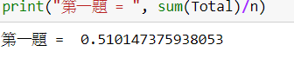

**2. (30%)**



<sol>

Simulation:

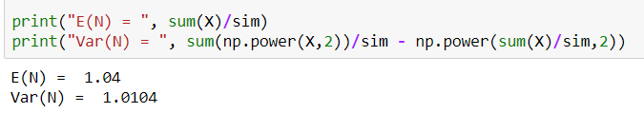

$$類似配對問題:第k個信封是否在第k個$$

$$P\left(恰有k個配對\right)= \sum_{n=k}^{100}{{\left(-1\right)}^{n-k}*\left({n \atop k}\right)*S_{k}}=\frac{1}{k!}(1-\frac{1}{1!}+\frac{1}{2!}-…+{\left(-1\right)}^{100-k}*)$$

$$WhereS_{k}=\sum_{i1}{…\sum_{ik}{{P(A}_{i1}∩{…∩A}_{ik})}}=\frac{1}{k!}, (Ai:第i個配對)$$

$$E\left(N\right)=\sum_{N=0}^{100}{N*P\left(恰有N個配對\right)}$$

$$=\sum_{N=1}^{100}{N*}\frac{1}{N!}\left(1-\frac{1}{1!}+\frac{1}{2!}-…+{\left(-1\right)}^{100-N}*\frac{1}{\left(100-N\right)!}\right)$$

$$Var\left(N\right)=E\left(N^{2}\right)-{(E(N))}^{2}$$

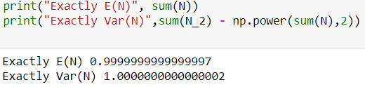

誤差:E(N) = 0.04

Var(N) = 0.0104

**3. (50%)**

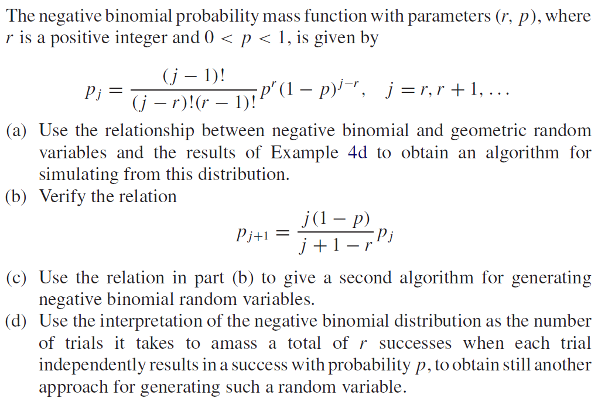

<sol>

$因為X_{i}\sim Gep\left(p\right), 參考投影片P.26\sim 28$

$$Algorithm:$$

$$Step1:Generate U \sim U\left(0,1\right)$$

$$Step2:X=int\left(\frac{\log\left(U\right)}{\log\left(1-p\right)}\right)+1$$

$$Step3:Repeat step2 r times;\sum_{i=1}^{r}{X_{i}}\sim NB(r,p)$$

$P_{j+1}=\frac{j!}{\left(j+1-r\right)!\left(r-1\right)!}p^{r}{\left(1-p\right)}^{j+1-r}$

$$=\frac{j\left(1-p\right)\left(j-1\right)!}{\left(j+1-r\right)\left(j-r\right)!\left(r-1\right)!}p^{r}{\left(1-p\right)}^{j-r}$$

$$=\frac{j\left(1-p\right)}{\left(j+1-r\right)}P_{j}$$

(c)

$$Algorithm: Start with p_{0}=p^{r}$$

$$Step1: Generate U\sim U(0,1)$$

$$Step2:X= \left\{\begin{aligned}r , 0≤U<p_{0} \\ r+1 , p_{0}≤U<p_{1} \\ ⋮\end{aligned} \right.,where P_{j+1}=\frac{j\left(1-p\right)}{\left(j+1-r\right)}P_{j}$$

(d)

$Algorithm:$

$$Step1:Set n=0$$

$$Step2:Set n=n+1$$

$$Step3:Generate U\sim U\left(0,1\right)$$

$$Step4:If U<p, set X_{i}=n, stop;else return step2$$

$$Step5:Repeat step1\sim 4 r times, \sum_{i=1}^{r}{X_{i}}\sim NB(r,p)$$