1. **Poison Process (50%)**

$$依照講義的thinning algorithm,因為λ必須≥λ\left(t\right), 所以選擇λ=7$$

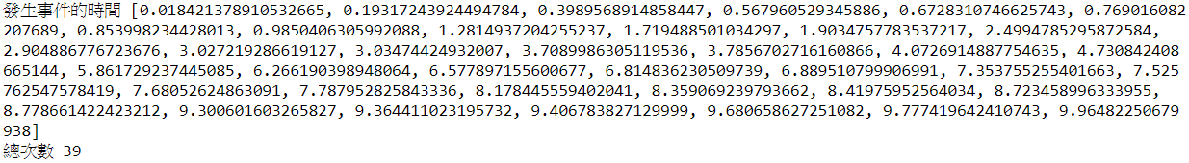

1. **Multivariate Normal Distribution (50%)**

$$因為Gaussion copulas 不變的是correlation matrix, 且在轉換回來時會$$

$$乘上standard deviation,因此設Cor\left(X\right)=Cor(W)= \left[\begin{matrix}1 & \frac{0.5}{2} & \frac{0.5}{3} \\ \frac{0.5}{2} & 1 & \frac{0.5}{6} \\ \frac{0.5}{3} & \frac{0.5}{6} & 1\end{matrix}\right],$$

$$並用cholesky decomposition 分解成 L=\left[\begin{matrix}1 & 0 & 0 \\ 0.25 & 0.9683 & 0 \\ 0.1667 & 0.043 & 0.9851\end{matrix}\right]$$

$$再生成y= \left[\begin{matrix}Y_{1} \\ Y_{2} \\ Y_{3}\end{matrix}\right]\sim U\left(0,1\right) 互相獨立$$

$$則 W= Ly為multivariate normal distribution$$

$$接著計算Φ\left(W_{i}\right), i=1,2,3$$

$$則X_{1}=-\log\left(Φ\left(W_{i}\right)\right) \sim Exp\left(λ=1\right)$$

$$X_{2}=-2\log\left(Φ\left(W_{i}\right)\right) \sim Exp\left(λ=\frac{1}{2}\right)$$

$$X_{3}=-3log\left(Φ\left(W_{i}\right)\right) \sim Exp(λ=\frac{1}{3})$$

$$且Cov\left(X_{i},X_{j}\right)=0.5$$

Via simulation:

