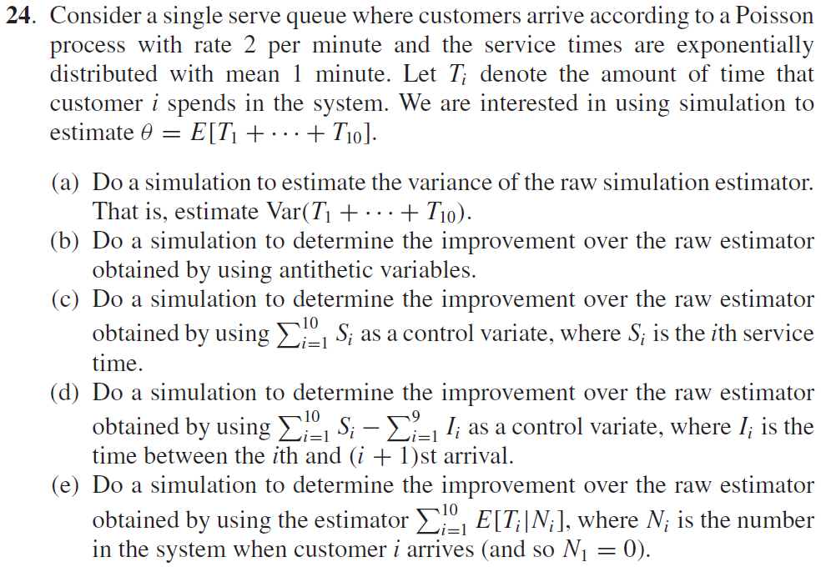

(a)

Step1 : Generate U ~ U(0,1) , t = t – log(U)/2,

Step2 : S[i] = t , repeat step 1~2 10 times

Step3 : Generate U ~ U(0,1), G = -log(U)

Step4 : D[1] = S[1]+G, if S[j] > D[j-1] , D[j] = S[j]+G ; else D[j] = D[j-1]+G ,

for j = 2~10

Step5 : theta = sum(D[1],…,D[10])

Step6 : Repeat step 1~5 n times , get theta(1),…,theta(n)

Step7 : Variance = Var(theta(i))



(b)

Step1 : Generate U ~ U(0,1) , t = t – log(U)/2,

Step2 : S[i] = t , repeat step 1~2 10 times

Step3 : Generate U ~ U(0,1), G = -log(U)

Step4 : D[1] = S[1]+G, if S[j] > D[j-1] , D[j] = S[j]+G ; else D[j] = D[j-1]+G ,

for j = 2~10

Step5 : theta1 = sum(D[1],…,D[10])

Step6 : Repeat step 1~5 by changing U to 1-U , get another theta2 & theta(i)= (theta1+ theta2)/2

Step7 : Repeat step 1~6 n times , get theta(1),…,theta(n)

Step8 : Variance = Var(theta(i))



(c)

Step1 : Generate U ~ U(0,1) , t = t – log(U)/2,

Step2 : S[i] = t , repeat step 1~2 10 times

Step3 : Generate U ~ U(0,1), G = -log(U)

Step4 : D[1] = S[1]+G, if S[j] > D[j-1] , D[j] = S[j]+G ; else D[j] = D[j-1]+G ,

for j = 2~10

Step5 : Y = 10\*E(G)

Step6 : theta = sum(D[1],…,D[10])

Step7 : Repeat step 1~6 n times , get theta(1),…,theta(n) , Y1,…,Yn

Step8 : Variance = Var(theta(i)) – cov(theta(i),Yi)^2/Var(Yi)



(d)

Step1 : Generate U ~ U(0,1) , t = t – log(U)/2,

Step2 : S[i] = t , repeat step 1~2 10 times , I[i] = S[i+1]-S[i] for i = 1,…,9

Step3 : Generate U ~ U(0,1), G = -log(U)

Step4 : D[1] = S[1]+G, if S[j] > D[j-1] , D[j] = S[j]+G ; else D[j] = D[j-1]+G ,

for j = 2~10

Step5 : Y = 10\*E(G) – 9\*E(I])

Step6 : theta = sum(D[1],…,D[10])

Step7 : Repeat step 1~6 n times , get theta(1),…,theta(n) , Y1,…,Yn

Step8 : Variance = Var(theta(i)) – cov(theta(i),Yi)^2/Var(Yi)



(e)

Step1 : Generate U ~ U(0,1) , t = t – log(U)/2,

Step2 : S[i] = t , repeat step 1~2 10 times

Step3 : Generate U ~ U(0,1), G = -log(U)

Step4 : D[1] = S[1]+G, if S[j] > D[j-1] , D[j] = S[j]+G ; else D[j] = D[j-1]+G ,

for j = 2~10

Step5 : If S[j] < D[i] for j<i , N[i] +=1 for i = 2,…,10, N[1]=0

Step6 : theta = sum(N[i]+1)\*1

Step7 : Repeat step 1~6 n times , get theta(1),…,theta(n)

Step8 : Variance = Var(theta(i))

