Output

> mean(mydata)

[1] 601.5714

> #descriptive stat of median in friend counts

> median(mydata)

[1] 434.5

> #descriptive stat of standard deivation in friend counts

> sd(mydata)

[1] 720.4366

boxplot(FriendsCount ~ Lang, data=df, xlab="Lang", ylab="FriendsCount")

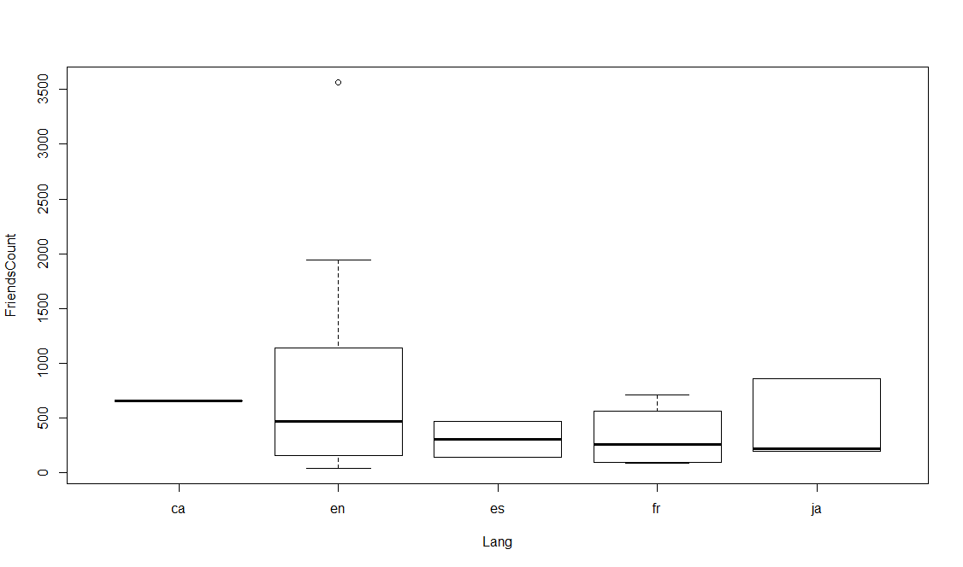

barplot(table(df$Lang))

